Deliverable 1 : Customer Lifetime Value Ranking
Step 1 :
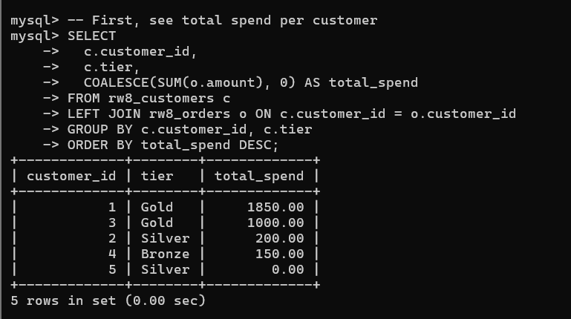
Step 2 : Add rankings and comparisons
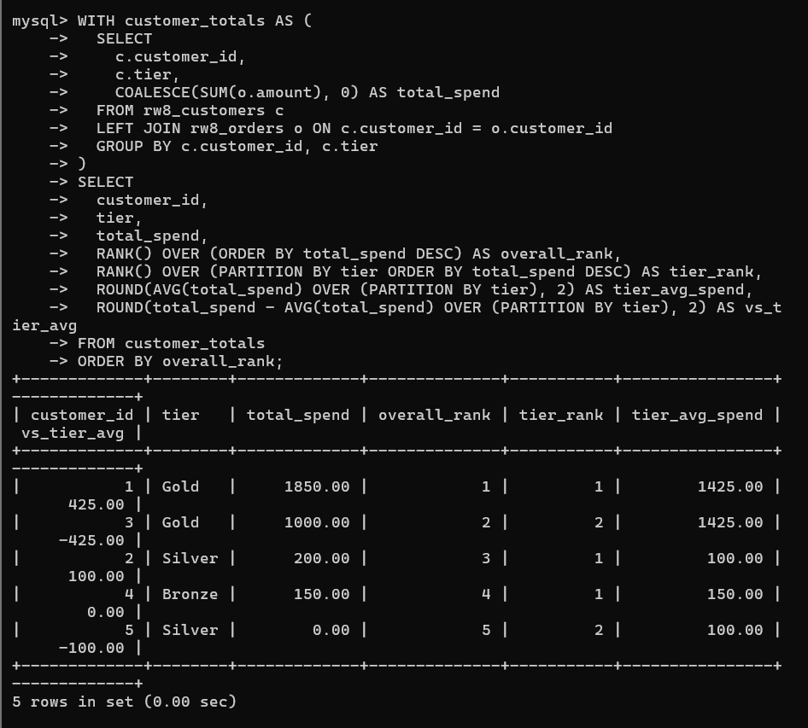
Deliverable 2 : Monthly Cohort Analysis
Step 1 :
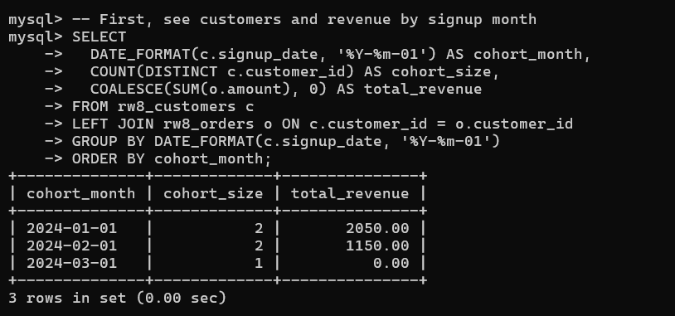
Step 2 :
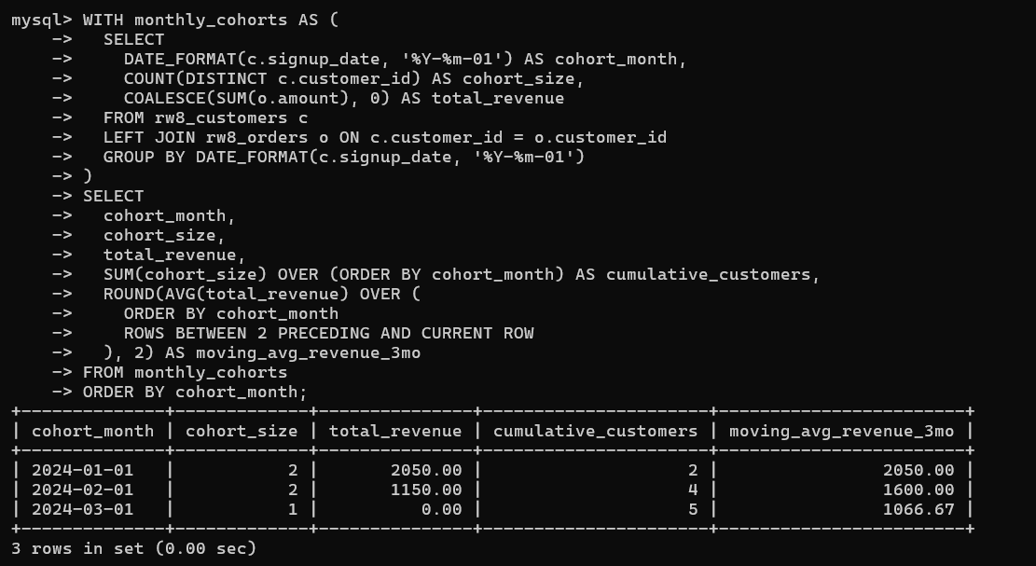
Deliverable 3 : Purchase Pattern Analysis
Step 1 :
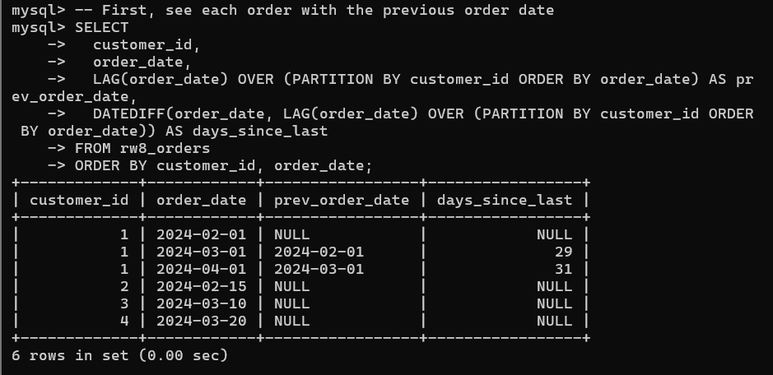
Step 2 :
