Activity 1: Clean Messy Prices for Display
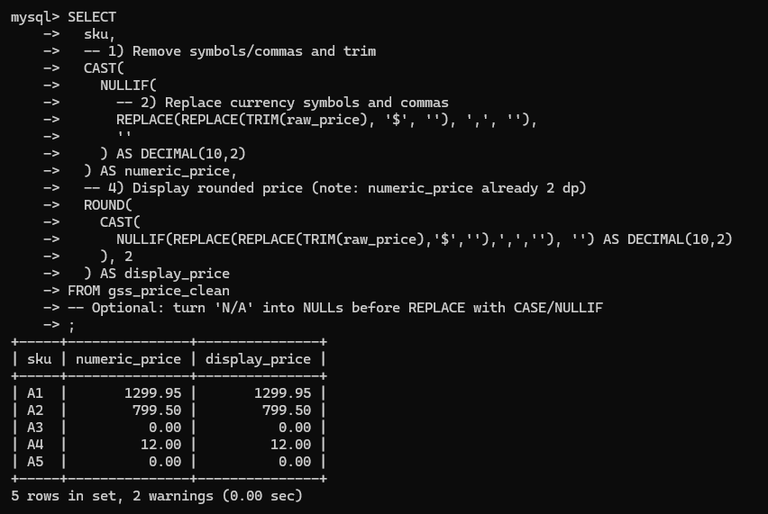
Activity 2: Normalize Names and Emails
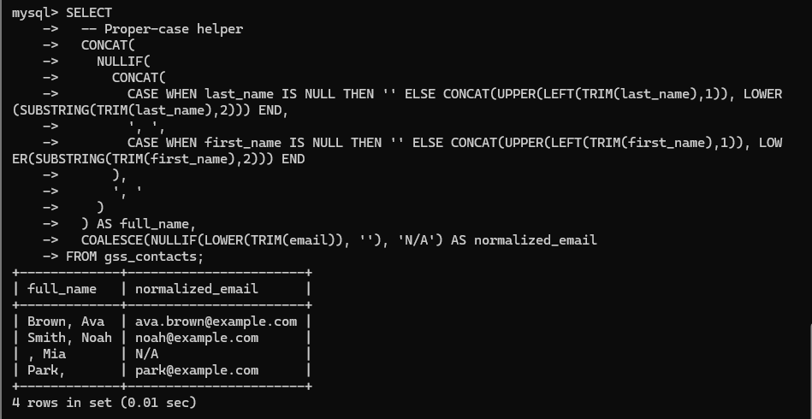
Activity 3: Appointment Durations and Buckets
