Easy :
- Tip Calculator Formatting
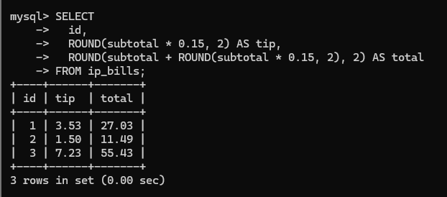
- Proper-Case Names
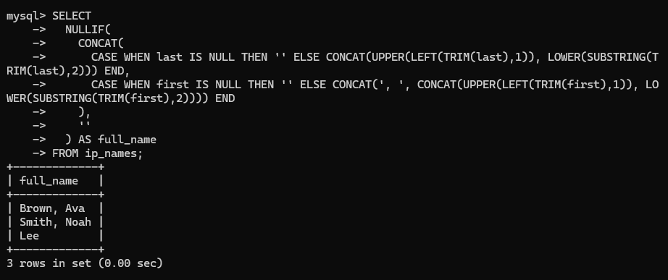
- Month and Weekday From Dates
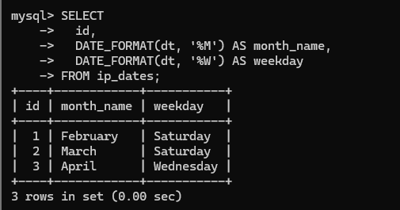
Medium :
- Parse Messy Prices
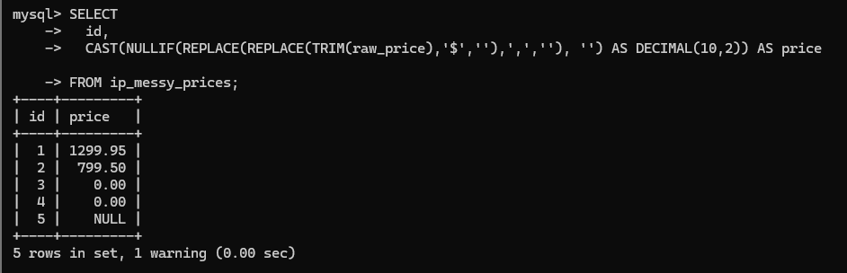
- Accurate Age in Years
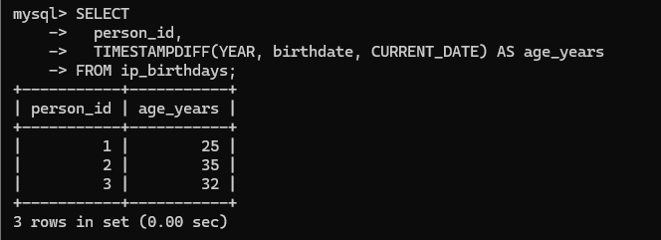
- Normalize Empty Strings to NULL
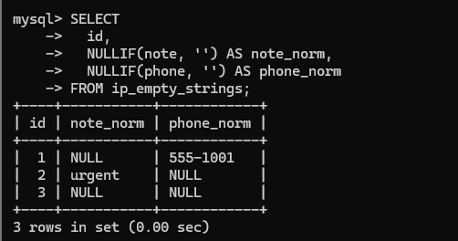
Challenge : Robust Conversion and Derived Metrics
