Paired Programming : Data Cleanup Lab
Part A : Normalize Users
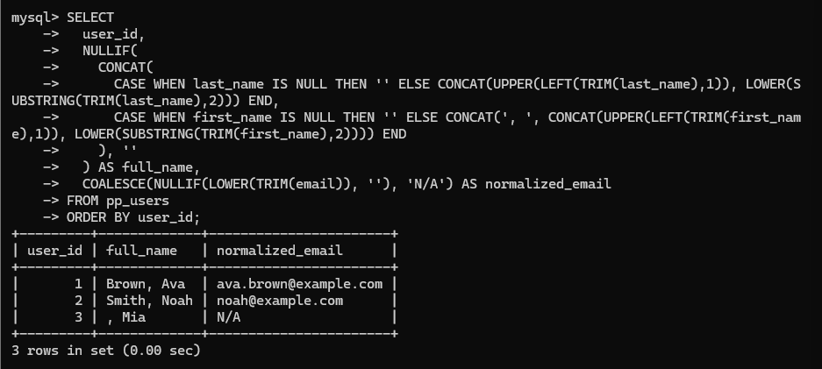
Part B : Clean Prices
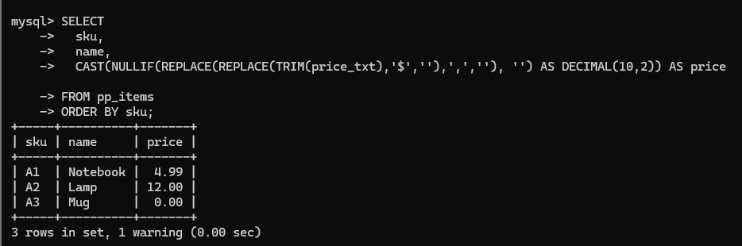
Part C : Safe Quantity Buckets
