Real-World Project : Clean Data Export Suite
- Clean customers export
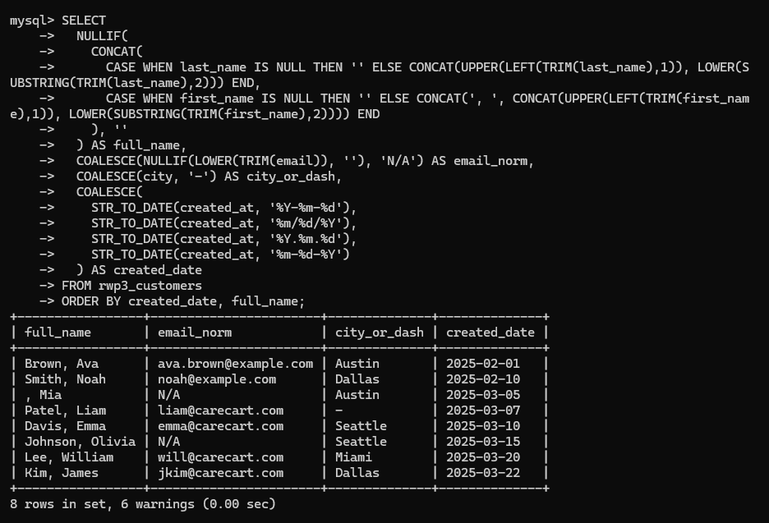
- Product price normalization
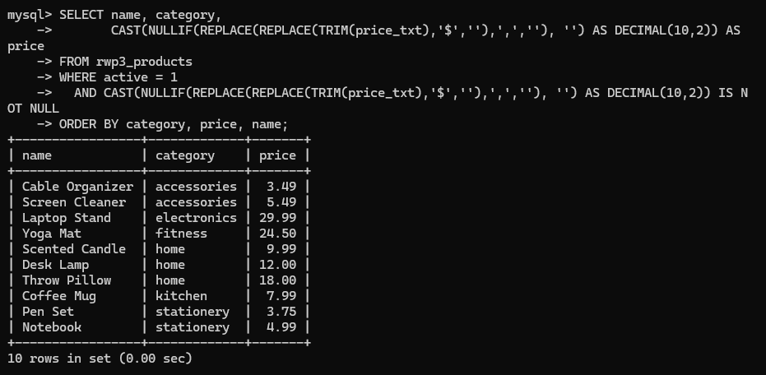
- Orders snapshot with parsed dates
