Challenge 1 : Marketing Contacts Normalization
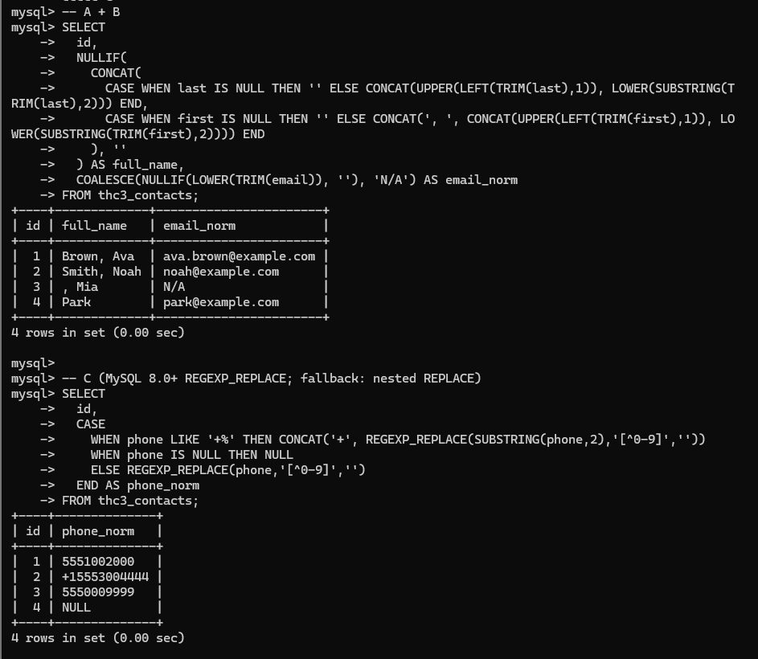
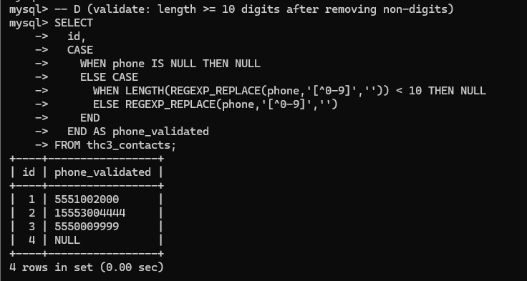
Challenge 2 : Product Pricing and Promotions
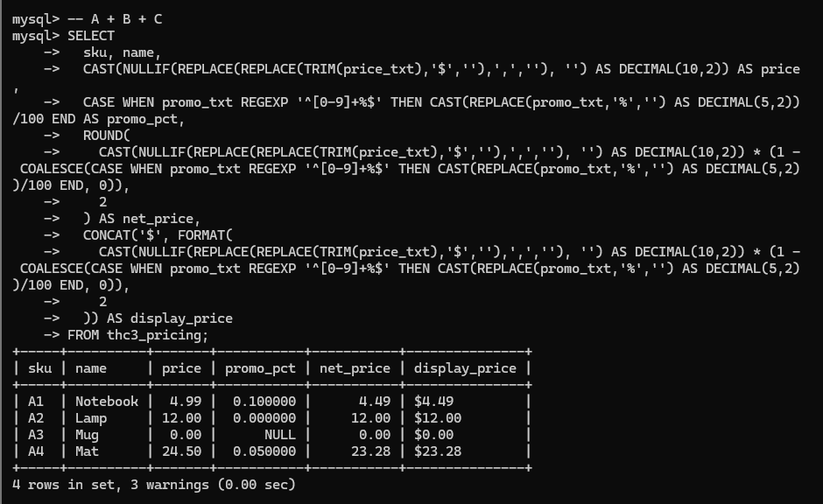
Challenge 3 : Order Windowing and Labels
