Activity 1 : Category Revenue Snapshot
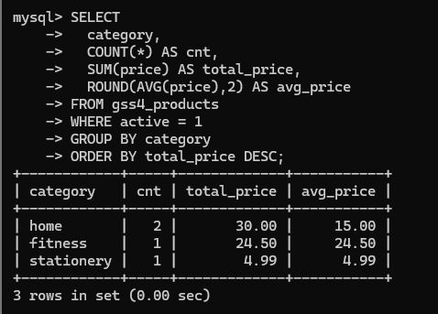
Activity 2 : Orders by Status With Threshold
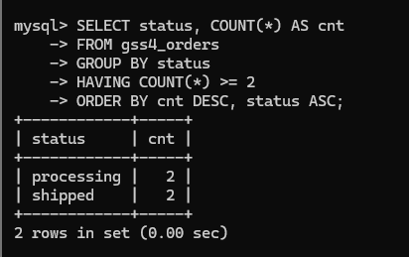
Activity 3 : Monthly Orders with GROUP_CONCAT
