Part A (Driver 1) : Orders per Status
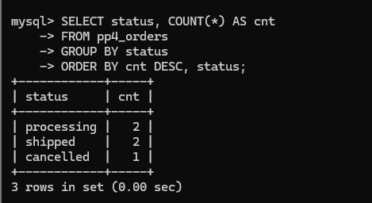
Part B (Driver 2) : Revenue by Order
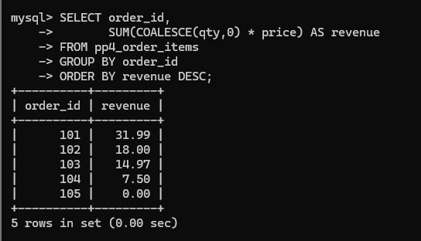
Part C (Driver 1) : Order Count by Status
