- Orders by status (last 30 days)
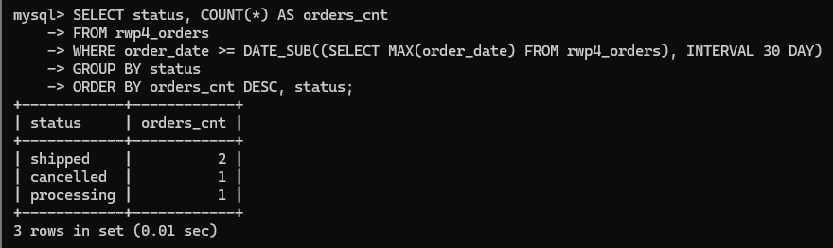
- Product summary by category
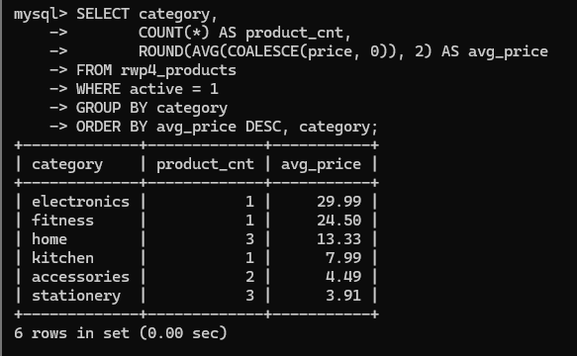
- Monthly order trend with sample IDs
