Challenge 1 : Customer Activity Summary
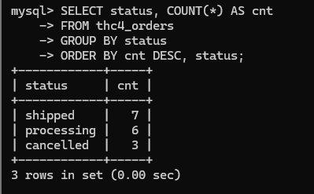
Challenge 2 : Category Sales Metrics
# Not Covered JOINs statement till now so skipping
Challenge 3 : Monthly Trend with Thresholds
