- Do not edit/delete any heading or section with red text.
- Type /paste you answers in relevant sections (below Final Answer (in all questions , Approach (wherever required ) and Charts & tables (wherever required)) of the solution
- Link to submission guidelines
- Please note that submission not following the guidelines will not be accepted

OBJECTIVE QUESTIONS

Question 1: What is the total no. of tables present in the data?

Solution:

Final Answer (if any):
Total number of tables present in the cleaned data: 1

Approach (if any):
If you checked the workbook structure and dataset sheet/dataset, we can find one single consolidated sheet for dataset, hence all records are stored in one sheet so one main table
- All records are stored in a single consolidated dataset
Therefore, counted 1 main table

Charts & Tables (if any):
Table Name: Cleaned Data Table
Description:
A single comprehensive dataset containing all call center records including user details, timestamps, durations, call status, ratings, and other attributes used for analysis.

Question 2: What is the total no. of attributes present in the data?

Solution:

Final Answer (if any):
Total attributes present in the data: 29

Approach (if any):

We can use the formula- =COUNTA(1:1) (if headers are in row 1)
Or
Manually open the sheet and go to the clean dataset and count the total number of the columns(headers)- it is 29

Charts & Tables (if any):
- Table / Chart Name:
<Name of the table or chart used>
- Description:
<What the table or chart represents>

Question 3: The data consists of some inconsistent and missing values so ensure that the data used for further analysis is cleaned.

Solution:

Final Answer (if any):
The dataset has been successfully cleaned and prepared for analysis by removing inconsistencies and handling missing values.

Approach (if any):
The following data cleaning steps were applied:
- Handling Missing Values- identify all missing values in each attribute and identify which suitable values need to be filed.
Like for any amount, number, duration- we used the average to be filled
For any text, string- we used the “no record”, “Missing” value to be enter
I have used if function with the isblank to see if there is any blank value, fill it with the average, others , missing or no records.
- Removing Duplicates
  - Checked duplicate records based on unique identifiers (e.g., ID) and select all data in sheet and click search bar and type remove duplicates based on all column selection
- Standardizing Data Formats
  - Converted date/time fields into a consistent datetime format- like createddate, updatedate , chatstarttime and chatendtime, format all date column in one standard format- using value and substitute function and convert to IST format
=VALUE(SUBSTITUTE(SUBSTITUTE(data!T2,"T"," "), "Z","")) + TIME(5,30,0)
  - Ensured numeric columns (duration, amounts)
- Text Standardization
  - Converted:
    - Names → Proper case - use the proper function to do it
  - Trimmed extra spaces to avoid hidden inconsistencies
- Fixing Inconsistent Values
  - Standardized categorical fields like:
    - CallStatus
    - Region
    - UserCallStatus
  - Removed variations like extra spaces or mismatched capitalization
- Column Structuring
  - Ensured all columns are clearly defined and correctly labeled
  - Verified total attributes (29 columns) are consistent

Charts & Tables (if any):
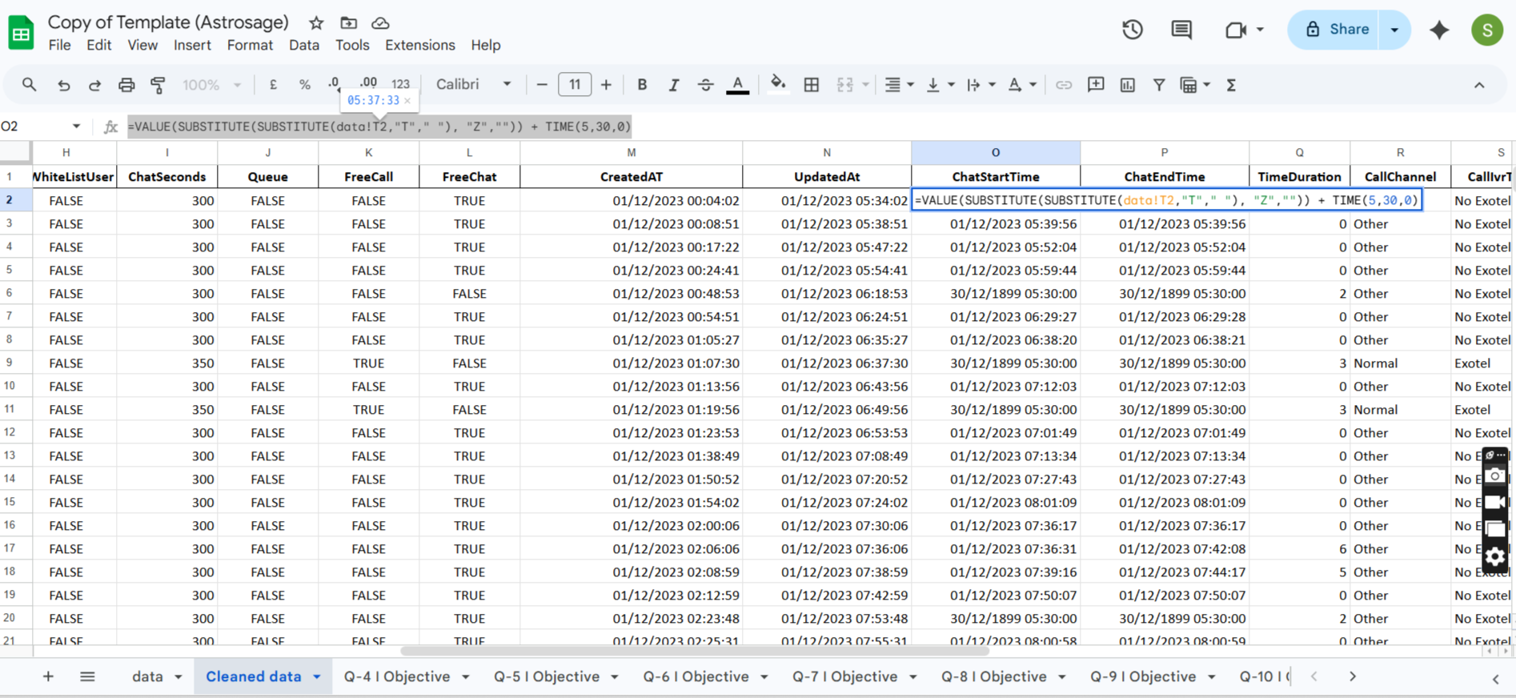

Question 4: What is the change in daily call volume day by day and also find the average daily call volume.

Solution:

Final Answer (if any):
The average daily call volume is 250.
Formula used- =average(call volume column)
The day by day change in the call volume can be seen in the column “Change in call volume” and can also be seen in the chart which shows call volume over the day by day basis.

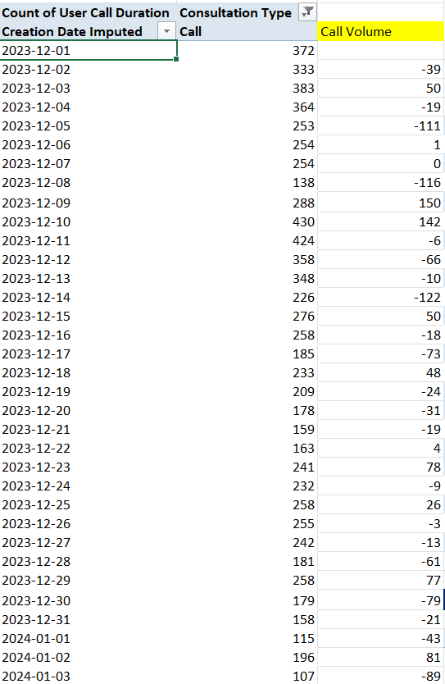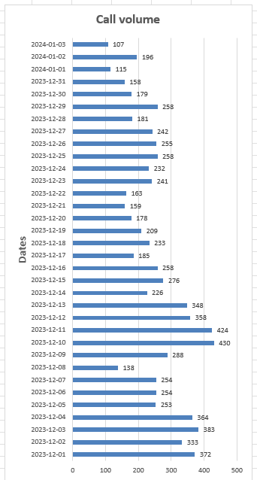

Change in daily call volume is different for each days, we can see in pivot table in attached sheet for objective question 4

Approach (if any):
Created a Pivot Table:
- Rows → Date (CreatedAt)
- Values → Count of Consultation Type
Calculated Day-by-Day Change:
- Formula used:
=Current Day Calls - Previous Day Calls
Calculated Average Daily Call Volume:
=AVERAGE(Call volume count)

Charts & Tables (if any):

Question 5: Which months experienced the highest and lowest call volumes?

Solution:

Final Answer (if any):
Ans-There are only 34 days are given which is of only two months December and January. 31 days of December and only 3 days of January.
On 10/12/23 there was highest call volume i.e 430.
Formula used- =Max(call volume column)
On 03/01/2024 there was lowest call volume i.e. 107.
Formula used - =Min(call volume column)
December – Highest call volume.
January – Lowest call volume.

Approach (if any):
Created a Pivot Table:
Consultation Type | Call
 |  | Count of Consultation Type
Jan |  | 418
 | 2024-01-01 | 115
 | 2024-01-02 | 196
 | 2024-01-03 | 107
Dec |  | 8090
 | 2023-12-01 | 372
 | 2023-12-02 | 333
 | 2023-12-03 | 383
 | 2023-12-04 | 364
 | 2023-12-05 | 253
 | 2023-12-06 | 254
 | 2023-12-07 | 254
 | 2023-12-08 | 138
 | 2023-12-09 | 288
 | 2023-12-10 | 430
 | 2023-12-11 | 424
 | 2023-12-12 | 358
 | 2023-12-13 | 348
 | 2023-12-14 | 226
 | 2023-12-15 | 276
 | 2023-12-16 | 258
 | 2023-12-17 | 185
 | 2023-12-18 | 233
 | 2023-12-19 | 209
 | 2023-12-20 | 178
 | 2023-12-21 | 159
 | 2023-12-22 | 163
 | 2023-12-23 | 241
 | 2023-12-24 | 232
 | 2023-12-25 | 258
 | 2023-12-26 | 255
 | 2023-12-27 | 242
 | 2023-12-28 | 181
 | 2023-12-29 | 258
 | 2023-12-30 | 179
 | 2023-12-31 | 158
Grand Total |  | 8508

Consultation Type | Call
 | Count of Consultation Type
Jan | 418
Dec | 8090
Grand Total | 8508

Charts & Tables (if any):

Question 6: What is the total operational cost for that month?

Solution:

Final Answer (if any):

Ans –The operational cost for that month= Total net income of month – Astrologer income of month
1) December –
Astrologer earning = 93786.16
Function used - =SUMIF('Clean Data'!J:J,"December",'Clean Data'!AB:AB)
Net Earning = 202214.6
Function used- =SUMIF('Clean Data'!J:J,"December",'Clean Data'!AC:AC)
Operation cost =202214.6 - 93786.16
December Operation cost = 108428.44
2) January –
Astrologer earning = 5360.41
Function used - =SUMIF('Clean Data'!J:J,"January",'Clean Data'!AB:AB)
Net Earning = 11772.69
Function used- =SUMIF('Clean Data'!J:J,"January ",'Clean Data'!AC:AC)
Operation cost = 11772.69 – 5360.41
January Operation cost = 6412.28

Month | Sum of Astrologers Earnings | Sum of Net Amount
Jan | 5360.408 | 11772.69
Dec | 93786.16295 | 202214.6253
Grand Total | 99146.57095 | 213987.3153
Operational Cost | Value
January | 6412.282
December | 108428.4624

CreatedAT - Year-Month | SUM of Operational Cost
2023-Dec | 108428
2024-Jan | 6412.28

Question 7: What is the average number of calls handled per agent per day?

Solution:

Final Answer (if any):
Average number of call handled by per agent per day is approx = 246.0294118

Approach (if any):

Total Calls – 8508
Function Used- =COUNTIF('Clean Data'!F:F,'Clean Data'!$F$9)
Number of days – 34
Function Used - =COUNT(UNIQUE(Created date Col))
Number of agents(Guru)- 131
Function used - =COUNT(UNIQUE('Clean Data'!D:D))

First we have to find average number of calls per day.
Average number of calls per day= Total calls / Number of days
= 5808 / 34
= 250.23
Now we have to find average number of calls handled by per agent per day.
Average number of calls handled by per agent per day = Average number of calls per day / Number of Agent
= 250.23 / 131
= 1.91
So we can say that approx. 2 calls are handled by per person per day.
Total Calls | 8508
Net Amount (Call) | 168442.035 | Average Call Per Day
Day Count | 34 | 250.2352941
 | average number of calls handled per agent per day
 |  | 1.910193085

Question 8: How many repeat callers are there, and what percentage of total calls do they represent?

Solution:

Final Answer (if any):

4879 are repeat call and 57.34 percent of total call are repeat call
Approach (if any):
With the help of this pivot table we can find the total number of callers.
Total number of callers=3629
Formula used- =COUNT()
Now we have to find the repeater callers. The callers who use the call service more than one time,
For that we can apply the filter on the pivot table in the user id section, which will show the callers who called more then one time.

Repeater callers = 1277
Formula used- =COUNT()
Single time callers (Non repeaters) = Total callers – Repeater callers
Non Repeater callers = 2352
PERCENTAGE OF TOTAL CALLS –
Total number of calls = 8508 ( count of calls )
Caller placed 6156 repeated calls.
Repeated calls = 6156 – 1st call placed by callers
= 6156 – 1277 (count of repeated callers )
Repeated calls = 4879
Percentage of repeated calls = (Repeated calls *100)/Total calls
= (4879*100/8508)
Percentage of repeated calls = 57.34 %

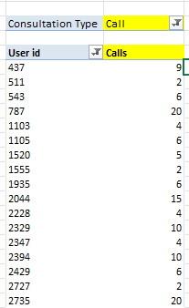

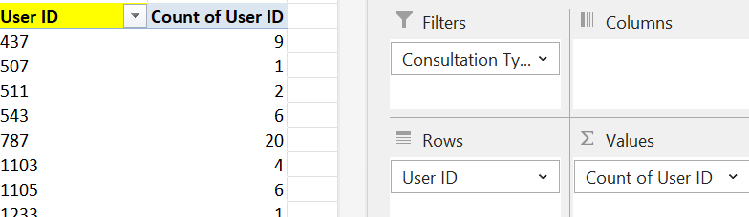

Total Calls |  |  |  |  | 8508
Repeat Calls |  |  |  |  | 6156
Total Caller Count |  |  |  |  | 3629
One Time Caller |  |  |  |  | 2352
Repeat Caller |  |  |  |  | 1277
Repeat call % over total calls |  |  |  |  | 57.35%

Question 9: What are the total sales generated by the call centre for each product category?

Solution:

Final Answer (if any):

Website (Source of consultation ) taken as the product categories.
Highest sales generated by App. And lowest by Dashboard.
Consult Type | Sum of Net Amount | Sum of Astrologers Earnings | Sum of Revenue
app | 125267.38 | 57078.34 | 68189.04
dashboard | 0.00 | 0.00 | 0.00
gurucool | 88719.93 | 42068.23 | 46651.71
Grand Total | 213987.32 | 99146.57 | 114840.74

Charts & Tables (if any):

Question 10: How many calls were made for each user ID and guru ID?

Solution:

Final Answer (if any):
The list is very long as there 3629 users who used call service and they made 8508 calls in total.
Formula used- =COUNTIF('Clean Data'!F:F,"Call") (To measure total calls )
=COUNT() (To measure users)
With the help help of pivot table we can see the calls made for each User ID and Guru ID.
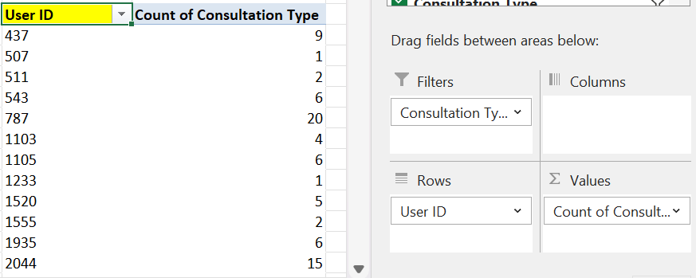

There are 131 Gurus who received calls from users.

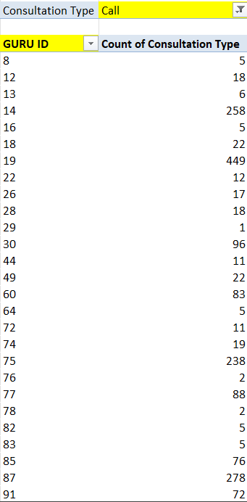
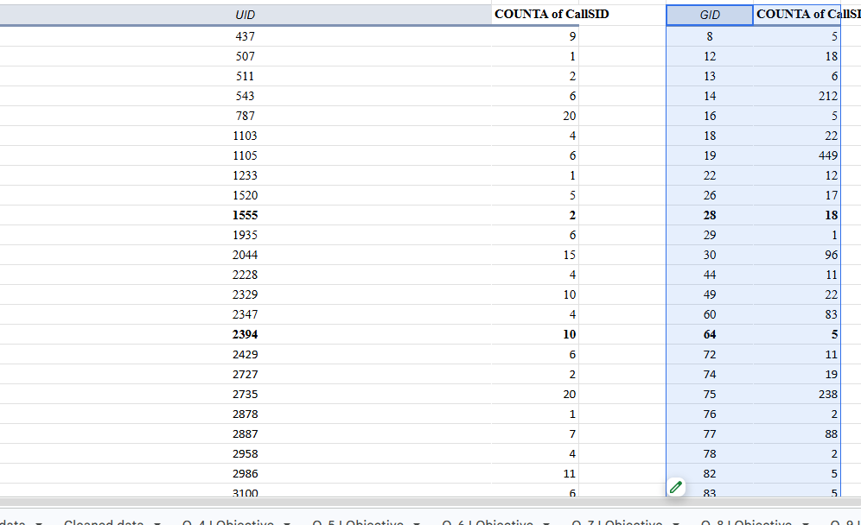

Charts & Tables (if any):

Displays the number of calls made by each user to each guru, helping analyze interaction patterns between users and service providers.

Question 11: What is the correlation between call duration and customer satisfaction?

Solution:

Final Answer (if any):

The correlation between call duration and customer satisfaction is
0.054758181

Formula used – ==CORREL('AstroSage Analysis_SauravNew.xlsx'!Table1[[#All],[User on Call Duration]],'AstroSage Analysis_SauravNew.xlsx'!Table1[[#All],[rating]])
A correlation of (-0.054758181) indicates an extremely weak negative relationship between call duration and rating. However, the value is so close to 0 that it essentially suggests no meaningful linear relationship between the two variables.

Charts & Tables (if any):

Question 12: Which guru has the highest and lowest customer satisfaction scores?

Solution:

Final Answer (if any):

If we take the average of all gurus rating then Tarot Rittika(Guru id – 80) got the lowest satisfaction score but she only consulted once and only one user rated her. While Tarot Mystical(Guru id – 305) got the highest average rating but she consulted only two users with chat service.
So I think its not fare to decide lowest and highest satisfaction scores with only two or one user review.

Tarot Rittika has lowest customer satisfaction rating
Astro Pujaa Rai and Tarot Mystical has highest customer satisfaction rating

 | Rating | Guru Name
Max of Avg Rating | 7.5 | Astro Pujaa Rai
 |  | Tarot Mystical
Min of Avg Rating | 0.102272727 | Astro K Ojha

Approach (if any):

Create Pivot Table
- Rows → Guru ID / Guru Name
- Values → Rating
  - Change to Average
This gives average satisfaction score per guru name
Another approach is to find out which Guru receive high number of lowest satisfaction score i.e. 0,and same for highest satisfaction score i.e. 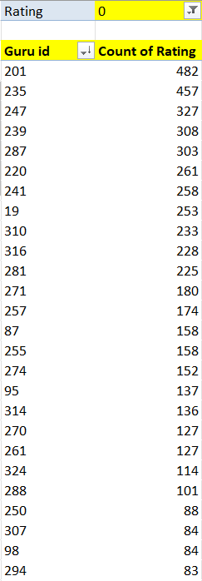
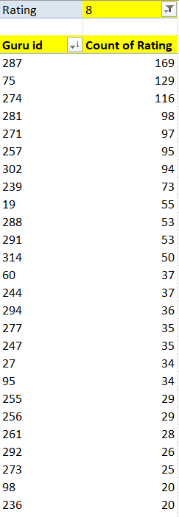

Charts & Tables (if any):

For the pivot table we can see that Astro Yogendra (Guru id- 201 ) got the highest number of 0 i.e. 482 times , so we can consider him as lowest satisfaction score earned guru.
While Astro Krishaa ( Guru id -287 ) got the highest number of 8 which is 169 times , so we can considered her as highest satisfaction score earned guru.
(Here sorting is use to see the highest count.)

Question 13: What is the average customer satisfaction score by month?

Solution:

Final Answer (if any):

There are only two months are given in data i.e. December 2023 and January 2024.
December – 2.95 January – 2.68

Formula used –
=AVERAGEIF(Sheet1!J:J,"December",Sheet1!AE:AE)
=AVERAGEIF(Sheet1!J:J,"January ",Sheet1!AE:AE)

CreatedAT - Year-Month | AVERAGE of Rating
2023-Dec | 2.949637572
2024-Jan | 2.676413255

Approach (if any):

Create Pivot Table
- Rows → Month (from CreatedAt)
- Values → Rating
  - Set to Average

Charts & Tables (if any):
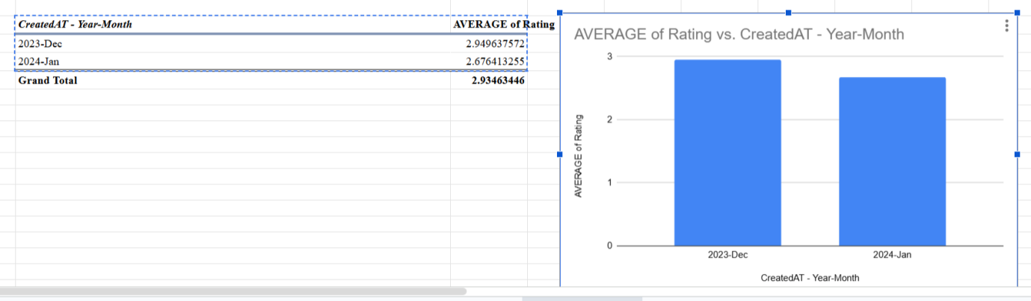

Question 14: How many categorical columns are there in the data? [Search about categorical and continuous data, and try to answer this question]

Solution:

Final Answer (if any):
Ans -
1) Categorical Columns:
Definition: These are variables that represent distinct categories or groups. The values are typically qualitative and can be divided into discrete, non-numeric groups or labels.
Categorical columns are:(From raw dataset)
_id
CallSid
user, astrologerCallStatus
chatStatus
region
guru userCallStatus
guruName gid
uid callStatus
consultationType callIvrType
website FreeChat
RefundStatus callChannel
isWhiteListUser FreeCall
queue
They are categorical columns because the show characteristics like –
Qualitative: They represent descriptive characteristics or labels.
Discrete: There is a limited or fixed number of values.
Non-numeric: Though some categorical variables can be numeric (like ID numbers), the numbers don't have mathematical meaning.
2) Continuous Columns:
Definition: These are variables that can take on any value within a certain range and are typically numeric. They represent measurable quantities.
Continuous Columns are : (From raw data)
chatSeconds timeDuration
amount astrologerOnCallDuration
astrologersEarnings netAmoun
userOnCallDuration rating
They are Continuous columns because the show characteristics like –
Quantitative: The data can be measured and expressed numerically.
Continuous: They can take any value within a range, including decimals.
Mathematically meaningful: You can apply arithmetic operations like addition and subtraction to continuous data.

SUBJECTIVE QUESTIONS

Question 1: Should the investment be used to hire more agents, improve training programs, or upgrade call center technology?

Solution:

Approach:
Hiring more agents
There are 131 Gurus, who provide service to the users.
Total call receive = 8508
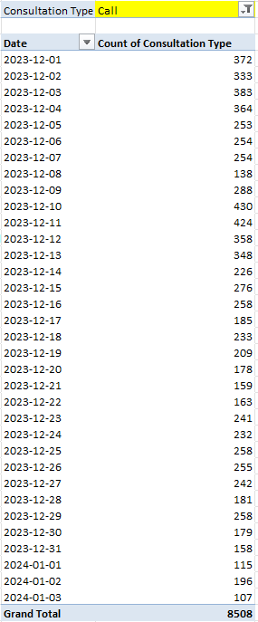
Average number of calls per day = 250 (Formula - =AVERAGE())
Call Status | Count of Call Status
busy | 1270
completed | 3453
failed | 1214
no-answer | 1729
percentage | 45.04304722

% of calls gets complete = 45.41 % {Formula= (Completed calls * 100)/ total calls}
Call centre receive approx. 250 calls per day but only 56.41% of calls gets complete in total. There is a need of investment in the hiring of agents to manage the workload.

2) Upgrade Call centre technology.
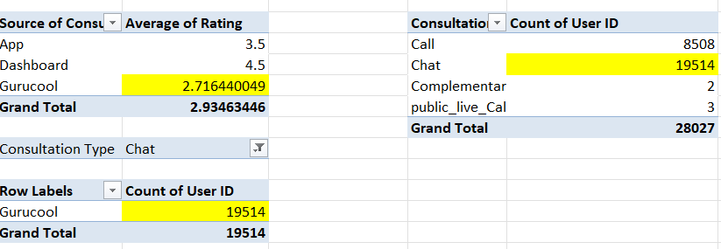
There is need for technology upgrades because 69.62% of total users use chat service. And Gurucool is only one platform which provide the service of the Chat to the users. But the average rating of the Gurucool is 2.71, which is the clear indicator of unsatisfied users. So it is very necessary to improve technology and provide satisfaction to the users . Investing in technology upgrades will help to improve the overall experience and will help to increase the retention rate of the users. But there are some risks in upgrading technology.

3) Training .
Only 27.49% of users are satisfied with the service.
Total users = 28027
Satisfied user (Rating-5,6,7,8) = 27.49 %
(formula- =(SUM(satisfied users)*100/total users))
Unsatisfied user (Rating-0,1,2,3,4) = 72.51 %
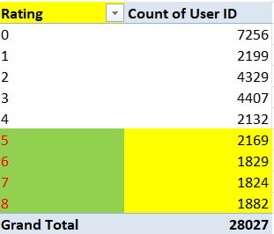
I think the investment should be used to improve training program. There are three reasons.
REASON 1 -
The total call duration of Astrologer is 1077344 sec (299.26 hours).
The total call duration of user is 993635 sec (276.0097 hours).
The difference is of 83709 sec (23.25 hours )
This suggest that Astrologer taking more time to handle calls, which indicating the need for improvement in efficiency.
(Formula use to calculate call duration is =Sum function)
REASON 2 -
Out of 8541 calls only 3453 calls are getting completed, which is 40.43 %.
That means 59.57 % of users are not getting the service despite of booking the call session.
It is one of the reasons why the average rating of the call service is 3.50 only.
( Formula used - =AVERAGEIF('Clean Data'!F:F,"Call",'Clean Data'!AE:AE))

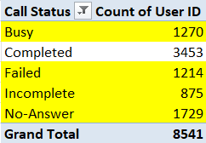
Call completed =3453
Other status(Busy, failed, incomplete, no answer) =5088
Percent of completed calls = (Completed calls * 100) / Total calls
= (3453*100)/8541
= 40.43 %
Percent of incomplete calls (other status) = 59.57%.
REASON 3-
The 78.72% of the total net income for the company comes from Call service only.
And the 78.46% of the total income for the astrologer comes from Call service.
So if the call service is a key revenue driver, investing in training programs would be a strategic move to sustain and enhance that success.
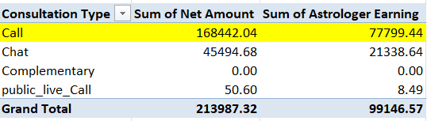
  - Percent of call income = (Call income * 100)/Total income

Question 2: What are the potential risks of each investment option (hiring, training, technology upgrades), and how can they be mitigated?

Name the chart/spreadsheet function you will use for solving the problem.

Solution:

Approach:
1} HIRING –
Potential risks –
1) Onboarding cost – To onboard any employee the company have to bare the onboarding cost, which can be high as company will pay certain agency to recruit perfect fit employee for them.
2) Training cost - Investing time and money into training a new hire who turns out to be a poor fit can be waste of resources.
3) Not retained for long term – If the individual is not retained long-term, then it will be waste of the time and resources.
4) Lack of Skills: Misjudging a candidate’s qualifications during the hiring process could lead to poor performance and potential rework.
5) Damage to Reputation: If a new hire behaves inappropriately or unethically ,it can damage the company’s reputation.
Mitigating these risks involves-
1) Long 4-5 rounds of interview.
2) Clear communication about job expectations.
3) And ensuring a good cultural fit during the hiring process.
2} TECHNOLOGY UPGRADES-
There is need for technology upgrades because 69.62% of total users use chat service. And Gurucool is only one platform which provide the service of the Chat to the users. But the average rating of the Gurucool is 2.71, which is the clear indicator of unsatisfied users. So it is very necessary to improve technology and provide satisfaction to the users . Investing in technology upgrades will help to improve the overall experience and will help to increase the retention rate of the users. But there are some risks in upgrading technology.


Potential risks –
1) Costs – Upgrades comes with high costs. Includes hardware ,software, software licenses, equipment, training and maintenance.
2)Training requirement- Employees require training to cope up with the new technology.
3) Performance issue- The new technology may not deliver the expected performance or may require more resourses.
4) Loss of data – During the upgrade data might get corrupted or loss.
Mitigating these risks involves-
1) Create a detail budget for potential costs before upgrading.
2) Provide training and support to employees.
3) Backup all the data before upgrade.

3} TRAINING-
Only 27.49% of users are satisfied with the service. To improve that, company must invest in training program. Investing in training programs would be a strategic move to sustain and enhance that success.
Total users = 28027
Satisfied user (Rating-5,6,7,8) = 27.49 %
Formula – {(sum of users that gave rating 5,6,7,8)*100} / Total users
Unsatisfied user (Rating-0,1,2,3,4) = 72.51 %

Potential risks –
1) High cost – Training programs involving external trainers and certificcations can be expensive.
2) Employees can resign- After gaining new skills, employee might seek better opportunity and can resign.
3) Ineffectiveness of training- The training may not be relevant or aligned with business goals.
Mitigating these risks involves-
1) Focus on in-house training and assess cost benefit ratio.
2) Create positive environment and growth opportunity. Also introduce contract agreements.

Insights:

Call volume is not consistently high, so full-scale hiring is risky
Customer satisfaction is moderate, indicating training gap
No strong evidence of system failure → tech upgrade not urgent

Recommendations:

Primary recommendation is - Invest in Training Programs which is likely improve the customer satisfaction and enhance agent performance and secondary recommendation is to hire more agents. And technology upgrade is very low priority as data has never shown any records about system failure.

Training provides the highest return with manageable risk, while hiring should be demand-driven and technology upgrades should be phased to minimize financial and operational risks

Question 3: How does AstroSage's call center performance compare to AstroGuru's average call volume, customer satisfaction, and agent performance?

Will you use any aggregation function or a visualization here to solve the problem?

Solution:
Approach:
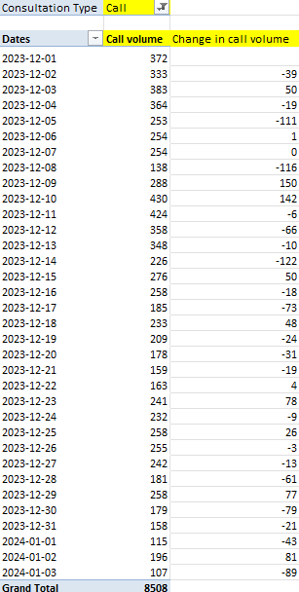
The average call volume per day is 250 calls .
There are 131 gurus who can receive calls.
But out of 8541 total calls only 3453 calls are getting completed, which is 40.43 %.
That means 59.57 % of users are not getting the service despite of booking the call session. This is the reason why the average rating of the call service is 3.5 only.
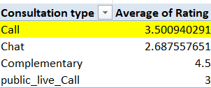
If the rating of the Astrologers increase then company rating also increase.

The 78.72% of the total net income for the company comes from Call service only.
And the 78.46% of the total income for the astrologer comes from Call service.
So if the call service is a key revenue driver, investing in training programs would be a strategic move to sustain and enhance that success.

Percent of call income = (Call income * 100)/Total income
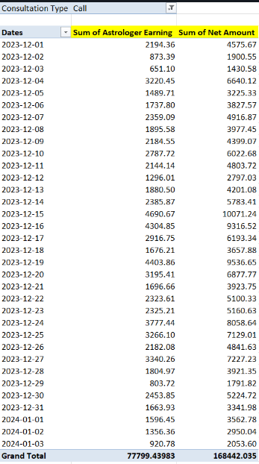

The performance of agents are very important to the company as they are interconnected. Because there is the correlation to the agent earning and net amount.
Correlation of agent earning and net amount= 0.9970
(Formula - =CORREL())
A correlation of 0.99 suggests a very strong positive linear relationship between two variables. This means that as one variable increases, the other variable almost always increases in a nearly predictable manner. The closer the correlation coefficient (r) is to 1, the stronger the relationship, with 1 representing a perfect positive correlation.

Question 4: How can the call center improve its handling of peak call periods to ensure high customer satisfaction?

Mention the functionality you will use for giving the suggestions, will it be any aggregated function or a visualization?

Solution:

Approach:

Date 2023-12-10 and 2023-12-11 receive the highest calls.

On 2023-12-10 and 2023-12-11 receive the highest calls, but only 68.27 % users get the service while other 31.73 % got the call of astrologer busy or there call got cancel as the astrologer was busy.
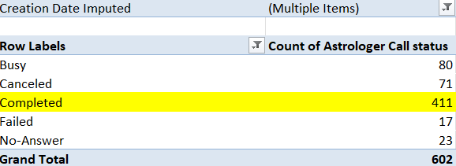
Completed call % = (Completed calls * 100)/ total calls

Suggestions-
1) So to come over this the company can start the option of live streaming model to engage users in live session and improve the handling of the crowd that comes in peak times. Live streaming will also bring revenue and more user to the company.
2) Shift optimization- Optimizing more agents shifts to peak periods accordingly. Ensure that more agents are scheduled during high – traffics time.
3) Use part time or freelancer agents , this reserve agents will balance the workload without increasing permanent cost.

Insights:
Call volume shows clear peak periods (high fluctuation)
During peak days:
- Agents likely face higher workload
- Customer satisfaction may drop slightly
Workload distribution is not always balanced

Recommendations:
Dynamic Agent Scheduling
- Increase agents during peak hours/days
- Use historical data for forecasting
- Improve Training for Peak Handling
  - Faster issue resolution
  - Handling high-pressure situations
Workload Balancing
  - Distribute calls evenly across agents
  - Avoid agent burnout
Monitor Real-Time Performance
  - Call volume
  - Wait time
  - Satisfaction

Question 5: Based on historical data, what strategic initiatives should be prioritized to improve efficiency and customer satisfaction?

Solution:

Approach:
The following strategies can help –
STATEGY 1- Training programs
Only 27.49% of users are satisfied with the service.
Total users = 28027
Satisfied user (Rating-5,6,7,8) = 27.49 %
(formula- =(SUM(satisfied users)*100/total users))
Unsatisfied user (Rating-0,1,2,3,4) = 72.51 %


TRAINING PROGRAM-
1) Call Handling Techniques: Train the astrologer on more efficient call-handling techniques to reduce the duration of calls without compromising the quality of service.
2) Enhancing Skills: Training can improve the skills of employees involved in the call service, leading to better customer interactions.
3) Cross-Selling: Training programs can teach employees techniques to upsell or cross-sell other services or products during calls, maximizing revenue from each interaction.
4) Adaptation to Growth: As the service grows, the company might need to scale up operations. Training helps employees adapt to new processes, tools, or technologies that support growth.

STRATEGY 2 – Upgrade Technology.

There is need for technology upgrades because 69.62% of total users use chat service. And Gurucool is only one platform which provide the service of the Chat to the users. But the average rating of the Gurucool is 2.71, which is the clear indicator of unsatisfied users. So it is very necessary to improve technology and provide satisfaction to the users . Investing in technology upgrades will help to improve the overall experience and will help to increase the retention rate of the users. But there are some risks in upgrading technology. Upgrading technology will help the smooth experience of providing service as well as user receiving service.
STRATEGY 3 – Hiring of Mental health professionals.
On 2023-12-10 and 2023-12-11 receive the highest calls, but only 68.27 % users get the service while other 31.73 % got the call of astrologer busy or there call got cancel as the astrologer was busy.

Completed call % = (Completed calls * 100)/ total calls
So there is need of hiring more agents. But as the time is changing. We can use different strategy to standout in market and grow our revenue.
In today time relationship and career uncertainty is at peak. And as in India therapy is very expensive and take it as a taboo. So Astrosage can work as pseudo therapy app for them, which provide sense of certainty.
This move can make the company stand separate among the rivals. And bring customers and revenue to the company .
Insights:
Call volume shows significant fluctuations → need flexible staffing
Customer satisfaction is moderate (not very high) → improvement needed
Agent workload is uneven → inefficiency in allocation
No strong correlation between duration and satisfaction → quality matters more

Recommendations:
Prioritize Training Programs (High Impact)
- Improve: communication skills and Issue resolution time
- Result → Higher customer satisfaction

Implement Smart Staffing Strategy
- Increase agents during peak periods
- Reduce idle time during low demand

Balance Workload
- Distribute calls evenly
- Monitor agent performance regularly

Improve Call Handling Efficiency
- Reduce unnecessary call duration
- Focus on first-call resolution

Question 6: What can be the key factors contributing to high customer satisfaction scores, and how can these be leveraged to improve overall performance?

What is the basis for the suggestions? And mention how you decided if the satisfaction score affects the ratings.

Solution:

Approach:

69.62 % of total users use chat service.
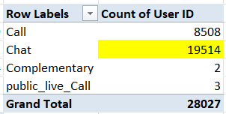
% of user using chat = (Chat user*100)/ Total user
Rating of 6,7,8 is consider as the high satisfaction range.
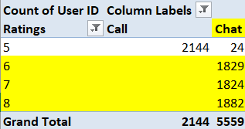
Only chat service receive the rating of 6,7,8.
As 69.62% of total user use chat service and 100% of high satisfaction score is given by chat user only, then Chat service can be consider as the key factor contributing to high satisfaction score.
IMPROVEMENT-
Company can improve the users experience by adding features like AI chat bots and training there employees to adapt to new processes, tools, or technologies that support growth. This will help the company to improve overall performance.

Question 7: How should the call center balance the workload among agents to ensure optimal performance and avoid burnout?

Mention your approach and spreadsheet function for the answer.

Solution:

Approach:
Total call receive = 8508

Average number of calls per day = 250 (Formula - =AVERAGE())
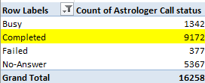
% of calls gets complete = 56.41 % {Formula= (Completed calls * 100)/ total calls}
Call centre receive approx. 250 calls per day but only 56.41% of calls gets complete in total from astrologer side.
Suggestions-
1) To balance workload company can analyse the historical data. The hourly distribution of calls can help the company to balance workload accordingly among agents.
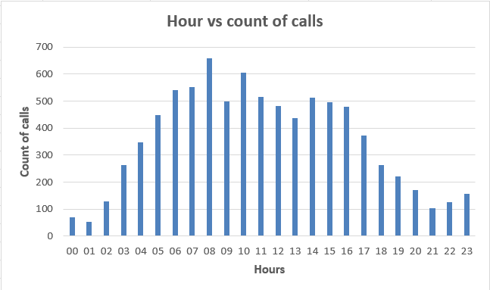
2) So to come over this the company can start the option of live streaming model to engage users in live session and improve the handling of the crowd that comes in peak times. Live streaming will also bring revenue and more user to the company.
3) Shift optimization- Optimizing more agents shifts to peak periods accordingly. Ensure that more agents are scheduled during high – traffics time.
4) Use part time or freelancer agents , this reserve agents will balance the workload without increasing permanent cost.
5) Introduce AI chart bot feature for customer care.

Charts & Tables:

Visualization
- Bar chart → Calls per agent
- Call duration vs Agent performance

Insights:
Workload is not evenly distributed across agents
Some agents handle significantly more calls
Overloaded agents may experience:
- Lower performance
- Reduced customer satisfaction
Underutilized agents indicate inefficiency

Recommendations:
Even call distribution
Set workload threshold
Smart scheduling
Skill based routing to call- if the call duration is very high, assign the call to skilled agent
Monitor real time agent performance

Question 8: What new technologies or tools could be implemented to enhance call center operations and customer service?

Solution:

Approach:

To enhance call center operations and customer service,
the following technologies/tools can be helpfull:
- AI-powered Chatbots & Virtual Assistants
- Intelligent Call Routing Systems
- Real-Time Analytics Dashboards
- Speech Analytics & Sentiment Analysis Tools

Insights:
Call volume shows peaks and variability → requires automation
Customer satisfaction is moderate → needs quality improvement tools
Workload is uneven → requires smart allocation
No strong correlation between duration & satisfaction → focus on quality, not time

Recommendations:
Leveraging AI-driven automation, intelligent routing, and real-time analytics, the call center can significantly improve efficiency, reduce workload imbalance, and enhance customer satisfaction.

Question 9: What metrics should be included in the final dashboard to comprehensively view call center performance and guide investment decisions?

Solution:

Approach:
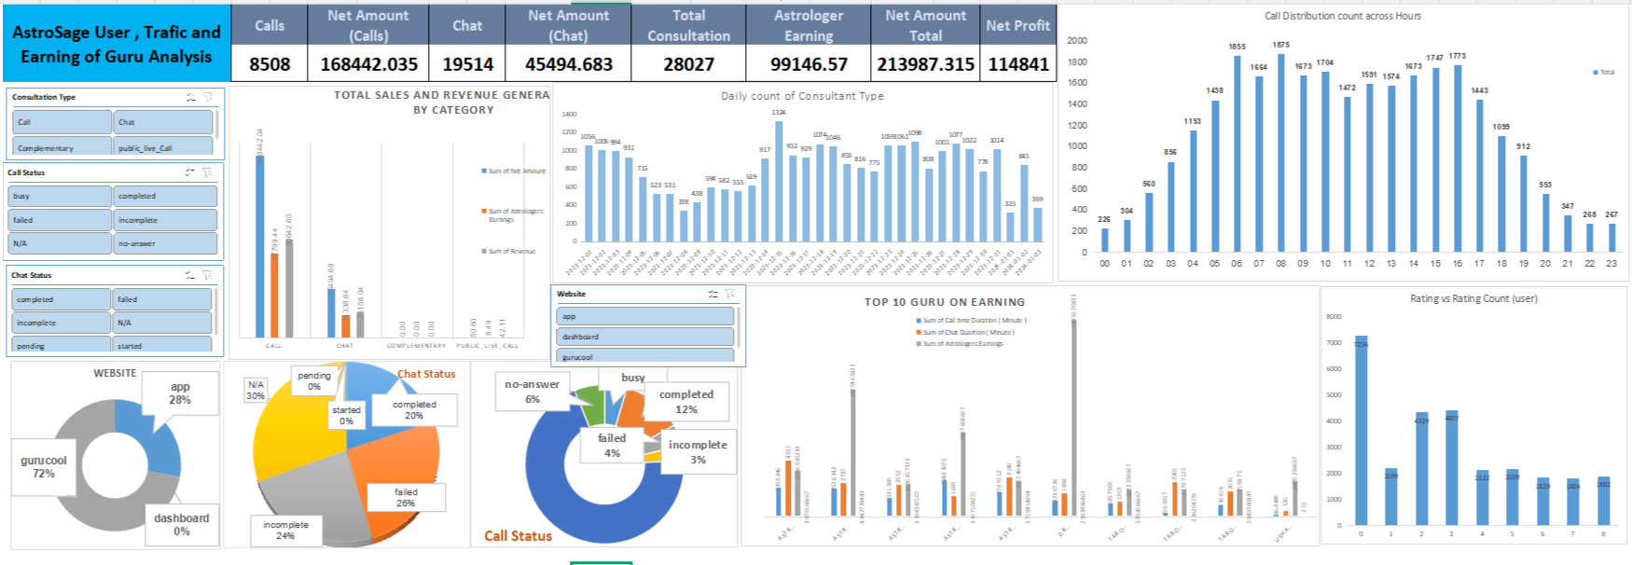

Metrics that are included in Dashboard-
1) KPI (Key performance indicator) – 1. Net Amount
2. Total Calls
3. Total Chats.
4. Total Gurus
5. Average Rating

2) Changes in call volume day by day- The chart will shows changes in average call volume day by day in seconds.
3) Hour vs Count of calls (Hourly active user)– It will show the numbers of call during different hour in day.
4) Date vs count of user (Daily active user)– This will show the numbers of user at that specific date.
5) Earning vs consultancy type – It will show the earning behind every consultancy type.
7) Website distribution- Will show the distribution of users on different website or source of consultancy.
8) Top 10 rated gurus Based on their Earning.
9) Guru distribution by rating.
Slicer (Filter)- 1. Consultancy type.
2. Rating

Question 10: How would you allocate a 1 crore rupee investment to optimize operational efficiency, enhance customer satisfaction, and boost profitability, and what analysis-based recommendations would you offer to support this?

[you have to give bullet pointers to answer this question]

Solution:

Approach:

If i have invest 1 cr rupee to optimizer the operational efficiency and enhance customer satisfaction, based on the data, i would invest more in training program and quality improvement rather than other areas

Agent Training & Quality Improvement- 40 percent of total amount
This will improve the
  - Communication skills for Agents
  - Faster issue resolution
  - Customer handling training
Smart Hiring- 25 percent of total amount
  - Hire agents for high-demand periods
  - Use flexible/shift-based staffing
Technology Upgrade- 20 percent of total amount
  - Implement AI based system for some area like chat bot system, virtual assistance based call system
  - Intelligent call routing system
  - Automation on few areas like monitoring and shifting the call where ever it is possible
Real-Time Monitoring & Dashboard- 10 Percent of total amount
  - Performance tracking tools
  - KPI dashboards for decision-making
Process Optimization- 5% of total amount
  - SOP improvements
  - Call flow redesign
Recommendations:
Prioritize training to improve customer satisfaction
Use data-driven hiring for peak periods
Implement automation tools to reduce workload
Balance workload across agents
Continuously monitor KPIs using dashboards

