# **User Interface Design of GrillHub**

**Project Background**

GrillHub, an imaginary restaurant located in Sunwal providing all sorts of BBQ services to the customers of this area since 2020.

Focusing on the goals of “Quality, Healthy and Tradition” the restaurant is family operation making each dish in their own kitchens from scratch. Through hard work and dedication, GrillHub began building its brand around the idea of delicious and authentic BBQ food.

They honor their customers by providing them with the freshest, most delicious and authentic meal experience possible with tranquil environment.

**Objective of designing this project**

The main objective of designing this project was to test my abilities on figma and gather as much feedback as possible for future improvements.

**Design Process**

**Design**

* Brainstorming
* Visual Design

**Prototyping**

**Ideate**

* Brainstorming
* Research

**Define**

* Project Background
* Objective

**Statement**

The user who intend to order quality and healthy food or who want to book their place for special occasions must find a restaurant which is reliable, qualitative and fast. To determine what can be best for them, the conclusions are outlined:

* Clear description about the restaurant
* Clear description about the process of ordering food to receiving food
* Other customers reviews
* Response time of Restaurant
* Pricing and presentation of food
* Quality of food
* The environment of restaurant

# **Design**

**Design System**

The most crucial aspect was selecting color palette which was pleasing to the users eye.

So, the primary and secondary color is used blue and red respectively with better combination of saturation.

**Color**

 Primary

Secondary



Neutral

**Typography**

Aa Display 1 Extra Bold 65px

Inter

Aa Display 2 Bold 45px

Inika Title 1 Regular 25px

Paragraph 1 Light 20px

# **Components**

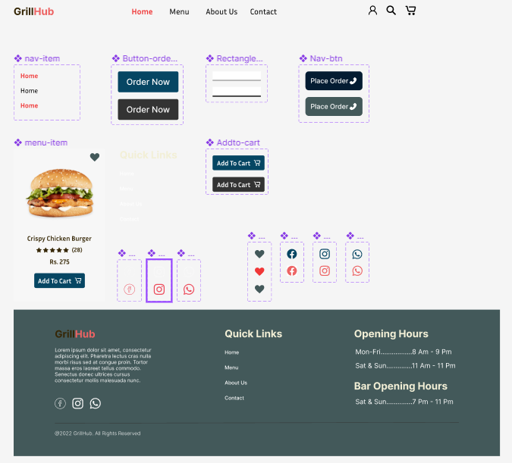

**Layout**



Total Column-12 Gutter width-20

# **Visual Design**

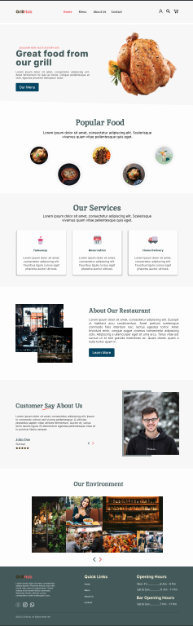

**Homepage**

# **Prototypes**

Prototypes are created using different component variants. Prototypes are then created on pages after component prototyping.

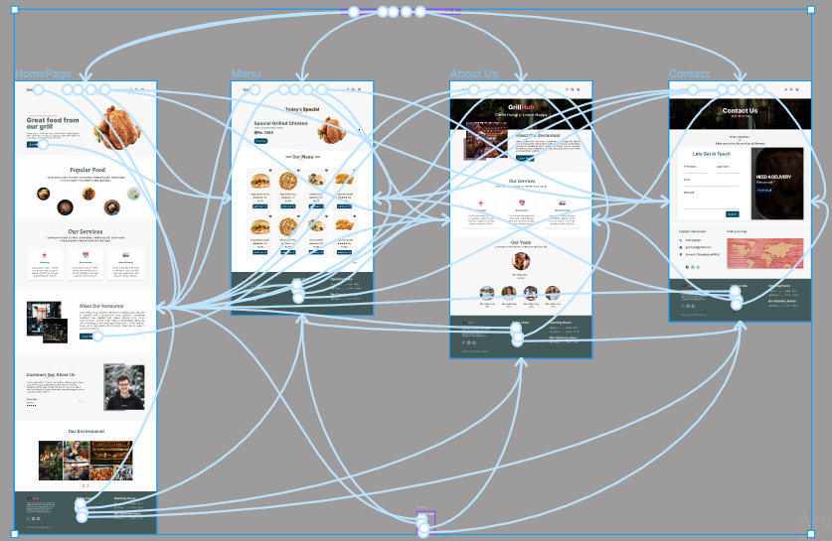

Prototype of various pages

**References**

* [**https://colorhunt.co/palette/2c36393f4e4fa27b5cdcd7c9**](https://colorhunt.co/palette/2c36393f4e4fa27b5cdcd7c9)
* [**https://dribbble.com/**](https://dribbble.com/)
* [**https://www.behance.net/**](https://www.behance.net/)
* [**https://www.uplabs.com/**](https://www.uplabs.com/)
* [**https://themeforest.net/**](https://themeforest.net/)
* [**https://bootcamp.uxdesign.cc/**](https://bootcamp.uxdesign.cc/)
* [**https://www.pngitem.com/**](https://www.pngitem.com/)
* [**https://www.pinterest.com/**](https://www.pinterest.com/)
* [**https://www.google.com/**](https://www.google.com/)

**Link to Figma File:**

[*https://www.figma.com/file/rFZexCrgpi6knGTlhmXF5y/GrillHub-Landing-Page?node-id=0%3A1*](https://www.figma.com/file/rFZexCrgpi6knGTlhmXF5y/GrillHub-Landing-Page?node-id=0%3A1)

**Link to Prototype:**

https://www.figma.com/proto/rFZexCrgpi6knGTlhmXF5y/GrillHub-Landing-Page?node-id=11%3A4&scaling=scale-down-width&page-id=0%3A1&starting-point-node-id=11%3A4

**Plugins Used**

* **Iconify**
* **Unsplash**
* **Lorem Ipsum**
* **Blobs**

**End Note**

*This project is designed in desktop version only and I’ll soon be designing this project for mobile version.*

*I’m constantly working to improve myself, and I’d like to hear your thoughts about what I’m doing well, and what areas I could improve upon. I would benefit most from opinions that are honest and sincere. I am ready to listen to all you have to offer and consider what I can change to improve my performance in the future. Thanks.*