# Strings

ASCII code for ‘A’ to ‘Z’ in both ASCII and UTF-16

What is ASCII and UTF

128 standard characters in ASCII

‘a’ has ASCII value as 97 and other are contiguous

‘A’ has ASCII as 65 and other are contiguous

JAVA is 16 bit char

C++ has 8 bit char

## Strings in C++

C-style Strings:

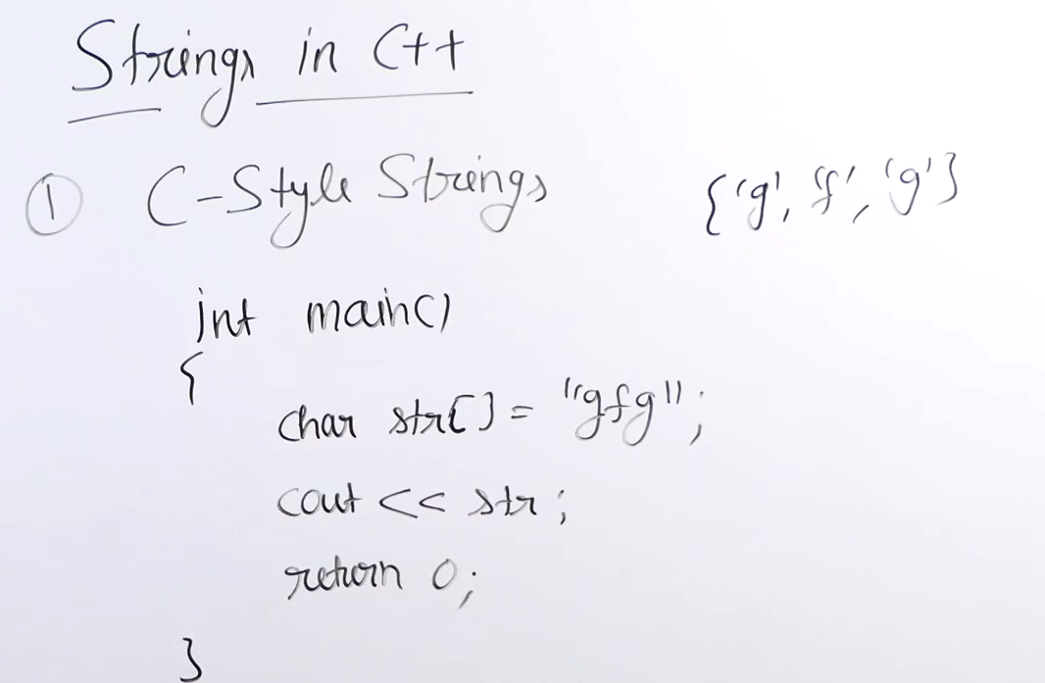

Strlen(str)

Strcmp(s1,s2);

Strcpy(s1,s2);

C++ style strings

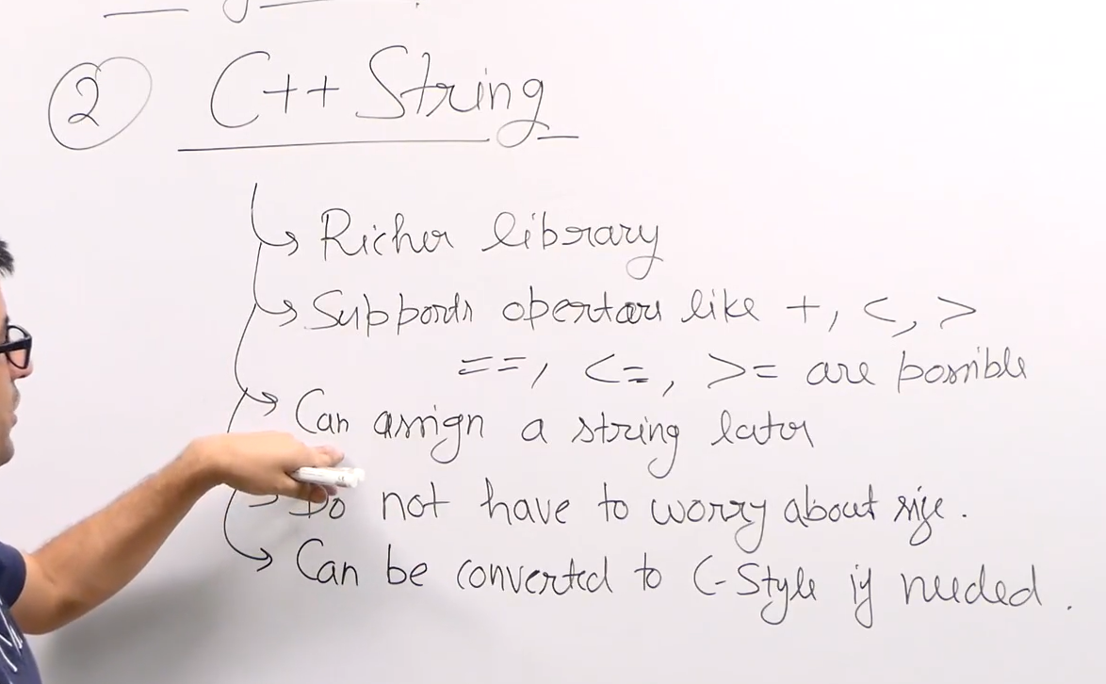

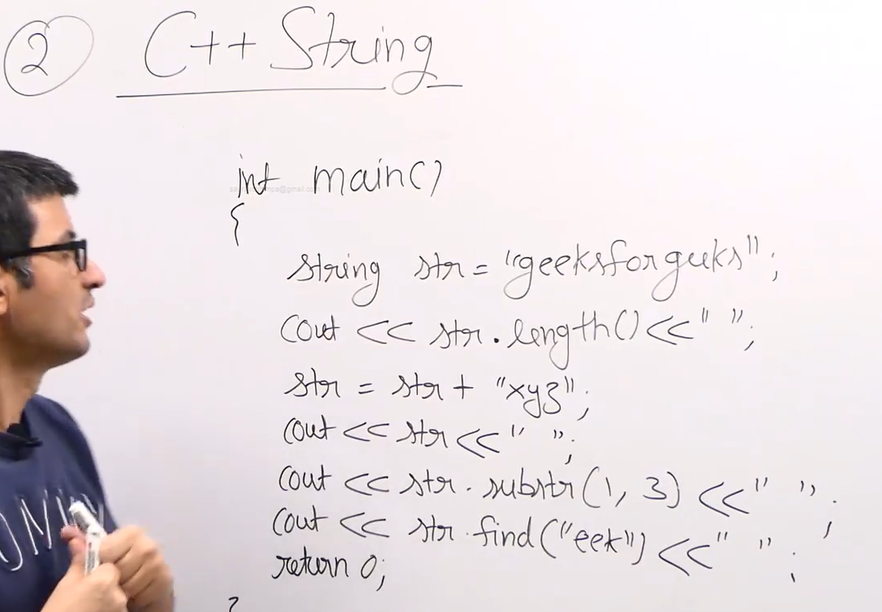

Reading strings with spaces

Getline()

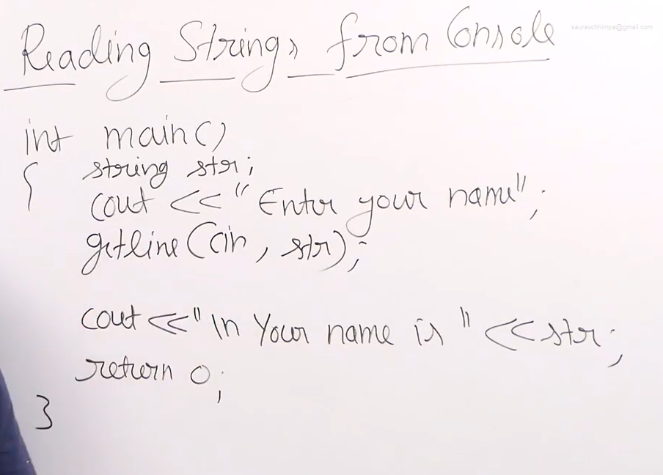

Getline(cin, str , ‘a’);

Stops when a is appeared

## Palindrome check

