**Saurav Kumar**

1.

|  |  |  |
| --- | --- | --- |
|  | Download Speed(Mbps) | Upload Speed(Mbps) |
| TESTMYSPEED | 92.58 | 0.67 |
| SPEEDTEST | 93.27 | 80.72 |

Even though download speed is the same, upload speed is somewhat different which might be due to congestion of the route/path used for the transmission of packet to the server IP.

2.

PING is a tool to check network connectivity between two IP hosts. It uses the ICMP protocol which has been created to check IP connectivity and get information about other machines in an IP network. It is considered part of the IP or Internet layer. Ping sends very small packets to an IP host who will answer by sending packets back. The ICMP packets sent to the host are called echo_request and the packets sent back echo_response.

|  |  |  |
| --- | --- | --- |
|  | RTT(milli-seconds) | IP |
| GOOGLE(closest) | 30 | 216.58.201.164 |
| RICE.EDU | 127.334 | 128.42.204.11 |
| IITD(farthest) | 163.827 | 103.27.9.20 |

I performed this test using a third party application so the main cause for such a difference in the RTT time of these servers might be due to the following factors:

* Network Pipes:
* Network Devices:
* Physical Remoteness:
* Source and Destination Devices:

3.

a) 127.0.0.1 , 10.201.137.212

b)

|  |  |  |
| --- | --- | --- |
| Name of Interface | Ethernet Address | MTU |
| Enp8so | 14:58:d0:c0:30:99 | 1500 |

A maximum transmission unit (**MTU**) is the largest size packet or frame, specified in octets (eight-bit bytes), that can be sent in a packet- or frame-based network such as the Internet.

c)

|  |  |
| --- | --- |
| Name of Interface | Ipv6 Address |
| Enp8so | fe80::354d:289d:c09e:74b2/64 |
| Lo | ::1/128 |

There are 128 bits in IPv6 address.

4.

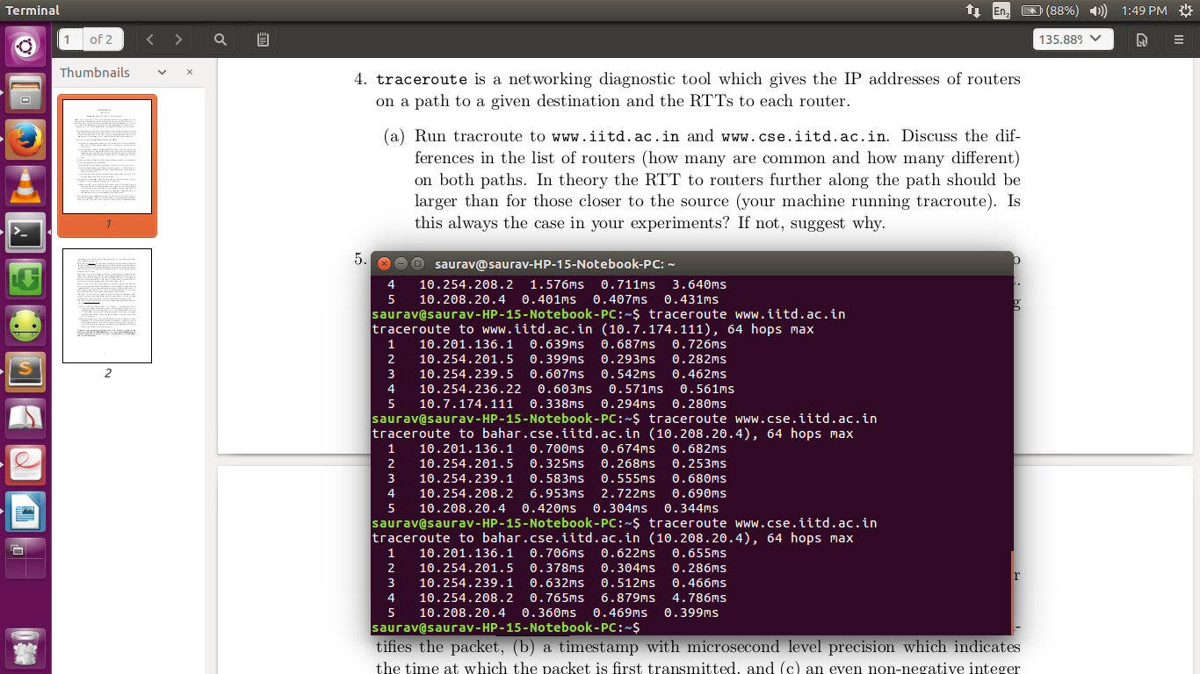

a)In total, 2 routers are common and 3 different.

b)No this is not the case here.This might be due to the congestion of the network.

5.

a)

Cummulative RTT : in milliseconds

Packet Size : in Bytes

**T=2000**

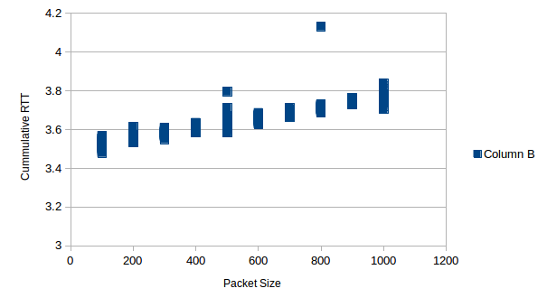 **T=8000**

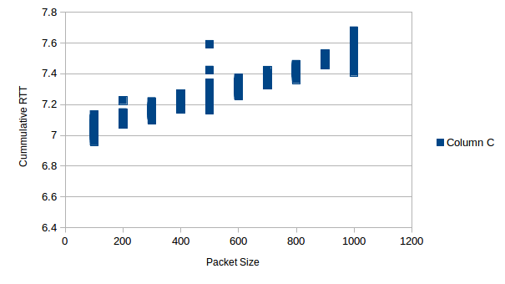

We see that the graph is almost linear between the cummulative RTT and Packet Size.The slope of the graph tells the round trip time taken for 1 byte.Also for T=8000,the readings are between 3-4 times the ones in T=2000.

b)

**T=2000**

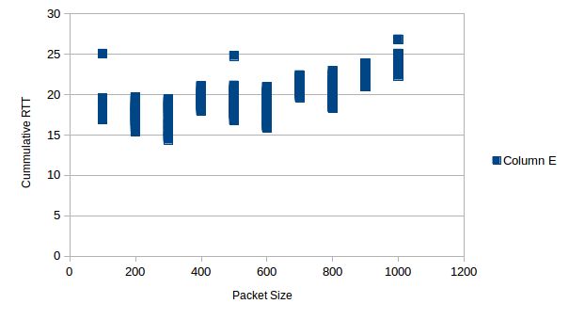

**T=8000**



Here due to random packet loss and delay produced manually,we can the shape of the graph somewhat changes but still the relationship between cummulative RTT and packet size remains somewhat same and also the relative magnitude of T=2000 and T=8000 is also same.