**Creating a Smart Contract that Returns Address and Balance of Owner using Solidity**

• [Read](javascript:void(0))

• [Discuss](javascript:void(0))

• [Courses](javascript:void(0))

• [Practice](javascript:void(0))

**Problem:** Create a smart contract named MyContract having a state variable as owner. Create a constructor to fetch the address of the owner from msg and hold it into the state variable owner. Also, create a function getBalance() to show the current balance of the owner.

**Solution:** Every smart contract is owned by an address called as owner. A smart contract can know its owner’s address using sender property and its available balance using a special built-in object called msg.

**Step 1:**Open [Remix-IDE.](https://remix.ethereum.org/#optimize=false&evmVersion=null&version=soljson-v0.6.6+commit.6c089d02.js)

**Step 2:** Select *File Explorer*from the left side icons and select *Solidity*in the environment. Click on *New*option below the Solidity environment. Enter the file name as***MyContract.sol***and Click on the *OK*button.

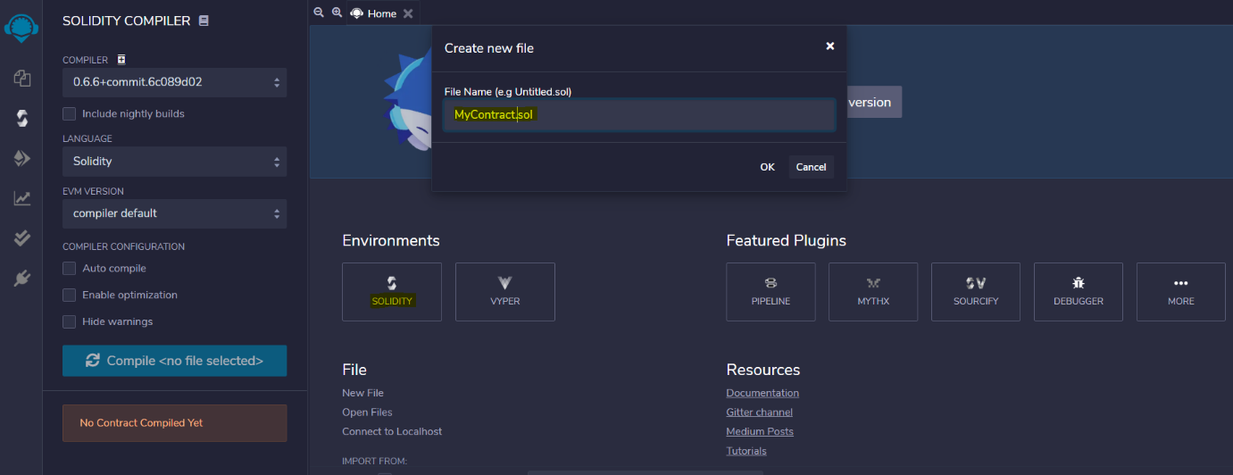

**Step 3:**Enter the following Solidity Code.

* Solidity

|  |
| --- |
| // Solidity program to  // retrieve address and  // balance of owner  pragma solidity ^0.6.8;    // Creating a contract  **contract** MyContract  {      // Private state variable      address **private** owner;         // Defining a constructor       constructor() **public**{          owner=msg.sender;      }        // Function to get      // address of owner      function getOwner(      ) **public** view returns (address) {  **return** owner;      }        // Function to return      // current balance of owner      function getBalance(      ) **public** view returns(uint256){  **return** owner.balance;      }  } |

**Step 4:**  Compile the file *MyContract.sol* from the Solidity *Compiler* tab.

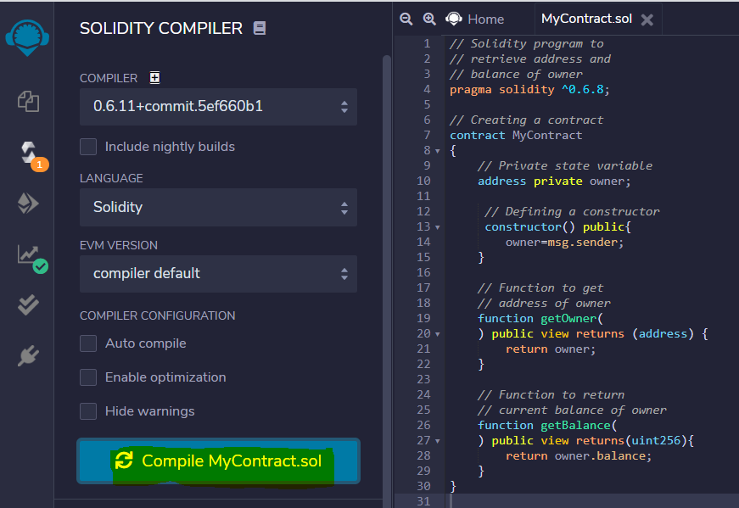

**Step 5:** Deploy the smart contract from the *Deploy and Run Transaction* tab and you will get the balance and address of the owner.

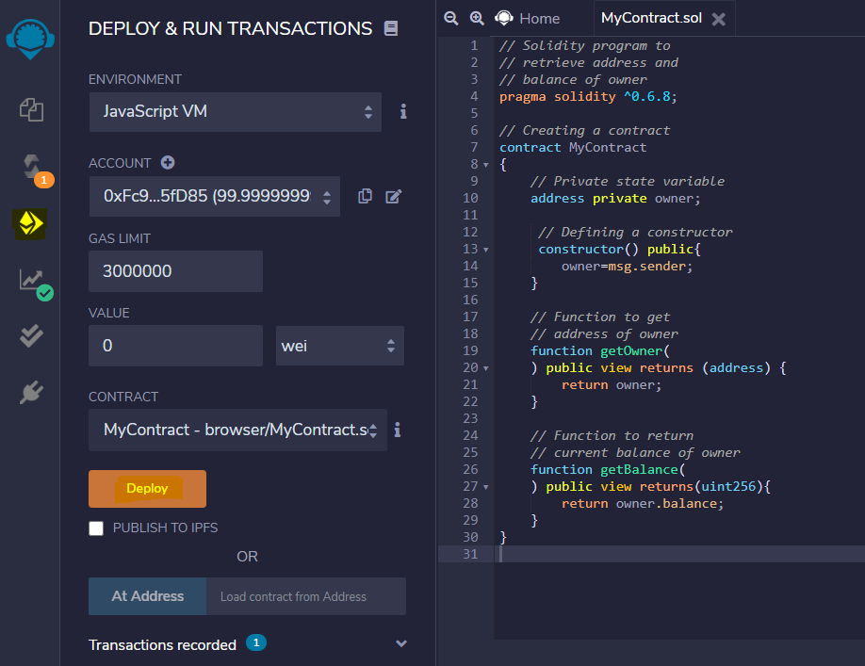

**Step 6:**The output below shows the address and the balance of the owner.

