**Solidity – Deploy a Smart Contract for Marks Management System**

• [Read](javascript:void(0))

• [Discuss](javascript:void(0))

• [Courses](javascript:void(0))

[Solidity](https://www.geeksforgeeks.org/introduction-to-solidity/) is a high-level language. The structure of smart contracts in solidity is very similar to the structure of classes in object-oriented languages. The solidity file has an extension .sol.

**What are Smart Contracts?**

Solidity’s code is encapsulated in contracts which means a contract in Solidity is a collection of code (its functions) and data (its state) that resides at a specific address on the Ethereum blockchain. A contract is a fundamental block of building an application on Ethereum.

**Example:**In the below example, the aim is to deploy a Smart Contract for Marks Management System by using Solidity. In this contract, the details of every student like student ID, Name, Marks, etc can be added and if one wants to give some bonus marks to students then they can also be added. After building the contract all the details of every student can be retrieved.

**Approach:**

1. The first step is to deploy the smart contract using the Remix IDE. After writing the code compile the code. When it is successfully compiled then deploy it. After deploying the contract a deployed Contract is obtained and then add the student details one by one.
2. If bonus marks need to be added then add in the bonusMarks section after that click on stdCount and fetch the student details to call the stdRecords.
3. Add one or more new student details in this Smart Contract by the increment of stdCount.

**Implementation**

**Step 1:**Open [Remix IDE](https://remix.ethereum.org/).

**Step 2:**Click on File Explorers and select Solidity in the environment and create a new file StudentMarksMangmtSys.sol by clicking on New File section.

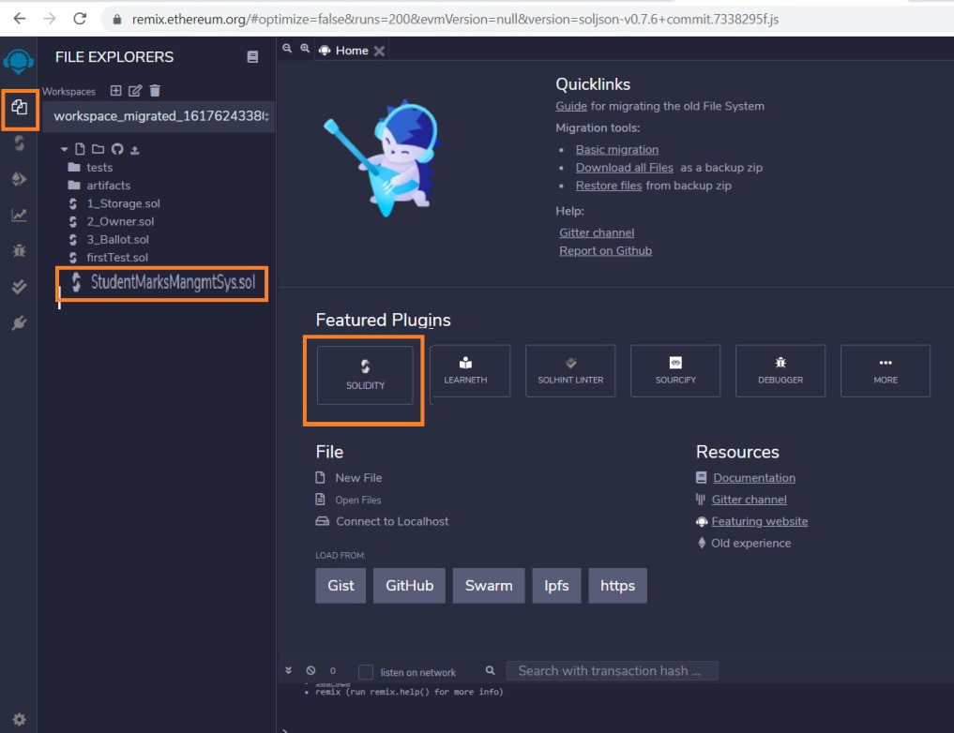

**Step 3:**Build a smart contract that contains all the details of the student with the help of Remix IDE by clicking on the file name.

**Solidity**

|  |
| --- |
| // Solidity program to implement  // the above approach  pragma solidity >= 0.7.0<0.8.0;    // Build the Contract  **contract** MarksManagmtSys  {      // Create a structure for      // student details  **struct** Student      {  **int** ID;          string fName;          string lName;  **int** marks;      }        address owner;  **int** **public** stdCount = 0;      mapping(**int** => Student) **public** stdRecords;        modifier onlyOwner      {          require(owner == msg.sender);          _;      }      constructor()      {          owner=msg.sender;      }        // Create a function to add      // the new records      function addNewRecords(**int** _ID,                             string memory _fName,                             string memory _lName,  **int** _marks) **public** onlyOwner      {          // Increase the count by 1          stdCount = stdCount + 1;            // Fetch the student details          // with the help of stdCount          stdRecords[stdCount] = Student(_ID, _fName,                                         _lName, _marks);      }        // Create a function to add bonus marks      function bonusMarks(**int** _bonus) **public** onlyOwner      {           stdRecords[stdCount].marks =                      stdRecords[stdCount].marks + _bonus;      }  } |

**Step 4:**After building the contract compile it. Select the compiler version before clicking on Compile button.

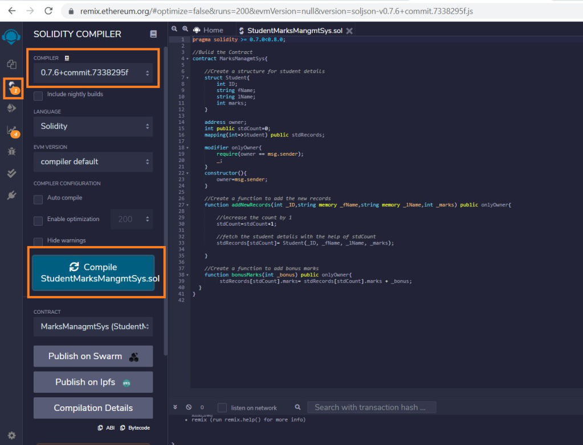

**Step 5:**After successful compilation, to deploy the contract, select the Environment JavaScript VM (Berlin) before clicking on the Deploy button.

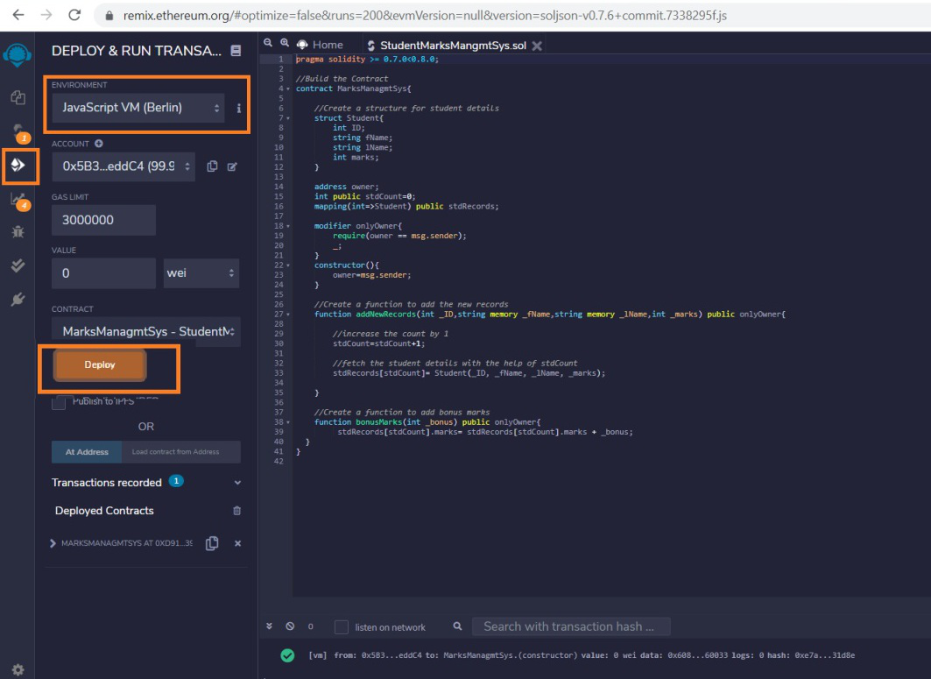

**Step 6:**If the contract is successfully deployed then deployed contract is obtained. Open the deployed contract and add the student details and transact it.

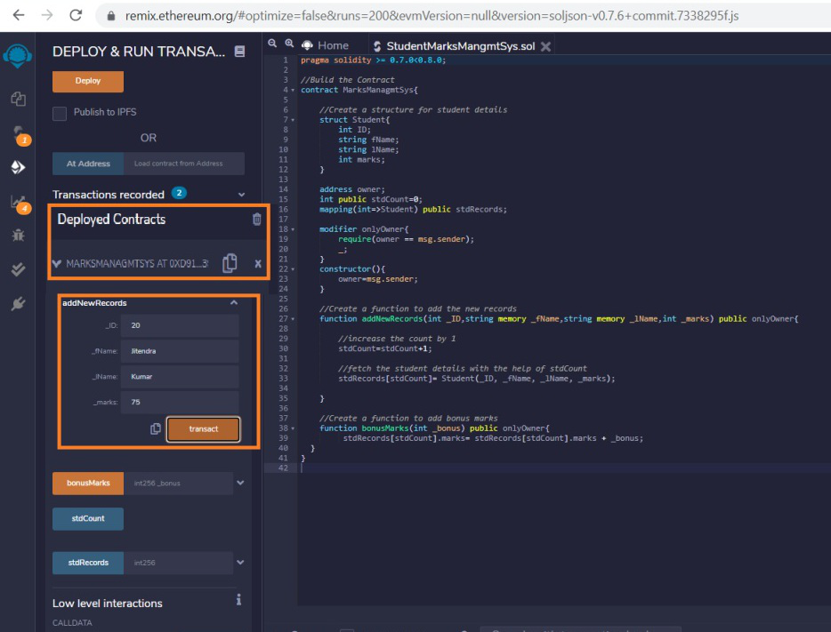

**Step 7:**Add the bonus marks if you want to give them to the student and transact it after that click on the stdCount. One can see the student details after calling the stdRecords by entering the stdCount.

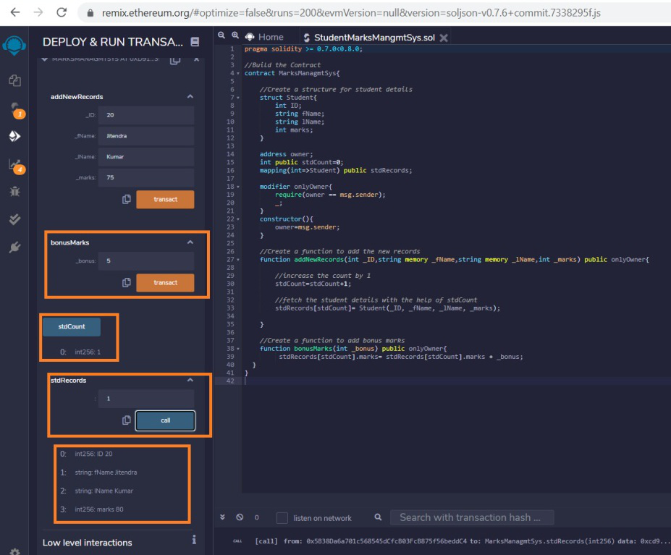

Whether you're preparing for your first job interview or aiming to upskill in this ever-evolving tech landscape, [GeeksforGeeks Courses](https://www.geeksforgeeks.org/courses?utm_source=geeksforgeeks&utm_medium=article_bottom_text&utm_campaign=courses) are your key to success. We provide top-quality content at affordable prices, all geared towards accelerating your growth in a time-bound manner. Join the millions we've already empowered, and we're here to do the same for you. Don't miss out - [check it out now!](https://www.geeksforgeeks.org/courses?utm_source=geeksforgeeks&utm_medium=article_bottom_text&utm_campaign=courses)