PRACTICAL NO : 04
Title : Design and develop custom Application (Mini Project) using Salesforce Cloud.

STEPS TO CREATE AN APPLICATION(mini project) :

- Open salesforce in Lightning Experience

- Open App Launcher → View all → Quick Search → App Manager → Click on New Lightning App → fill the mention information → Next → App option(optional ) → Next → Add Utility (optoinal) → Next → Navigation Item(you can add item) → Next → User Profile(use the user profile that can access this app) → Save and Finish.
You will get Lightning Experience App Manager Window → Search Your App by its name in App Launcher → just by entering some character, you can see app name with its logo → Click on App → you can see your application appearance in window → Output
Note : steps images are provided here……..
- . Open salesforce in Lightning Experience
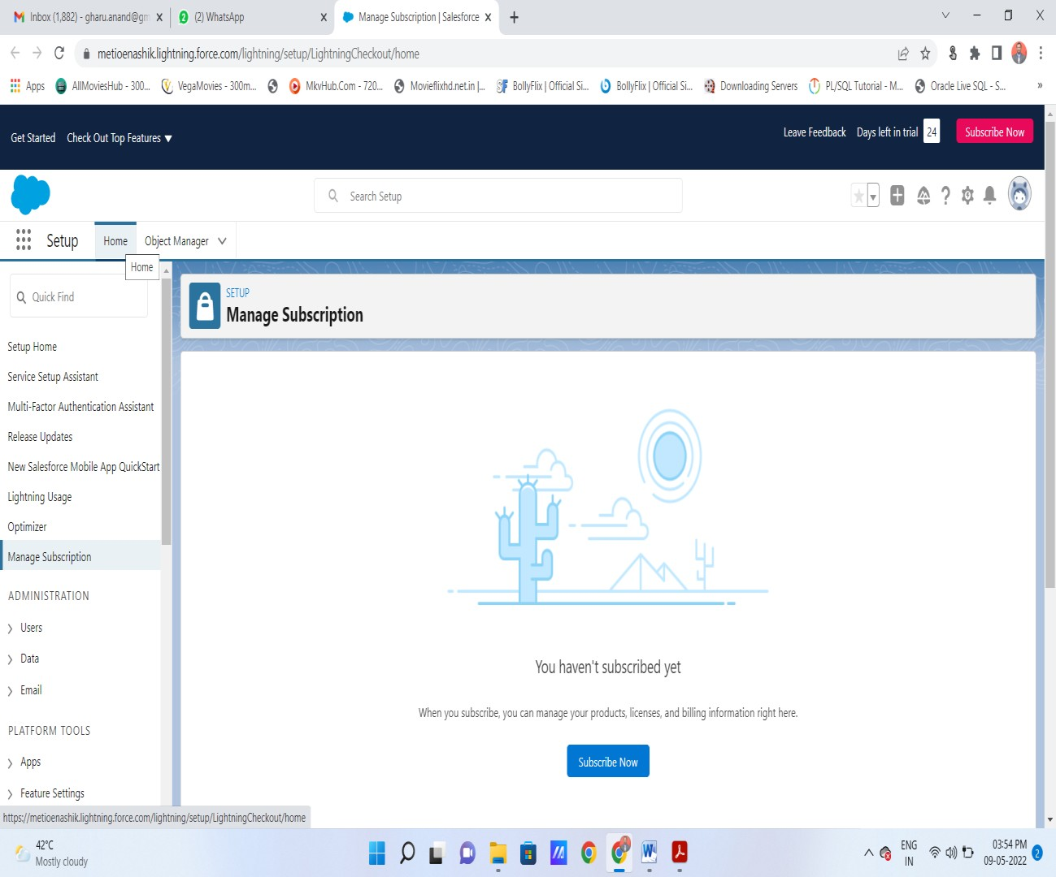
- Open App Launcher → View all →( Quick Search → App Manager) → Click on New Lightning App
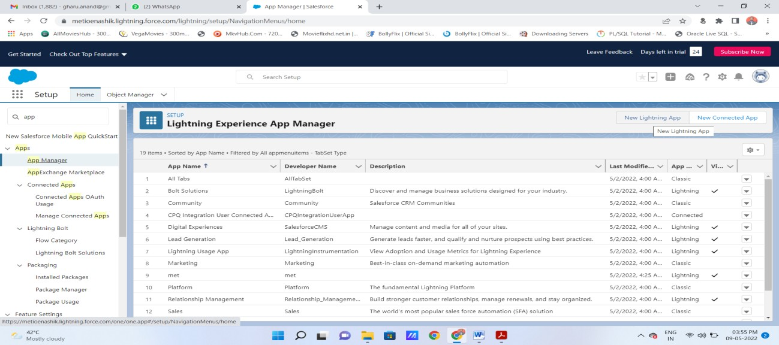
- fill the mention information in new lightning app : then next
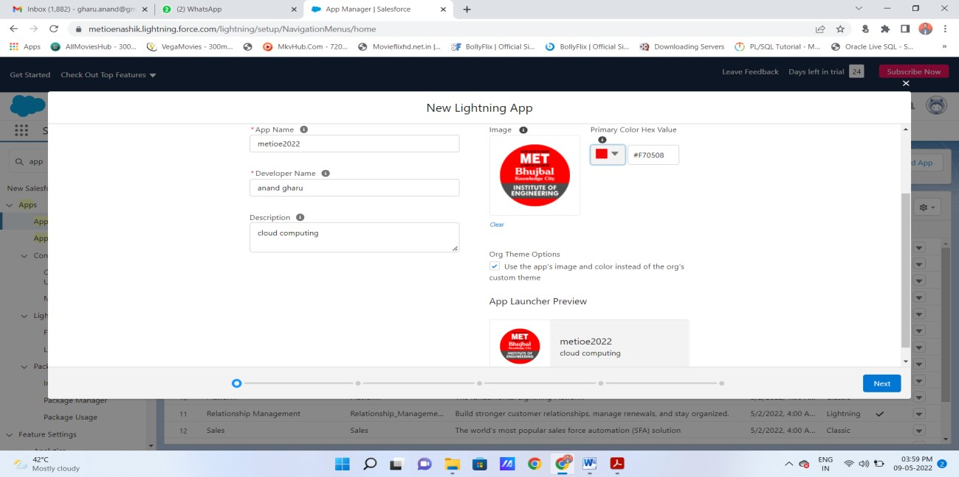
- App option(optional ) → Next →
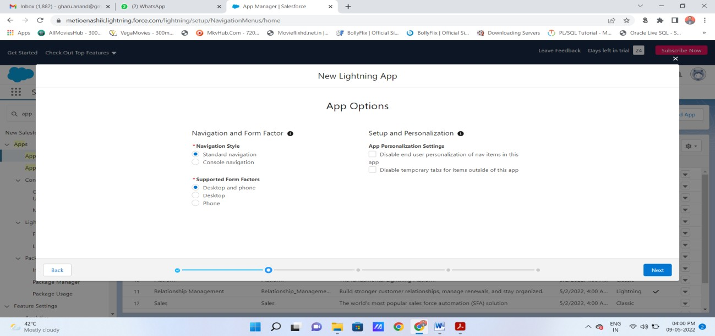
- Add Utility (optoinal) → Next →.
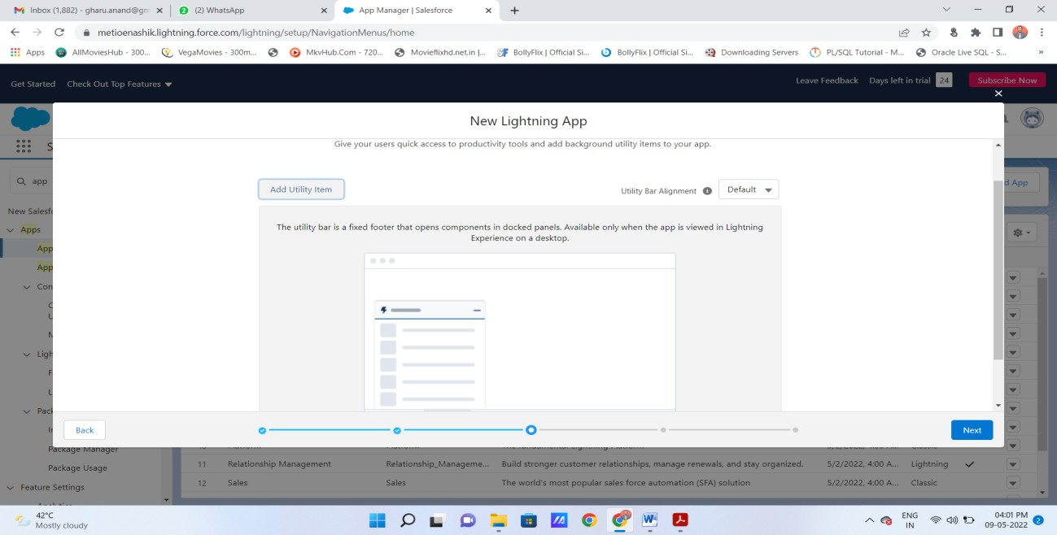
- Navigation Item(you can add item) → Next →
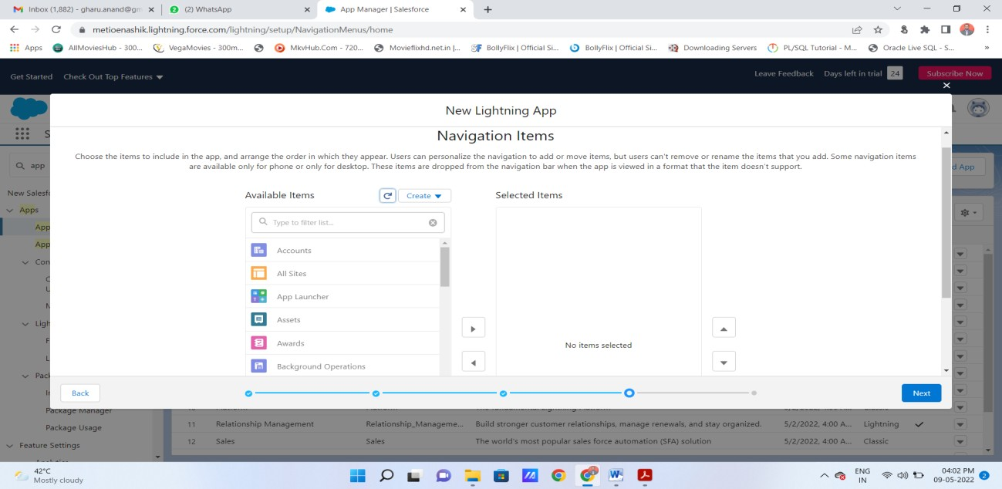
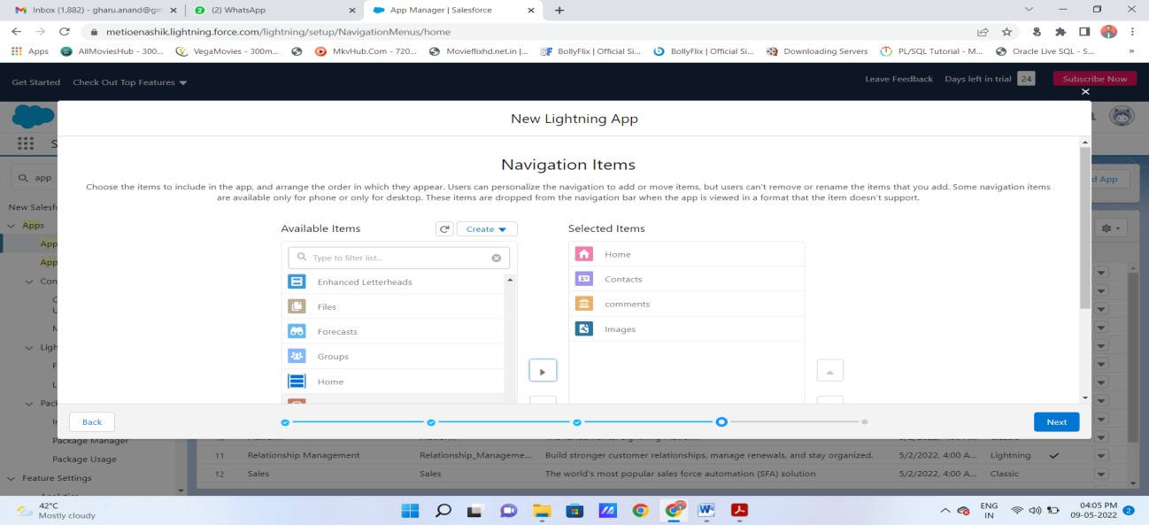
- User Profile(use the user profile that can access this app) → Save and Finish
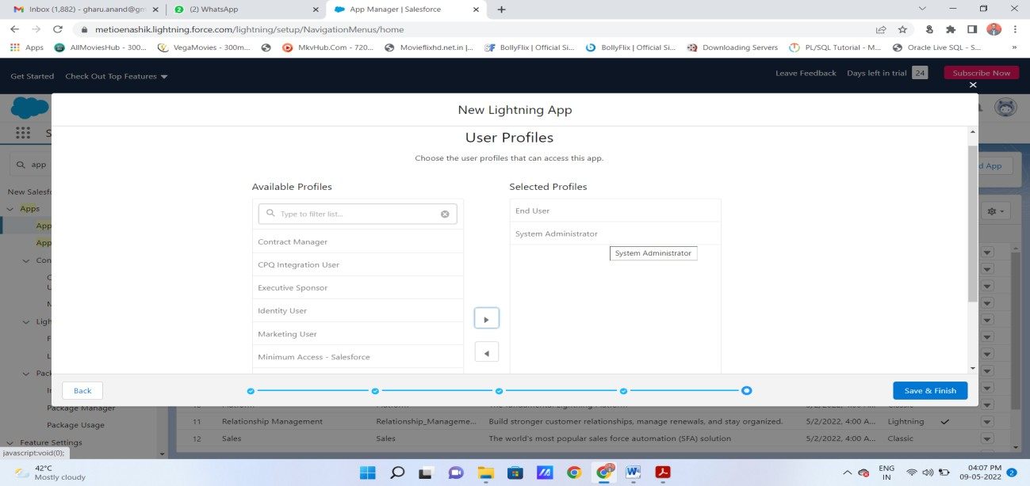
- You will get Lightning Experience App Manager Window(here, you can see your application)
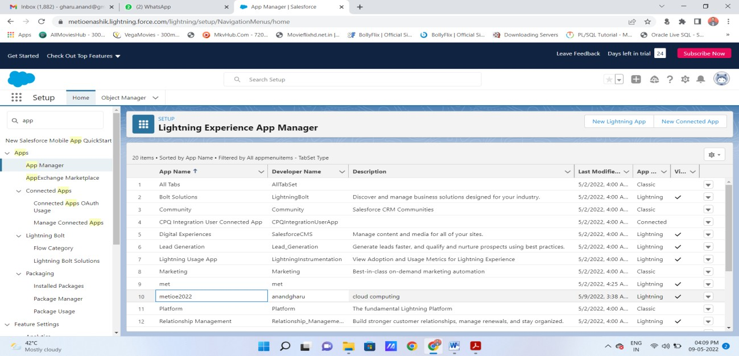
- Search Your App by its name in App Launcher → just by entering some character, you can see app name with its logo → Click on App → you can see your application appearance in window → Output.
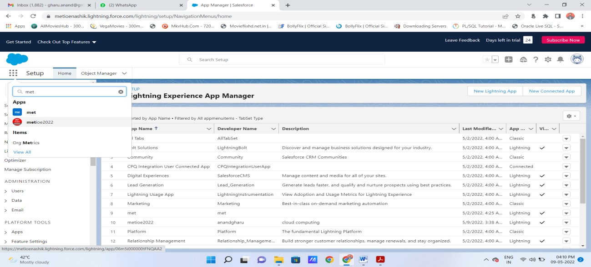
Output : You can see your application here….
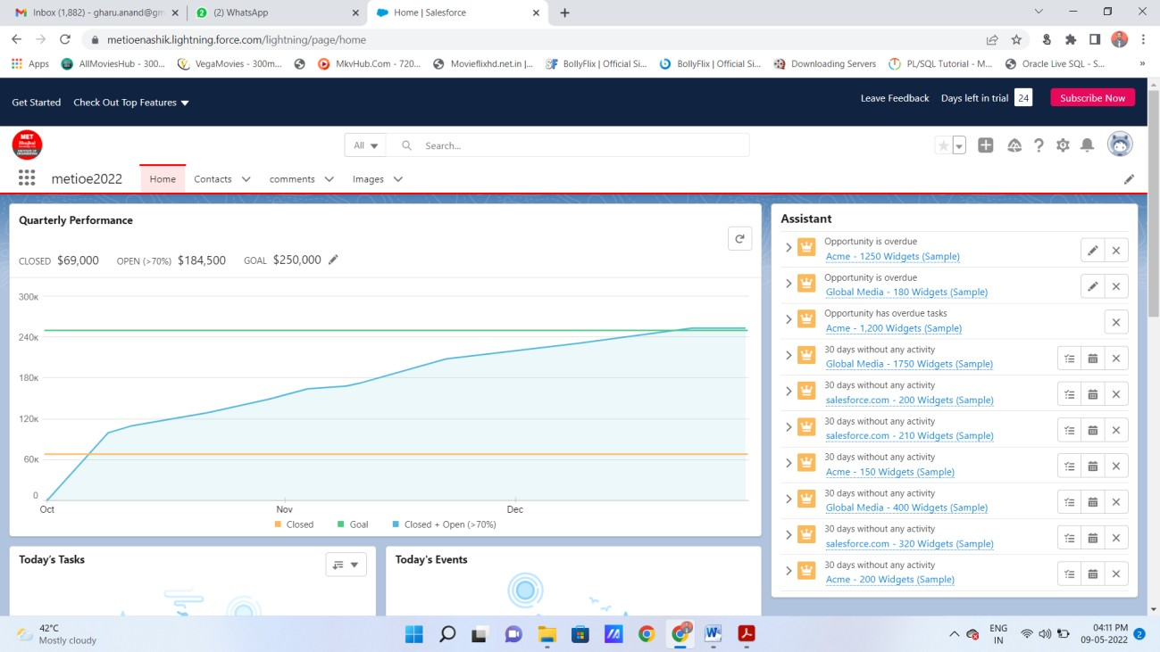
- You can add new contact in your application :
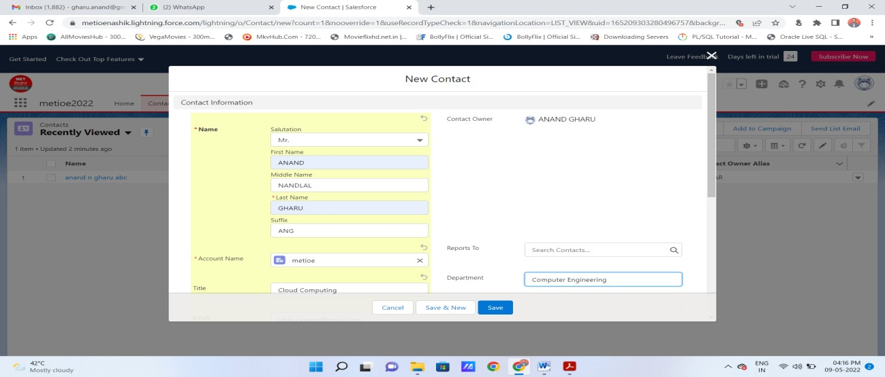
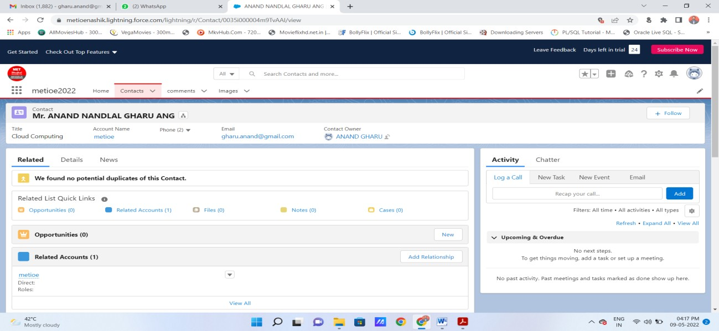

- You can add images also :
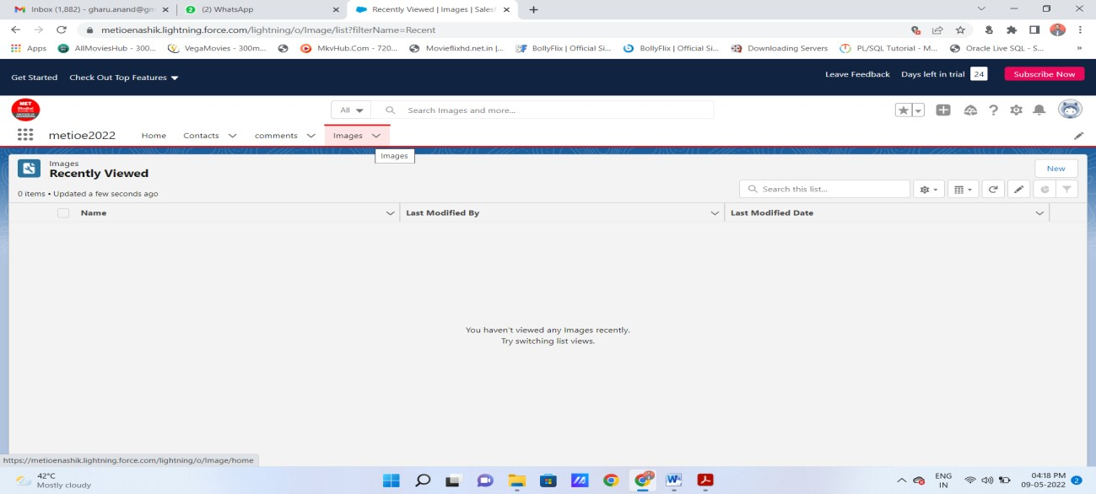
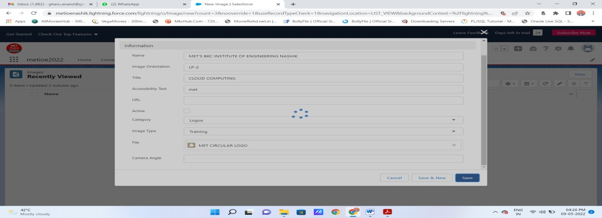

You can see here that image is added as MET Circular logo(its image file name) :
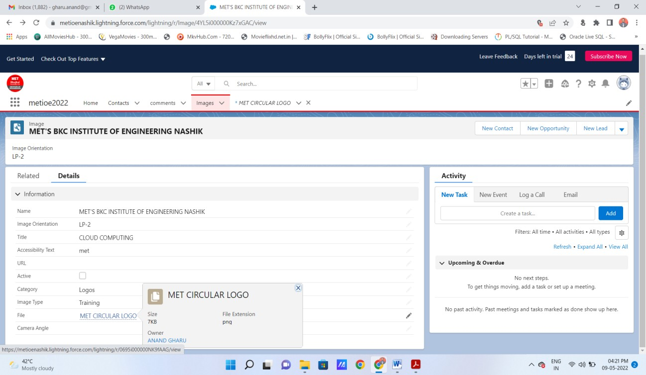
You can see actual image by clicking on link :
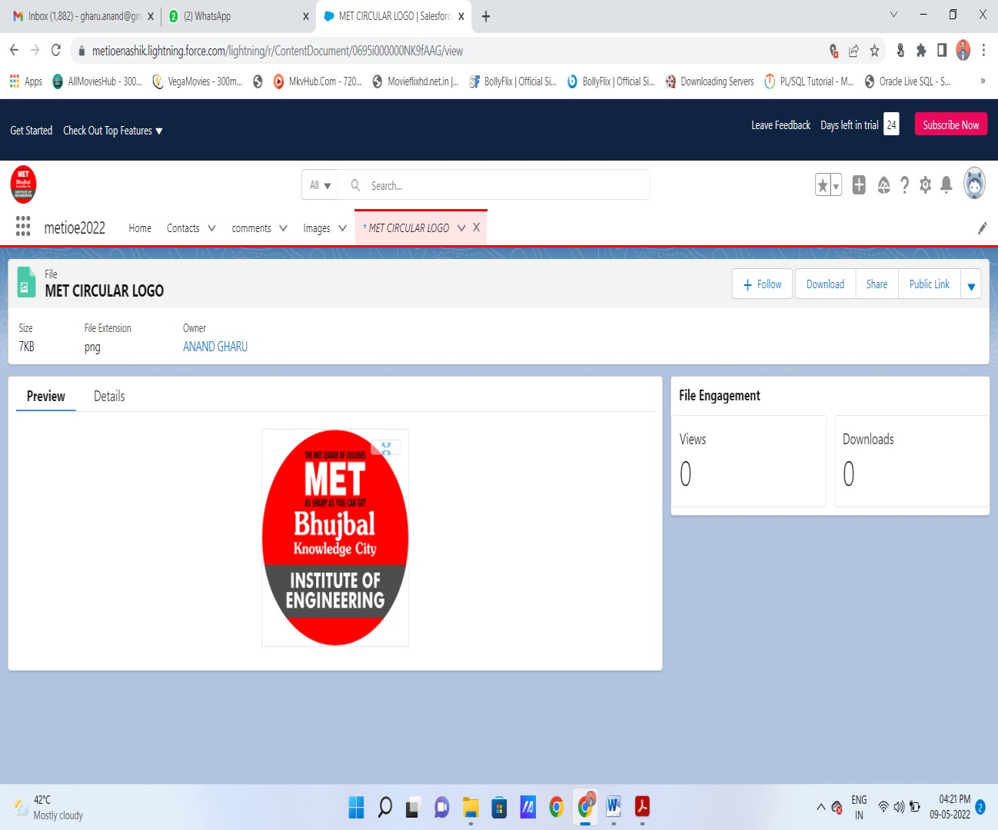

You mini project application get created
Note : you can add navigations, utilities , profiles as per your requirements for your mini project application.

