**COLLEGE EVENT MANAGER APP**

A Mini Project Report Submitted by

**Saurav N Shetty (4NM18CS160) Shashank (4NM18CS165)**

UNDER THE GUIDANCE OF

**Mr. Ramesha Shettigar**

Assistant Professor

Department of Computer Science and Engineering

# in partial fulfilment of the requirements for the award of the Degree of

Bachelor of Engineering in

Computer Science & Engineering

from

# Visvesvaraya Technological University, Belagavi



DEPARTMENT OF COMPUTER SCIENCE AND ENGINEERING

# N.M.A.M. INSTITUTE OF TECHNOLOGY

(An Autonomous Institution under VTU, Belgaum) (AICTE approved, NBA Accredited, ISO 9001:2008 Certified) NITTE -574 110, Udupi District, KARNATAKA.



(ISO 9001:2015 Certified), Accredited with ‘A’ Grade by NAAC

   ☎: 08258 - 281039 – 281263, Fax: 08258 – 281265

Department of Computer Science and Engineering

B.E. CSE Program Accredited by NBA, New Delhi from 1-7-2018 to 30-6-2021

DEPARTMENT OF COMPUTER SCIENCE AND ENGINEERING

CERTIFICATE

“College Event Manager App”

is a bonafide work carried out by

Saurav N Shetty(4NM18CS160) Shashank(4NM18CS165)

in partial fulfilment of the requirements for the award of Bachelor of Engineering Degree in Computer Science and Engineering prescribed by Visvesvaraya Technological University, Belagavi during the year 2019-2020.

It is certified that all corrections/suggestions indicated for Internal Assessment have been incorporated in the report.

The Mini project report has been approved as it satisfies the academic requirements in respect of the project work prescribed for the Bachelor of Engineering Degree.

Signature of Guide Signature of HOD

**ACKNOWLEDGEMENT**

We believe that our project will be complete only after we thank the people who have contributed to make this project successful.

First and foremost, we express our deep sense of gratitude and indebtedness to our guide **Mr. Ramesha Shettigar**, Assistant Professor, Department of Computer Science and Engineering, for his inspiring guidance, constant encouragement, support and suggestions for improvement during the course of our project.

We sincerely thank **Dr. K.R. Udaya Kumar Reddy**, Head of Department of Computer Science and Engineering, Nitte Mahalinga Adyantaya Memorial Institute of Technology, Nitte.

Our sincere thanks to our beloved principal, **Dr. Niranjan N. Chiplunkar** for giving us an opportunity to carry out our project work at our college and providing us with all the needed facilities.

We also thank all those who have supported us throughout the entire duration of our project.

Finally, we thank the staff members of the Department of Computer Science and Engineering and all our friends for their honest opinions and suggestions throughout the course of our project.

Saurav N Shetty(4NM18CS160) Shashank(4NM18CS165)

**ABSTRACT**

This application provides a new technique of casting votes using mobile phones. Student voting app is an application developed for android devices to deploy an easy and flexible way of casting votes anytime and from anywhere. The application is especially developed for schools and colleges to get student votes for elections. The names of the candidates under a designation or post for elections are fed into the firebase database by the admin.

The required data is stored and retrieved using firebase database. The app is coded in Java using Android Studio.

**Table of Contents:**

**Page no.**

1. **INTRODUCTION 6**
2. **LITERATURE SURVEY 7**
3. **SYSTEM REQUIREMENT AND SPECIFICATION 8 - 11**
4. **SYSTEM DESIGN 12 - 16**
5. **IMPLEMENTATION 17- 23**
6. **SCREENSHOTS 24 - 26**
7. **CONCLUSION AND FUTURE WORK 27**

**8. REFERENCES 28**

**CHAPTER 1**

**INTRODUCTION**

**1.1 Scope**

College Event Manager APP is a flexible, easy to use and securely designed to benefit the student. It is used to digitize the college event creation and registration all in one single android mobile phone and manage them efficiently.

**1.2 Importance**

It is difficult to keep track of all the ongoing and upcoming college events for the clubs as well as students if it’s done in existing way. With the help of this app, the data is stored in the digitized form and hence reduces the clerical work. The data can be efficiently stored and retrieved which makes the application sophisticated and user friendly. The application is implemented on android platform which is linked to the Google firebase as a server for access of data.

**1.3 Objective:**

The objective of this project is a mobile application developed for managing college clubs, events and registration for the events in real time. Using this application, students can then view clubs, view events and register for those events. All information about the registered students in a particular event is stored in firebase real time database which can be used by the club members to verify whether the student is registered for the event or not.

**CHAPTER 2**

**LITERATURE SURVEY**

**2.1 Technical Background:**

In this app the information about student’s Google account is fetched from Google api and data of students using the app is stored in database. GUI of the application enables to access and modify data efficiently.

**2.2 Existing system:**

The existing system of event management in our college makes use of social media like WhatsApp and Instagram, and google forms for registration.

1. Using other social media is risky as it may not reach all of the intended students. It also requires more effort in order to publicise an event in various social media platforms.
2. The students are usually given a google form to fill their details in order to register for an event. A lot of event will need redundant data like email, usn, branch etc. It’s also tedious for the students to fill the google form.

**2.3 Proposed system**

Our college event manager app provides many advantages over the existing system.

1. The app provides an all in one platform for events and club activities. So, the organisers will need minimum effort to create events as it is assured that the event reaches all students.
2. Registration process is much simpler, a student can register for an event with a single click. The required common data will be available for each student in the database.

**CHAPTER 3**

**SYSTEM REQUIREMENT AND SPECIFICATION**

**3.1 Introduction**

Requirements are during early stages of a system development as a specification of what should be implemented or as a constraint of some kind of on the system. They may be a user level facility description, a detailed specification of expected system behaviour, a general system property, a specific constraint on the system, and information on how to carry out some computation or a constraint on the development of the system. The end product of the requirement analysis phase is a requirement specification. The requirement specification is a reconstruction of the result of this analysis phase. Its purpose is to communicate this result to others. System requirements are more detailed descriptions of the user requirements. They may serve as the basis for a contract to the implementation of the system and should therefore be a complete and consistent specification of the whole system. They are used by software engineers as the starting point of system design. In principle, the system requirements should state what the system should do and not how it should be implemented. However, at the level of detail required to specify the system completely, it is virtually impossible to exclude all design information.

Natural language is often used to write system requirements specifications. Further problems with natural language can arise when it is used for more detailed specification:

1. Natural language understanding relies on the specification of the readers and writers using the same words for the same concept. This leads to misunderstandings because of the ambiguity of the natural language.
2. A natural language requirements specification is over-flexible. You can say the same thing in completely different ways. It is up to the reader to find out when requirements are same and when they are distinct.

**3.2 Functional Requirements**

The functional requirements are the statement of services the system should provide, how system reacts to particular inputs and how system should behave in particular situation. It describes the functionality that the system provides.

Our app requires:

1. Active internet connection.
2. A firebase console to store the data

**3.3 User Requirements**

Student requires active internet connection to use the app.

**3.4 Software Requirements**

1. Operating System: Windows 7/8/10 (32-bit or 64-bit)

2. Android SDK

3. Android Studio

4. Firebase

**3.4.1 Android SDK**

The Android SDK provides you the API libraries and developer tools necessary to build, test, and debug apps for Android. The ADT bundle includes the essential Android SDK components and a version of the Eclipse IDE with built-in Android Developer Tools to streamline the Android app development. ADT bundle consists of following components for developing the application II. Eclipse ADT plugin.

1. Android SDK Tools
2. Android Platform-tools
3. The latest Android platform
4. The latest Android system image for the emulator

**3.4.2 Android Studio**

Android Studio is the official integrated development environment (IDE) for Google's Android operating system, built on Jet Brains IntelliJ IDEA software and designed

Specifically, for Android development. It is available for download on Windows, macOS and Linux based operating systems. It is a replacement for the Eclipse Android Development Tools (ADT) as the primary IDE for native Android application development.

Android Studio was announced on May 16, 2013 at the Google I/O conference. It was in early access preview stage starting from version 0.1 in May 2013, then entered beta stage starting from version 0.8 which was released in June 2014. The first stable build was released in December 2014, starting from version 1.0. The current stable version is 3.3, which was released in January 2019.

**3.4.3 Firebase**

Firebase is a mobile and web application development platform developed by Firebase, Inc. in 2011, then acquired by Google in 2014.As of October 2018, the Firebase platform has 18 products, which are used by 1.5 million apps. Firebase provides a real-time database and backend as a service. The service provides application developers an API that allows application data to be synchronized across clients and stored on Firebase's cloud. Firebase Storage provides secure file uploads and downloads for Firebase apps, regardless of network quality. The developer can use it to store images, audio, video, or other user-generated content. Firebase Storage is backed by Google Cloud Storage.

**3.5 HARDWARE REQUIREMENTS**

1. Minimum 4 GB RAM (8GB recommended).
2. 5GB free disk space
3. USB 2.0 or higher
4. Android Device

**CHAPTER 4**

**SYSTEM DESIGN**

* 1. **USE CASE MODEL**

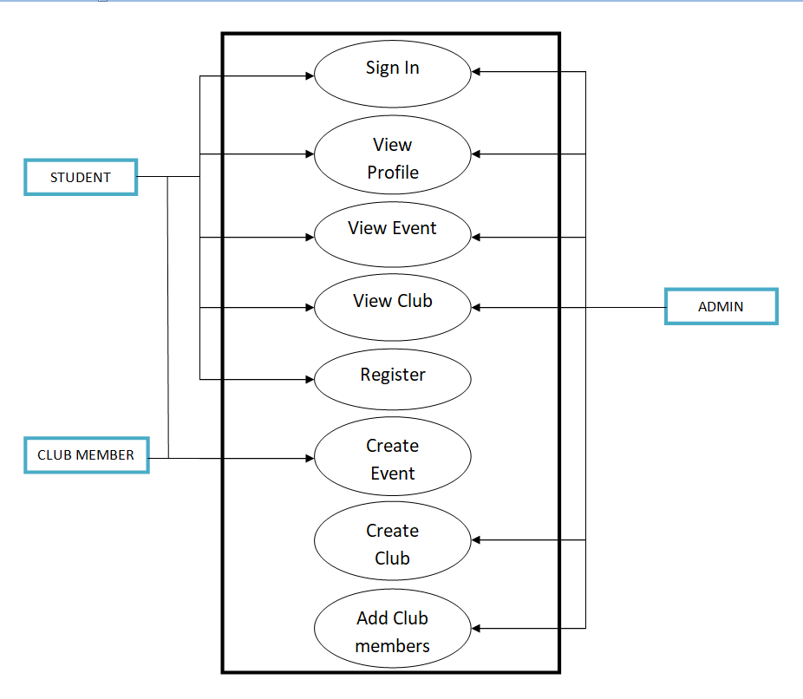

* 1. **Dataflow Diagram**

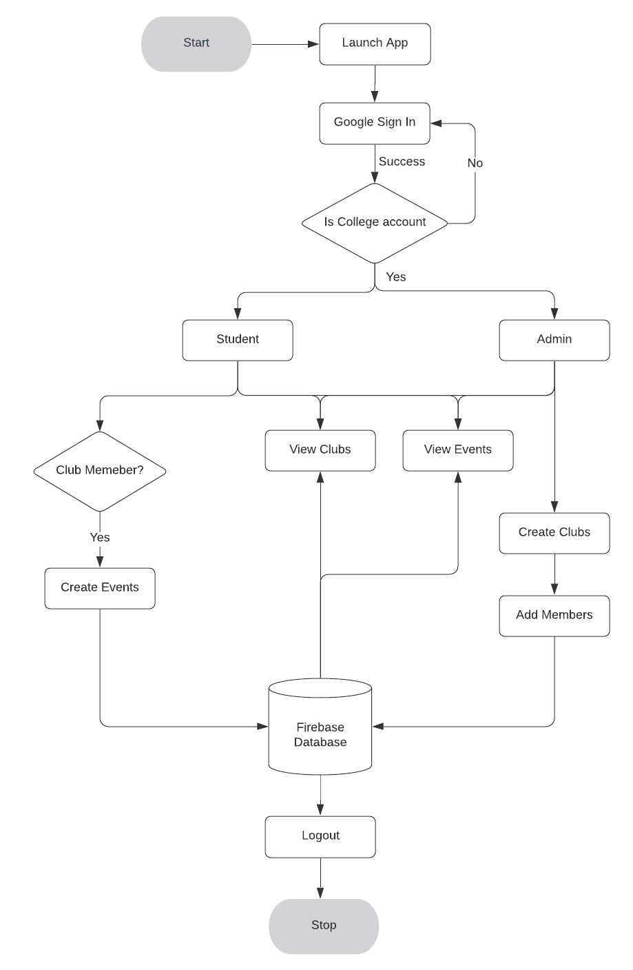

All types of users can view clubs and events.

**Admin:**

1. Admin can create clubs and add members to the club.

**Student:**

1. Student can register for the events under different clubs
2. Students can also create events under a club, iff they are a member of the club.
3. Students get notification one hour prior to a registered event as a reminder.

**4.3 Database Design**

The database is designed using Google Firebase Console in which data is stored in popular data structure known as JSON tree (JavaScript Object Notation). Every time when the data transfer happens from client end, the information given to the UI is converted into JSON tree structure which is efficient and faster way to retrieve and store data.

**A snapshot of the data in the firebase database**

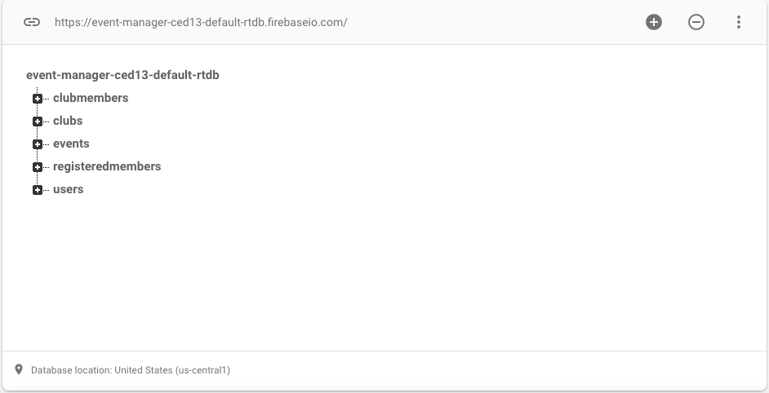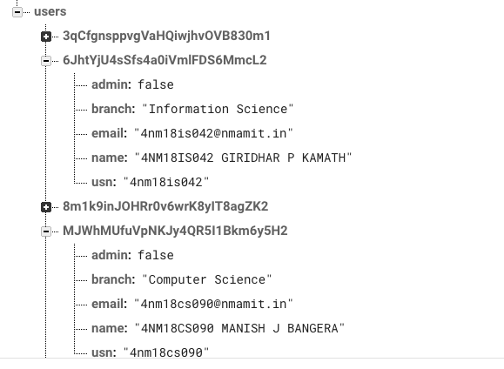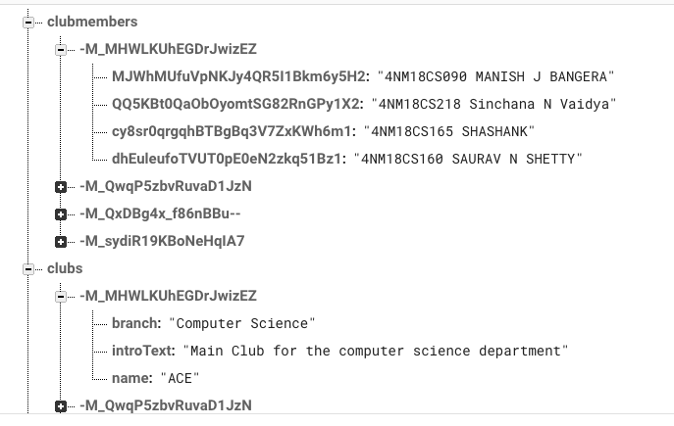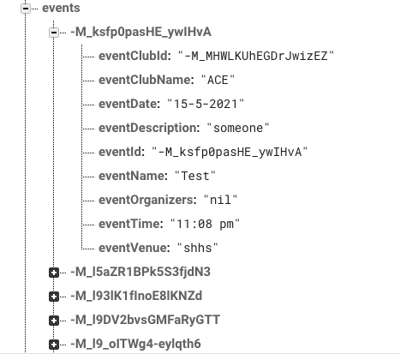

**CHAPTER 5**

**IMPLEMENTATION**

The college event manager allows creation and management of events. Data is stored in a remote database and loaded dynamically. Therefore, internet connection is required for the app to function.

**5.1 SOLUTION APPROACH/METHODOLOGY**

We use xml and java for the front end and firebase for the backend as a server.

**5.1.1 FIREBASE**

Firebase is considered as web application platform. It helps query for inserting, updating, deleting or adding data to it. It is the backend of a system that is used as a database for storing data

Firebase real-time database feature is very easy to use. Once the Firebase and database dependency is added to the app, unstructured data can be added to database.

**5.1.2 STORAGE**

The files like images, audio, video etc can be stored in the app. The data stored is highly secured and is robust in nature means it resumes from the last point if any network error occurs. For our project, we’ll need to store images like the display picture of various clubs and event poster. For this purpose, we have used Firebase Storage to store these images remotely and securely.

**5.1.3 FIREBASE AND ANDROID APP**

An Android application has been developed for the demonstration of Firebase. In this app images along with strings are loaded to Firebase and retrieved from Firebase similar to Instagram. For the development of an Android app to demonstrate the use of Firebase, prototyping model has been followed.

Steps for connecting App to Firebase:

Step1: An account in the Firebase Login has to be created at https://www.firebase.com/login/ using the Google account.

Step2: Creating a new application on Firebase. Firebase creates a new application when one logs in for the first time. Also, at the bottom left corner, one can find an option to create a new application on the Firebase server. The app url has to be unique among all applications deployed on Firebase.

Step3: Next step is to add Firebase as a project dependency. Make changes to the following lines to the build.gradle file, which is located in the app’s project folder, and not the root folder. After adding any dependency, one has to make sure to sync the application. If there is any build error complaint about duplicate files then one can choose to exclude those files by adding the packaging Options directive to the build.gradle file.

Firebase is a Backend-as-a-Service — BaaS — that started as an YC11 start up and grew up into a next-generation app-development platform on Google Cloud Platform.

**5.1.4 Java**

There are several ways to create apps for Android devices, but the recommended method for most developers is to write native apps using Java and the Android SDK. Java for Android apps is both similar and quite different from other types of Java applications.

If you have experience with Java (or a similar language) then you’ll probably feel comfortable diving right into the code and learning how to use the Android SDK to make your app run. But if you’re new to programming or object-oriented languages then you’ll probably want to get familiar with the syntax of the Java language and how to accomplish basic programming tasks before learning how to use the Android SDK.

**5.1.5 Design Architecture**

The design pattern that we have used is a loose version of the MVC design pattern. We created a package called model which contains Java classes that map to the database design in the backend. This allows flexibility while designing the app as we require minimum changes in code, when there is a change in database schema. Also, the UI and data can be separated, which helps making changes to the app easier.

ViewModels were used for some of the fragments in the app. By using viewModels it became easier to isolate the asynchronous code to fetch data from database from the app logic.

**5.2 IMPLEMENTATION CODE**

**Login page:**

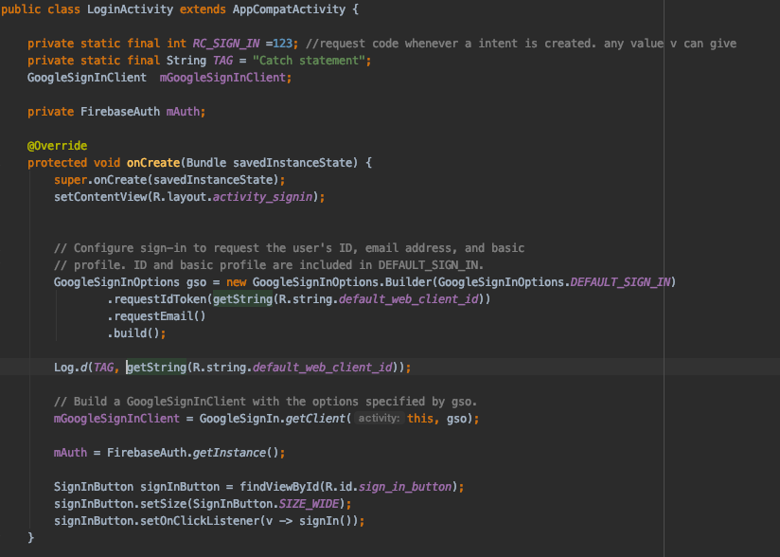

**RecyclerView Adapter:**

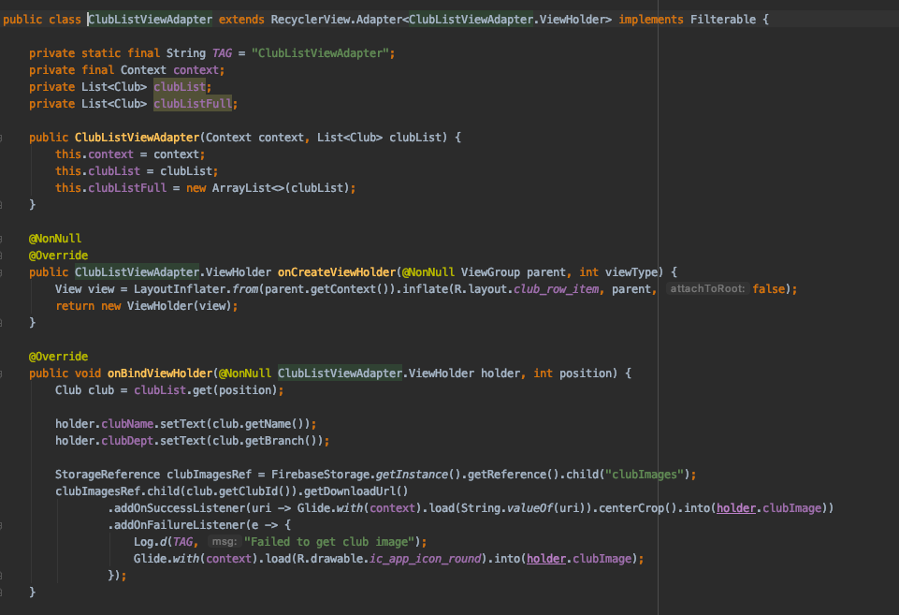

**Broadcast Receiver for notifications:**

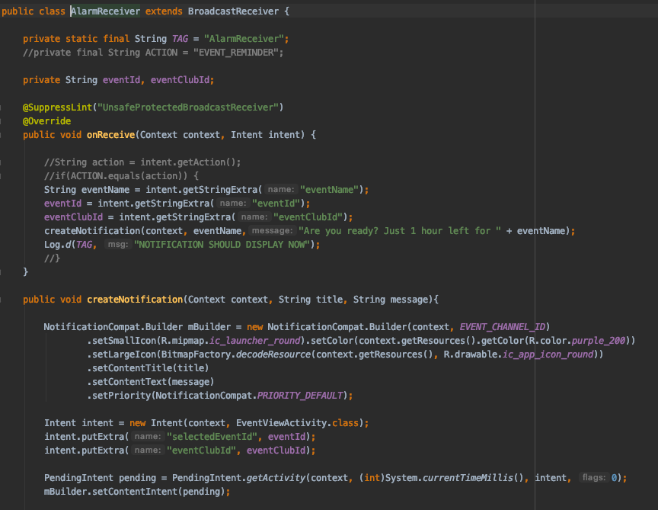

**Event View:**

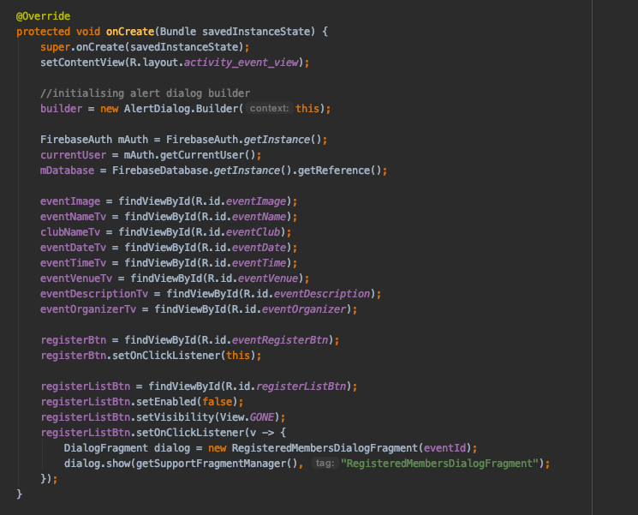

**View Model:**

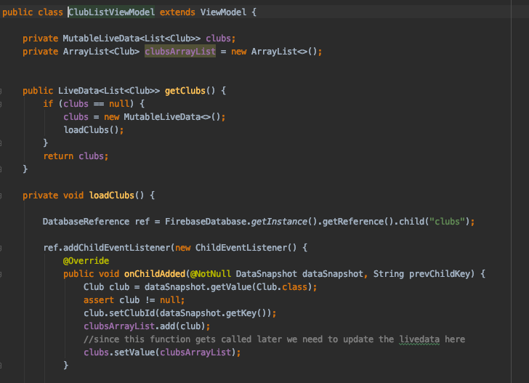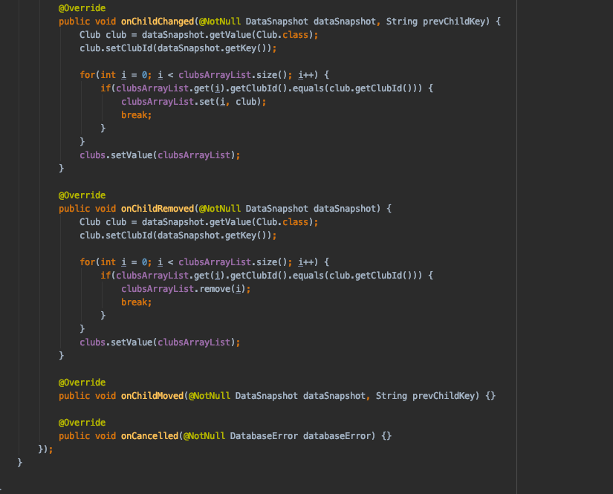

**CHAPTER 6**

**SCREENSHOTS**

Navigation Activity:

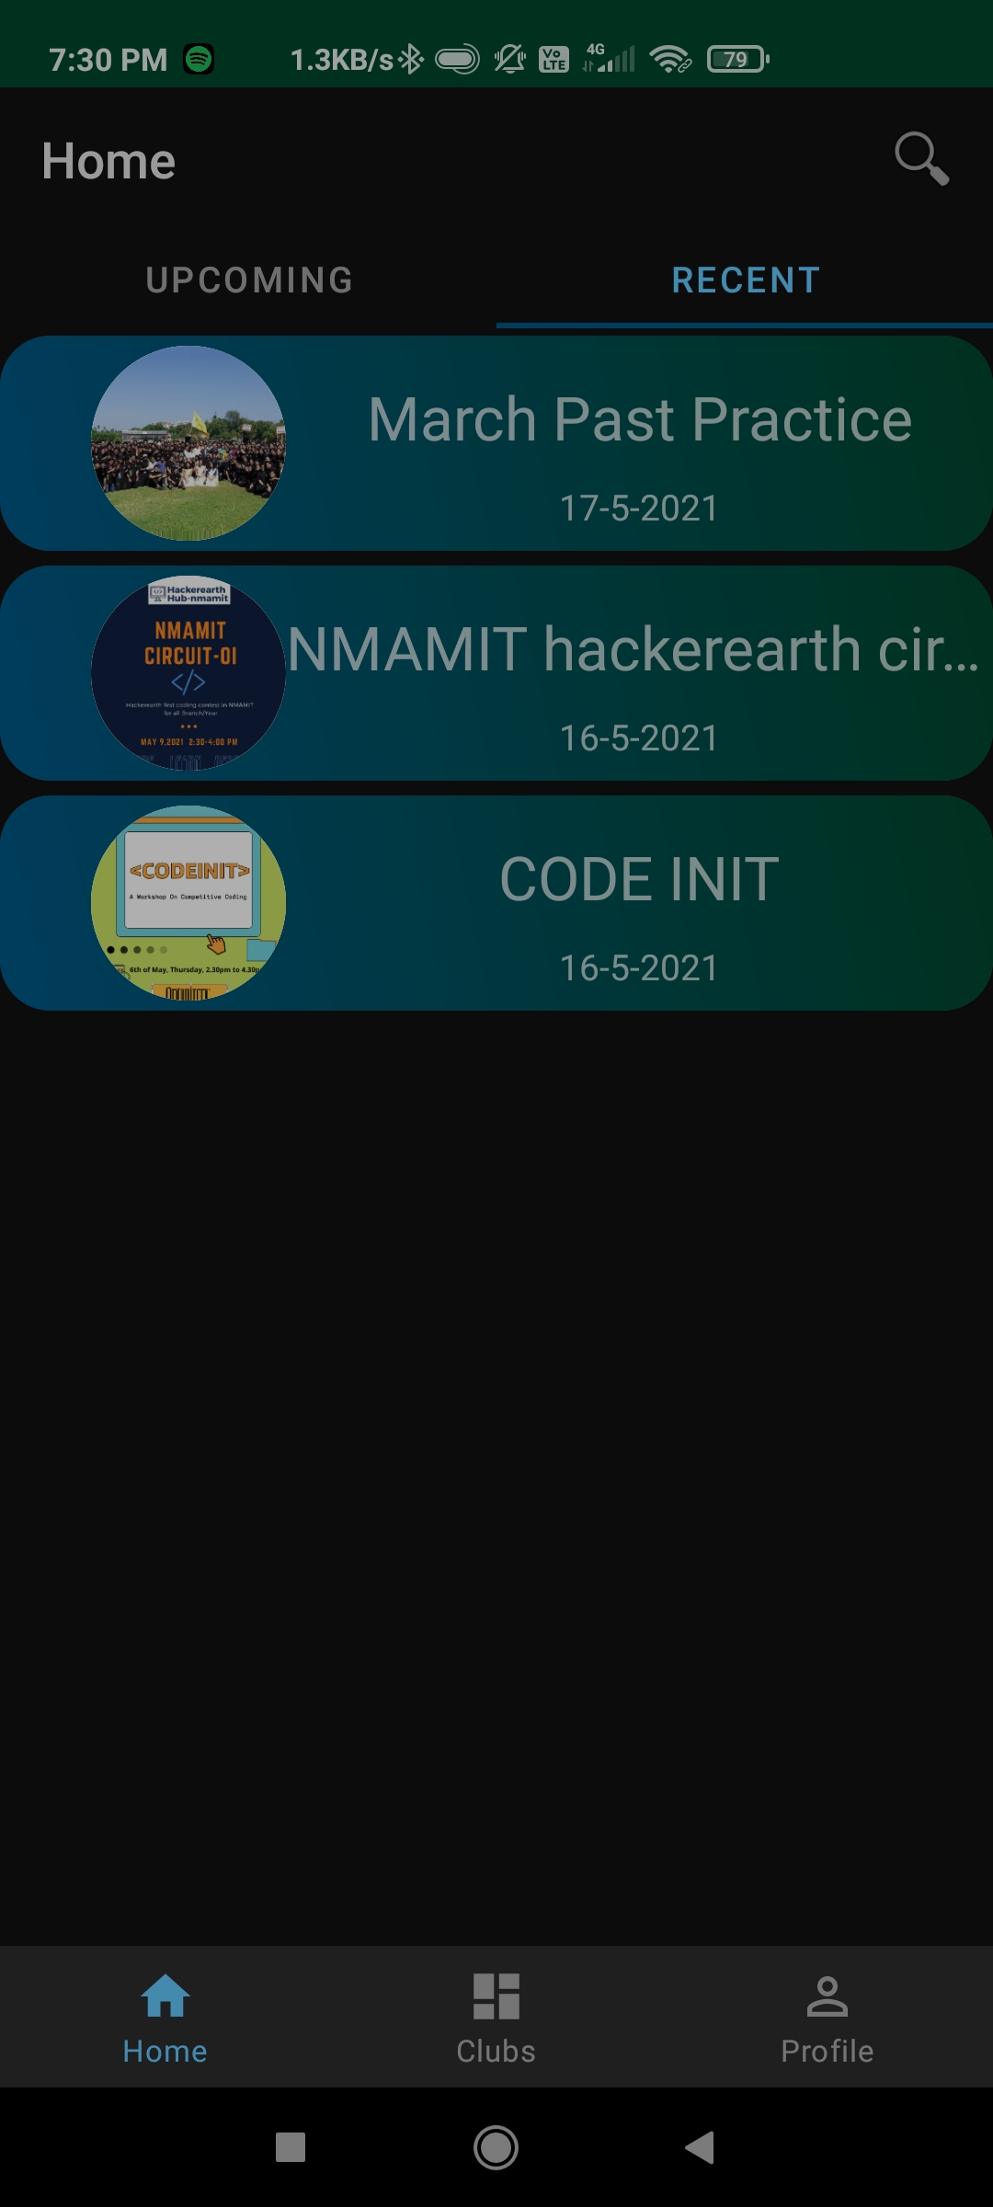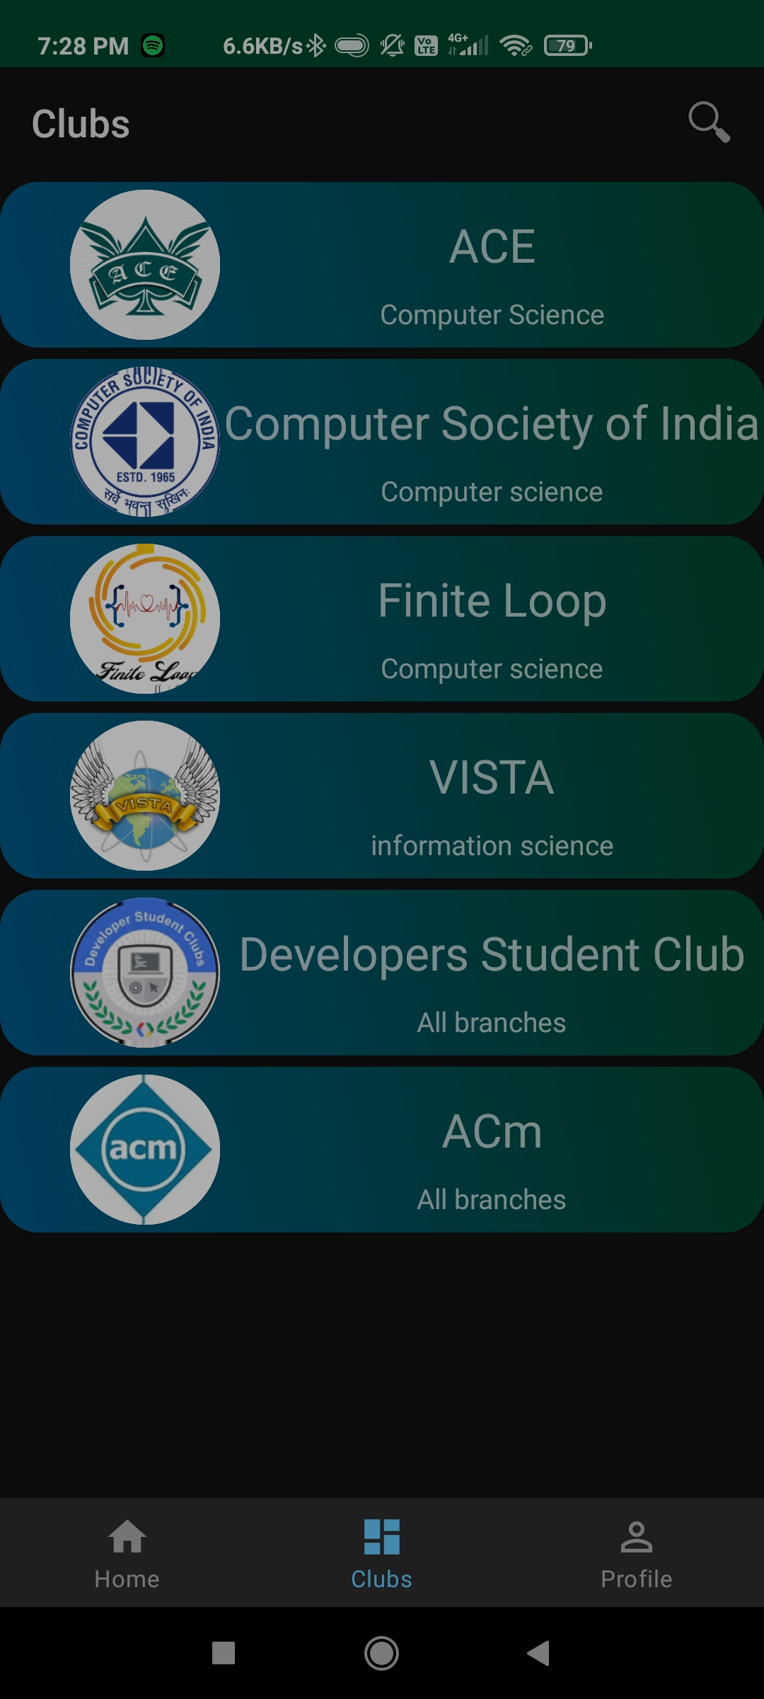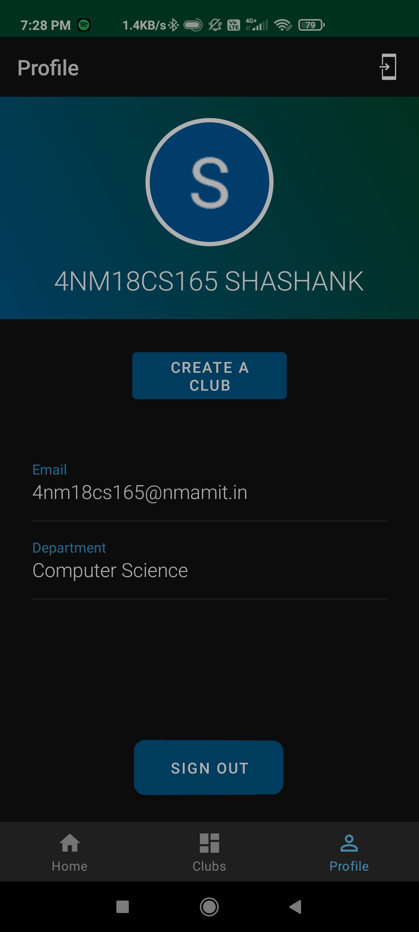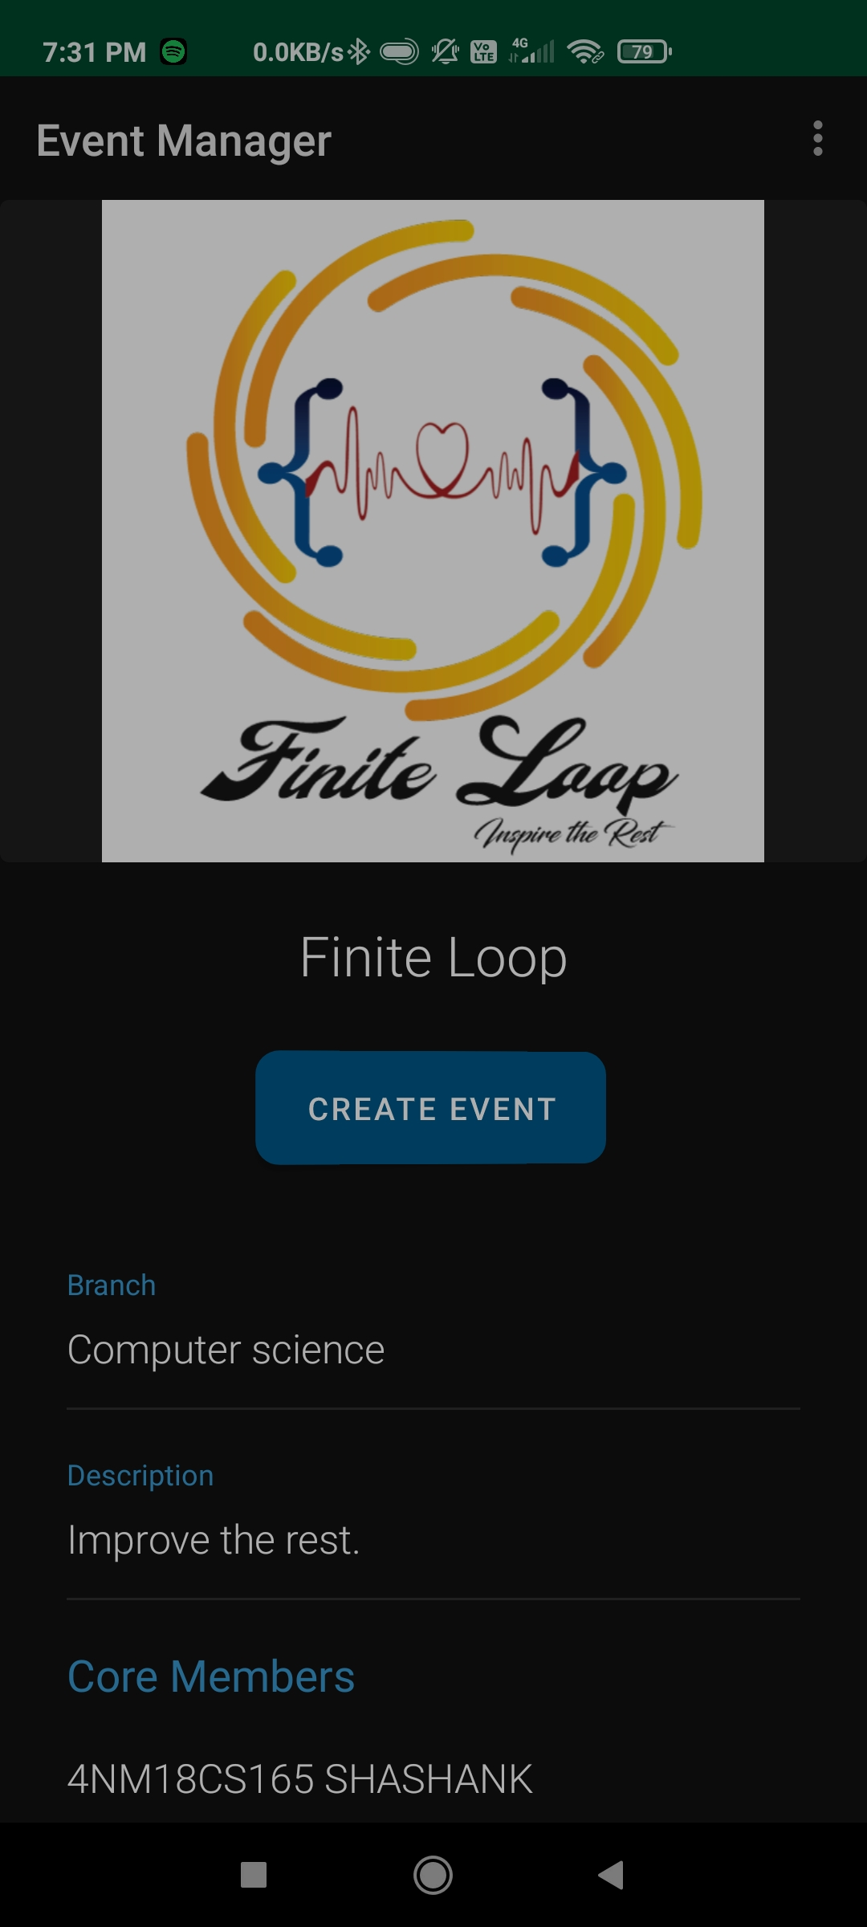

Profile View Club View

Event View

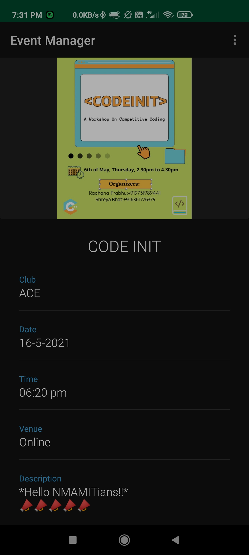

**CHAPTER 7**

**CONCLUSION AND FUTURE WORK**

**7.1 Results/Conclusion:**

1. College Event Manager app can be used to create and manage various club activities conducted in college.
2. Students can register for various events with a single click, and also receive reminders for the events they registered for.
3. Admin can create/edit any club in the college, allowing them to add members to the clubs.
4. Students can also easily create/organise club events using the app.
5. As it uses android platform it supports all Android devices.

**7.2 Future Works**

In the future, we may extend this project by adding extra features to our android app like,

1. Providing this service for multiple schools and collages simultaneously.
2. Make the app more interactive and extend it as a social network for the college.

**8 References**

1. Documentation Firebase, <https://firebase.google.com/docs/>
2. Android Development Documentation, https://developer.android.com/docs
3. Stack Overflow, [https://stackoverflow.com](https://stackoverflow.com/)