**How to run the code**

1. Unzip the solar power forecasting code.zip
2. Search Google collab in the browser

Link : https://colab.research.google.com/?utm_source=scs-index

1. Click on the new notebook to upload the solar power forecasting.ipynb file.

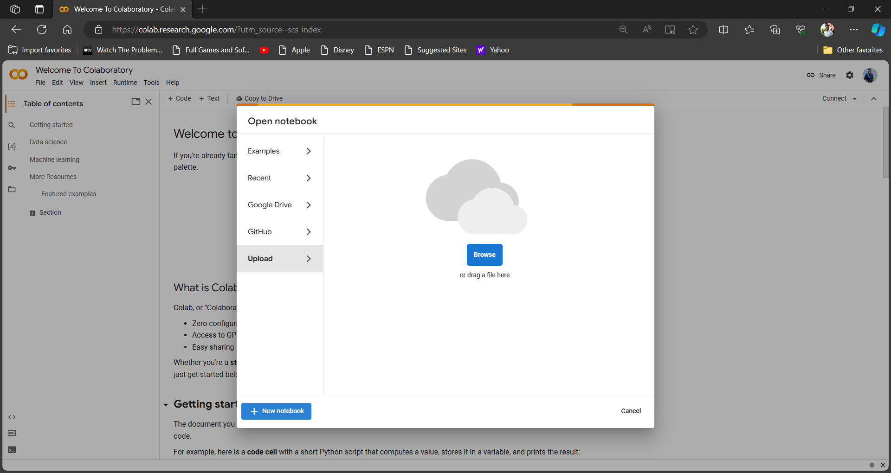

1. After uploading click on the file icon on the left side in the image. Click on the icon that is shown in the image by red arrow. 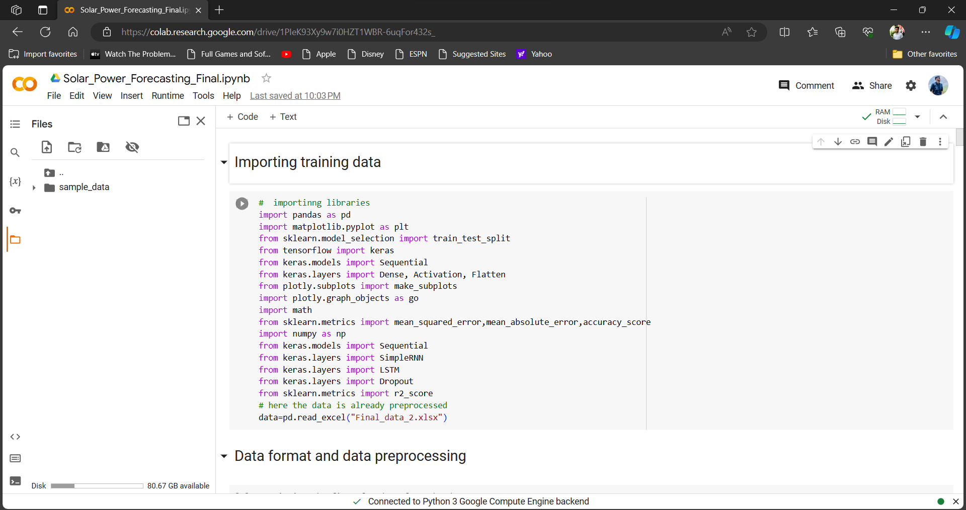
2. 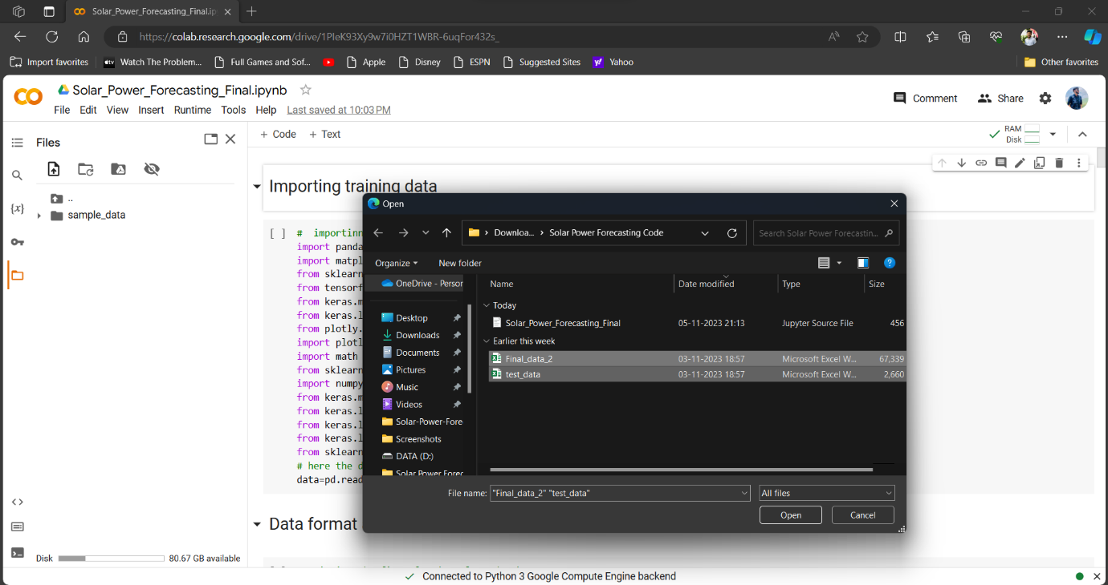Upload the Final_data2.xlsx and test_data.xlsx into file folder of collab.
3. In the menubar of the collab select runtime the select run after clicking on it. It will run all the cell after some time output will at the bottom of the file.

