SS LAB
EXPERIMENT 3
PAGE REPLACEMENT
Saurav S B
Roll no: 56
1.FIFO
#include<iostream>
using namespace std;

bool ondo(int ele,int frame[],int size){
for(int i=0;i<size;i++){
if(ele==frame[i])
return true;

}
return false;

}

bool isempty(int frame[],int size){
for(int i=0;i<size;i++)
if(frame[i]==-1)
return true;
return false;
}

int main(){
int n,a;
string s;
cout<<" enter the no of elements";
cin>>n;
int arr[n];
cout<<"enter the string";
for(int i=0;i<n;i++){
cin>>a;
arr[i]=a;
}

cout<<"enter the size of the frames";
int size;
cin>>size;
int faults=0;
int fram[size];
for(int k=0;k<size;k++)
fram[k]=-1;
int head=-1;
for(int j=0;j<n;j++){

if(ondo(arr[j],fram,size)&&isempty(fram,size))
cout<<"hit\t\t"<<arr[j]<<"\t\t";
else if(ondo(arr[j],fram,size)&&!isempty(fram,size))
cout<<"hit\t\t"<<arr[j];
else if(!ondo(arr[j],fram,size)&&isempty(fram,size)){
head++;
fram[head]=arr[j];
faults++;
}

else if(!ondo(arr[j],fram,size)&&!isempty(fram,size)){
head++;
if(head==size)
head=0;
fram[head]=arr[j];
//cout<<head;
faults++;
}

}

cout<<"\n\nFaults\t";
cout<<faults;

cout<<"\n";
for(int m=0;m<size;m++)
cout<<fram[m]<<"\t";

return 0;
}

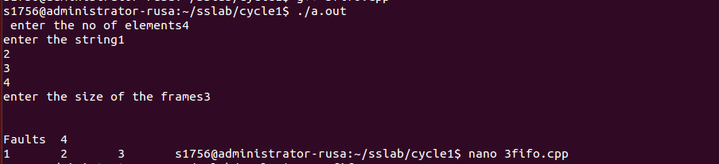

2.SJF
#include<iostream>
#include<algorithm>
#include<map>
using namespace std;

bool ondo(int ele,int frame[],int size){
for(int i=0;i<size;i++){
if(ele==frame[i])
return true;

}
return false;

}

bool isempty(int frame[],int size){
for(int i=0;i<size;i++)
if(frame[i]==-1)
return true;
return false;
}

int main(){
map <int,int> lru;
int n,a;
cout<<" enter the no of elements";
cin>>n;
int arr[n];
cout<<"enter the string";
for(int i=0;i<n;i++){
cin>>a;
arr[i]=a;
}

cout<<"enter the size of the frames";
int size;
cin>>size;
int faults=0;
int fram[size];
for(int k=0;k<size;k++)
fram[k]=-1;
int head=-1;
for(int j=0;j<n;j++){

if(ondo(arr[j],fram,size)&&isempty(fram,size)){
cout<<"hit\t\t"<<arr[j]<<"\t\t";
lru[arr[j]]=j;
}
else if(ondo(arr[j],fram,size)&&!isempty(fram,size)){
cout<<"hit\t\t"<<arr[j];
lru[arr[j]]=j;
}
else if(!ondo(arr[j],fram,size)&&isempty(fram,size)){
head++;
fram[head]=arr[j];
lru.insert(pair<int,int>(fram[head],j+1));
faults++;
}

else if(!ondo(arr[j],fram,size)&&!isempty(fram,size)){

int index=-1;
int min[size];
for(int l=0;l<size;l++)
min[l]=lru[fram[l]];

sort(min,min+size);
for(int h=0;h<size;h++){
if(lru[fram[h]]==min[0])
index=h;
}
fram[index]=arr[j];
faults++;
}

}

cout<<"\n\nFaults\t";
cout<<faults;

cout<<"\n";
for(int m=0;m<size;m++)
cout<<fram[m]<<"\t";

return 0;
}

