HOMEWORK
Simulate the following file organization techniques
a) Single level directory b) Two level directory c) Hierarchical

Single Level Directory

#CODE

#include<bits/stdc++.h>
using namespace std;
int main()
{
string s;
cout<<"enter the name of the directory";
cin>>s;
cout<<"\nenter the number of files";
int n;
cin>>n;
vector<string> v;
while(n--){
int flag=0;
cout<<"enter the file name";
string temp;
cin>>temp;
for(int i=0;i<v.size();i++){
if(v[i]==temp)
{ flag=1;
cout<<"Already existing file";
break;
}
}
if(flag==0)
v.push_back(temp);
}

cout<<"The files are "<<endl;
for(int j=0;j<v.size();j++)
cout<<v[j]<<endl;

return 0;
}
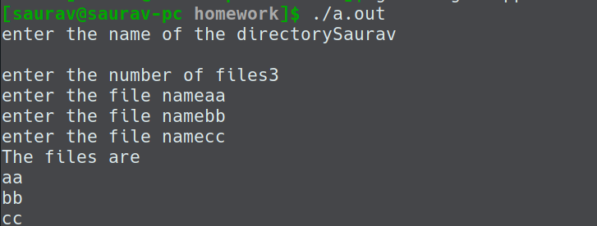

Two Level Directory

#CODE

#include<bits/stdc++.h>
int k=0;
using namespace std;
int main(){
int a=0;
vector<string> dir[10];
bool cc=true;
while(cc){
string s;
string f;
cout<<"Do you want to enter a directory? (0)";
cin>>a;
if(!a){
cin>>s;
dir[k].push_back(s);
k++; }

else{
// string f;
int index=-1;
cin>>s;
cin>>f;
for(int i=0;i<k;i++)
{
for(auto x: dir[i]){
if(x==s)
{
index=i;
break;
}
}
}
if(index>=0){
dir[index].push_back(f);
}
}

cout<<"do you want to continue 1";
cin>>a;
if(!a)
cc=false;
}

cout<<k<<endl;
for(int j=0;j<=k;j++){
for(auto y : dir[j])
cout<<y<<"->";
cout<<endl;
}

return 0;
}
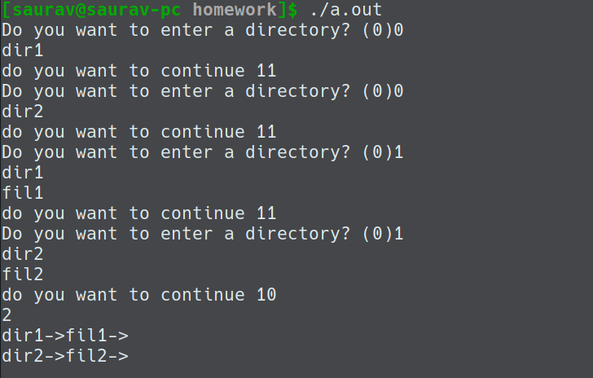

Hierarchical Directory

#CODE

