# “Revolutionizing Healthcare: Disease & Symptom based Hospital Prediction using Machine Learning”

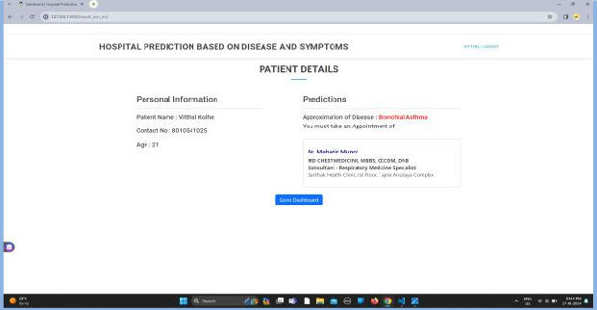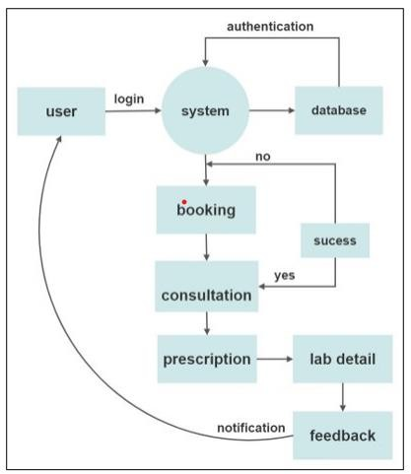

**[1] Vitthal Kolhe, [2] Mahesh Tawar, [3] Saurav Shimpi [4] Om Narhare Guided by Dr.B.L.Gunjal**

# Information Technology

Amrutvahini college of Engineering, Sangamner IT

**01**

1. **Introduction**

The healthcare industry is experienced in a transformative shift towards patient-centric care, driven by technological advancement and the growing demand for personalize services.

1. **Need and Necessity of Project**

A disease and symptoms-based hospital prediction project could help streamline healthcare services by predicting patient influx based on prevalent diseases in a specific region.

1. **Objective**

The primary objective is to improve the overall patient experience by providing a user-friendly platform for symptom analysis, disease prediction, and appointment scheduling.

1. **Methodology**

The project begins with a comprehensive analysis of existing healthcare processes, patient needs and technological infrastructure

1. **Block Diagram**
2. **Result**
3. **Advantages**
   * Cost Efficiency
   * Early-Disease Detection

**8. Applications**

* Communication Accessibility
* Healthcare
* Hospital Allocation

**9. Conclusions**

In conclusion, the development and implementation of the patient-centric healthcare system represent a significant leap forward in the healthcare industry.