Regression 2.1
Goal-difference prediction
HIT140 Foundations of Data Science | Assessment 3 | Updated scientific evaluation
Contributor: Bibek • Latest dataset: regression_2_1_dataset_latest.csv • Evaluation date: 15 October 2026

Executive overview
This report supersedes the earlier Regression_2_1_Reviewed_Report.docx results. It uses the updated 104-match dataset and the newly generated results_latest outputs. The analysis compares six model families under the required 70/30 and 80/20 train/test splits (seed 42), with 200 repeated splits per ratio. All eight pre-specified predictors remain in the input dataset.

Key findings
Measure | 70/30 repeated tests | 80/20 repeated tests
Lasso mean test R² | 0.321 | 0.315
Lasso test R² standard deviation | 0.178 | 0.221
Lasso mean test NRMSE | 18.70% | 20.54%
Lasso mean test RMSE (goals) | 1.590 | 1.573
Lasso mean test MAE (goals) | 1.236 | 1.228
Lasso produced the highest average held-out R² and lowest mean held-out NRMSE at both ratios. Its split-to-split R² variation is substantial, so these mean scores should not be treated as guaranteed future accuracy. The fixed-seed 80/20 test instead favoured Random Forest, illustrating why repeated evaluations matter.
Conditional model recommendation. Use tuned Lasso as the accuracy leader if the requirement is to retain all eight supplied input columns. If the eight predictors must all have non-zero fitted coefficients, use Ridge as the primary regularised model; Lasso sets several coefficients exactly to zero.

Audit status
The new modelling outputs are internally consistent. The official 11 June 2026 FIFA ranking was published before the World Cup began, supporting its timing as a pre-tournament input. Nevertheless, the ZIP contains older pre-tournament source CSVs alongside the newly rebuilt modelling CSV; the dated upstream replacement files must be archived consistently before claiming complete end-to-end reproducibility.
Source basis: supplied ZIP, especially results_latest/regression_2_1_model_details.csv, regression_2_1_repeated_summary.csv, regression_2_1_diagnostic_tests.csv and regression_2_1_dataset_latest.csv.

1. Dataset, target and predictor definitions
Regression 2.1 has one observation per FIFA World Cup 2026 match (n = 104), with 104 unique match IDs, no missing required model cells and eight locked numerical predictors. The target is goal_difference = home_goals − away_goals. A positive value favours the home/team-A side; a negative value favours the away/team-B side.
Predictor | Interpretation
fifa_points_difference | FIFA ranking points: home minus away
points_per_match_difference | Prior points earned per match: home minus away
avg_goals_scored_difference | Prior average goals scored: home minus away
avg_goals_conceded_difference | Prior average goals conceded: home minus away
scoring_match_rate_difference | Prior proportion of matches with ≥1 goal: home minus away
scoring_consistency_difference | Prior scoring standard deviation: home minus away
clean_sheet_rate_difference | Prior proportion of clean sheets: home minus away
host_country_indicator | Signed host flag: +1 home host, −1 away host, 0 otherwise

1.1 Updated historical-feature dataset
The latest modelling CSV differs from the preceding regression_2_1_dataset_corrected.csv in 54 historical predictor cells across nine opening-round matches. Goal outcomes, FIFA-point differences, signed host indicators and the remaining match rows are unchanged. The newer values reflect the replenished five-match historical baselines supplied during the audit.
In the ZIP provided for this report, pre_tournament_matches.csv is still an older copy containing 18 team-level records dated on or after 11 June 2026. Its associated baseline CSV is likewise not the newly regenerated source. These older files must not be cited as the direct upstream inputs of regression_2_1_dataset_latest.csv. The model-integrity output still marks independent verification of all six historical-form inputs as incomplete; that is a documentation limitation, not a newly detected numerical mismatch.

2. Evaluation design and safeguards
The comparison comprises a mean-only dummy baseline, ordinary multiple linear regression (OLS), tuned Ridge, tuned Lasso, tuned Random Forest and tuned Gradient Boosting. All models use the same held-out match observations for a given random seed. The 70/30 split has 72 training and 32 test matches; the 80/20 split has 83 training and 21 test matches. No random split is grouped by team.
For each outer training set, Ridge, Lasso, Random Forest and Gradient Boosting are tuned by shuffled five-fold cross-validation on training rows only. StandardScaler is included inside the Ridge and Lasso pipelines, so transformation parameters are learned within each CV fold rather than from held-out data. The hyperparameter search is deliberately limited; results describe those candidate grids, not all possible model configurations.
Metrics: R² measures explanatory performance relative to a mean predictor. RMSE and MAE are in goals. NRMSE = RMSE / [max(observed goal difference) − min(observed goal difference)] for the relevant scored partition, shown as a percentage. The observed target range can vary by repeated test subset, so RMSE/MAE complement NRMSE. The repeated trial seeds are 42–241 (200 repeats per split).

3. Fixed-seed held-out performance
Table 1. Seed-42 70/30 test comparison (n test = 32).
Model | R² train | R² test | RMSE | NRMSE | MAE
Mean baseline | 0.000 | -0.003 | 2.182 | 21.82% | 1.653
OLS | 0.523 | 0.264 | 1.869 | 18.69% | 1.419
Ridge | 0.510 | 0.300 | 1.823 | 18.23% | 1.373
Lasso | 0.498 | 0.307 | 1.813 | 18.13% | 1.360
Random forest | 0.644 | 0.306 | 1.814 | 18.14% | 1.382
Gradient boosting | 0.616 | 0.280 | 1.848 | 18.48% | 1.380
Table 2. Seed-42 80/20 test comparison (n test = 21).
Model | R² train | R² test | RMSE | NRMSE | MAE
Mean baseline | 0.000 | -0.001 | 2.239 | 22.39% | 1.690
OLS | 0.471 | 0.344 | 1.813 | 18.13% | 1.311
Ridge | 0.464 | 0.346 | 1.809 | 18.09% | 1.316
Lasso | 0.457 | 0.342 | 1.815 | 18.15% | 1.318
Random forest | 0.624 | 0.365 | 1.783 | 17.83% | 1.379
Gradient boosting | 0.553 | 0.361 | 1.789 | 17.89% | 1.312
On the single 70/30 seed-42 split, Lasso leads marginally (R² = 0.307, NRMSE = 18.13%). On the 80/20 split, Random Forest leads (R² = 0.365, NRMSE = 17.83%). These rankings are sample-specific and should not be substituted for the 200-repeat results.

4. Stability across 200 repeated splits
Table 3. Repeated held-out results, mean ± sample SD (n = 200 per row). Mean RMSE and MAE are expressed in goals.
Split / model | Test R² mean ± SD | Test NRMSE mean ± SD | RMSE | MAE
70/30 — Mean baseline | -0.041 ± 0.064 | 23.34% ± 2.21 pp | 1.992 | 1.570
70/30 — OLS | 0.245 ± 0.222 | 19.67% ± 3.06 pp | 1.668 | 1.294
70/30 — Ridge | 0.277 ± 0.176 | 19.31% ± 2.65 pp | 1.642 | 1.270
70/30 — Lasso | 0.321 ± 0.178 | 18.70% ± 2.65 pp | 1.590 | 1.236
70/30 — Random forest | 0.296 ± 0.151 | 19.08% ± 2.28 pp | 1.622 | 1.278
70/30 — Gradient boosting | 0.309 ± 0.130 | 18.92% ± 2.11 pp | 1.612 | 1.261
80/20 — Mean baseline | -0.067 ± 0.096 | 25.98% ± 3.05 pp | 2.000 | 1.586
80/20 — OLS | 0.241 ± 0.277 | 21.54% ± 3.84 pp | 1.645 | 1.281
80/20 — Ridge | 0.269 ± 0.226 | 21.22% ± 3.38 pp | 1.626 | 1.260
80/20 — Lasso | 0.315 ± 0.221 | 20.54% ± 3.34 pp | 1.573 | 1.228
80/20 — Random forest | 0.271 ± 0.197 | 21.24% ± 3.02 pp | 1.625 | 1.284
80/20 — Gradient boosting | 0.299 ± 0.169 | 20.86% ± 2.78 pp | 1.602 | 1.257
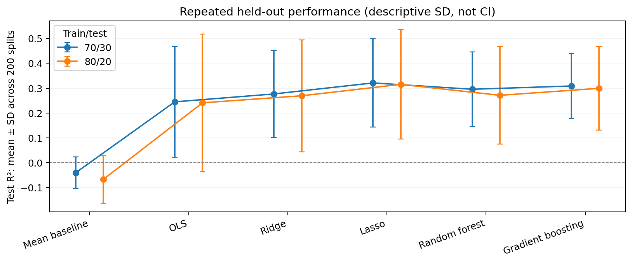
Figure 1. Mean test R² ± descriptive SD for 200 overlapping random splits. Error bars are not confidence intervals.
At 70/30, Lasso mean test R² is 0.321 (SD 0.178), against Ridge 0.277 and Gradient Boosting 0.309. At 80/20, Lasso scores 0.315 (SD 0.221), against Ridge 0.269 and Gradient Boosting 0.299. The stronger overall Lasso mean is accompanied by meaningful split-dependent variation and only 21 held-out matches for 80/20.

5. Training-only exploratory assessment
Feature–target correlations and variance inflation factors were calculated using only the seed-42 80/20 training partition (n = 83), avoiding exploratory inspection of the corresponding held-out outcomes. These statistics are descriptive and do not indicate causality.
Feature | Training Pearson r | VIF
fifa_points diff. | +0.669 | 1.60
points_per_match diff. | +0.373 | 5.31
avg_goals_conceded diff. | -0.351 | 2.07
avg_goals_scored diff. | +0.275 | 6.10
FIFA strength is the strongest univariate signal (r = +0.669), followed by points per match (+0.373), goals conceded (−0.351) and goals scored (+0.275). The maximum observed VIF is 6.10 for average goals scored, with points per match at 5.31: substantial but not automatically disqualifying overlap, which regularisation can moderate.
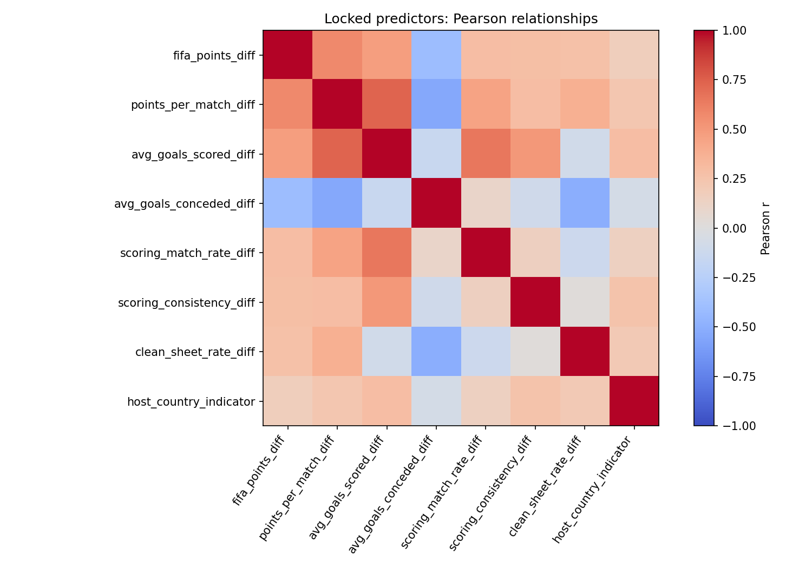
Figure 2. Correlation matrix of the eight locked predictors on the 80/20 training partition (n = 83).
All eight feature columns were retained in the model comparison. Feature-selection decisions were not based on the held-out outcomes.

6. OLS residual and influence diagnostics
Diagnostics refer to the seed-42 OLS fit on the 80/20 training sample (n = 83), not to the separately tuned Lasso model. These are model checks rather than proof of the statistical assumptions.
Diagnostic | Updated result | Interpretation
Breusch–Pagan LM test | p = 0.271 | No rejection of constant error variance at 5%
Breusch–Pagan F test | p = 0.281 | Consistent with LM conclusion
Shapiro–Wilk exploratory | p = 0.659 | No clear normality rejection; not proof
Cook’s distance | 4 above 4/n | Threshold 0.048
Maximum Cook’s distance | 0.471 | Influential row requires inspection
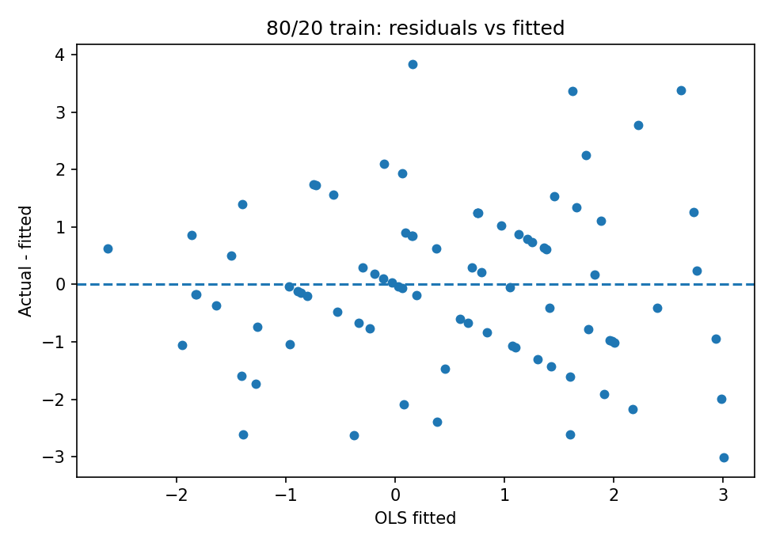 | 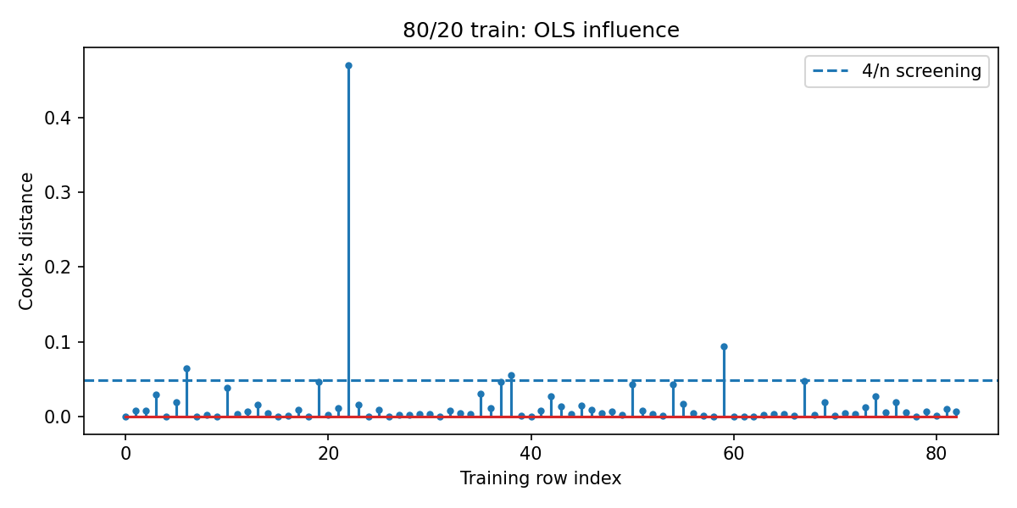
Figure 3. OLS training residuals versus fitted values (left) and Cook’s-distance screen (right).
Breusch–Pagan p = 0.271 and the F-test p = 0.281 do not supply evidence against constant variance at α = .05, but neither proves homoscedasticity. The Q–Q and residual plots should be used alongside the tests. Four observations exceed the 4/n Cook’s screening threshold (0.048), with the largest Cook’s distance 0.471 for match ID 400021465. These cases merit contextual review rather than automatic deletion.
The OLS host-effect estimate is +0.663 goals (p = 0.213) and the intercept is +0.121 (p = 0.491). They are not individually statistically distinguishable from zero at the conventional 5% threshold in this sample.

7. Coefficients and model recommendation
Because Ridge and Lasso are fitted to standardised inputs, their fitted standardised coefficients provide a conditional comparison of predictive weights—not causal effects. Collinearity can alter individual signs or weights even when univariate feature–target correlations are positive.
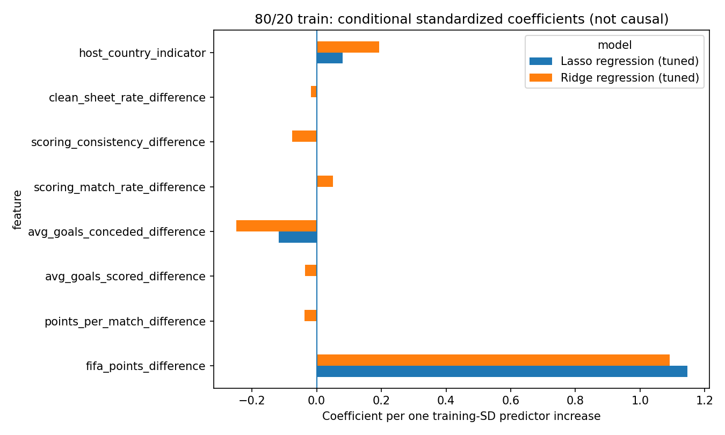
Figure 4. Standardised Ridge and Lasso coefficients on the seed-42 80/20 training set.

7.1 Preferred model with a predictor-lock caveat
Lasso is the accuracy-based primary recommendation because it has the highest mean test R² and lowest mean test NRMSE for each repeated-split ratio. However, it sets 2/8 predictor coefficients to zero at the 70/30 fixed seed and 5/8 at 80/20, leaving six and three nonzero coefficients, respectively. This may conflict with a stricter interpretation that all eight predictors must remain active in the final fitted model.
If the assessment requires eight columns only, report Lasso as the lead model and retain all inputs as specified. If it requires eight nonzero effects, report Ridge as the compliant regularised primary candidate and Lasso as a sensitivity benchmark, subject to lecturer/team confirmation. Ridge preserves all eight coefficients, though its average test performance is weaker than Lasso.

8. Limitations, provenance and handoff

8.1 Interpretation limits
These results concern 104 World Cup match observations rather than an independent prospective validation cohort. With 21–32 matches in a test fold, R² can fluctuate materially. The 200 random splits re-use observations and share team identities; their means and SDs are descriptive summaries, not 200 independent experiments or confidence intervals. Random holdouts may perform optimistically when similar teams appear in both training and test fixtures. A chronological or team-held-out stress test could be proposed separately without replacing the required split design.

8.2 Provenance checklist before final submission
• Retain regression_2_1_dataset_latest.csv as the current modelling source and do not silently substitute the old corrected CSV.
• Replace or separately archive the older pre_tournament_matches.csv and pre_tournament_baselines.csv inside the ZIP. The current packaged pre-match file still contains 18 records dated 11 June 2026 or later, although the newer modelling dataset does not use those contaminated values.
• Include the updated feature-building scripts and their regenerated historical source files when documenting complete point-in-time reproducibility. The saved integrity CSV still flags the six historical predictors as not independently verified by that script.
• Confirm whether the locked-eight requirement means eight supplied predictors or eight nonzero coefficients before making Lasso the sole reported final estimator.
• Replace stale tables and figures in any group report with the results_latest outputs; do not combine old and new performance figures.

8.3 Reproducibility
Execution: python regression_2_1_modeling_reviewed.py --data regression_2_1_dataset_latest.csv --output results_latest --repeats 200. The supplied run_metadata.csv records Python 3.10.11, scikit-learn 1.7.2, seed 42 and five-fold shuffled training-only CV. The script additionally uses NumPy, pandas, SciPy, statsmodels, Matplotlib and joblib.

Evidence and reference sources
Internal: Regression_2_1_Scientific_Review_Validated(1).zip; regression_2_1_dataset_latest.csv; regression_2_1_modeling_reviewed.py; results_latest/regression_2_1_results.csv; regression_2_1_model_details.csv; regression_2_1_repeated_splits.csv; regression_2_1_repeated_summary.csv; regression_2_1_diagnostic_tests.csv; regression_2_1_coefficients.csv; regression_2_1_data_integrity.csv; run_metadata.csv.
FIFA. (2026, June 11). Argentina reclaim top spot in the FIFA/Coca-Cola Men’s World Ranking. https://grassroots.fifa.com/fifa-rankings/world-ranking/men/news/argentina-reclaim-top-spot-mens-world-ranking-fifa-coca-cola
FIFA. (2026, July 12). Top four in FIFA/Coca-Cola World Ranking set for historic semi-final showdown. https://www.fifa.com/en/tournaments/mens/worldcup/canadamexicousa2026/articles/top-four-fifa-coca-cola-ranking-semi-final
Status: Updated performance report, internally cross-checked against the ZIP outputs. Final grading readiness remains dependent on the exact unit rubric and group agreement about the predictor-lock interpretation.

