Regression 2.2 – Predicting Goals Scored by a Team in a Match
Draft report sections. Figures come from the final dataset (208 team-match rows, 104 matches). Check every number against your own notebook run and rewrite in your own words before submitting.

1. Data and Predictor Selection
The response variable is goals_scored: the goals one team scored in one match (mean 1.48, variance 1.94). The dataset has 208 rows, two per match (one per team). The eight explanatory variables are all known before kick-off, so no current-match information is used.
Predictor | Football reasoning
team_fifa_points | Overall team strength before the match
opponent_fifa_points | Opponent strength; stronger opponents should reduce goals scored
avg_goals_scored_before | The team's attacking record
avg_goal_difference_before | Overall past performance (attack minus defence)
win_rate_before | Past winning form
opponent_avg_goals_conceded_before | Weak defences should concede more
opponent_clean_sheet_rate_before | Opponents who often keep clean sheets make scoring harder
opponent_scoring_match_rate_before | How often the opponent scores; a proxy for how open its games are

EDA evidence. There are no missing values. The strongest correlations with goals_scored are team_fifa_points (+0.385) and opponent_fifa_points (−0.339), which fits the football logic. The largest correlation between two predictors is 0.787 (avg_goal_difference_before with win_rate_before), below the |0.80| limit. All VIF values are below 5 (highest 4.058, for avg_goal_difference_before), so multicollinearity is acceptable.

2. Baseline Multiple Linear Regression and Train/Test Evaluation
Both rows of a match always go into the same set (a grouped split by match_id). A random row-level split would put one team in training and its opponent in testing, which leaks information. Seed 42. Normalized RMSE = RMSE ÷ (max − min of observed goals_scored).
Split | R² train | R² test | NRMSE train | NRMSE test
80/20 | 0.288 | 0.207 | 0.166 | 0.215
70/30 | 0.300 | 0.191 | 0.170 | 0.198

Comparing the splits. The 80/20 split gives a slightly higher test R² and the 70/30 split a lower NRMSE, so neither is clearly better. With 208 rows the test sets are only about 42 and 62 rows. To check stability, each split was repeated 200 times with different seeds:
Split | Mean test R² (SD) | Mean test NRMSE (SD)
80/20 | 0.173 (0.154) | 0.226 (0.033)
70/30 | 0.171 (0.117) | 0.212 (0.024)

The average R² is almost identical across splits and the spread is large, so the difference seen in a single split is mostly chance. The 70/30 split is slightly more stable (smaller SD) because its test set is larger. Test R² is lower than training R² (about 0.29), as expected, so the model generalises modestly.

3. Diagnostics and Weaknesses
On the full data, R² = 0.276 (adjusted 0.247). Only the two FIFA points variables are statistically significant (team_fifa_points coefficient 0.0033, p < 0.001; opponent_fifa_points −0.0020, p = 0.007; cluster-robust standard errors by match). The other six predictors have p > 0.17.
- Low explanatory power. Goals in a single match are few and highly random, so a low R² is expected.
- Non-normal residuals. Shapiro–Wilk p ≈ 0. Goals are non-negative counts, so residuals are right-skewed.
- Mild heteroscedasticity. Breusch–Pagan p = 0.033.
- Independence. Durbin–Watson = 1.95, but the two teams' residuals within the same match correlate at 0.18. This is why grouped splits and cluster-robust standard errors were used.
- Impossible predictions. 2 of 208 predictions are negative.
- Influential points. 11 rows exceed the Cook's distance threshold of 4/n. One observation (around row 69) stands out at about 0.26; the rest are below about 0.09. They were examined but not removed, because they are real matches and there is no data-quality reason to drop them.

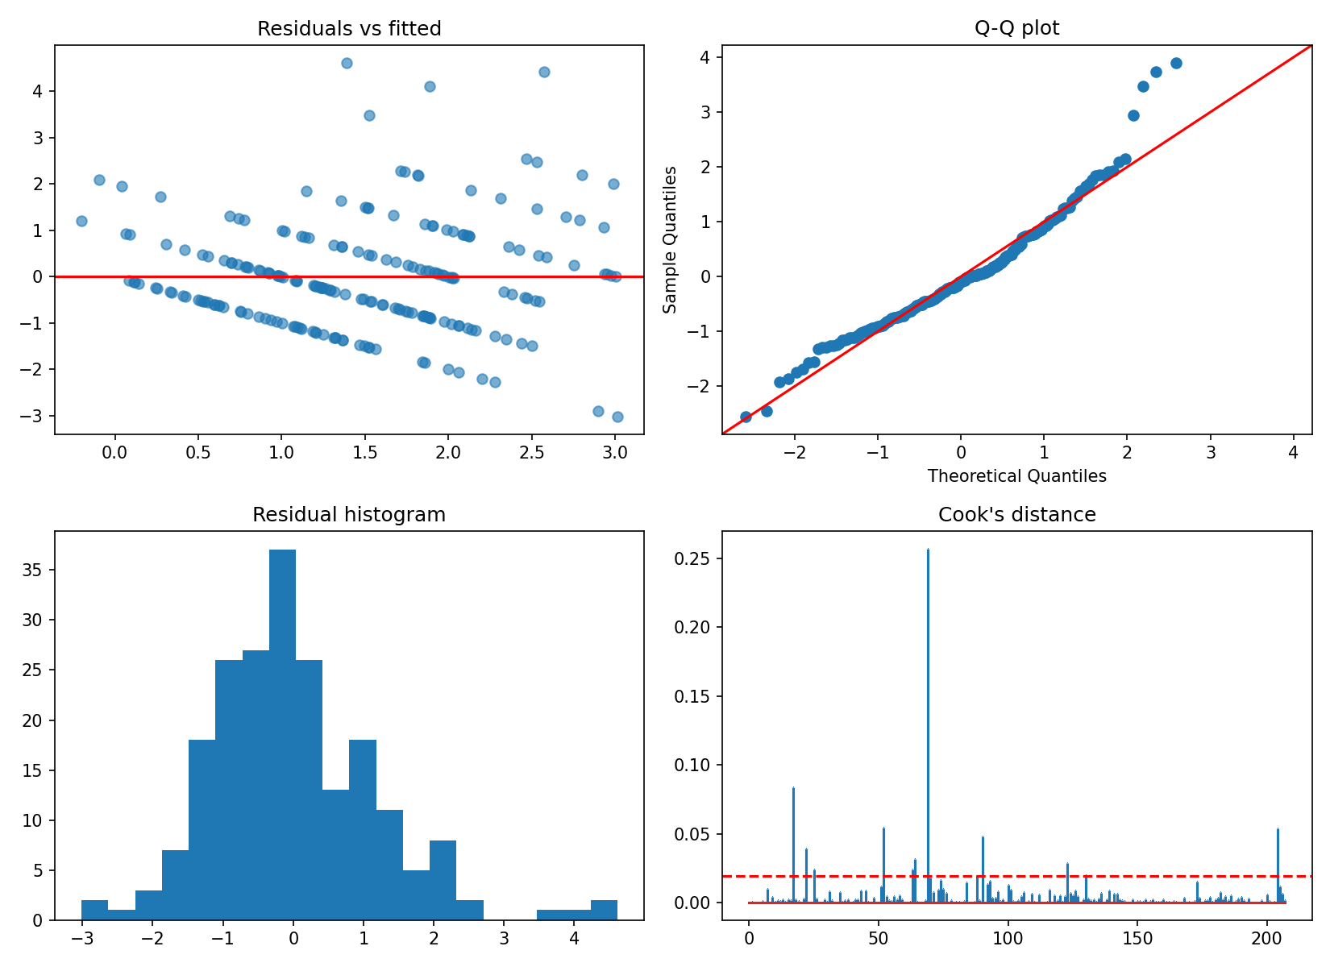
Figure 1. Diagnostic plots for the baseline linear model.
The residuals-vs-fitted plot shows diagonal bands because goals are whole numbers, and a handful of large positive residuals (up to about 4.6) where a team scored far more than predicted. The Q-Q plot follows the line in the middle but bends away in the upper tail, and the histogram is right-skewed, confirming non-normality. Cook's distance shows one dominant point and several smaller ones above the 4/n line.

4. Model Optimisation (predictors unchanged)
The eight predictors were kept as agreed by the group. Each change below targets one diagnostic problem and was judged on 200 repeated grouped splits.
Variant | Problem addressed | Mean test R² (80/20 / 70/30) | Beats baseline
Baseline OLS | – | 0.173 / 0.171 | –
OLS, negatives clipped at 0 | Impossible negative predictions | 0.177 / 0.174 | 61.0% of splits
OLS on log(1 + goals) | Skewed residuals | 0.159 / 0.161 | 39.0%
OLS on √goals | Skew and heteroscedasticity | 0.126 / 0.131 | 29.0%
Ridge (alpha by cross-validation, α ≈ 41.8) | Weak, partly correlated predictors | 0.188 / 0.188 | 64.5%

The transformations made predictions worse, so they were rejected. Clipping at zero is a small, logical improvement because goals cannot be negative. Ridge regression gave the best average test R² and the lowest variability, because shrinking the coefficients of the weak predictors reduces overfitting on a small dataset. The gain is small (about +0.016 R²) and Ridge beat the baseline in only about two-thirds of splits, so it is a modest improvement, not a decisive one.

5. Competing Algorithm Comparison
Linear regression was kept as the baseline. Poisson regression, Random Forest and Gradient Boosting were evaluated on exactly the same grouped splits and metrics.
Model | R² train (80/20) | R² test, 200-split mean (80/20 / 70/30) | NRMSE test (80/20 / 70/30)
Linear (baseline) | 0.283 | 0.173 / 0.171 | 0.226 / 0.212
Poisson | 0.294 | 0.152 / 0.141 | 0.229 / 0.216
Random Forest | 0.584 | 0.135 / 0.140 | 0.231 / 0.216
Gradient Boosting | 0.609 | 0.133 / 0.131 | 0.231 / 0.217

Why the results differ. The tree-based models fit the training data far better (train R² about 0.6) but do worse than linear regression on unseen matches. They are overfitting: with only 208 noisy observations they learn patterns that are just chance. Tuning Gradient Boosting with cross-validation chose the simplest setting (depth 1, 100 trees) and still scored only 0.156 test R² (80/20, seed 42), which suggests there is little non-linear signal to find. Its feature importance agrees with the linear model: the two FIFA points variables and the opponent's goals conceded matter most. Poisson regression suits count data in principle, but with this little data and weak predictors it showed no advantage. The main conclusion is that single-match goals are inherently hard to predict from pre-match statistics, so a simple, stable model is the most defensible.

6. Limitations
- Only 208 observations, so test metrics are unstable (see the large standard deviations).
- Pre-match statistics are based on limited history for each team.
- Only team-strength variables are included; lineups, injuries, tactics and match context are not.
- The two rows from each match are not fully independent.

