Assessment 3 — Objective 2: Regression 2.1 (Goal-Difference Modelling)
Contributor: Bibek
Status: Reproducible analysis prepared for group integration; the source-data correction and optional competitor section require approval from Saurab.
Dataset: 104 matches, one observation per match, eight locked predictors.
Shared protocol: Seed 42; 70/30 and 80/20; train/test R² and range-normalised RMSE; 200 repeated random splits.

1. Data and predictor justification
The response variable is goal_difference = home_goals − away_goals. A positive number favours the listed home/Team A side, and a negative number favours the listed away/Team B side. Because goal difference can be negative, count models (Poisson) and log/square-root transformations are not appropriate by default for this continuous-outcome task.
The following eight predictors are locked and used in every fitted model:
Predictor | Football rationale
fifa_points_difference | Relative FIFA rating strength of home vs away team before the tournament.
points_per_match_difference | Prior match-form/points efficiency difference.
avg_goals_scored_difference | Attacking production difference.
avg_goals_conceded_difference | Defensive vulnerability difference; the sign must remain home minus away.
scoring_match_rate_difference | Relative frequency of scoring in earlier matches.
scoring_consistency_difference | Difference in variability of prior scoring, representing consistency rather than average output.
clean_sheet_rate_difference | Difference in frequency of conceding no goals.
host_country_indicator | Signed host-side marker: +1 if home is host, −1 if away is host, 0 otherwise.
No match outcomes, team identifiers, match stages or dates are supplied as predictors. The FIFA rating feature was verified against fifa_rankings_11_june_2026.csv as home FIFA points minus away FIFA points for all 104 observations. The target was separately verified as home_goals − away_goals for all matches. Independent row-level reconstruction of the other six pre-match difference features requires the team's upstream team-match source table, which has not been provided here; this is a remaining provenance check.
The modelling matrix contains no missing or non-finite predictor/target values, and all 104 match_id entries are unique. For the signed host variable, there are 11 values of +1, four of −1 and 89 of 0. The indicator is sparse but not binary. In line with the locked-predictor rule, no features were removed.
Exploratory relationships. The largest observed absolute Pearson correlation between distinct predictors is 0.647 (points_per_match_difference with avg_goals_scored_difference), indicating overlapping information but not perfect collinearity. The maximum predictor variance-inflation factor (VIF) is 4.31, for points_per_match_difference (next: 4.01 for avg_goals_scored_difference). These are moderate correlations/multicollinearity; they should be discussed because related attack/form variables overlap, but the values do not justify quietly substituting new predictors. The accompanying correlation, VIF and missingness CSVs document all eight predictors.

2. Baseline multiple linear regression and split comparison
Splitting. With a shared seed of 42, the data are randomly split at match level into 72 train / 32 test (70/30) and 83 train / 21 test (80/20). Unlike Regression 2.2, which has two team-level rows per match and needs grouping to keep a match together, Regression 2.1 contains one row per match; a conventional randomized split is therefore appropriate for preventing duplicate-match leakage. That does not rule out broader dependence where teams appear in several different matches.
Baselines and scoring. A mean-only dummy estimator provides a minimal benchmark. The required interpretable baseline is ordinary multiple linear regression (OLS) using all eight predictors. Both OLS and Ridge receive train-only standardization through a scikit-learn pipeline. The response is not transformed.
The reported metrics have the teammate-requested column names model, split, R2_train, R2_test, NRMSE_train, NRMSE_test. For each partition, NRMSE = RMSE ÷ [max(observed goal difference) − min(observed goal difference)]. The training and testing ranges are calculated separately from their respective observed outcomes; NRMSE is stored as a fraction (0.18 = 18%). Confirm with your group that Regression 2.2 uses this exact range convention; some alternatives use a single global range. An R² closer to 1 is better, and a lower NRMSE is better.

Locked seed-42 train and held-out test results
Model | Split | R² train | R² test | NRMSE train | NRMSE test
Mean baseline | 70/30 | 0.0000 | −0.0029 | 19.36% | 21.82%
Multiple linear regression | 70/30 | 0.5273 | 0.2553 | 13.31% | 18.80%
Ridge (tuned) | 70/30 | 0.5127 | 0.2948 | 13.51% | 18.29%
Mean baseline | 80/20 | 0.0000 | −0.0009 | 19.54% | 22.39%
Multiple linear regression | 80/20 | 0.4722 | 0.3436 | 14.19% | 18.13%
Ridge (tuned) | 80/20 | 0.4644 | 0.3448 | 14.30% | 18.11%
Interpretation. Ridge improves held-out fit modestly over unregularised OLS on both fixed splits. However, the 80/20 advantage is extremely small (R² 0.3448 vs 0.3436). These are not evidence of a universally best split because each ratio tests on a different selection of matches.

Reliability across 200 repeated random splits
The script repeats 200 shuffled match-level partitions per requested split, using seeds 42–241. For each partition, all models are fitted anew, and Ridge tuning is performed only inside that partition's training data. Values below are the mean ± sample standard deviation across repetitions (these are split-sensitivity statistics, not confidence intervals from independent future datasets).
Model | Split | R² test, mean ± SD | Test NRMSE, mean ± SD
Mean baseline | 70/30 | −0.0407 ± 0.0638 | 23.34% ± 2.21 pp
Multiple linear regression | 70/30 | 0.2446 ± 0.2243 | 19.67% ± 3.07 pp
Ridge (tuned) | 70/30 | 0.2826 ± 0.1766 | 19.24% ± 2.68 pp
Mean baseline | 80/20 | −0.0672 ± 0.0963 | 25.98% ± 3.05 pp
Multiple linear regression | 80/20 | 0.2404 ± 0.2801 | 21.54% ± 3.85 pp
Ridge (tuned) | 80/20 | 0.2801 ± 0.2154 | 21.08% ± 3.32 pp
The accompanying repeated-summary CSV also includes training R² and NRMSE means and SDs, and the repeated-splits CSV contains all 1,200 individual model/split/repetition results. The substantial held-out R² variability demonstrates why reporting only a single random split is unreliable with 32 or 21 test matches. Across repetitions, Ridge remains somewhat more stable and has a higher mean held-out R² than OLS for each split.

3. Diagnostics and weaknesses
Training-set diagnostics were assessed on the 80/20 training portion only for the unregularised OLS baseline, so test responses were not used for model diagnostics or tuning. The package includes diagnostic plots and CSVs:
- Residuals vs fitted: visual check for curvature, heterogeneous spread, or influential extreme goal-difference matches. Inspect the plot rather than declaring a pattern from a test alone.
- Normal Q–Q: visual check of residual normality; goal-difference outcomes are discrete integers, so perfect normal residuals are unlikely.
- Breusch–Pagan: the heteroskedasticity test yielded LM p = 0.195 (F p = 0.198). There is insufficient evidence to reject constant residual variance at a 5% level; this does not prove the assumption holds.
- Cook's distance: six of 83 training points exceed the conventional exploratory 4/n = 0.0482 flag, and the maximum is 0.467. Large wins/losses may exert disproportionate influence; these are review flags, not automatic exclusions.
- Intercept and host indicator: the raw-scale OLS intercept is +0.120 goals (p = 0.493), close to zero here. The signed host coefficient is +0.649 (p = 0.218) in the training OLS, not statistically distinguishable from zero in this small sample. With only 15 nonzero host indicator rows overall, inference is imprecise; absence of statistical significance is not proof of no home-host effect.

4. Optimisation without changing predictors
The optimisation step uses Ridge regression (L2 regularisation), retaining all eight inputs. For every training partition, the Ridge alpha is selected from {0.01, 0.1, 1, 10, 100} by efficient training-only leave-one-out cross-validation via RidgeCV. The seed-42 70/30 and 80/20 training partitions both select alpha = 10. This differs intentionally from the previous fixed-alpha=1 report. The test-set target values never participate in alpha selection. No features are dropped or swapped.
Ridge regularisation is appropriate here as related attacking/form variables show correlation, but it is not a cure for inaccurate prematch features or a tiny test set.

5. Competing algorithms — OPTIONAL, pending Saurab's approval
A separate, explicitly optional run compares tuned Lasso, Random Forest and Gradient Boosting against the baseline, OLS and Ridge using the same locked eight predictors, seed and two splits. These additional one-split-per-ratio scores are available in results_optional_competitors/ and should not be merged into the group's common plot until the team agrees that Objective 2.1 includes competing algorithms.
Optional model | R² test 70/30 | NRMSE test 70/30 | R² test 80/20 | NRMSE test 80/20
Lasso (tuned) | 0.3068 | 18.14% | 0.3403 | 18.17%
Random Forest | 0.2377 | 19.02% | 0.3473 | 18.08%
Gradient Boosting | 0.1566 | 20.01% | 0.2520 | 19.35%
Random Forest is marginally ahead of Ridge on one particular 80/20 held-out sample, but it shows much higher training R² and provides no demonstrated repeat-split advantage here. The 200-repeat summary currently evaluates the three agreed core models (mean baseline, OLS and tuned Ridge), not the optional algorithms; an explicit --repeat-competitors switch is available if the group requests repeated competitor comparisons.

6. Limitations and data-provenance warning
- Provisional input correction: the originally provided pre_tournament_matches.csv contains 18 team-level entries from nine World Cup fixtures that were used in supposedly pre-tournament team baseline statistics. A separate correction script excludes records dated on or after 11 June 2026 and reconstructs six affected feature values for nine identified fixture rows (52 feature cells change). The resulting regression_2_1_dataset_corrected.csv is used here, without overwriting the team's source datasets. Saurab must confirm the correction and whether other derived features for later matches were computed strictly from information available prior to each relevant fixture; the current inputs alone do not independently prove that every one of the 104 rows is leakage-free.
- Small, dependent football sample: 104 rows are a modest regression dataset. Repeated participation by the same national teams means match observations are not entirely independent. A random match split is correct for avoiding within-match duplicate leakage in Regression 2.1, but results may still be optimistic relative to genuinely unseen teams/tournaments.
- Small held-out groups: the 70/30 and 80/20 test sets contain only 32 and 21 matches. High repeated-split variance cautions against overinterpreting a seed-42 ranking.
- Model checks: the OLS diagnostic flags and feature correlations are reasons to interpret inference cautiously; neither suggest changing the locked features without group agreement.
- No causal claims: coefficients and held-out scores describe predictive associations, not causes, guaranteed outcomes, or betting recommendations.

7. Reproducibility and handover
Run from the package directory:
python -m pip install pandas numpy scikit-learn scipy statsmodels matplotlib
python regression_2_1_modeling.py --data regression_2_1_dataset_corrected.csv --output results_aligned
The first model run writes:
- results_aligned/regression_2_1_results.csv — primary common-format six-column table for Shuvo (model, split, R2_train, R2_test, NRMSE_train, NRMSE_test).
- results_aligned/regression_2_1_repeated_summary.csv — 200-repetition means and SDs for all four train/test metrics.
- results_aligned/regression_2_1_repeated_splits.csv — results for every repeated partition; same six columns plus repeat_id and seed.
- results_aligned/regression_2_1_predictions.csv — match ID, actual and predicted goal differences for Shuvo's plotting.
- Supporting CSVs: data integrity, EDA summary, correlations, VIF, coefficients, detailed model metrics, Breusch–Pagan/Cook test results and influential-match review; three diagnostic PNGs and a correlation heatmap.
For team-approved competitor comparison only:
python regression_2_1_modeling.py --data regression_2_1_dataset_corrected.csv --output results_optional_competitors --competitors
Before merging: (a) Saurab confirms source-data correction and optional competitor scope; (b) the group checks NRMSE is normalised the same way in Regression 2.2; (c) Shuvo confirms the six exact column names and expected numeric proportions rather than percentages. Neither code nor results should overwrite the existing Regression 2.2 branch/files.

Appendix — EDA and diagnostic plots
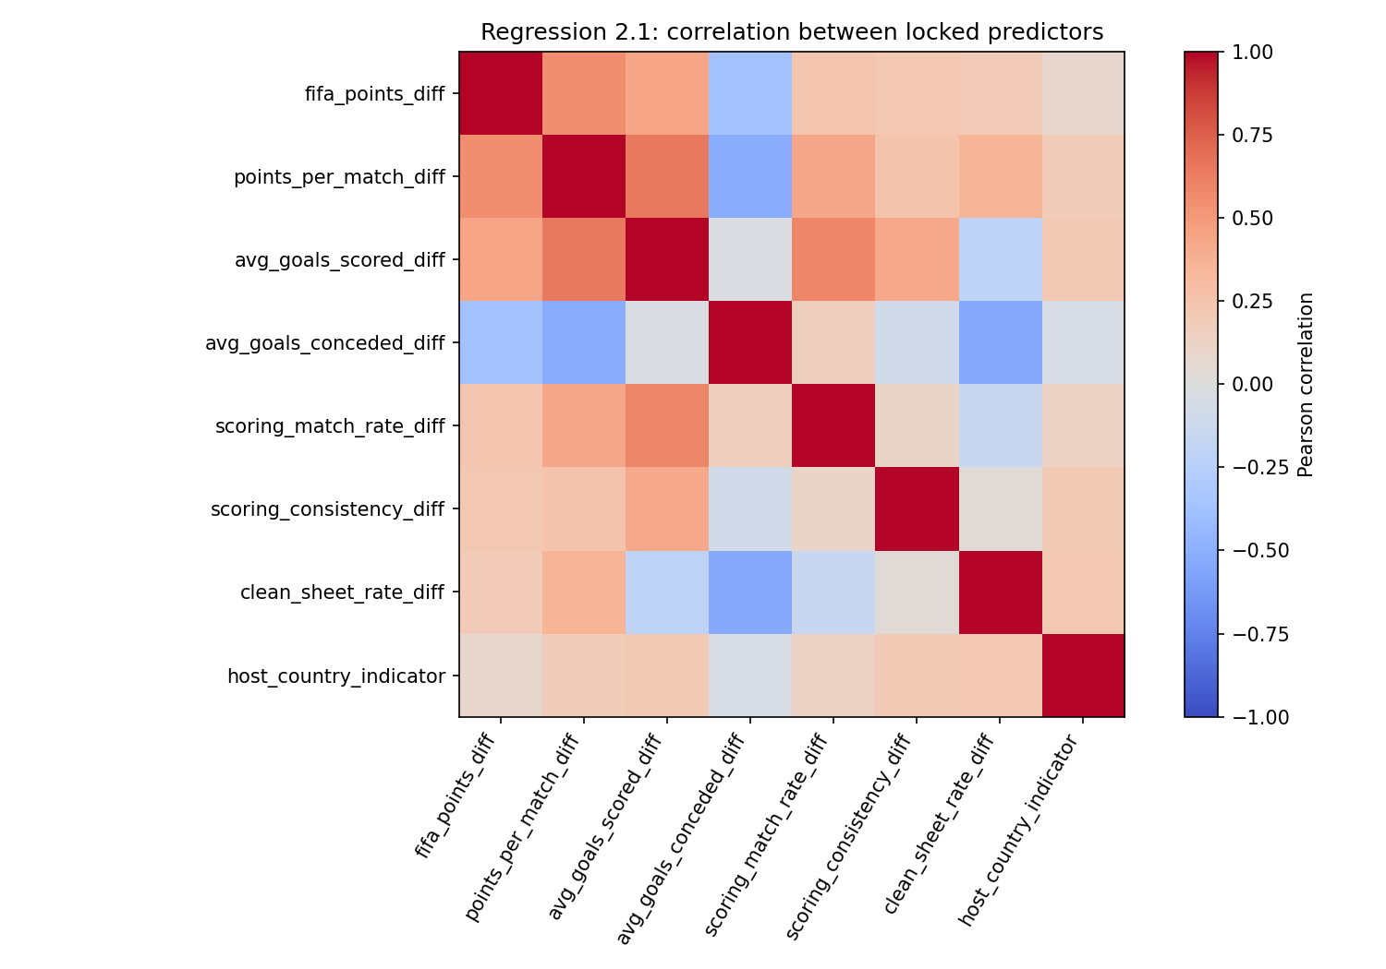
Figure A1. Predictor correlation heatmap
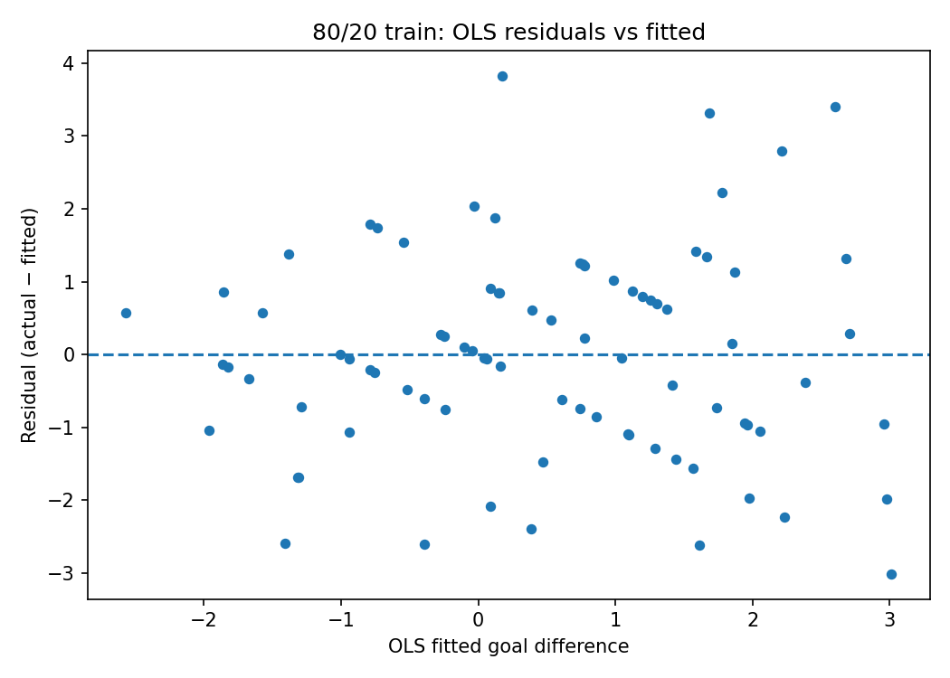
Figure A2. Residuals versus fitted values (80/20 training)
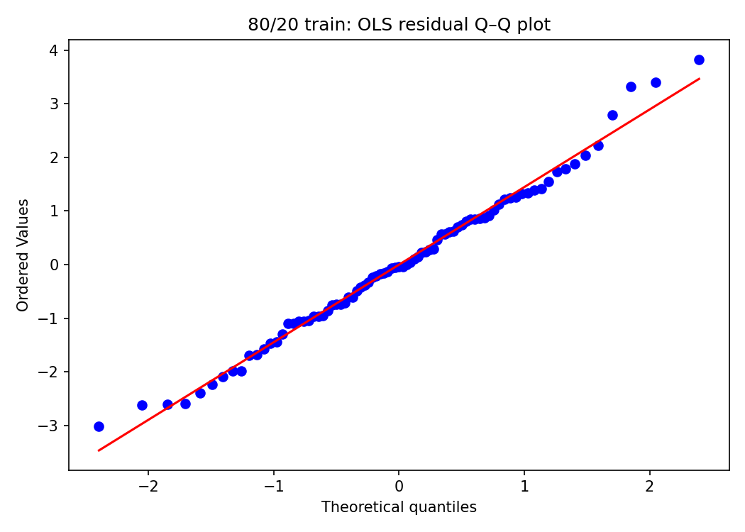
Figure A3. OLS residual Q–Q plot (80/20 training)
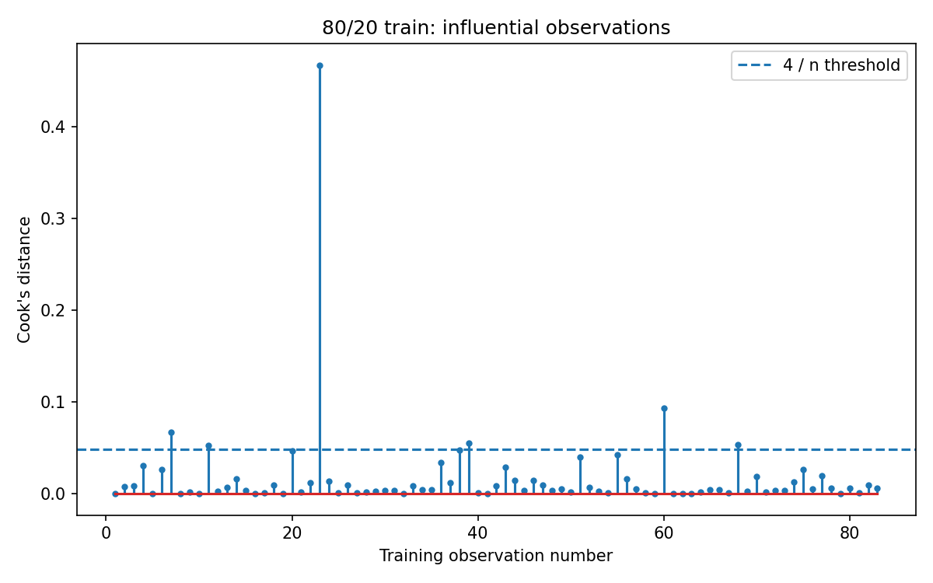
Figure A4. Cook’s distance (80/20 training)

