HIT140 | Regression 2.1 — Reviewed Model Evaluation
Contributor: Bibek • Audit date: 13 October 2026 • Status: Technically validated; rubric and upstream provenance checks remain open
This revision preserves 104 match observations, goal_difference = home_goals − away_goals, the eight locked pre-match input columns, the Saurab-approved corrected CSV, seed 42, 70/30 and 80/20 holdouts, and 200 repeated splits. Original artefacts remain available for audit.

1. Data integrity, feature logic and provenance
The corrected CSV has 104 unique match identifiers, eight non-missing finite numeric predictors and no missing target values. For all 104 rows, the outcome equals home_goals minus away_goals and the FIFA points difference equals home ranking points minus away ranking points (verified against the supplied ranking reference). The signed host indicator occurs 11 times as +1, four times as −1 and 89 times as zero.
The earlier correction script was independently executed and reproduced the supplied corrected CSV exactly. It removes 18 World Cup team-records embedded in the pre-tournament data, correcting 52 feature cells in nine matches without altering targets or unaffected rows. However, the remaining six time-varying form differences cannot be independently reconstructed for all match dates without the original full feature-building pipeline and dated upstream inputs. This limitation should be disclosed, notwithstanding team approval of the correction.

2. Leakage-safe model development
Identical seed-42 match-level random holdouts were used for every algorithm: 70/30 (72 train, 32 test) and 80/20 (83 train, 21 test). Each hyperparameter search is fitted solely to the outer training rows, using shuffled five-fold KFold cross-validation. For Ridge and Lasso, a StandardScaler and estimator are enclosed together inside a Pipeline passed to GridSearchCV. Scaling is therefore learned afresh within each inner training fold and refitted on the full outer training set only after CV selection. No target transformation or predictor replacement was made.
The comparisons include a dummy mean-only baseline, multiple linear regression, Ridge, Lasso, Random Forest and Gradient Boosting. All four tunable families use explicitly restricted candidate grids to limit variance in this small dataset. Hyperparameter choices and five-fold CV scores are included in model details and tuning output; the search is not guaranteed to locate a globally optimal model.
R², RMSE (goals), MAE (goals) and NRMSE were computed on train and held-out test subsets. NRMSE equals RMSE divided by max minus min of the observed target in the partition being scored. It is stored as a fraction; e.g. 0.18 is 18%. Test-set range can change between repeated splits, so RMSE and MAE should also be used in comparisons.

3. Fixed-seed results: six families under identical splits
70/30 holdout
Model | R² train | R² test | RMSE test | NRMSE test | MAE test
Mean baseline | 0.000 | -0.003 | 2.182 | 21.82% | 1.653
OLS (eight predictors) | 0.527 | 0.255 | 1.880 | 18.80% | 1.429
Ridge (CV-tuned) | 0.513 | 0.295 | 1.829 | 18.29% | 1.379
Lasso (CV-tuned) | 0.499 | 0.307 | 1.814 | 18.14% | 1.360
Random Forest (CV-tuned) | 0.655 | 0.291 | 1.834 | 18.34% | 1.410
Gradient Boosting (CV-tuned) | 0.609 | 0.244 | 1.894 | 18.94% | 1.421

80/20 holdout
Model | R² train | R² test | RMSE test | NRMSE test | MAE test
Mean baseline | 0.000 | -0.001 | 2.239 | 22.39% | 1.690
OLS (eight predictors) | 0.472 | 0.344 | 1.813 | 18.13% | 1.305
Ridge (CV-tuned) | 0.464 | 0.345 | 1.811 | 18.11% | 1.315
Lasso (CV-tuned) | 0.456 | 0.340 | 1.817 | 18.17% | 1.320
Random Forest (CV-tuned) | 0.624 | 0.354 | 1.798 | 17.98% | 1.420
Gradient Boosting (CV-tuned) | 0.557 | 0.336 | 1.824 | 18.24% | 1.352

Do not infer superiority from tiny differences between models on a single test split. Lasso and Ridge use regularisation to reduce unstable coefficient estimates; trees offer nonlinearities but can fit 104 match observations too closely.

4. Stability: 200 training-only repeated splits
Seeds 42–241 define 200 repeated random holdouts at each ratio. Every algorithm uses the same row assignments within a given repeat, with inner CV refitted on that repeat’s training rows. Mean and sample standard deviation (SD) are descriptive across highly overlapping re-samples; they are NOT independent confidence intervals.
70/30 repeated test results
Model | Mean test R² ± SD | Mean test NRMSE ± SD | Mean test MAE
Mean baseline | -0.041 ± 0.064 | 23.34% ± 2.21 pp | 1.570
OLS (eight predictors) | 0.245 ± 0.224 | 19.67% ± 3.07 pp | 1.296
Ridge (CV-tuned) | 0.277 ± 0.176 | 19.31% ± 2.64 pp | 1.272
Lasso (CV-tuned) | 0.318 ± 0.179 | 18.73% ± 2.64 pp | 1.239
Random Forest (CV-tuned) | 0.296 ± 0.149 | 19.08% ± 2.33 pp | 1.279
Gradient Boosting (CV-tuned) | 0.285 ± 0.147 | 19.23% ± 2.29 pp | 1.287

80/20 repeated test results
Model | Mean test R² ± SD | Mean test NRMSE ± SD | Mean test MAE
Mean baseline | -0.067 ± 0.096 | 25.98% ± 3.05 pp | 1.586
OLS (eight predictors) | 0.240 ± 0.280 | 21.54% ± 3.85 pp | 1.283
Ridge (CV-tuned) | 0.267 ± 0.227 | 21.26% ± 3.35 pp | 1.264
Lasso (CV-tuned) | 0.313 ± 0.224 | 20.57% ± 3.34 pp | 1.231
Random Forest (CV-tuned) | 0.271 ± 0.200 | 21.23% ± 3.02 pp | 1.285
Gradient Boosting (CV-tuned) | 0.273 ± 0.177 | 21.25% ± 2.79 pp | 1.288

The repeated results give a more meaningful view of performance than the single seed-42 sample. Because team identities recur across matches, random splits still may overstate extrapolation to unfamiliar teams or tournament phases.

5. EDA and predictor rationale
All eight features are retained: FIFA strength, points per match, goals scored/conceded, scoring-match rate, scoring variability, clean-sheet rate and signed host effect. Positive FIFA points and points-per-match differences generally favour the home/Team A side; higher goals-conceded difference indicates vulnerability. These are associations, not causal effects.
To avoid target leakage through feature selection, predictor–target exploratory correlations and VIF are now calculated on the seed-42 80/20 TRAINING rows only (n=83). Strongest training Pearson associations: fifa_points_difference: +0.669, points_per_match_difference: +0.356, avg_goals_conceded_difference: -0.339, avg_goals_scored_difference: +0.273.
The largest training VIF values are avg_goals_scored_difference: 6.32, points_per_match_difference: 5.48. Multicollinearity is material; Ridge reduces sensitivity without deleting the approved predictors. No feature was selected or removed based on exploratory correlations.
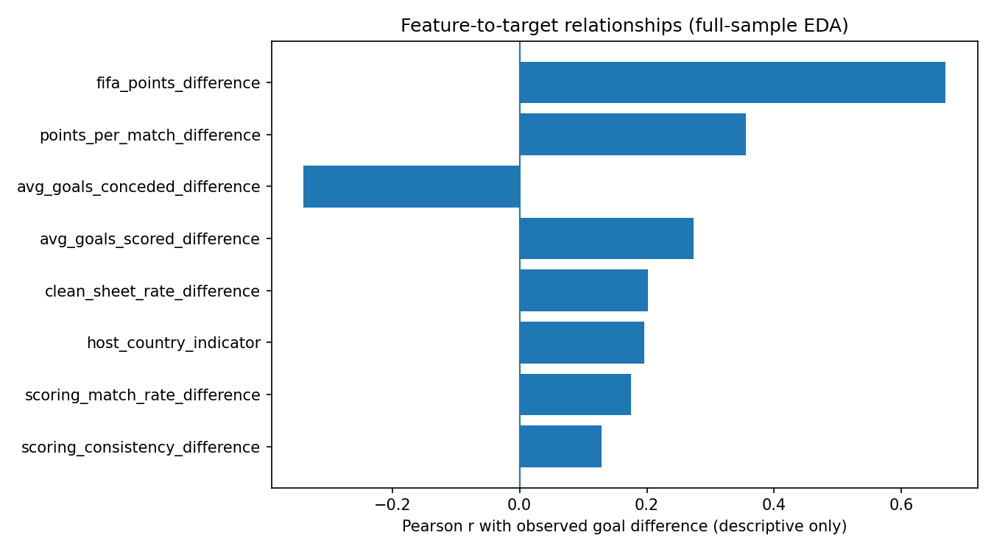
Figure 1. Feature–target correlations on the seed-42 80/20 training data.

6. Model diagnostics and interpretation
For the OLS 80/20 training fit, Breusch–Pagan LM p=0.195 and F p=0.198; there is insufficient evidence to reject constant variance at 5%, not proof of homoscedasticity. The Q–Q plot is broadly linear with departures at the tails. The residual-vs-fitted plot shows several sizeable errors without a compelling funnel pattern. The exploratory Shapiro p=0.677 also does not establish exact normality.
Six of the 83 training observations exceed Cook’s conventional 4/n screening threshold (0.048); maximum Cook’s distance is 0.467. These are influence alerts requiring row-level review, not instructions to discard matches. OLS raw intercept=+0.120 goals (p=0.493); signed host coefficient=+0.649 (p=0.218), which is not statistically distinguishable from zero in this sample.
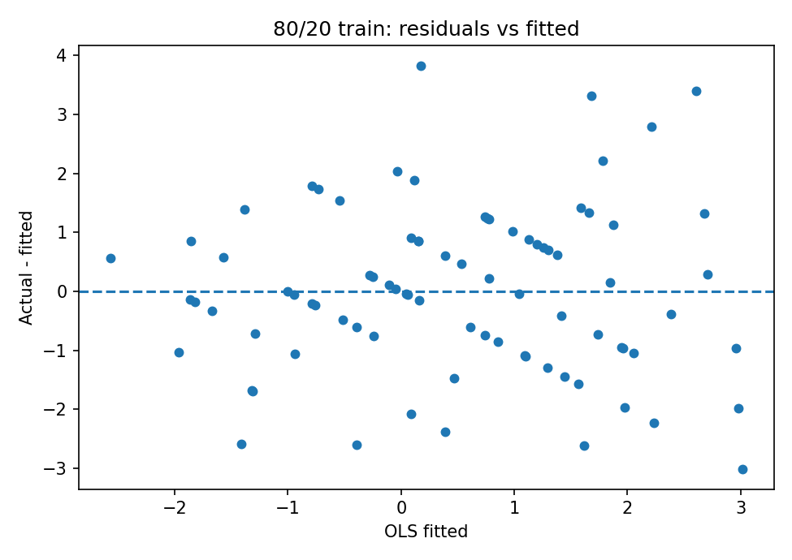
Figure 2. Training OLS residuals versus fitted goal differences.
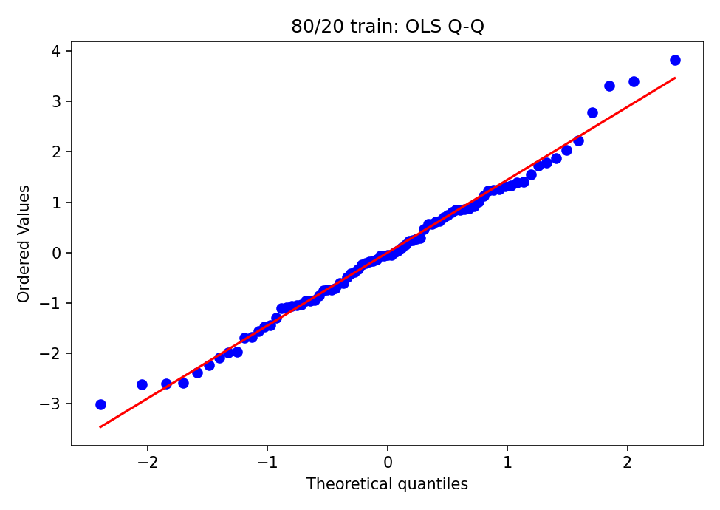
Figure 3. OLS training residual normal Q–Q plot.
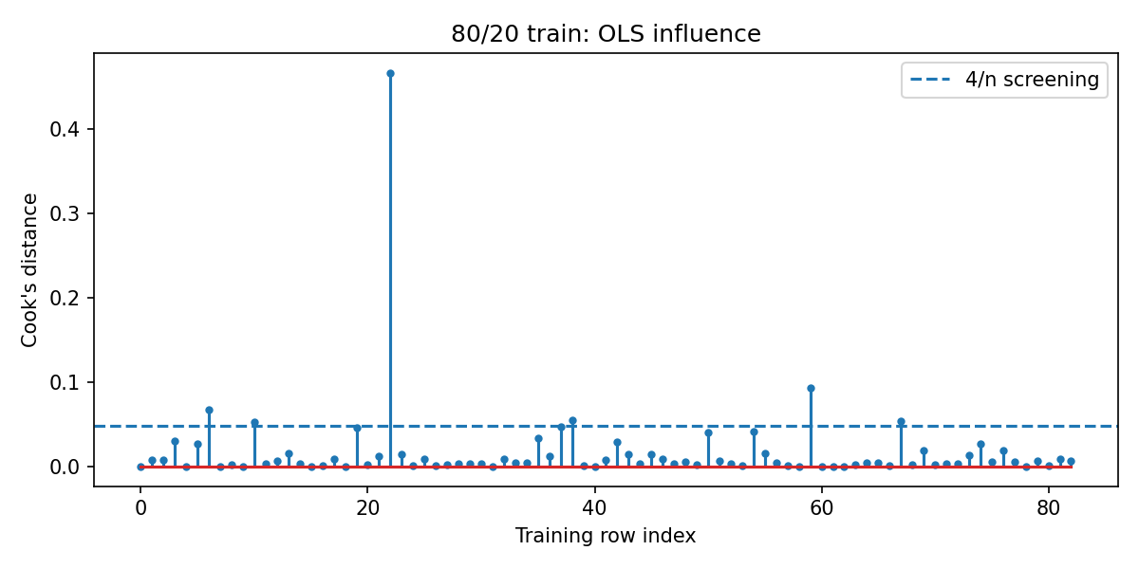
Figure 4. Influence screening (Cook’s distance; 4/n line).

7. Predictive interpretation and recommendation
Lasso has the strongest average held-out R² and smallest average test NRMSE across the two 200-repeat comparisons, though the mean differences from Ridge are modest relative to split-to-split variability. On the seed-42 heldouts, the leading family varies by ratio, highlighting sampling noise. Both Lasso and Ridge substantially outperform the dummy baseline.
Important qualification: although Lasso receives all eight input columns, its selected coefficients are non-zero for only 6/8 inputs on 70/30 and 3/8 on 80/20. If the group’s “eight locked predictors” rule requires all eight to remain active, Lasso would constitute implicit predictor elimination and should NOT replace Ridge without approval. Under that strict interpretation, Ridge is the preferred interpretable, regularised primary model; Lasso is the better-performing but conditional challenger.
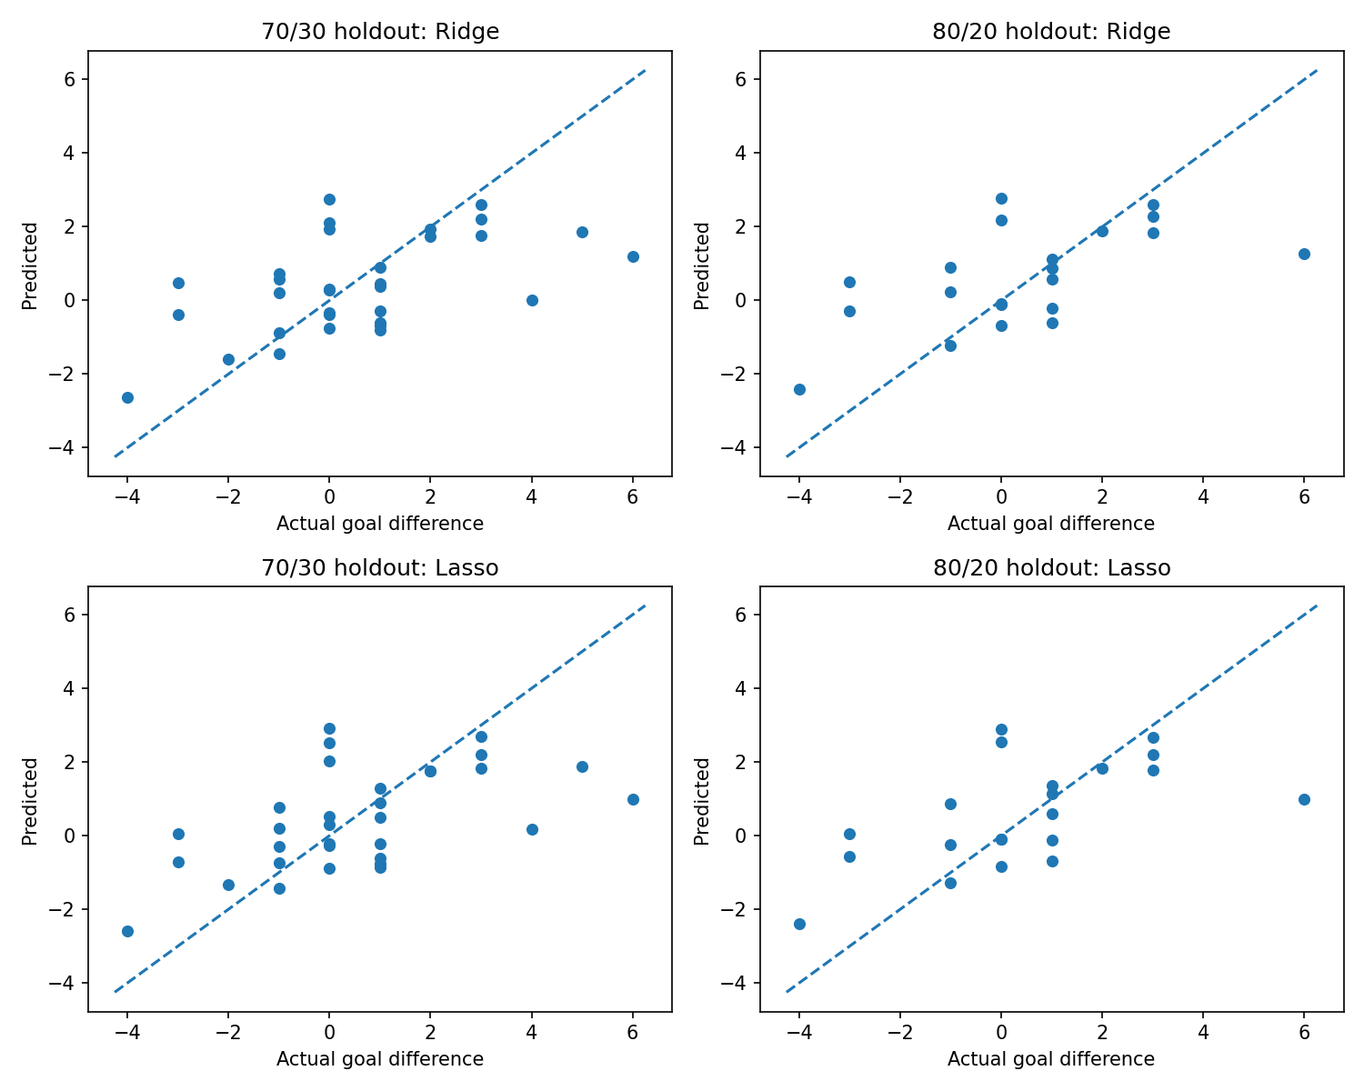
Figure 5. Observed versus predicted test outcomes for Ridge and Lasso.
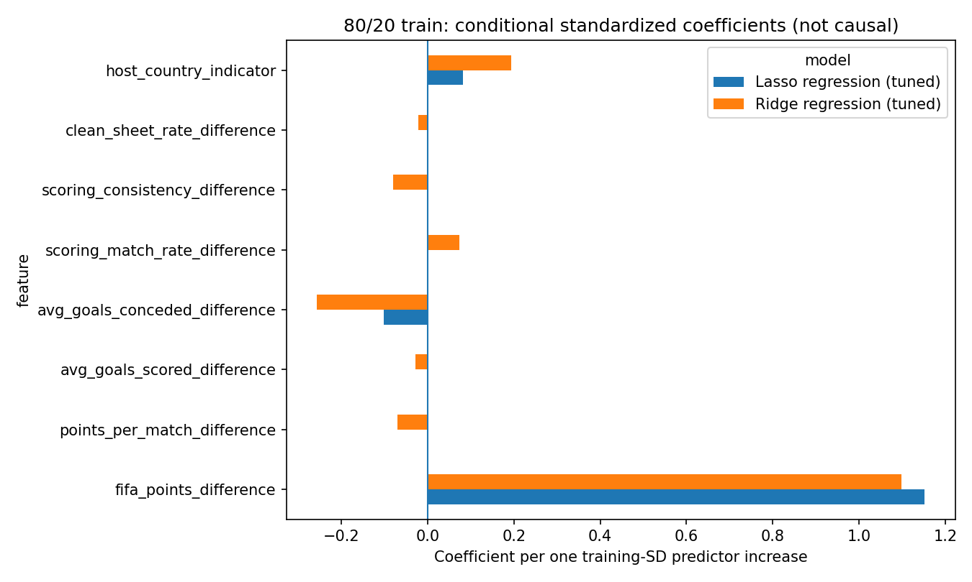
Figure 6. Standardised coefficients; Lasso zero coefficients are visible.

8. Remaining verification and defensible scope
The actual 2026 HIT140 Assessment 3 HD rubric and lecturer-specific marking notes were not supplied, so official grading readiness cannot be certified. Request the exact document before claims of HD compliance or specific marks. The other six pre-match form differences still require the original dated feature-generation script; league-match coverage, data provenance, date handling and outcome information unavailable before kickoff require team-level verification.
The dataset is small (104 observations, test samples of 32 and 21); both holdout and repeated test results remain variable. Repeated splits share matches and are not independent replications. Teams appear in several fixtures, and the models are not validated prospectively or on a new tournament. A date-based/leave-team-out sensitivity study would be valuable if approved, but it is not substituted for the required match-level 70/30 and 80/20 analyses.
The revised code and output CSVs are mutually consistent and successfully executed on this dataset. Code should be placed alongside—not silently over—earlier approved GitHub files until teammates review the methods and the Lasso predictor-lock interpretation.

