**Assignment Cover Sheet**

|  |  |
| --- | --- |
| Unit Code: **BIT103** | Unit Name: **Web Application Development** |
| Assignment Title: **Group Assignment** | |

|  |  |  |  |  |
| --- | --- | --- | --- | --- |
| **Group Assignment:** | | | |  |
| Group name (with name of your application): | |  | |
| Family Name: | Given Name: | | Student ID: |
|  |  | |  |
|  |  | |  |  |
|  |  | |  |  |
|  |  | |  |  |

I declare that this work:

* upholds the principles of academic integrity, as defined in the SIHE’s *Academic and Professional Integrity Policy*;
* is my/our own work, and does not contain any contribution by other people;
* is individual work, except where collaboration (for example group work) has been authorized in writing by the lecturer in the unit outline and/or the Learning Management System;
* is original and produced for the purposes of this assessment task and has not been submitted for assessment in any other context, except where authorized in writing by the lecturer;
* gives appropriate acknowledgment of the ideas, scholarship, and intellectual property of others insofar as these have been used;
* in no part involves copying, cheating, collusion, fabrication, plagiarism, or recycling.

Typing your name below acknowledges acceptance of this declaration:  
Name: _______________________________________ Date: ___________________

**How to submit assignments:**

* All assignments must be submitted electronically into the link for that assessment in the unit website.
* Email submissions or hand-in of paper copies are not permitted.
* To submit your assignment, click on the relevant assignment submission link in the unit website.
* Before final submission, please confirm that you have attached the correct assignment.

A copy of this Assignment Cover Sheet is available from Student Forms.

For more on assessment help and academic integrity see the student support resources available via the Learning Management System.

|  |  |  |  |
| --- | --- | --- | --- |
| **Group Assignment Details** | | | |
| This is a group assignment due Saturday 7 October 2023 @ 10:00pm. | | | |
| You will be working in a team of a maximum four (4) students. | | | |
|  | | | |
| **The problem specification: Web Application** | | | |
| **#** | **Question** | **Description** | **Marks** |
| 1. | Choose a shop type and give it a name | * ~~This is an online shop you create – not an existing brand.~~ * ~~Your shop is to supply either goods or services.~~ * ~~The shop can provide books, gaming, or anything you enjoy.~~ | 5 |
| 2. | A home page | * ~~The home page can be a .html or a .php file.~~ * Links to:   + ~~displaying items~~   + ~~ordering an item~~   + ~~list of customers~~ | 10 |
| 3. | A database | * ~~Name and create a database.~~ * ~~It must have at least 4 tables~~. * Provide the output script file to export so I can import it. * ~~If an item is ordered it adds an entry into the customer’s order and removes the quantity from the stock table.~~ | 25 |
| 4. | .php files | * To display the items, and ordering and removing the items | 20 |
| 5. | Style sheet | * All your html / .php files must import the same style sheet file | 20 |
| 6. | JavaScript | * Include JavaScript to provide a calculation to the user | 10 |
| 7. | File structure | * Ensure your Web Application is named under *htdocs* * Under that there are folders for scripts and images | 10 |
|  | **Total** | | 100 |

|  |
| --- |
| **Submit the following:** |
| In your application, create a folder named students and place the files for:   1. The SQL script of the output of your database, and 2. This word document with screenshots of your web pages.   Create and submit a Zip file containing your full directory structure which includes the items listed above.  **Note**. The .zip file must be able to be opened by me. Ensure you are reading your emails. If I am unable to open, then I will need to contact someone in your group ASAP. |

# Screenshots of your application – each web page you have created

Index.php (Homepage)

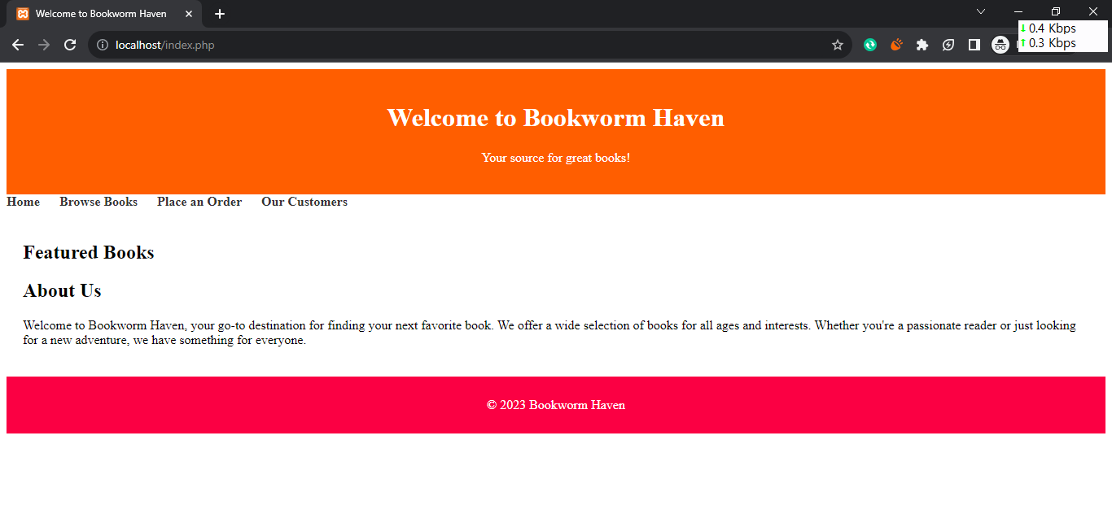

Place Order (items.php)

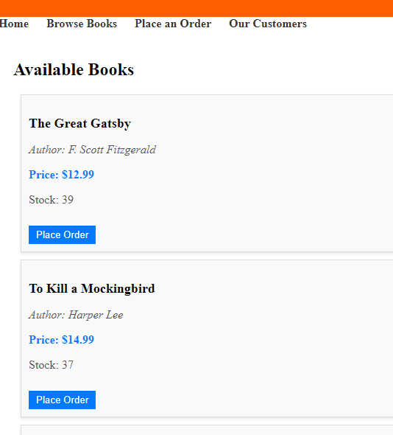

Order.php

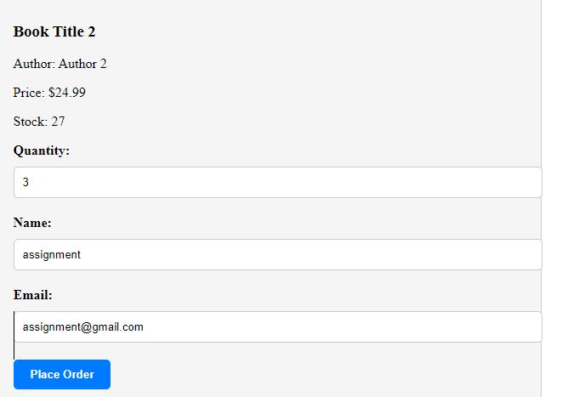

Order_process.php

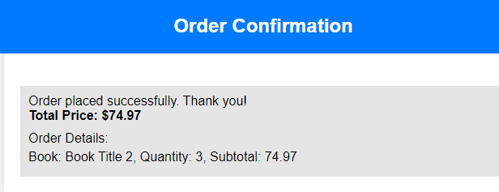

‘

Updated Stocks

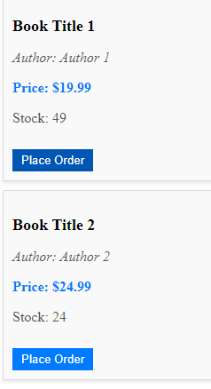

Customers.php

