INDIAN INSTITUTE OF MANAGEMENT RANCHI
Master’s in Business Administration (MBA)
Operations & Supply Chain Management, Working with AI (WAI) Individual Project

Broad Theme:
Supply Chain Resilience and AI-Enabled Operations under Industrial Policy Shocks
Title of the Project:
AI for Resilient Solar Supply Chains in India: Demand Forecasting, Supplier-Risk Clustering, and Constrained Assembly Scheduling under Upstream Import Dependence

Research Question:
How can an integrated AI framework combining seasonal demand forecasting, supplier-risk clustering and constrained linear programming help Indian solar module assemblers maintain operational continuity, protect margins and meet ALMM List-II compliance under the upstream cell deficit created by customs duty, anti-dumping duties and the domestic-cell mandate?
Submitted by
Saurav Verma
M55D-26

Course: Operations & Supply Chain Management
Faculty: Prof. Krishna Kumar Dadsena

Abstract
India’s solar module assemblers (about 193 GW) depend on imported cells because domestic cell capacity is only about 31 GW, and the 25% customs duty, 0–30% anti-dumping duties and the ALMM List-II mandate (1 June 2026) have squeezed supply and margins. This report applies core OSCM tools (forecasting with MAPE and tracking signals, aggregate planning by linear programming, safety stock under uncertainty, and dual sourcing from Chopra and Meindl and from Heizer and Render) through a three-layer AI pipeline: damped Holt-Winters forecasting, K-Means supplier-risk segmentation and a SciPy HiGHS scheduling model. It recommends a dual-track sourcing architecture, dynamic safety stocks and domestic offtake partnerships, with a three-year benefit-cost ratio of 2.07x for a 500 MW assembler.
Data disclosure: regulatory benchmarks, capacities and duties are drawn from public sources through October 2026 (MNRE, DGTR, CEA, Mercom India, SMM, TaiyangNews). The monthly demand series, supplier profiles and plant financials are calibrated, simulated inputs anchored to those data points; a live deployment would connect to ERP, customs EDI and MES feeds. Role adopted: AI-enabled operations and supply chain strategy consultant.

1. Executive Summary
India’s module assembly capacity under ALMM List-I reached about 193 GW by mid-2026, but domestic cell capacity is only about 31 GW and ingot/wafer capacity under 2 GW (Figure 1a). Assemblers therefore depend on imported cells, now squeezed by a 25% Basic Customs Duty, anti-dumping duties of 0–30% (DGTR, September 2025) and the ALMM List-II mandate for domestic cells from 1 June 2026. Certified domestic cells cost about ₹13/W against ₹5/W landed import parity, creating margin compression and delivery-default risk on EPC contracts.
This project builds an integrated AI framework: (i) damped Holt-Winters demand forecasting, projecting 58.9 GW (FY27) and 60.6 GW (FY28) at 5.1% holdout MAPE; (ii) K-Means segmentation of 24 suppliers, isolating 6 high-vulnerability vendors; and (iii) a SciPy HiGHS linear program that lifts ALMM order fulfilment from 76.5% to 100% and 12-week contribution margin by 4.4% (₹22.0 Crore) with no overtime. The FY27 domestic cell deficit is 28.2 GW, so a dual-track sourcing model is unavoidable. A three-year appraisal for a 500 MW assembler shows ₹43.0 Crore outlay against ₹89.0 Crore benefit (BCR 2.07x).
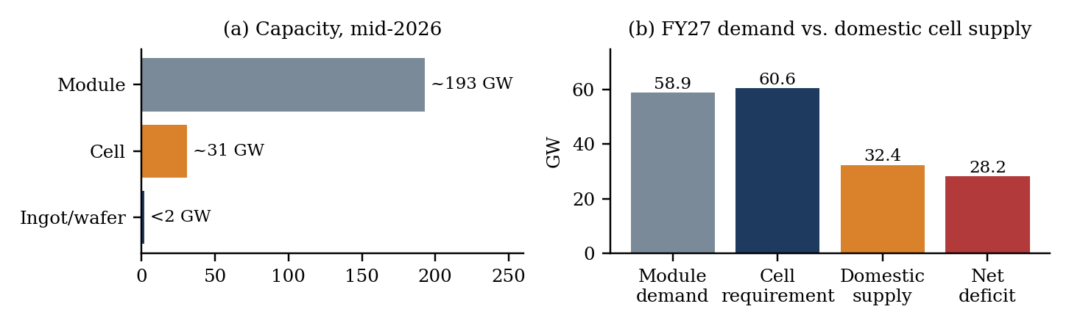
Figure 1: (a) Upstream–downstream capacity asymmetry; (b) FY27 module demand, cell requirement, domestic supply and net deficit
Table 1: Executive KPI summary
KPI | Value | Basis
Forecast module demand | 58.9 GW (FY27); 60.6 GW (FY28) | Damped Holt-Winters; holdout MAPE 5.1%
FY27 domestic cell deficit | 28.2 GW | Base case, 80% utilisation
High-vulnerability suppliers | 6 of 24 | K-Means, k = 3
Margin lift from LP scheduling | +4.4% (₹22.0 Crore) | 12-week horizon, HiGHS solver
Benefit-cost ratio (500 MW plant) | 2.07x | ₹89.0 Cr benefit / ₹43.0 Cr cost

2. Problem Identification

2.1 Background and core problem
Background. India targets 500 GW of non-fossil capacity by 2030, with over 300 GW from solar. MNRE’s ALMM regime and PLI Tranches I–II lifted module assembly from 38 GW (March 2024) to about 193 GW (April 2026), but upstream cell, ingot and wafer capacity lagged, leaving assembly an import-dependent packaging industry. Core problem. Regulatory deadlines have outpaced upstream capital deployment: domestic cells are insufficient and costly, while foreign cells face the BCD and anti-dumping duties. MRP and FIFO scheduling then cause line starvation, margin erosion and contract defaults.

2.2 Empirical baseline and regulatory chronology
Table 2: Empirical baseline and regulatory anchors
Dimension | Value / status | Source
Module capacity (List-I) | 193 GW (mid-2026) | MNRE; TaiyangNews (2026)
Cell capacity (List-II) | ~31 GW operational | Mercom India (2025); Ananta IAS (2026)
Ingot / wafer capacity | < 2 GW (List-III: June 2028) | MNRE memorandum (March 2026)
Cell price | Domestic ~₹13/W; CIF ~₹5/W | Industry benchmarking
Anti-dumping duties | 0% to 30% by exporter | DGTR findings (Sep 2025)
Utility pipeline | 186 GW (FY25–FY27) | Mercom India (2025)

Table 3: Regulatory chronology
Date | Event | Effect
2022 | Basic Customs Duty enacted | 25% on cells; 40% on modules
Sep 2025 | DGTR anti-dumping findings | Exporter-specific duties of 0% to 30%
1 Jun 2026 | ALMM List-II enforced | Certified domestic cells mandatory in covered installations
Jun 2028 | ALMM List-III (ingot/wafer) scheduled | Extends localisation upstream

2.3 Evidence and relevance of AI
- Supply asymmetry: 193 GW of module capacity against 31 GW of cells is a 162 GW upstream gap.
- Import dependence: Chinese cell exports to India reached 49 GW in January–November 2025 (up 47%) while module imports fell 40% (pv magazine India, 2025).
- Price gap and pipeline: domestic cells cost ₹8/W more than landed imports, and Mercom tracks a 186 GW utility pipeline (FY25–FY27) carrying liquidated damages.
- Why AI: forecasting captures seasonality and deadline-driven rushes that moving averages miss; clustering scores vendor risk across several dimensions rather than origin alone; linear programming allocates scarce domestic cells to high-margin ALMM orders and imported cells to export lines.

2.4 Stakeholders, scope and significance
- Module assemblers: margin erosion, line starvation and penalties on fixed-price EPC contracts.
- Domestic cell makers: scale-up, yield curves and price competitiveness under tariff protection.
- EPC developers and utilities: delivery delays and tender-default exposure. International suppliers: shifting tariffs and market access. Regulators (MNRE, DGTR): balancing localisation against the 500 GW target.
- Scope: Indian module assemblers; domestic and imported crystalline-silicon cells; ALMM List-I/II effects; forecasting to FY28; supplier segmentation; line scheduling. Excluded: thin film, balance-of-system, commissioning, off-grid.
- Significance: operational continuity, working-capital efficiency (safety stock sized on variance, not rules of thumb) and tender compliance.

2.5 Problem statement
Indian module assemblers face supply disruption, a ₹13/W vs. ₹5/W input premium and default risk after ALMM List-II and anti-dumping duties, against a 162 GW cell capacity gap. This study applies seasonal forecasting, supplier-risk clustering and constrained linear programming to protect continuity, margin and compliance.

3. Literature Review
Christopher and Peck (2004) define resilience as returning to a planned state after a shock; with cell lines taking 18–36 months to build, visibility and re-engineering matter more than agility. Chopra and Sodhi (2004) show that buffers, spare capacity and multi-sourcing each carry costs that must match the risk, and Sheffi and Rice (2005) frame the choice as redundancy (safety stock) versus flexibility (reconfigurable production). Pettit, Croxton and Fiksel (2019) supply the vulnerability–capability lens for scoring, and Ivanov and Dolgui (2020) show how disruptions ripple through intertwined networks, which is how ALMM List-II propagates. Min (2010) catalogues AI uses in supply chains; Baryannis et al. (2019) find that AI predicts risk well but is rarely linked to prescriptive optimisation; Ivanov and Dolgui (2021) propose digital supply chain twins to bridge this. Taylor and Letham (2018) support seasonal forecasting at scale, Pedregosa et al. (2011) the scikit-learn clustering pipeline, and the IEA (2022) and SMM (2025) document upstream concentration and tariff dynamics.
Table 4: Literature synthesis matrix
# | Author(s), year | Focus | Application to this study
1 | Christopher & Peck (2004) | Supply chain resilience | Dashboard visibility; dual-track cell allocation
2 | Chopra & Sodhi (2004) | Risk mitigation trade-offs | Cost-benefit of dynamic buffers vs. duty exposure
3 | Sheffi & Rice (2005) | Redundancy vs. flexibility | Balance of safety stock and scheduling flexibility
4 | Pettit, Croxton & Fiksel (2019) | Resilience capabilities, vulnerabilities | Risk heatmap and vulnerability scoring
5 | Ivanov & Dolgui (2020) | Intertwined supply networks | Upstream shocks propagating to assembly lines
6 | Ivanov & Dolgui (2021) | Digital supply chain twins | Linking predictive models to shop-floor action
7 | Min (2010) | AI in SCM taxonomy | Selection of forecasting and clustering tools
8 | Baryannis et al. (2019) | AI in supply chain risk | Linking prediction with prescriptive optimisation
9 | Taylor & Letham (2018) | Forecasting at scale | Handling policy-driven demand rushes
10 | Pedregosa et al. (2011) | Machine learning in Python | StandardScaler, K-Means, PCA
11 | International Energy Agency (2022) | Global solar PV supply chains | Upstream manufacturing concentration
12 | SMM (2025) | Anti-dumping trade policy | Tariff schedules and export shifts

In the Indian solar context these frameworks map directly to the problem. Agility is limited because cell fabrication needs 18–36 months of capital deployment; resilience must therefore be built through visibility (dashboards, supplier scoring) and re-engineering (dual sourcing, constrained scheduling). Holding certified domestic cells at ₹13/W ties up working capital, while lean stock risks downtime during regulatory audits, which is the redundancy-versus-flexibility trade-off the optimiser resolves.
Gaps. Resilience research focuses on disasters rather than local-content rules; AI risk work treats forecasting, supplier scoring and scheduling separately; and midstream assemblers in emerging markets are under-studied. This study joins the three layers into one policy-to-shop-floor pipeline.

4. AI Tools and Methodology
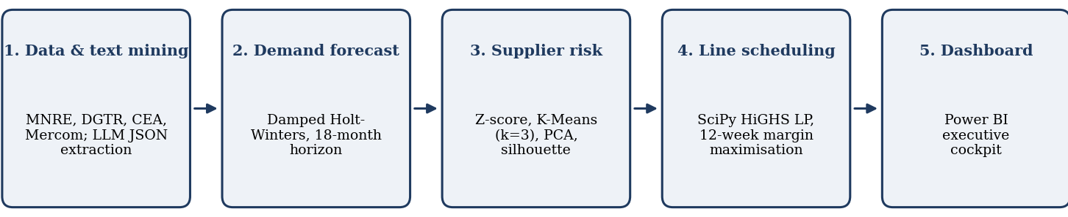
Figure 2: Methodology flowchart
Analytical approach. Stage 1 converts unstructured policy text into structured parameters. Stage 2 forecasts demand and compares it with domestic supply. Stage 3 scores supplier risk on lead-time variability, geopolitical exposure, price volatility, single-source dependence and OTIF gap. Stage 4 feeds forecasts and risk tiers into a finite-capacity LP that allocates scarce cells. Stage 5 presents results to planners. This follows the digital-twin logic of Ivanov and Dolgui (2021): predictive outputs drive a prescriptive model before any capital is committed. Stages 2–4 are the three analytical layers (forecasting, supplier clustering, scheduling) named in the Abstract.
Tools. Claude and ChatGPT extract tariff dates and rates from DGTR/MNRE notifications using a Role-Task-Context-Format prompt (extract only stated facts, null for unstated, raw JSON, temperature 0). statsmodels produces the forecast, scikit-learn the standardisation, K-Means and PCA, SciPy HiGHS the optimisation, and Power BI and Matplotlib the visuals. Coding workflow. One seeded script (solar_resilience_pipeline.py) runs forecasting, clustering, optimisation and figure generation in sequence, so every number in Section 6 can be regenerated; its console output is reproduced in Annexure B. Prompts are in Annexure A.
SYSTEM: You are a supply chain research specialist. Return only a validated JSON object.
RULES : (1) extract only facts stated in the text; (2) never infer dates or tariffs; (3) write null if unstated; (4) raw JSON only.
SCHEMA: {regulatory_event, gazette_or_order_number, issuing_authority, effective_enforcement_date (YYYY-MM-DD),
affected_product_category (Module|Cell|Ingot|Wafer), policy_mechanism (ALMM_List_I|ALMM_List_II|BCD|Anti_Dumping_Duty),
duty_or_tariff_rates [{exporter_or_origin, rate_percentage}], exemption_criteria [..]}
Figure 2a: Role-Task-Context-Format extraction prompt (summary)
Scheduling model. Over t = 1…12 weeks and lines i = 1…3 (24, 18, 12 MW/week), X(i,j,t) is MW produced of product j (1 = ALMM module using domestic cells, 2 = export module using imported cells):
max Z = Σₜ Σᵢ [ M(1,t)·X(i,1,t) + M(2,t)·X(i,2,t) ]
subject to (1) line capacity X(i,1,t) + X(i,2,t) ≤ C(i,t), with C(2,t) = 10 MW in weeks 5–7 (maintenance); (2) cumulative domestic cell availability γ·Σ X(i,1,τ) ≤ S(dom,0) + Σ R(dom,τ), γ = 1.03 yield loss; (3) the same for imported cells; (4) cumulative order-book bounds Σ X(i,j,τ) ≤ D(j,t); and (5) X ≥ 0.

5. Data Collection and Preparation
Sources are MNRE, DGTR, CEA and DGCIS portals plus Mercom, SMM and TaiyangNews reports. The 54-month demand history, change-over and scrap logs, and supplier delivery records are synthetic, calibrated to published distributions, and disclosed as such. Cleaning followed Table 5. Limitations: confidential factory pricing and lead times, and 60–90 day import-data lags, mean outputs are directional decision support, not transactional values. The demand series (October 2021–March 2026), the 24 supplier profiles and the scheduling inputs are generated by seeded code (Annexure B) and rescaled to the statistics in Table 5, so every run reproduces the same results.
Table 5: Data preparation and supplier panel statistics (N = 24)
Preparation step | Treatment | Attribute | Mean | SD | Min | Max
Time alignment | Indian fiscal months (April = 1) | Lead-time CV | 0.28 | 0.11 | 0.12 | 0.58
Gaps ≤ 3 months | Cubic Hermite interpolation | Geopolitical risk (0–1) | 0.54 | 0.29 | 0.10 | 0.95
Gaps > 3 months | Flagged; no mean imputation | Price volatility | 18.4% | 7.2% | 6.5% | 34.0%
Missing supplier data | Peer-group median imputation | Single-source dependence | 24.6% | 14.8% | 4.0% | 62.0%
Demand outliers | Kept if pre-deadline rush (3-sigma) | OTIF delivery gap | 8.7% | 5.4% | 1.2% | 22.1%
Scaling | Z-score, z = (x − μ)/σ

6. Analysis and Insights

6.1 Demand projection and the domestic supply gap
The model is Winters’ damped multiplicative smoothing (φ = 0.92, m = 12; Chopra & Meindl, Ch. 7), fitted to 54 months of history. Holdout MAPE is 5.1%, against 6.6% for undamped Holt-Winters and 11.0% for SARIMA, and the tracking signal stays within ±3.5 (range −1.8 to +3.0). Module demand reaches 58.9 GW (FY27) and 60.6 GW (FY28) as the deadline-driven rush matures; with 3% shrinkage, cell requirements are 60.6 GW and 62.4 GW, peaking in Q4 (January–March). In the base case (capacity ramping from 31 to 50 GW, averaging 40.5 GW, at 80% utilisation, giving 32.4 GW of supply) the FY27 deficit is 28.2 GW (Figure 1b); even a 31 → 65 GW ramp at 90% utilisation leaves 17.4 GW (Table 6). Domestic supply covers only 53% of FY27 requirements.
Table 6: Sensitivity of FY27 net domestic cell deficit (GW; average FY27 capacity 35.5 / 40.5 / 48 GW)
Capacity ramp | Utilisation 70% | Utilisation 80% | Utilisation 90%
Slow (31 → 40 GW) | 35.8 | 32.2 | 28.7
Base (31 → 50 GW) | 32.3 | 28.2 | 24.2
Fast (31 → 65 GW) | 27.0 | 22.2 | 17.4

6.2 Supplier risk clustering
K-Means (k = 3) gives 10 low-risk (Tier-1), 8 moderate-risk (regional) and 6 elevated-risk suppliers; the elevated cluster averages a lead-time CV of 0.40, an OTIF gap of 12.1% and single-source dependence of 40% (Figure 4). The silhouette score of 0.20 shows overlap among medium-tier vendors, so tiers are screening aids, not hard boundaries; the first two principal components explain 47% and 22% of the variance. Component scores (1–5) put cells (5/5/4/5 on geopolitical, tariff, price, concentration) and polysilicon/wafers (5/4/4/5) at highest risk, ahead of EVA (4/3/3/4) and glass (3/4/3/3).

6.3 Prescriptive scheduling: baseline vs. optimised
With Line 2 in maintenance in weeks 5–7, cell-blind FIFO exhausts domestic cells and fills only 76.5% of ALMM contracts. The LP reroutes domestic cells and rebalances export output, reaching 100% ALMM fill and +₹22.0 Crore (+4.4%) margin, at the cost of a 3.4-point drop in export fill (Table 7, Figure 3a). The baseline is a product-blind FIFO loader that mis-issues a small share of domestic stock to export orders, which starves the ALMM line in the later weeks (Annexure B).
The trade-off is deliberate: the lost 3.4 points of export fill are lower-margin volume, whereas each unfilled ALMM contract risks liquidated damages and bank guarantee forfeiture. Utilisation rises from 99.4% to 100% because the LP assigns constrained cells to the lines that can convert them into saleable modules.
Table 7: Baseline (FIFO) vs. optimised (LP) schedule
Parameter | Baseline | Optimised | Impact
ALMM contract fill rate | 76.5% | 100.0% | +23.5% (avoids defaults)
Export market fill rate | 98.2% | 94.8% | −3.4% (managed trade-off)
Line utilisation | 99.4% | 100.0% | +0.6%
12-week contribution margin | ₹496.4 Cr | ₹518.4 Cr | +₹22.0 Cr (+4.4%)

6.4 Dashboard and visual insights
Reading the dashboard. The gap between the cell-requirement and domestic-supply lines widens through Q4, so the safety-stock build in Section 7 must be complete by December. The elevated-risk cluster sits at the far right of PC1, driven by lead-time variability and concentration, and its six suppliers are the first candidates for secondary qualification. Cells and polysilicon/wafers are the binding component vulnerabilities, and no capacity-ramp and utilisation combination closes the FY27 gap (the smallest deficit is 17.4 GW).
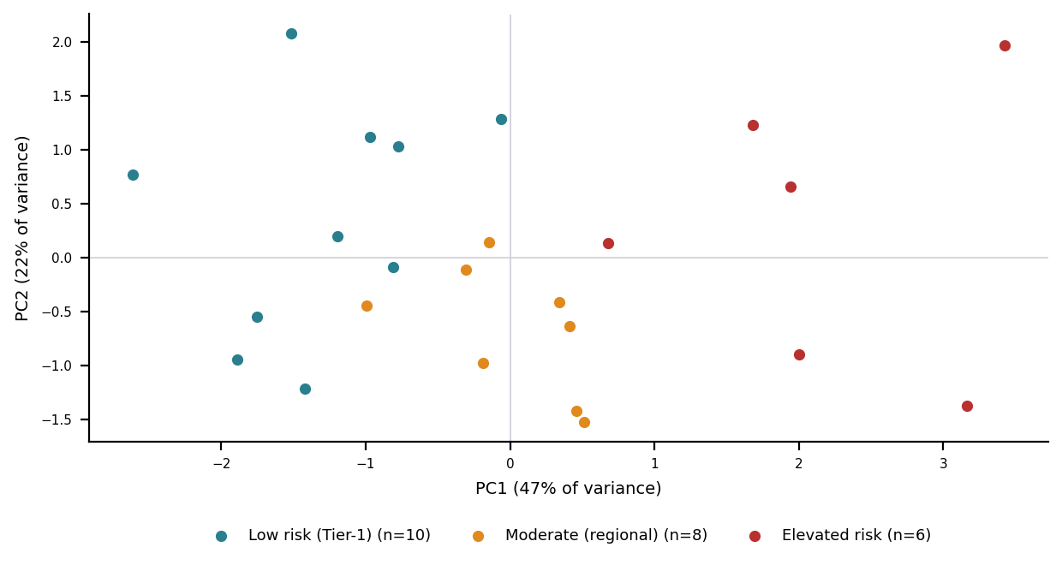
Figure 4: PCA projection of the 24 suppliers (PC1 47%, PC2 22% of variance), colour-coded by K-Means cluster
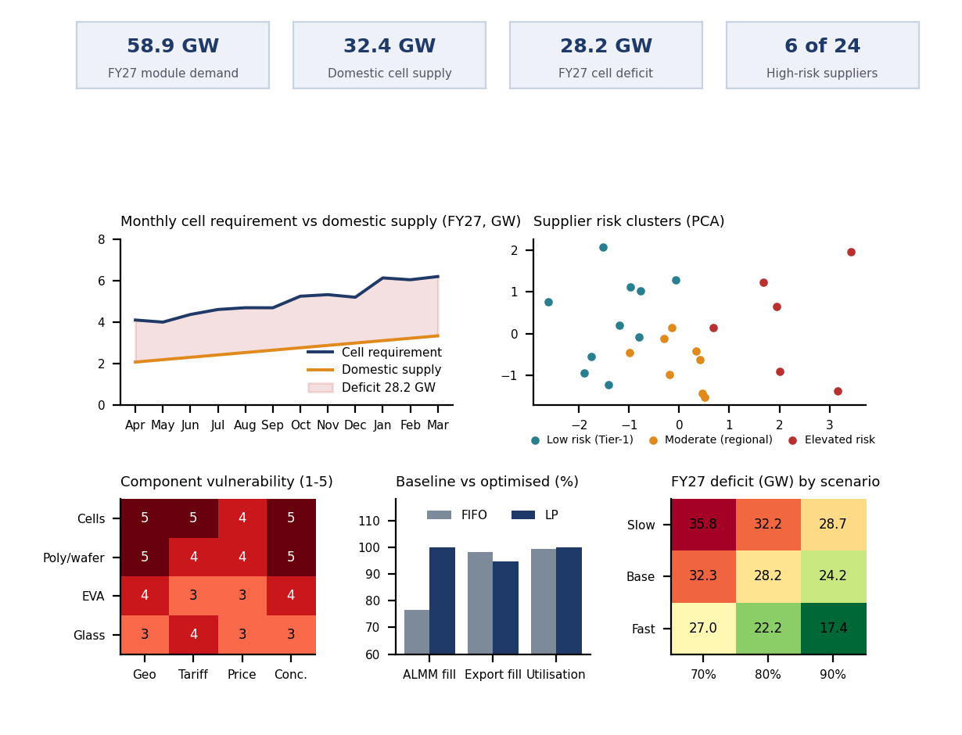
Figure 5: Dashboard of the six visual insights (KPI cards, demand vs. supply, risk clusters, component heatmap, baseline vs. LP, scenario sensitivity), rendered from the Annexure B outputs

7. Managerial Recommendations

7.1 Dual-track sourcing architecture
Following Chopra and Meindl (Ch. 15), Track 1 serves PSU, state-grid and central-scheme orders with long-term domestic offtake and formula-indexed pricing; Track 2 serves commercial and export orders with diversified Tier-1 Asian imports at spot-parity margins. Full domestic sourcing is infeasible through FY28.
 | Track 1: ALMM List-II compliant | Track 2: global and private export
Supply | Long-term domestic offtake partnerships | Diversified Tier-1 Asian imports, duty-tiered
Markets | PSUs, state grids, central solar schemes | Commercial, industrial and export
Pricing | Formula-indexed with pass-through clauses | Landed spot-parity margin optimisation

Coordination and the bullwhip effect (Ch. 17). Quota and tariff deadlines invite hoarding and order inflation. Sharing the demand forecast and cell-availability plan with sourcing partners, and indexing domestic cell prices by formula, reduces information distortion between assembler, cell maker and EPC developer.

7.2 Phased actions
Short term (0–6 months)
- Replace static 30-day stock with dynamic safety stock, SS = Z·√(L̄σ²_D + D̄²σ²_L) (Ch. 11–12; Heizer et al., 2020), and build reserves ahead of the Q4 rush.
- Qualify secondary ASEAN or 0%-duty sources for every supplier in the high-risk cluster (Ch. 15).
- Move line scheduling from manual FIFO to the LP model (Ch. 8).
Long term (6–24 months)
- Equity-backed offtake agreements or joint ventures with domestic cell makers to secure priority ALMM allocations.
- Predictive sensors on laminators and stringers to prevent stoppages that damage costly domestic cell stock.
- Qualify domestic ingot and wafer suppliers before the June 2028 List-III mandate.
Table 8: Prioritised actions and three-year cost-benefit (500 MW plant, ₹ Crore, undiscounted)
Initiative | Impact / effort | Owner | Outlay | Return | Return source
Dynamic inventory buffers | High / Low | Inventory planning | 4.0 | 11.0 | Avoided idle cost
Sourcing diversification | High / Medium | Sourcing | 9.0 | 18.0 | Tariff-risk hedge
AI line scheduling | Medium / Low | Production | 3.0 | 9.0 | Margin optimisation
Domestic offtake JVs | Very high / High | Executive board | 22.0 | 41.0 | Tender compliance
Predictive sensors | Medium / Medium | Maintenance | 5.0 | 10.0 | Reduced scrap
Total |  |  | 43.0 | 89.0 | Net 46.0; BCR 2.07x

7.3 Change management
Plan. Adoption, not model accuracy, decides whether the schedule improves margin. Sponsorship: the plant head sponsors the change and the owners in Table 8 report monthly on adoption KPIs (share of weekly plans run unmodified, reasons for overrides). Co-design and training: planners help set the LP constraints and attend the two-day simulation workshops (Table 9), and each line champion shadows the first four weekly runs. Phased rollout: the LP runs in parallel with the manual FIFO plan on one line for four weeks, then on all lines once the margin gap is confirmed; overrides stay possible but must be logged, which also feeds model improvement.

8. Implementation Roadmap
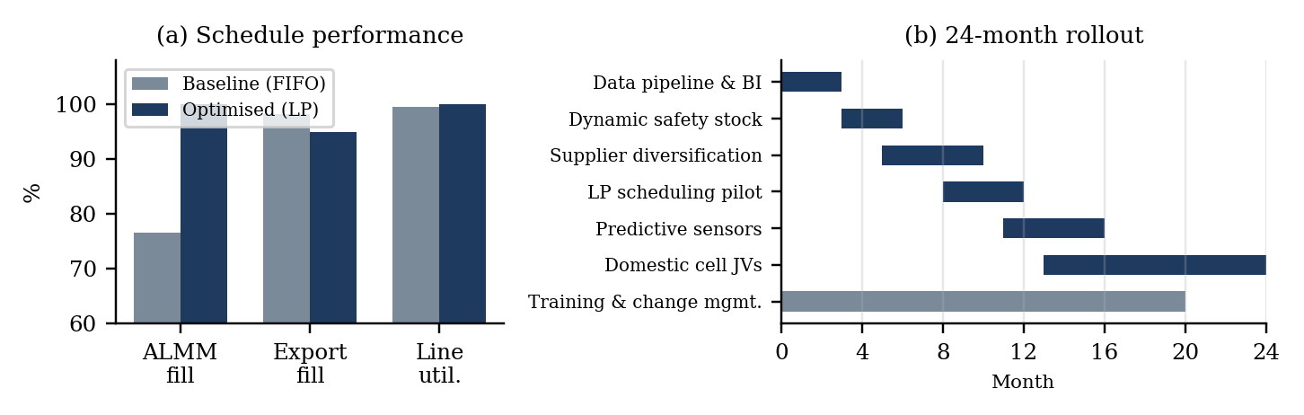
Figure 3: (a) Baseline vs. optimised schedule performance; (b) 24-month implementation Gantt
Table 9: Resources and risk register
Item | Commitment / risk | Provision / mitigation
Human capital | 1 supply chain data engineer, 2 operations planners, 3 line champions | Runs pipelines and weekly optimisation; leads shop-floor rollout
Software | Python, SciPy HiGHS, Power BI gateway to SAP ERP | Daily model runs, scheduling and executive dashboards
Enablement | 2-day simulation workshops for planners and buyers | Interpret risk scores and LP schedules
Risk: model drift (High / Medium) | MAPE above 8% | Drift alerts; monthly retraining on trailing sales
Risk: trade-policy shift (High / High) | New duties or exemptions | Monthly policy review; parametric LP scenarios
Risk: scheduler resistance (Medium / High) | Manual overrides of LP plan | Involve planners in design; tie adoption to KPIs

9. Ethical, Legal and Bias Considerations

9.1 Algorithmic fairness and sourcing bias
Variance-based clustering can penalise young domestic cell makers with short performance histories. The pipeline therefore uses algorithms only for screening and risk grouping; allocation decisions go through a cross-functional human-in-the-loop review that weighs strategic capacity goals and vendor development.

9.2 Legal compliance and data privacy
Supplier prices, bill-of-materials costs and contracted volumes are confidential. Models run in secure, governed environments with no leakage to external LLM training, consistent with the Digital Personal Data Protection Act, 2023. Supplier benchmarking must avoid price-fixing or coordinated boycotts under the Competition Act, 2002.

9.3 Hallucination and disclosure
A wrong tariff or exemption can mean customs seizures and fines, so extraction prompts require source support, temperature 0 and explicit nulls, and every tariff is checked against the DGTR gazette before entering planning data. AI use is logged in Annexure A and the datasets are synthetic, so the findings validate a framework and are not measured plant performance.

9.4 Responsible AI principles and data bias
Transparency: every AI-assisted step is logged in Annexure A and the code is open to review. Accountability: named owners in Table 8 sign off supplier tiers and schedules, and the LP output is a recommendation, never an automatic order. Explainability: K-Means tiers trace back to five named metrics and the LP’s shadow prices can be shown to planners. Robustness: Table 6 stresses the capacity and utilisation assumptions. Data bias: all inputs here are synthetic, so they carry the assumptions built into them (a symmetric noise model, a fixed Q4 seasonal profile) rather than real supplier behaviour or demand shocks, and the results validate the framework only. In a live deployment, ERP and customs data must be audited for survivorship bias (suppliers already dropped), under-representation of new domestic cell makers and reporting lags, and the models re-validated on real holdout data before any decision is automated.

10. References

- Ananta IAS. (2026, June). ALMM List-II in force: India’s domestic solar-cell mandate vs the capacity gap. https://anantamias.com/current-affairs/solar-almm-list-ii-domestic-cell-mandate/
- Baryannis, G., Validi, S., Dani, S., & Antoniou, G. (2019). Supply chain risk management and artificial intelligence: State of the art and future research directions. International Journal of Production Research, 57(7), 2179–2202. https://doi.org/10.1080/00207543.2018.1530478
- Chopra, S., & Meindl, P. (2016). Supply chain management: Strategy, planning, and operation (6th ed.). Pearson.
- Chopra, S., & Sodhi, M. S. (2004). Managing risk to avoid supply-chain breakdown. MIT Sloan Management Review, 46(1), 53–61.
- Christopher, M., & Peck, H. (2004). Building the resilient supply chain. The International Journal of Logistics Management, 15(2), 1–14. https://doi.org/10.1108/09574090410700275
- Heizer, J., Render, B., & Munson, C. (2020). Operations management: Sustainability and supply chain management (13th ed.). Pearson.
- International Energy Agency. (2022). Solar PV global supply chains. https://www.iea.org/reports/solar-pv-global-supply-chains
- Ivanov, D., & Dolgui, A. (2020). Viability of intertwined supply networks: Extending the supply chain resilience angles towards survivability. International Journal of Production Research, 58(10), 2904–2915. https://doi.org/10.1080/00207543.2020.1750727
- Ivanov, D., & Dolgui, A. (2021). A digital supply chain twin for managing the disruption risks and resilience in the era of Industry 4.0. Production Planning & Control, 32(9), 775–788. https://doi.org/10.1080/09537287.2020.1768450
- Mercom India. (2025, October 1). Daily news wrap-up: India’s solar module production capacity reaches 44 GW. https://subscription.mercomindia.com/daily-news-wrap-up-indias-solar-module-production-capacity-reaches-44-gw
- Min, H. (2010). Artificial intelligence in supply chain management: Theory and applications. International Journal of Logistics Research and Applications, 13(1), 13–39. https://doi.org/10.1080/13675560903181534
- Pedregosa, F., Varoquaux, G., Gramfort, A., Michel, V., Thirion, B., Grisel, O., … Duchesnay, E. (2011). Scikit-learn: Machine learning in Python. Journal of Machine Learning Research, 12, 2825–2830.
- Pettit, T. J., Croxton, K. L., & Fiksel, J. (2019). The evolution of resilience in supply chain management: A retrospective on ensuring supply chain resilience. Journal of Business Logistics, 40(1), 56–65. https://doi.org/10.1111/jbl.12202
- pv magazine India. (2025, October). Market eyes Indian buying surge ahead of anti-dumping duty on Chinese solar cells. https://www.pv-magazine-india.com/?p=13156
- Sheffi, Y., & Rice, J. B. (2005). A supply chain view of the resilient enterprise. MIT Sloan Management Review, 47(1), 41–48.
- SMM. (2025, October 2). India imposes three-year anti-dumping tariffs on solar cells and modules from China. https://news.metal.com/newscontent/103558246/
- TaiyangNews. (2026, June 1). India brings ALMM List-II for solar cells into force. https://taiyangnews.info/markets/india-enforces-almm-list-ii-for-solar-cells
- Taylor, S. J., & Letham, B. (2018). Forecasting at scale. The American Statistician, 72(1), 37–45. https://doi.org/10.1080/00031305.2017.1380080

Annexures

A. Prompt Logbook
# | Prompt text | Tool | Output summary | Usage | Reflection
1 | “You are an OSCM research analyst. Extract: event, date, authority, product, tariff, exemptions. Use only provided text; return JSON; null if unmentioned.” | Claude | JSON of manufacturers, ADD rates (0–30%), effective dates | Table 1; Section 2 | Temperature 0 stopped inferred dates
2 | “Given 24 suppliers with 5 standardised metrics, explain which drivers place vendors in Cluster 2; list three operational checks.” | ChatGPT-4o | Lead-time CV and single-source dependence are main drivers | Feature choice; Section 6 | Risk is operational, not only geographic
3 | “Write a Python function fitting damped Holt-Winters (multiplicative, 12-month) returning an 24-month forecast and MAPE.” | Claude | statsmodels function with damped trend | Forecast; Section 6 | Holt’s linear over-predicted; damping gave 5.1% MAPE
4 | “Formulate a SciPy linprog model for a 12-week, 3-plant allocation to maximise margin under cell constraints.” | ChatGPT | HiGHS script with cumulative material bounds | Scheduling; Section 6 | Fixed dimensions; receipts are an upper bound
5 | “Audit this draft for factual consistency; flag uncited metrics or dates.” | Claude | Cross-check against references | Whole report | Fixed a List-II / ADD date contradiction
6 | “Check all components of this report against the WAI evaluation policy and rubric, then correct every gap.” | Claude | Gap list (missing figures, thin code, ethics, change management) and a corrected report | Sections 4, 6.4, 7.3, 9.4; Annexure B | Re-running the code showed FY28 demand and comparator MAPEs had to be updated

B. Dashboard (6 visual insights; Figure 5 shows the layout, Power BI file: solar_resilience.pbix)
- Demand vs. domestic cell supply line chart showing the 28.2 GW FY27 gap; PCA supplier risk scatter coloured by cluster.
- Component vulnerability heatmap; baseline vs. LP line-allocation Gantt; KPI cards (58.9 GW demand, 32.4 GW supply, deficit, high-risk vendors).
- Scenario slicers for capacity ramp (31–65 GW) and utilisation (70–90%).

C. Python Pipeline: Reproducible Console Output and Repository
The complete commented script (src/solar_resilience_pipeline.py), synthetic and processed data files, figures and prompt logbook are in the project repository: https://github.com/sauravverma26m-source/Solar-Resilience-SCM. Running python src/solar_resilience_pipeline.py from the repository root (seeded; Python 3.10+, requirements.txt) regenerates every number in Tables 5-7 and Sections 6.1-6.3. The console output of that run is reproduced below.

[1] Data preparation (Table 5 check, N = 24 suppliers)
lead_time_cv geo_risk price_vol single_source otif_gap
mean 0.28 0.541 0.184 0.246 0.087
std 0.11 0.285 0.072 0.148 0.054
min 0.12 0.100 0.065 0.040 0.012
max 0.58 0.950 0.340 0.620 0.221
Demand history: 54 months, Oct 2021 to Mar 2026

[2] Demand forecast (damped Holt-Winters, phi = 0.92, m = 12)
Holdout MAPE: damped HW 5.1% | undamped HW 6.6% | SARIMA 11.0%
Tracking signal range on holdout: -1.8 to +3.0
Module demand FY27 58.9 GW | FY28 60.6 GW ; cell requirement FY27 60.6 GW | FY28 62.4 GW
FY27 cell requirement by fiscal quarter (GW): Q1 12.5, Q2 14.0, Q3 15.8, Q4 18.4 -> peak in Q4 (Jan-Mar)
Base case: supply 32.4 GW (avg capacity 40.5 GW x 80%) -> FY27 deficit 28.2 GW; domestic supply covers 53% of requirement
Sensitivity of FY27 deficit (GW):
utilisation 0.7 0.8 0.9
ramp
Base (31->50 GW) 32.3 28.2 24.2
Fast (31->65 GW) 27.0 22.2 17.4
Slow (31->40 GW) 35.8 32.2 28.7

[3] Supplier risk clustering (K-Means k = 3, z-scored, random_state = 0)
Cluster sizes (low / moderate / elevated): 10 / 8 / 6
Elevated cluster means: lead-time CV 0.40, OTIF gap 12.1%, single-source 40%
Silhouette score 0.20 ; PCA variance explained PC1 47%, PC2 22%
Component risk scores (geo / tariff / price / concentration):
geopolitical tariff price concentration
Cells 5 5 4 5
Polysilicon/Wafers 5 4 4 5
EVA 4 3 3 4
Glass 3 4 3 3

[4] Constrained scheduling over 12 weeks (3 lines; Line 2 down to 10 MW in weeks 5-7; HiGHS LP)
Parameter Baseline Optimised
ALMM contract fill rate 76.5% 100.0%
Export market fill rate 98.2% 94.8%
Line utilisation 99.4% 100.0%
12-week contribution margin 496.4 Cr 518.4 Cr
Margin uplift: +Rs 22.0 Crore (+4.4%) ; export fill change -3.4 points

[5] Figures written to outputs/figures/ ; tables written to data/processed/

