CS229 INNOVATION LAB REPORT, IIT PATNA

**Stock Portfolio Optimization using LSTM and MPT**

By- Shivanshu Sanjeev(1901CS56) and Saurav Sonu(1901MM30)

 Under the supervision of Prof. Somnath Tripathy, IIT Patna

**Introduction**

Stock markets have existed for centuries. Since its inception, stock markets have served many purposes, the most important being to provide companies with a source to raise capital for investment and expansion. For the individual investor, the stock market provides a way to invest your income to earn a share of the companies’ profits. And for a risk averse investor the most important thing is to manage a portfolio.

Portfolio management refers to managing an individual’s investments in the form of bonds, shares, cash, mutual funds etc so that he earns the maximum profits within the stipulated time frame. Portfolio management **minimizes the risks** involved in investing and also increases the chance of making profits.

So, the goal of this project is to build an **optimized portfolio for investment** in the stock market where the investor will provide the names of certain number stocks and the model will return the best possible combination of shares amongst the top-performing stocks which will be first predicted by the **LSTM model** and then the selected stocks will be optimized using **Markowitz Portfolio Theory.**

**Existing Work And Our Innovation**

There are numerous classical methods to build a portfolio like Dow Jones theory, Random Walk theory, Formula theory and then the most accurate one is **Markowitz Portfolio theory.**

But since Markowitz portfolio theory considers covariance and correlation between two stocks as a measure of risk, it overlooks the possibility of unwanted and unexpected changes in stock prices such as downside risks.

So to back up the decision of what stocks we should invest in, we first predict the behaviour of stocks with the help of **LSTM**, by doing this we have decreased the risk of choosing the unwanted stocks even further as MPT alone, only decides on the basis previous performance but LSTM will feed in the the predicted future data to the MPT model which makes it more accurate and less risky for investors.

* **How LSTM is Helping make a better stock choice for a higher return in lesser time**As accurate as MPT is for portfolio optimization, its dependency on covariance and correlation sometimes tend to overlook the sudden changes in the market price also called downside risk.   
              **Two portfolios that have the same level of variance and returns are considered equally desirable under modern portfolio theory. One portfolio may have that variance because of frequent small losses. In contrast, the other could have that variance because of rare spectacular declines.** Even though the two stocks behaviour might show satisfactory correlation according to MPT, it might result in overall loss in a shorter span of time.

**What LSTM will do is** predict such a sudden change and will discard the risky  stock well before passing it into the MPT model and not only it will satisfy the diversity of MPT but also takes care of sudden decline in stock value making the model more accurate and useful for investment in a shorter span of time and on a higher frequency.

**THEORY**

* **LSTM**

The Long short-term memory (LSTM) is a special type of Recurrent Neural Networks (RNN) architecture that is mainly used in deep learning. LSTM uses a set of feedback connections to process sequences of data. This architecture is known for its efficiency in making predictions, processing, and classifying large-scale time-series data despite the presence of some lags between events. It was named long short-term memory because its cell unit has the ability to forget a part of previously stored data and can, at the same time, memorize additional new pieces of information.

An LSTM unit encapsulates the following elements:

• Cell: represents the memory part of the LSTM that monitors the dependencies between different elements constituting the input sequence.

           • Input gate: regulates the information flowing into the cell.

           • Output gate: regulates the information flowing out of the cell.

• Forget gate: remember the different values over a  time interval.

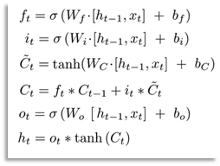

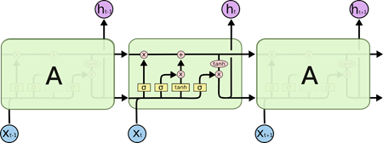

* **Adam Optimizer**

The type of optimizer used can greatly affect how fast the algorithm converges to the minimum value. Here we have chosen to use Adam optimizer. The Adam optimizer combines the perks of two other optimizers: ADAgrad and RMSprop.

The stochastic gradient descent update for RMS prop is given by:

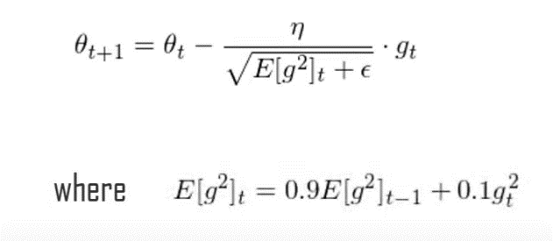

Adam(Adaptive Movement Estimation) is another method that computes the adaptive learning rates for each parameter based on its past gradients.

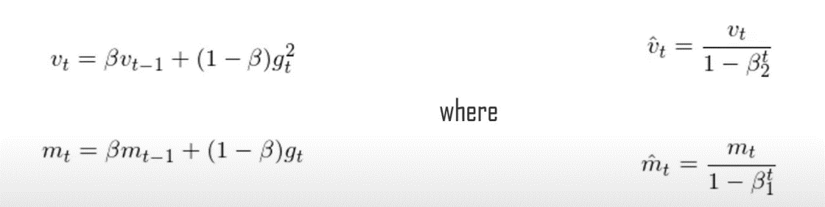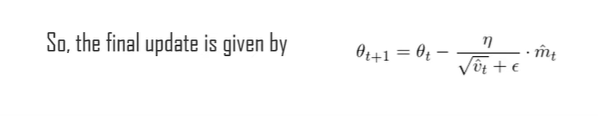

The minimization problem is given by:

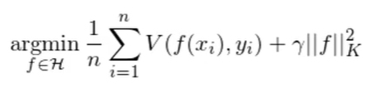

Another important aspect of training the model is making sure the weights do not get too large, hence, overfit. For this purpose, we chose to do regularization.

* **MPT**

Modern [portfolio](https://www.investopedia.com/terms/p/portfolio.asp) theory (MPT) is a theory on how risk-averse investors can construct portfolios to maximize [expected return](https://www.investopedia.com/terms/e/expectedreturn.asp) based on a given level of market risk. [Harry Markowitz](https://www.investopedia.com/terms/h/harrymarkowitz.asp) pioneered this theory in his paper “Portfolio Selection”.

Modern portfolio theory argues that an investment's risk and return characteristics should not be viewed alone, but should be evaluated by how the investment affects the overall portfolio's risk and return. MPT shows that an investor can construct a portfolio of multiple assets that will maximize returns for a given level of risk.

Likewise, given a desired level of expected return, an investor can construct a portfolio with the lowest possible risk. Based on statistical measures such as [variance](https://www.investopedia.com/terms/v/variance.asp) and [correlation](https://www.investopedia.com/terms/c/correlation.asp), an individual investment's performance is less important than how it impacts the entire portfolio. MPT assumes that investors are risk-averse, meaning they prefer a less risky portfolio to a riskier one for a given level of return.

* **Efficient Frontier Curve and Max Sharpe Ratio**

The Efficient Frontier is a common phrase in Modern Finance since the inception of Modern Portfolio Theory in 1952 by Harry Markowitz.

The efficient frontier, a cornerstone of modern portfolio theory, shows the set of portfolios that provide the highest level of return for the lowest level of risk. When a portfolio falls to the right of the efficient frontier, they possess greater risk relative to their return. Conversely, when a portfolio falls beneath the slope of the efficient frontier, they offer a lower level of return relative to risk.

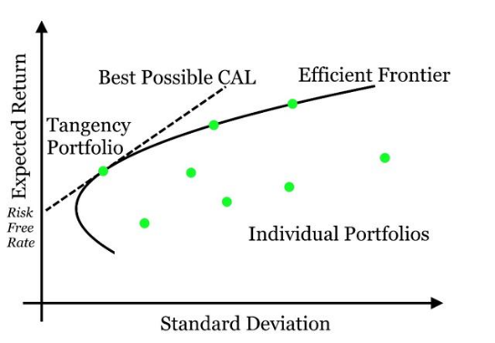

Owning a portfolio with the Maximum Sharpe Ratio is the dream of every investor ("or more likely should be")!!!

Sharpe Ratio - It is the average return earned in excess of the risk-free rate per unit of [volatility](https://www.investopedia.com/terms/v/volatility.asp) or total risk. Volatility is a measure of the price fluctuations of an asset or portfolio.

**So what is the dream portfolio and how can you make one?**

According to Markowitz's theory, there is an optimal portfolio that could be designed with a perfect balance between risk and return.

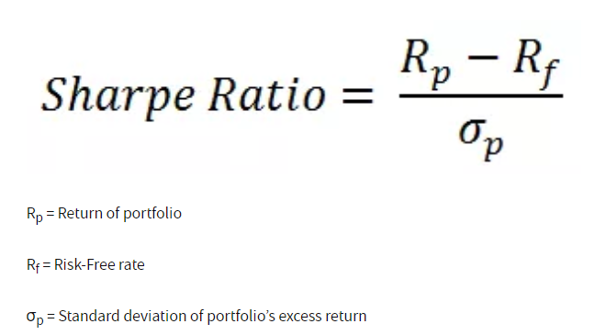

**IMPLEMENTATION**

1. First our Goal is to fetch the current stock data using Yahoo Finance API. The fetched data will keep on changing as the market changes because it always gives present day stock values and hence it was chosen instead of reading data from CSV files.

         

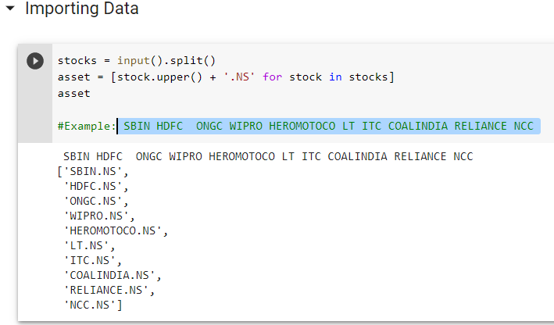

1. The Imported data is Now Plotted, processed and regularised for using it efficiently in a single LSTM trainer. Also, Train Data and Test data is stored separately.

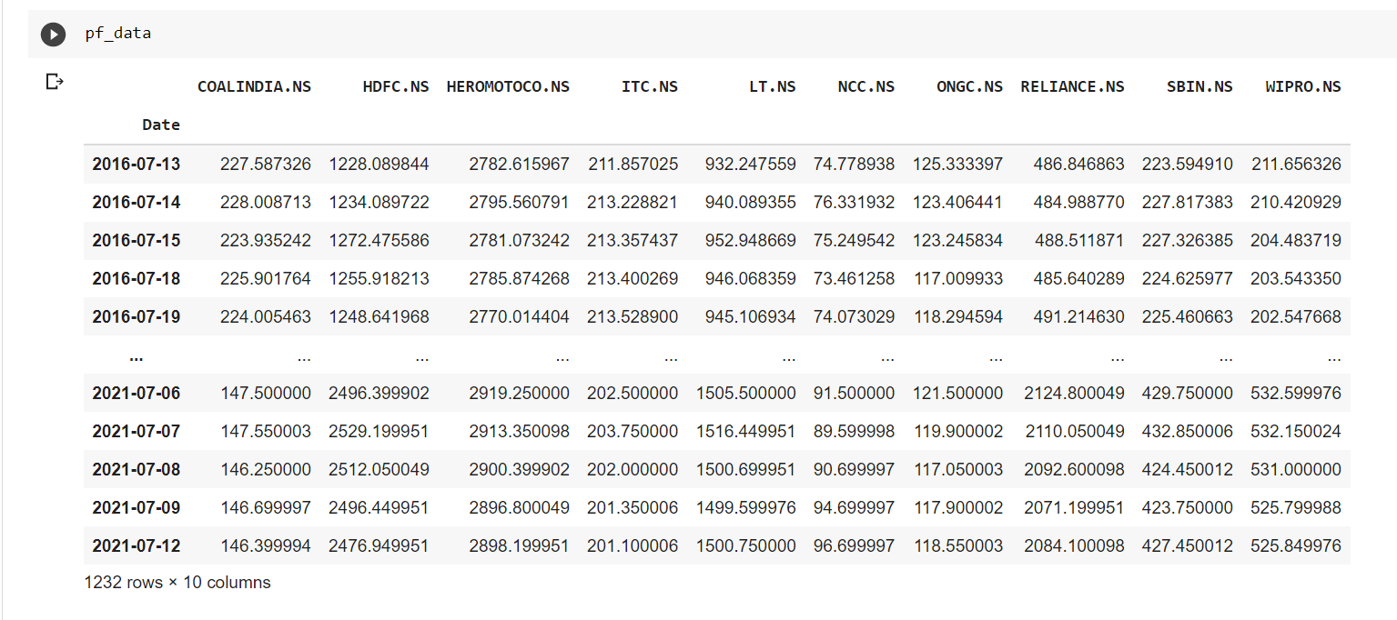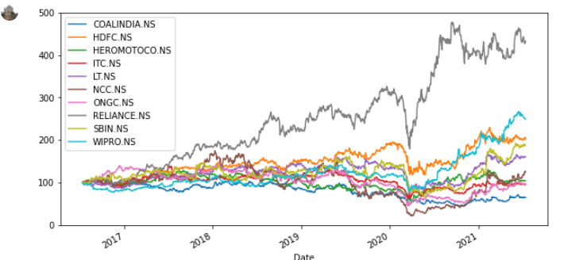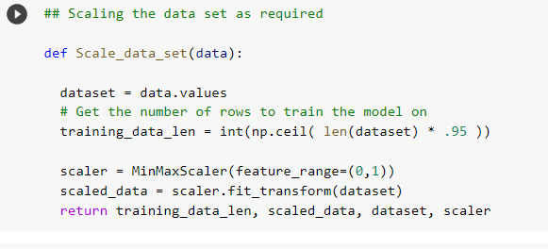

1. To improve the speed of the model we will first optimise it with the help of Adam optimiser. Without it just to run all the epochs for a single company stock  it takes more time than all the stock predicted at once using Adam Optimiser.

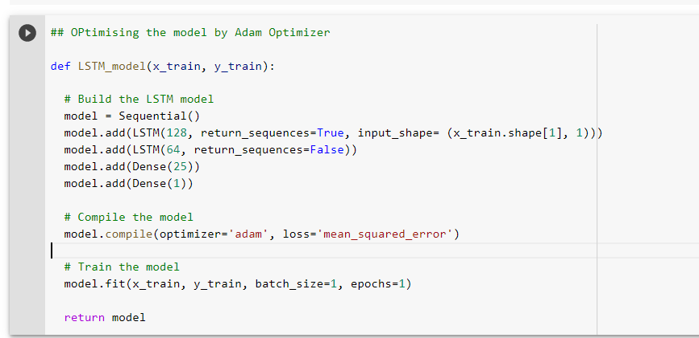

1. Now the Data is ready to train and predict the values which will be compared by test data later on. Graphs plotted and rms values are also calculated.

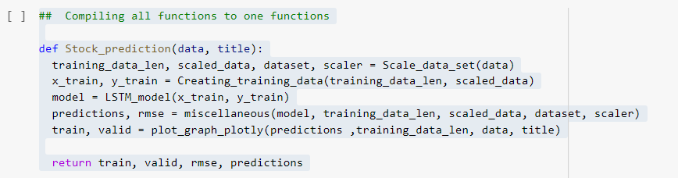

1. After the prediction is made the predicted data give a certain return value for each stock share. We then took the Moving **Average** of daily return of stocks for next six months and then selected the top 5 best performing stocks.

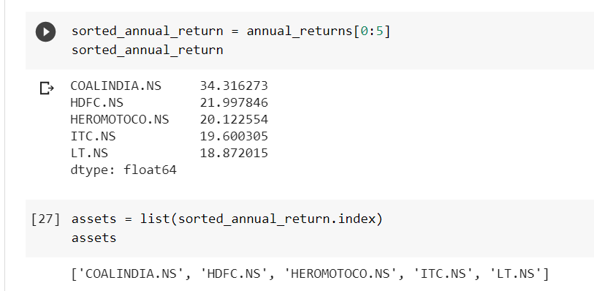

1. Now that we have successfully selected the appropriate stocks to invest in we will proceed on building an Optimum Portfolio. First we will calculate the variance of each stock, and then **covariance** and leading to correlation between each pair of stocks.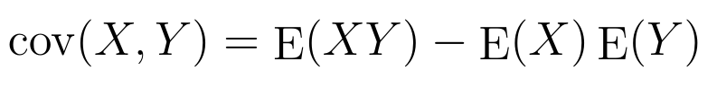

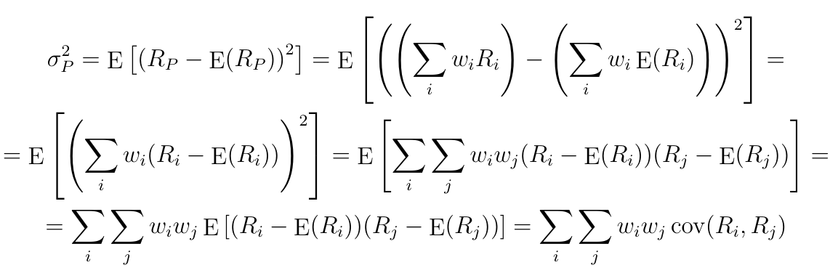

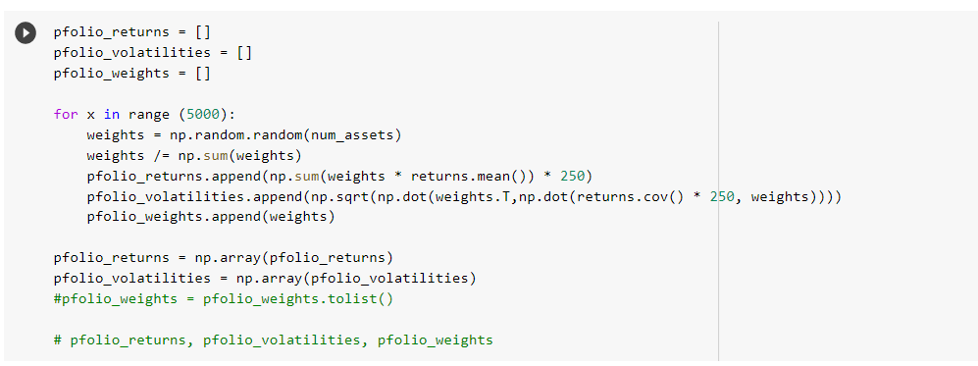

And then we plotted the correlation matrix of each stock.

1. With 5000 randomized weights we now plotted the graph of return versus volatility and visualized the efficient frontier. And then we finally calculated the maximum return, minimum risk and maximum Sharpe ratio portfolios.

           Hence, we finally receive our desired percentage of investment in each stock.

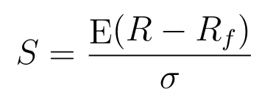Calculating Sharpe ratio

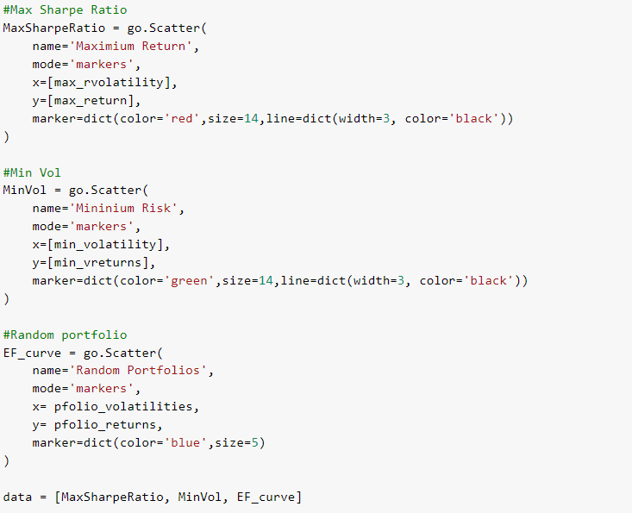

**Results And Observation**

* For LSTM the testing RMSE values we found were as low as 2.646, 3.524 and 3.895 for ONGC, NCC and ITC stocks respectively which is pretty accurate to predict future values of stock. Given aside are the closing actual and predicted values of Wipro Stock given by the LSTM model.

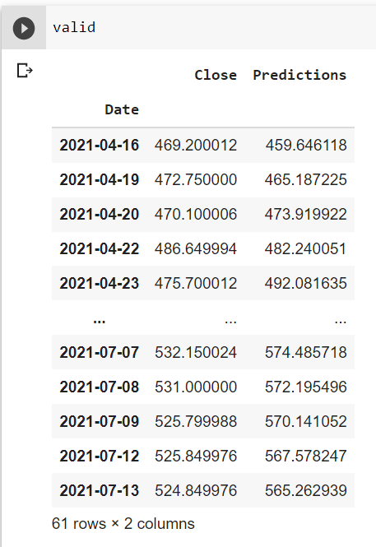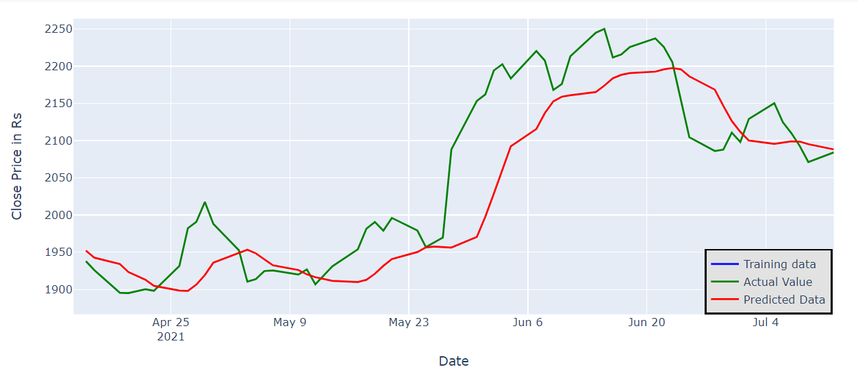

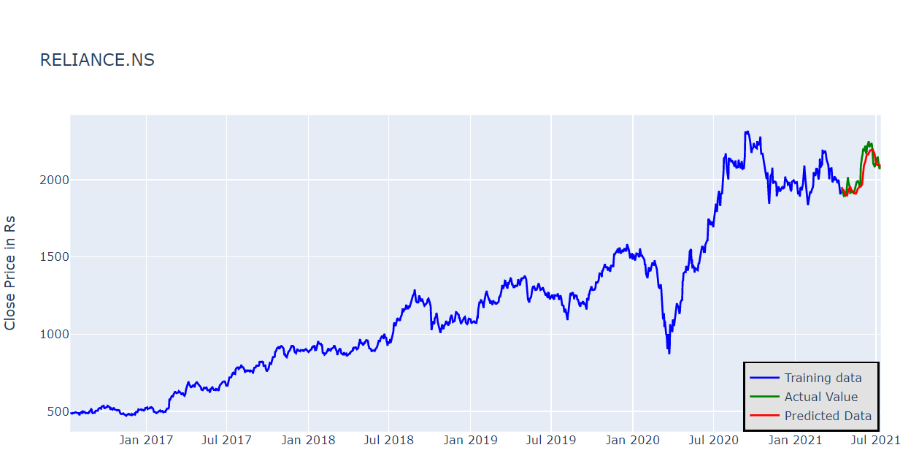

* For MPT below is the correlation matrix and efficient frontier graph observed.

By the table below, we can get the max return of 16.085% with a volatility of 25.235% by investing the highest 65.127% in HDFC.It also shows that we can get the return of 4.919% at the min risk possible by investing the highest 26.631% in Coal India.

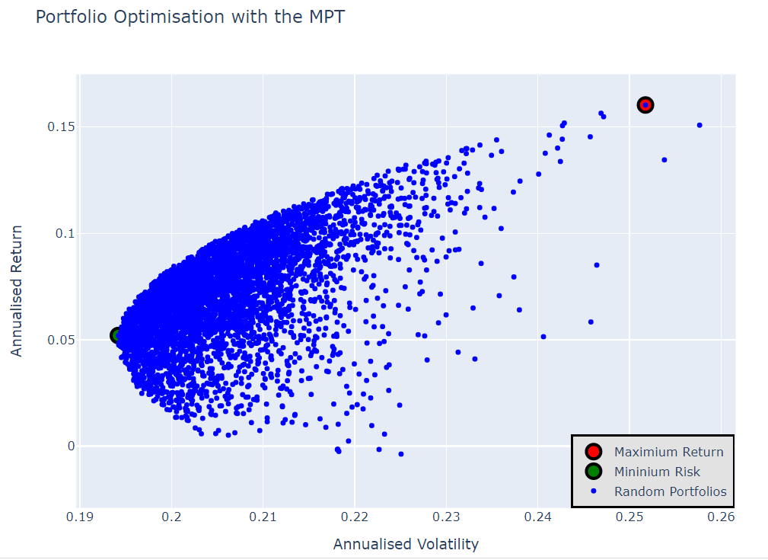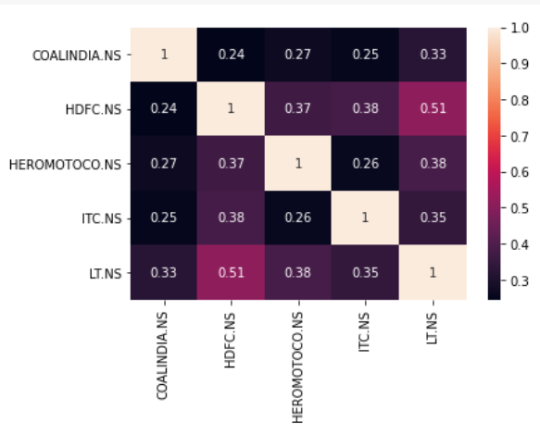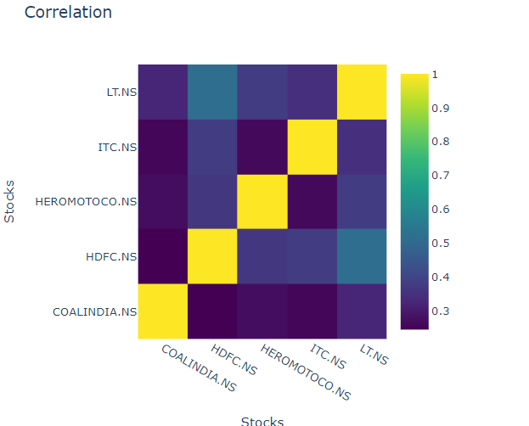

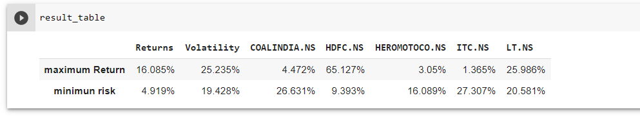

**Hence, we successfully built a risk averse portfolio and maximum sharpe ratio portfolio. The portfolio we get is Dynamic and can be used for high frequency tradings.**

**CONCLUSION**

Through this project, we learnt how to apply deep learning techniques such as LSTM and Linear Regression Models, how to use keras-tensorflow library, how to collect and pre-process given data, how to analyse model's performance and optimise LSTM Network and to ensure increase in positive results. We built a model to accurately predict the future closing price of a given stock, using the Long Short-Term Memory Neural Net algorithm.

And also using the predicted stock prices from the LSTM, we were able to make an optimized portfolio which can help investors in making risk-averse decisions using Markowitz Portfolio theory.

**References**

[**Long Short Term Memory (LSTM) - Recurrent Neural Networks | Coursera**](https://www.coursera.org/lecture/nlp-sequence-models/long-short-term-memory-lstm-KXoay)

[**Modern Portfolio Theory Explained! - YouTube**](https://www.youtube.com/watch?v=8jKrnUfIYEg)

[**Modern Portfolio Theory (MPT) (investopedia.com)**](https://www.investopedia.com/terms/m/modernportfoliotheory.asp#:~:text=Modern%20portfolio%20theory%2C%20introduced%20by%20Harry%20Markowitz%20in,risk%20level%20for%20the%20same%20level%20of%20return.)

[**LSTM Networks | A Detailed Explanation | Towards Data Science**](https://towardsdatascience.com/lstm-networks-a-detailed-explanation-8fae6aefc7f9)