Insert words, table and image demo



The combination of computer science, mathematics and business knowledge is critical to the success of data science projects. Without one of these elements, the data science process would be incomplete, and the insights generated would be less valuable.

* Computer Science plays a crucial role in data science by providing the tools and techniques for collecting, storing, and manipulating large amounts of data. It also provides the algorithms and statistical models used in data analysis and machine learning. Knowledge of programming languages such as Python and R, as well as databases and big data technologies, is essential for a data scientist
* Mathematics is also a key component of data science. It provides the foundation for understanding the underlying statistical and probabilistic models used in data analysis. Knowledge of linear algebra, calculus, and optimization is necessary for understanding the mathematical concepts used in machine learning, such as gradient descent and neural networks.
* Business knowledge is important for data science because it provides context and relevance for the data analysis. A data scientist with a solid understanding of the business domain they are working in can better understand the problem they are trying to solve and how the insights they uncover can be used to drive business decisions. This can help to ensure that the data science project is aligned with the organization's goals and objectives.

Figure 1: Data Science requirement

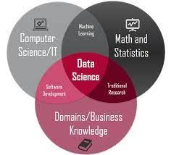

The data science lifecycle is a process that helps data scientists to structure their work and ensure that all important steps are covered. It typically includes several stages: problem definition, data acquisition, data preparation, data exploration, modeling, evaluation, deployment and monitoring.  
   
In the first stage, Problem definition, the goal is to clearly define the problem and objectives of the project. Data Acquisition is the second stage, where the necessary data is gathered and imported. Data preparation is the third stage where data is cleaned, transformed and organized for analysis. Data Exploration and Modeling are the fourth and fifth stage, respectively, where data is analyzed to gain insights and identify patterns, and models are built and trained to make predictions or solve the problem.  
  
In the sixth stage, Evaluation, the performance of the model is assessed and improvements are made. Deployment is the seventh stage, where the model is deployed in a production environment for use by stakeholders. The final stage, Monitoring, is where the model's performance is tracked over time and updates are made as needed.

Figure 2: Data Science Lifecycle

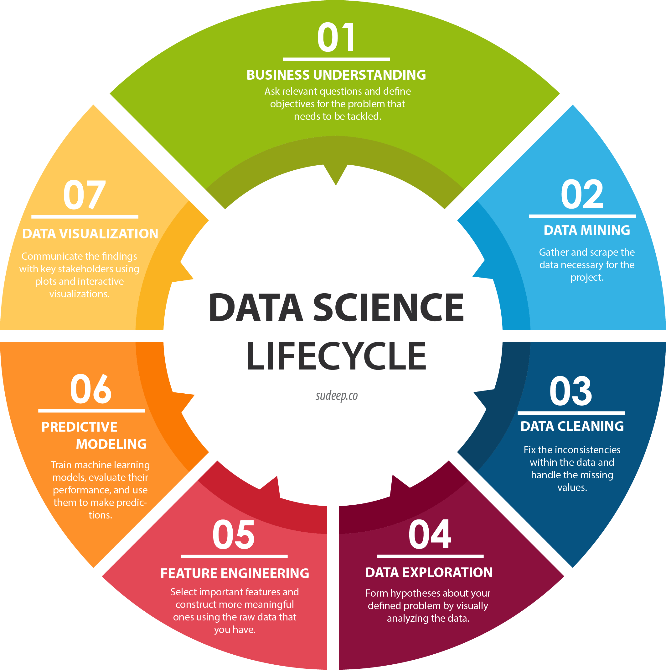

India's GDP has grown at an average annual rate of around 6% between 1994 and 2017. The country has seen an overall increase in economic growth, with some fluctuations due to various factors such as global economic conditions, government policies, and structural changes in the economy. However, GDP growth has accelerated in the recent years, with GDP per capita also increasing. Despite this growth, India still faces significant economic challenges, including poverty, inequality, and unemployment. Refer below table for exact GDP numbers

Table 1: India’s GDP

|  |  |  |  |  |  |  |
| --- | --- | --- | --- | --- | --- | --- |
| **Year** | **GDP Nominal (Current USD)** | **GDP Real (Inflation adj.)** | **GDP change** | **GDP per capita** | **Pop. change** | **Population** |
| 2017 | $2,650,725,335,364 | $2,660,371,703,953 | 0.0668 | $1,987 | 0.0107 | 1338676785 |
| 2016 | $2,290,432,075,124 | $2,482,433,620,957 | 0.0711 | $1,874 | 0.011 | 1324517249 |
| 2015 | $2,103,587,813,812 | $2,294,947,293,526 | 0.0815 | $1,752 | 0.0112 | 1310152403 |
| 2014 | $2,039,127,446,299 | $2,125,024,908,809 | 0.0741 | $1,640 | 0.0115 | 1295600772 |
| 2013 | $1,856,722,121,394 | $1,978,419,519,434 | 0.0639 | $1,545 | 0.0119 | 1280842125 |
| 2012 | $1,827,637,859,136 | $1,859,659,673,960 | 0.0546 | $1,469 | 0.0124 | 1265780247 |
| 2011 | $1,823,049,927,772 | $1,763,439,576,431 | 0.0664 | $1,410 | 0.013 | 1250287943 |
| 2010 | $1,675,615,312,693 | $1,675,615,312,693 | 0.1026 | $1,358 | 0.0136 | 1234281170 |
| 2009 | $1,341,886,699,393 | $1,544,380,258,529 | 0.0848 | $1,268 | 0.0142 | 1217726215 |
| 2008 | $1,198,895,498,504 | $1,431,812,818,925 | 0.0389 | $1,193 | 0.0148 | 1200669765 |
| 2007 | $1,216,735,426,855 | $1,388,940,404,163 | 0.098 | $1,174 | 0.0152 | 1183209472 |
| 2006 | $940,259,892,375 | $1,290,107,534,501 | 0.0926 | $1,107 | 0.0156 | 1165486291 |
| 2005 | $820,381,672,148 | $1,193,872,693,289 | 0.0928 | $1,040 | 0.0159 | 1147609927 |
| 2004 | $709,148,531,775 | $1,106,221,983,522 | 0.0792 | $979 | 0.0163 | 1129623456 |
| 2003 | $607,699,299,977 | $1,025,010,946,219 | 0.0786 | $922 | 0.0167 | 1111523144 |
| 2002 | $514,937,961,194 | $950,312,739,671 | 0.038 | $869 | 0.017 | 1093317189 |
| 2001 | $485,441,026,156 | $915,487,809,335 | 0.0482 | $852 | 0.0174 | 1075000085 |
| 2000 | $468,394,948,472 | $873,357,345,618 | 0.0384 | $827 | 0.0178 | 1056575549 |
| 1999 | $458,820,428,318 | $841,052,590,011 | 0.0885 | $810 | 0.0182 | 1038058156 |
| 1998 | $421,351,487,589 | $772,701,320,024 | 0.0618 | $758 | 0.0186 | 1019483581 |
| 1997 | $415,867,763,817 | $727,697,481,831 | 0.0405 | $727 | 0.0189 | 1000900030 |
| 1996 | $392,897,063,751 | $699,374,084,350 | 0.0755 | $712 | 0.0191 | 982365243 |
| 1995 | $360,281,961,339 | $650,280,977,289 | 0.0757 | $675 | 0.0194 | 963922588 |
| 1994 | $327,275,591,370 | $604,493,654,736 | 0.0666 | $639 | 0.0196 | 945601831 |