**API for adding product details.**

Adding Product details , Here we can put consumable as true/false as required. If we put false, then expiryDate will be considered as null always.

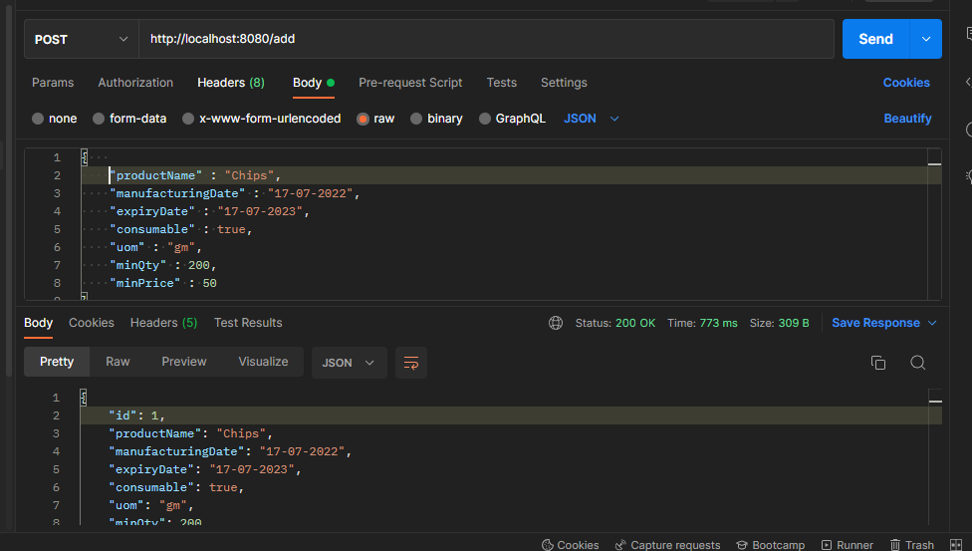

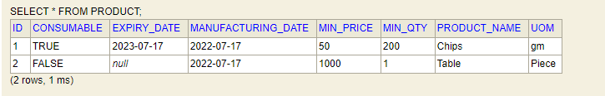

curl --location --request POST 'http://localhost:8080/add' \

--header 'Content-Type: application/json' \

--data-raw '{

    "productName" : "Chips",

    "manufacturingDate" : "17-07-2022",

    "expiryDate" : "17-07-2023",

    "consumable" : true,

    "uom" : "gm",

    "minQty" : 200,

    "minPrice" : 50

}'

**API for Enquiring order details.**

This for enquiry for Client. This is a basic positive case.

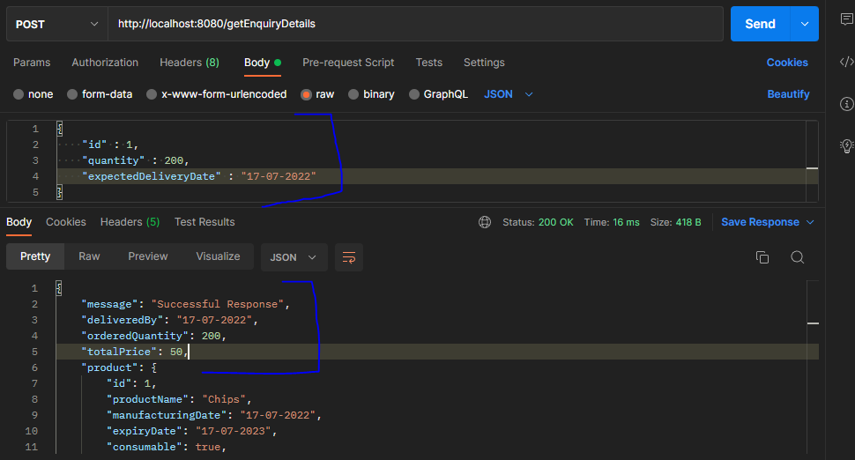

When product is expired.

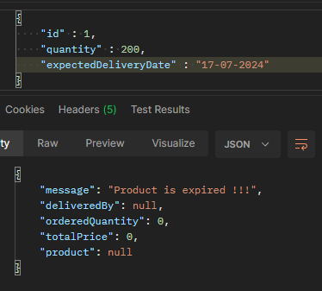

When product qty is less than minOrderQty.

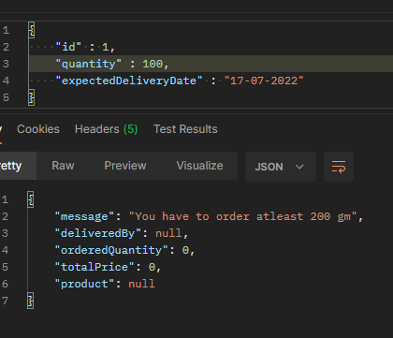

When product is not present in DB.

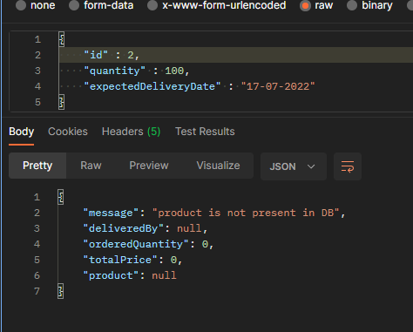

curl --location --request POST 'http://localhost:8080/getEnquiryDetails' \

--header 'Content-Type: application/json' \

--data-raw '{

    "id" : 1,

    "quantity" : 200,

    "expectedDeliveryDate" : "17-07-2022"

}'