**CORONAVIRUS VISULIZATION AND PREDICTION**

A

Mini Project Report submitted to Savitribai Phule Pune University, Pune



In partial Fulfillment for the awards of Degree of Engineering in Computer Engineering

**Submitted by**

**Ms.Snehal Balasaheb Kolhe (S190664227)**

**Ms.Vaishnavi Suresh Changle (S190664207)**

**Mr.Sourabh Govind Yeshal (S190664256)**

**Mr.Abhishek Vilas Gore (S190664216)**

**Mr.Girish Shivkumar Puranik (S190664243)**

**Under the Guidance of**

**Prof. Y.Sisodia**

**Designation of Guide**



**May 2020-21**

**Department of Computer Engineering**

G. H. Raisoni Collage Of Engineering And Management , Ahmednagar

G.H.Raisoni College of Engineering And Management,

Ahmednagar

**Department of Computer Engineering**

(2020-21)

**Certificate**



This is to certify that,

Ms.Snehal Balasaheb Kolhe (S190664227)

Ms.Vaishnavi Suresh Changle (S190664207)

Mr.Sourabh Govind Yeshal (S190664256)

Mr.Abhishek Vilas Gore (S190664216)

Mr.Girish Shivkumar Puranik (S190664243)

have successfully completed the Mini project entitled “ **Coronavirus Visulization And Prediction** ”under my guidance in partial fulfillment of the requirements for the Second Year of Engineering in Computer Engineering under the Savitribai Phule Pune University during the academic year 2021-2022

**Date : ……………….**

**Place:……………….**

**……………………………….**

**Prof. Y. Sisodia**

**Project Guide**

**Prof .Y. Sisodia**

**Head,**

**Department of Computer Engineering**

**Acknowledgements**

With deep sense of gratitude we would like to thank all the people who have lit our path with their kind guidance. We are very grateful to these intellectuals who did their best to help during our project work.

It is our proud privilege to express a deep sense of gratitude to **Prof. Dr. Jaykumar Jayaraman,** Principal of G.H.Raisoni collage of Engineering And Management Ahmednagar, for his comments and kind permission to complete this project. We remain indebted to **prof. Y. Sisodia,** H.O.D.Computer Engineering Department for his timely suggestion and valuable guidance.

The special gratitude goes to excellent and precious guidance in completion of this work .We thanks to all the colleagues for their appreciable help for our working project. With various industry owners or lab technicians to help, it has been our endeavor throughout our work to cover the entire project work.

We are also thankful to our parents who provided their wishful support for our project completion successfully .And lastly we thank our all friends and the people who are directly or indirectly related to our project work.

**[Project Members Name]**

Mr.Sourabh Govind Yeshal

Mr.Abhishek Vilas Gore

Mr.Girish Shivkumar Puranik

Ms.Vaishnavi Suresh Changle

Ms.Snehal Balasaheb Kolhe

***Abstract***

*In Coronavirus Visualization and Prediction, The 2019-nCoV is a contagious coronavirus that hailed from Wuhan, China. This new strain of virus has strikes fear in many countries as cities are quarantined and hospitals are overcrowded. This dataset will help us understand how 2019- nCoV is spread around the world. In the following dataset global death rate, new cases, new recovered, confirmed, active, change in 1 week and %increment, total population, timestamps etc. have been included and considered.*

*Useful Python data analysis & visualization libraries numpy, pandas, matplotlib, seaborn etc. have been used to answer. Finally, it analyzed the publications’ impact to showcase the most influential contributions of the new coronavirus research.* *As COVID-19 becomes a dangerous pandemic worldwide, there is an urgent need to understand all aspects of it through data visualization. As part of a larger COVID-19 response by KAIST, we have worked with students on generating interesting COVID-19 visualizations including demographic trends, patient behaviors, and effects of mitigation policies. A major challenge we experienced is that, in an open world setting where it is not even clear which datasets are available and useful, generating the right visualizations becomes an extremely tedious process. Traditional data visualization recommendation systems usually assume that the datasets are given, and that the visualizations have a clear objective. We contend that such assumptions do not hold in a COVID-19 setting where one needs to iteratively adjust two moving targets: deciding which datasets to use, and generating useful visualizations with the selected datasets. We thus propose interesting research challenges that can help automate this process.*

*.*

***Keywords:***

*Data Visualisation, Diseases, Epidemics, Health Care, Medical Computing, Data Visualization, COVID 19, Policy Makers, Pandemic, COVID 19, Data Visualization, Pandemics.*

**Table of Contents**

|  |  |  |
| --- | --- | --- |
| Serial No | Title | Page No |
| 1. | Introduction   * Overview * Aim/Motivation * Objective * Organization of Report |  |
| 2. | Literature Survey |  |
| 3. | Problem Statement |  |
| 4. | Software Requirements Specification   * Software Requirement * Hardware Requirement |  |
| 5. | System Architecture |  |
| 6. | Data Flow Diagrams |  |
| 7. | Conclusion and Future Scope |  |
| 8. | References |  |

**Chapter 1**

**Introduction**

**Introduction:**

Infectious diseases are caused by various pathogens that can be transmitted from person to person, animal to animal, or person to animal. They can be transmitted in various ways, and the speed of transmission is fast. The virus, named the 2019 Novel Coronavirus (2019-nCoV) by the World Health Organization (WHO) on January 12, 2020, causes Corona Virus Disease 2019 (COVID-19).

The agenda has touched the lives of every human being on Earth, bringing out the best and worst of human emotions, among others. In this challenging time, scientists around the world have been expressing there concern and workmanship through academic cohesiveness. The phenomenal increase of scholarly literature on coronavirus disease has been observed. The Google Search yielded about 458× 107 results of the on( 31 May 2020). Scholar-google also returned a total of 147,000 hits on the topic. A retrieval of this keyword in the re3data (a global registry) has resulted as many as 34 research data repositories. However, the WHO COVID-19 Database has recorded more than 22,000 entries of current literature from multilingual sources (with a few overlaps). Approximately 14,588 scholarly articles are indexed in Scopus during a few month of 2020. So , it was felt worthy of looking at the publication scenario of this specialty of research in diferent dimensions.

* **Overview:**

In this project we will visualize data from the early months of the corona virus outbreak to see how this grew to be a global pandamic.

Project Tasks:

* Confirmed cases
* Active cases
* Death cases
* **Goals of purposed system:**
* To study COVID-19 data to avoid believing misconceptions that the media and those in power try to impose.
* Learn how to interpret different visualizations
* Assess to see how close it is to possibly predict cases and deaths
* **Aim:**

To visualize the incidental break-out of scientifc information concerning the new coronavirus disease (COVID-19). It also aims to showcase the scientometric dimensions of novel coronavirus (2019-nCov) research. Therefore, this study intends to map the scholarly publications of this promising issue in quantitative terms. The real spirit of this work is implicit in a curious response of the global researchers during a public health emergency.

* **Objectives:**
* To understand the quantum of knowledge through scholarly publication growth in COVID-19.
* To observe the orientation of research and to visualize the corpus of research focus.
* To determine the extent of collaborative research across the countries.
* To map the collaboration network through co-authorship analysis.
* To reveal the dynamics of publishing and find core-journals.
* To evaluate the influence of publications as a whole.

**Chapter 2**

**Literature Survey**

|  |  |  |  |
| --- | --- | --- | --- |
| **Sr.No** | **Paper Title** | **Author** | **Publish Year** |
| 1 | The transmissibility and control  of pandemic influenza A(H1N1)virus. | Yang Y.,  Halloran M.E | 2009 |
| 2 | Initial public health response and interim clinical guidance for the 2019 novel coronavirus outbreak. | Patel A.,  Jernigan D.B. | 4 Feb 2020 |
| 3 | Clinical features of patients infected with 2019 novel coronavirus in Wuhan,China. | Huang C | 2020 |

**Chapter 3**

**Problem Statement**

Coronavirus disease (COVID-19) is an infectious disease caused by a newly discovered coronavirus. Most people infected with the COVID-19 virus will experience mild to moderate respiratory illness and recover without requiring special treatment.

* **Coronavirus affect:-**

Older age People of any age, even children, can catch **COVID**-19 . But it most commonly affects middle-aged and older adults. The risk of developing dangerous symptoms increases with age, with those who are age 85 and older at the highest risk of serious symptoms.

* **Issue occur for corona virus:-**

Coronavirus disease (COVID-19) is an infectious disease caused by a newly discovered coronavirus. Most people infected with the COVID-19 virus will experience mild to moderate respiratory illness and recover without requiring special treatment.  Older people, and those with underlying medical problems like cardiovascular disease, diabetes, chronic respiratory disease, and cancer are more likely to develop serious illness.

* **Where is the corona virus issue occurring:-**

The first transmission to humans was in Wuhan, China. Since then, the virus has mostly spread through person-to-person contact.

* **Safety precautions of corona virus**:-
* Avoid close contact with people who are sick.
* Minimize touching your eyes, nose, and mouth.
* Stay home when you are sick.
* Cover your cough or sneeze with a tissue, then throw the tissue in the trash.
* Clean frequently touched objects and surfaces regularly.
* Wash your hands often with soap and water.
* **Advantages:**
* To visualization the COVID -19 cases in India.
* It’s easy to conclude confirmed, cures, death and active cases in India.
* We can predict recovery rate by using visualization.
* We can take caution and aware of the COVID-19 cases.
* To find out the corona virus numbers of cases to the specific states and we update ourselves continuously.
* **Disadvantages:**
* It is not possible to predict exactly and accurate prediction.
* We cannot visualize future data.

**Chapter 4**

**Software Requirements Specification**

**Software Requirements**

Python Editor Notebook

**Chapter 5**

**System Architecture**

* A system architecture is the [conceptual model](https://en.wikipedia.org/wiki/Conceptual_model) that defines the [structure](https://en.wikipedia.org/wiki/Structure), [behavior](https://en.wikipedia.org/wiki/Behavior), and more [views](https://en.wikipedia.org/wiki/View_model) of a [system](https://en.wikipedia.org/wiki/System). An architecture description is a formal description and representation of a system, organized in a way that supports reasoning about the [structures](https://en.wikipedia.org/wiki/Structure) and [behaviors](https://en.wikipedia.org/wiki/Behavior) of the system.
* A system architecture can consist of system [components](https://en.wikipedia.org/wiki/System) and the sub-systems developed, that will work together to implement the overall system. There have been efforts to formalize languages to describe system architecture, collectively these are called [architecture description languages](https://en.wikipedia.org/wiki/Architecture_description_languages) (ADLs).

Dataset Collection

Of Covid-19 Case



Visualization

* **DFD(Data Flow Diagram) :**
* A data flow diagram shows the way information flows through a process or system. It includes data inputs and outputs, data stores, and the various subprocesses the data moves through. DFDs are built using standardized symbols and notation to describe various entities and their relationships.
* A picture is worth a thousand words. A Data Flow Diagram (DFD) is a traditional way to visualize the information flows within a system. A neat and clear DFD can depict a good amount of the system requirements graphically. It can be manual, automated, or a combination of both.

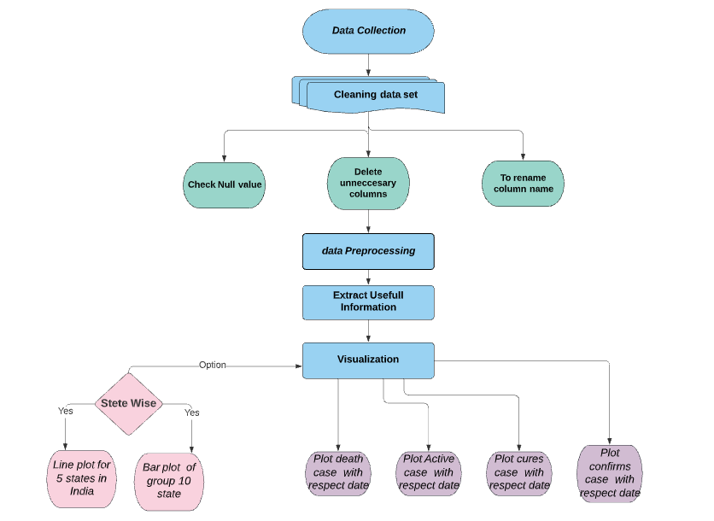

**Chapter 6**

**Conclusion and Future Scope**

**Conclusion:**

* To Extract useful information from data of COVID-19 upto the last date 08 jun 2021.
* The historical data points that we can perceive some pattern and relevant facts.
* Visualization showed that the majority of the COVID-19 cases in India.
* In Order to remain safe, we should practice social distancing .
* COVID-19 is still an unclear infectious disease.
* The outbreak spreads are largely influenced by each country’s policy and social responsibility.
* In a pandemic like this, providing timely information to the public is paramount.
* As data transparency is crucial inside the government, it is also our responsibility not to spread unverified news and to remain calm in this situation.

**Future Scope:**

* We can analyse and predict by taking past data of COVID-19 virus cases
* Everybody understand and aware the impact of Corona virus in a day to day life.
* This information is most useful for News reporter, Doctors and Government to comprehend easily.

**Reference**

* World Health Organization(WHO),”Coronavirus disease 2019(COVID-19) situation”
* The transmissibility and control of pandemic influenza A(H1N1)virus.

Yang Y., Halloran M.E.

2009

* Initial public health response and interim clinical guidance for the 2019

novel coronavirus outbreak.

Patel A., Jernigan D.B.

4 Feb 2020