Determination of a correct particle size distribution requires the identification of overlapping/touching particles in the image. The existing methods based on image processing and analysis are ineffective in separating overlapped particles. Following method uses image processing techniques like segmentation and morphological processing in an alternative way to identify and separate overlapped particles.

Reading Images
The algorithm reads a stream of images from a folder (specified by the user) using imread() iteratively. This is necessary as the method needs to process large number of images to determine the correct particle size distribution. These images are then stored and indexed as an array in a global structure variable images for easy access by different functions. Magnification of the images is also read by the algorithm as it determines the value of some variables like erosion_radius.
Initializing the Variables
Once the images are read using the read() function, they are processed individually. The global structure variable process_image() is declared, which stores the information (segments, diameter and centroid co-ordinates) for the current image. The global variable image_size() is initialized with the size of the image using size() function. The erosion radius variable erosion_radius and black-white area radius variable bwarea_radius are also initialized depending on the value of magnification. The global variables final_image and boundary_image variables that store the final processed image and the image containing boundaries are also initialized with blank images.
Image Segmentation
Image segmentation is an important step, as it subdivides the region into meaningful segments. It also reduces the amount of processing required in further steps. Watershed segmentation is used as the segmentation technique in this algorithm. As compared to other segmentation techniques, watershed segmentation provides closed contours. In many cases it can even separate overlapped particles into separate segments thus reducing the computation required in following steps. In the algorithm, watershed_algo() function carries out the watershed segmentation. It inputs the original image of nanoparticles and outputs a comma-separated array of segments with their properties. In the watershed segmentation process the input image is converted to black-white image by using the functions:
- rgb2gray() – converts rgb image to grayscale
- graythresh() – determines the threshold of the image
- im2bw() – converts the grayscale image to black-white image depending on the threshold
Small objects are removed from the black-white image using the bwareaopen() function with the bwarea_radius denoting the amount of pixels. This is followed by an extended-maxima transform using imextendedmax() and closing operation using imclose(). Small regions and holes are filled using the imfill() function. Finally, the watershed transform is computed using the watershed() function and the region properties are obtained using the regionprops() function. The output of the regionprops() is a comma-separated array containing the segments and properties – centroid, bounding box and equivalent diameter.
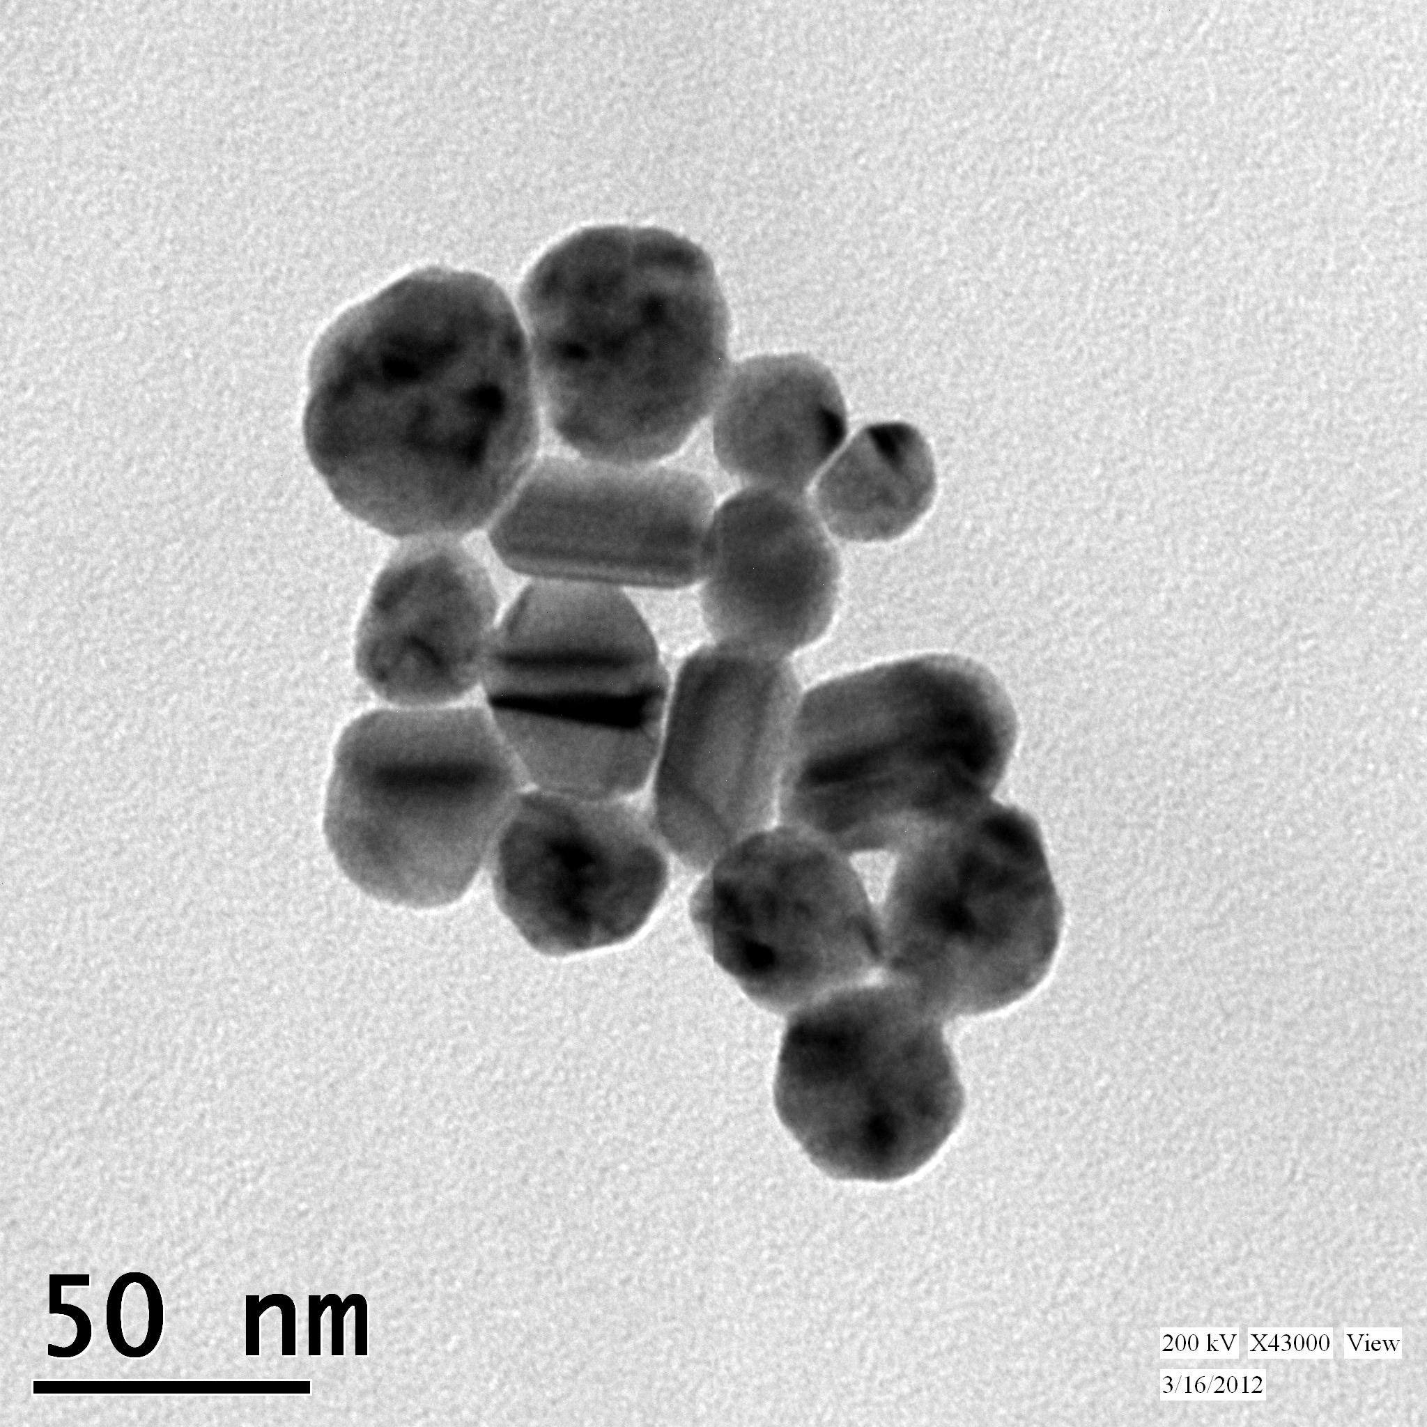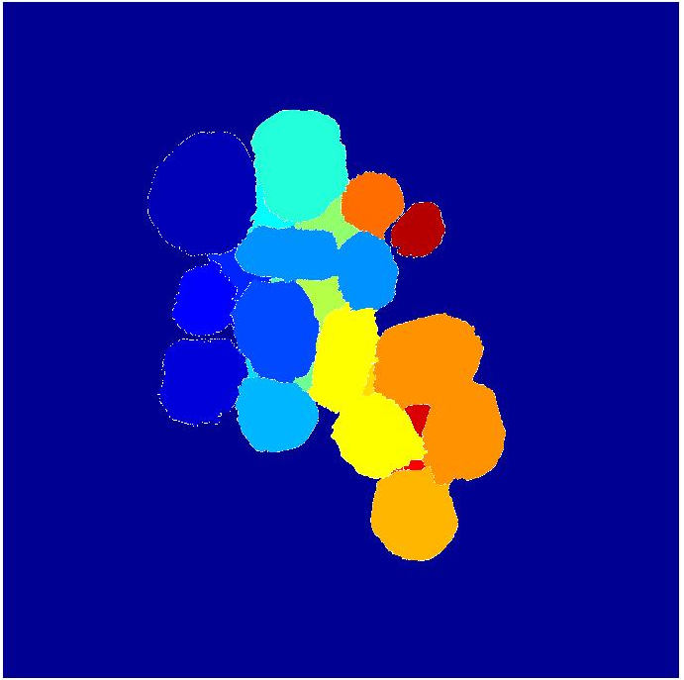

Opening Image (Erosion Dilation)
Erosion and dilation operations are performed in succession on the individual watershed segments, by using a disk structuring element with the radius equal to the erosion_radius. This operation smoothens the boundaries and also removes small protrusions. This operation can also be used to set a lower limit on the size of particles to be detected. Also, the type and size of the structuring element is kept same for both erosion and dilation as otherwise it may change the shape and size of the particle after the operation.
Recursion Erosion Algorithm
The overlapped particles are separated using the recursion erosion algorithm that is carried out in the recursion() function. The recursion() function is called on each segment separated by the watershed segmentation (after it has been pre eroded dilated) and it outputs the separated segment into the process_image global variable. The properties of the segments returned from this algorithm is that, they will not generate new segments when eroded further. The total erosion that has occurred before the call of the recursion function is stored in the variable rad_o. Thus, to start the recursion we use the following statement where the rad_o is zero:
recursion(segment, 0)
The starting radius of erosion, the step-size of erosion and the maximum radius of erosion are stored in the variables rad_min, rad_interval and rad_max respectively. These variables are initialized at the start of the recursion. The structuring element se is also initialized with “disc” as the shape and radius equal to the current radius of erosion rad. Erosion is carried out on the segment iteratively (in the while loop) and the region properties are determined using regionprops() after the erosion. In each iteration the radius rad of erosion is incremented by the amount rad_interval. The number of segments after erosion can be determined using the length of the regionprops variable s, which is equal to length(s). Thus, for:
- No segments, length(s) = 0
- For single segment, length(s) = 1
- For multiple segments, length(s) > 1
When erosion is carried out repeatedly on a segment, a point may come where:
- There are no segments remaining due to excessive erosion
- New segments are generated
This can be represented as shown in the following figure
The iteration is stopped if either:
- The segment gets vanished
- Multiple segments are formed
- The radius of erosion becomes greater than maximum (rad > rad_max)
Case 1
The case when all the segments get vanished denotes that there are no new segments that can be obtained by erosion. Therefore, we set flag to zero to mark the end of iteration. A dilation operation is performed on the starting segment, using a structuring element with size equal to the total amount of erosion rad_o that has been carried out. The segment returned by the dilation operation is the final separated segment. The properties of this segment – centroid coordinates and equivalent diameter is computed using regionprops() and these properties are then stored in the global variable process_images.
Case 2
The case when multiple segments are formed denotes that the segments has separated into 2 or more segments or in other words it has generated new segments. These new segments are then iterated, and recursion is initiated with the individual segments being the starting point. The total amount of erosion when the recursion function is called on these segments is equal to the erosion that has happened before the call of recursion function (rad_o) and after the call of recursion function (rad). Thus, the following statement is passed:
recursion(new_segment, rad_o + rad)
When none of the above cases are encountered the iteration continues, with the radius of erosion being incremented in every step.
Example run of the algorithm
The following figure depicts an example run of the algorithm. The starting segment is present at the parent node. We erode the segment by an erosion radius of 20 to move down the tree. In each step we count the total number of separate segments present (for example the number of segments in step 2 is 1 and in step 3 is 2) and impose the cases that have been discussed above. We continue the iteration if there are no new segments formed. If the number of segments are more than one we start the recursion using these segments as the starting parent nodes for the following sub tree. If the number of segments becomes zero i.e. the segment vanishes, we return to the last position where the iteration began. This segment is dilated with the same amount as it was eroded (for example particle 1 is dilated by 60 and particle 3 by 80) to obtained the final segment. This marks the end of the algorithm.

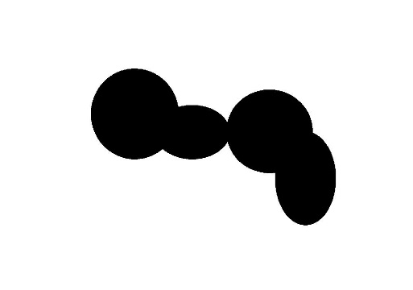
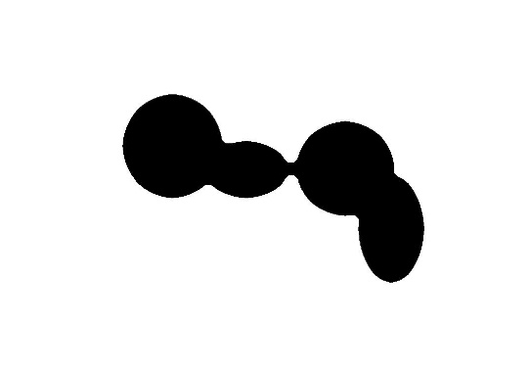

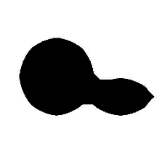
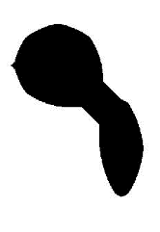
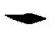

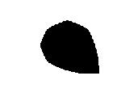
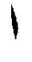

0

20

40

60

80

1 2

3 4 Erosion radius

Removing particles on the edges
In some cases there are particles that are present on the edges of the image and are not completely visible. These may give incorrect reading of size due to incomplete shape and may alter the particle size distribution. To remove such particles we compute the watershed segments and identify the segments whose bounding box coordinates match with any of the bounding box coordinates of the whole image. Once such segments are identified, these segments are made zero (blank segment).
In the following image the left edge bounding box coordinates of particle 1 and bottom edge bounding box coordinates of particle 2 match with the bounding box coordinates of the image. Thus, they are identified as edge particles by the algorithm and removed.
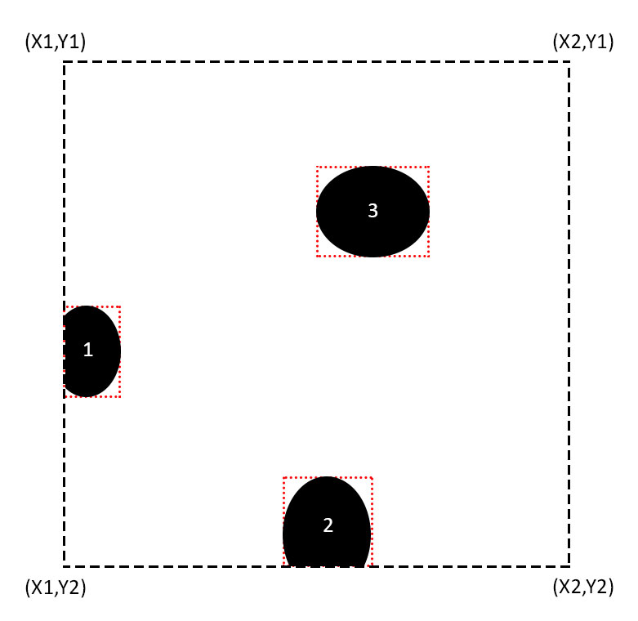

Removing oversized particles
In some images the particles may appear as a big cluster with no significant features to separate them from each other. These are identified as big oversized particles and are needed to be removed to get correct results. The method for identifying these particles is to first get a list/array of the particle sizes once the algorithm completes. After this the inter-quartile range method is used to identify particle sizes that are outliers/oversized. The steps of the method are as follows:
- Data of the particle sizes is arranged in order.
- The first Quartile (Q₁) corresponding to 25th percentile and the third Quartile (Q₃) corresponding to the 75th percentile is calculated.
- The Inter Quartile Range (IQR = Q₃-Q₁) is computed.
- If the particle lies outside the range (R₁, R₂) where R₁ = Q₁ – 1.5(IQR) and R₂ = Q₃ + 1.5(IQR) then it is an outlier.
Once these particles have been identified using the above method, we can remove these particles from the final image. Following is the process:

START
INPUT ARRAY
SORT ARRAY
COMPUTE MEDIAN
FIND Q1, Q2 and Q3
FIND IQR
GET INDEX OF OUTLIERS
REMOVE OUTLIERS
END

Removing repeating particles
When a particle is recursively eroded, there is a specific erosion radius for which we may observe many separate small segments. These separate segments ultimately lead to separate particles when the second phase of the algorithm runs. This can result in an incorrect particle size distribution. This problem can be partially solved by reducing the step radius of erosion (this may in turn reduce the efficiency of the algorithm). A proper solution is to identify these repeating particles, form pairs of these particles and then merge them into a single particle. The steps of the method are as follows:
- All the possible pairs of the particles are iterated.
- For each pair, the distance between centroid or Euclidean distance (D₁) and the average equivalent diameter (D₂) is computed.
  - D₁ = ((x₁-x₂)² + (y₁-y₂)²)^{1/2} where (x₁, y1) and (x₂, y2) are the centroid coordinates of particle 1 and 2 respectively.
  - D₂ = (d₁ + d₂)/2 where d₁ and d₂ are the equivalent diameters of the two particles respectively.
- The condition that these particles are close (not necessary overlapping) is D₁<D₂. If this condition holds true for the pair then we move to the area condition.
- We compute the area of particle 1 and 2 and the area of Y = (P₁ ∩ P₂) where Y represents the region of intersection of the particles.
Area of Particle 1 = A₁
Area of Particle 2 = A₂
Area of Region Y = A₃
- If A₃ is non-zero, means the particle are overlapped. To measure the amount of overlap we can compute the ratio X₁ = (A₃/A₁) and X₂ = (A₃/A₂). By taking a threshold value of X₁ and X₂ we can detect if the particles are repeating (In this method we take a value of 0.75). Thus if the particles are close and if the area of intersection is greater than 75% of individual areas, we can safely assume that the pair are repeating. These pairs are then stored in an array.
- All such pairs are then merged into single particles one-by-one.
The process can be represented by the following diagram:
START
INPUT IMAGE DATA
FIND CENTROID COORDINATES
FIND EUCLIDEAN DISTANCE
FIND AREA A₁, A₂, A₃
FIND AREA RATIOS X₁ and X₂
IDENTIFY PAIRS WITH RATIO OUTSIDE RANGE
CLUB MULTIPLE PAIRS TOGETHER
END
MERGE PAIR SEGMENTS
REMOVE PAIRS

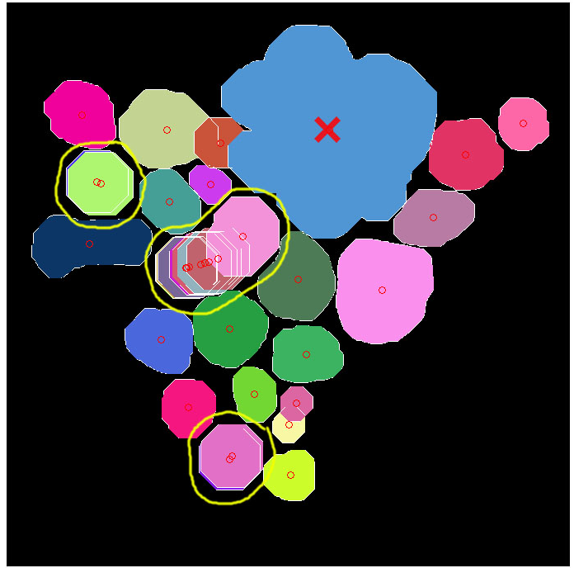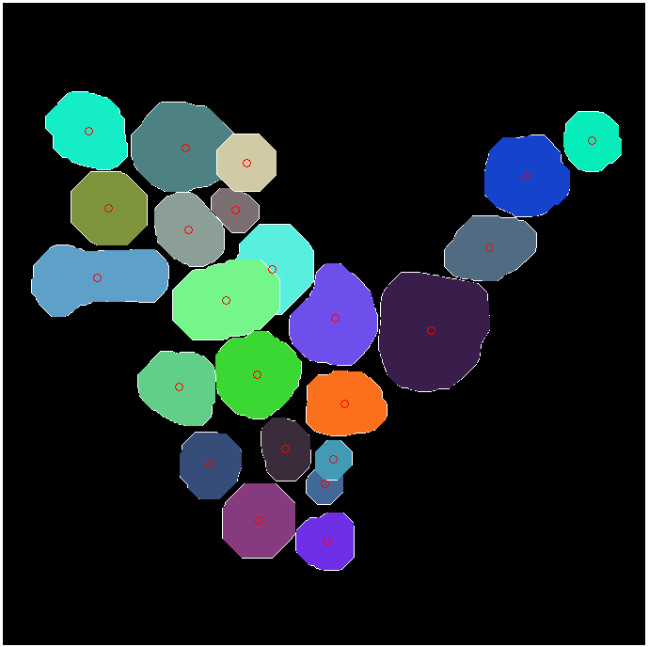
- In this image (x) marks the oversized particles and repeating particles are identified by yellow circles
(b)The oversized particle have been removed and the repeating particles have been merged

