**Interview Question**

**Question 1**

**Best way to create thread ?**

In Java, there are several ways to create threads. Each method has its own advantages and use cases. Here are the three most common ways:

1. **Extending the Thread class:** This method involves creating a new class that extends the **Thread** class and overrides its **run()** method to define the code that will run in the new thread.

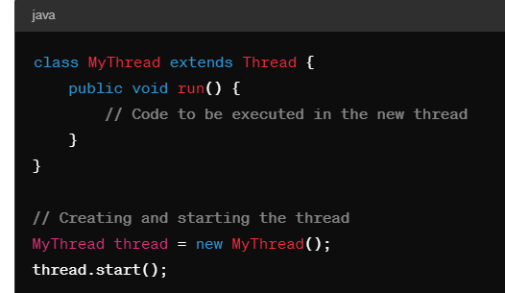

**Implementing the Runnable interface:** This method involves creating a class that implements the **Runnable** interface and providing an implementation for its **run()** method. Then, you can pass an instance of this class to a **Thread** object.

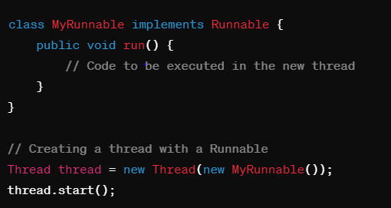

**Using lambda expressions (Java 8 and later):** With Java 8's lambda expressions, you can create threads concisely by passing a lambda expression to the **Thread** constructor.

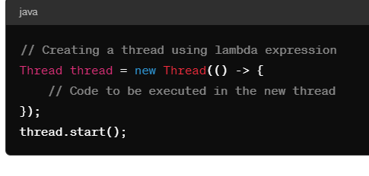

Among these methods, using the **Runnable** interface is generally preferred over extending the **Thread** class because it allows better separation of concerns and reusability. Additionally, using lambda expressions can make the code more concise and readable, especially for simple tasks.

Furthermore, you might also consider using higher-level concurrency utilities provided by the **java.util.concurrent** package, such as **ExecutorService**, **ThreadPoolExecutor**, or **ForkJoinPool**, depending on your specific requirements and the complexity of your application's threading needs. These utilities provide more control over thread lifecycle, task scheduling, and resource management.

**Question 2:**

**Sleep vs wait compairision ?**

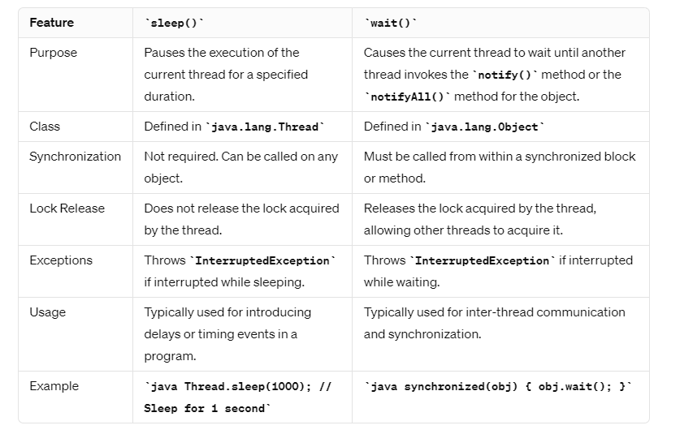

In summary, **sleep()** is used to introduce delays or timing events in a program and does not release any locks held by the thread. On the other hand, **wait()** is used for inter-thread communication and synchronization, and it releases the lock acquired by the thread, allowing other threads to acquire it. Additionally, **wait()** must be called from within a synchronized block or method, whereas **sleep()** can be called on any object without synchronization.

Question 3

Join vs yield

A yield() method is a static method of Thread class and it can stop the currently executing thread and will give a chance to other waiting threads of the same priority. If in case there are no waiting threads or if all the waiting threads have low priority then the same thread will continue its execution.

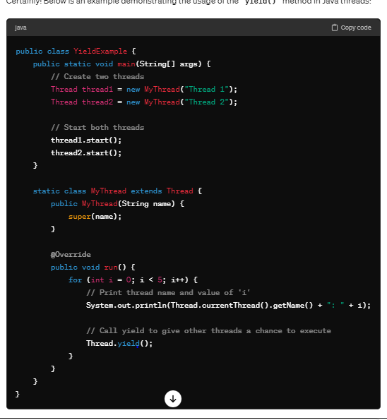

In this example:

* We define a class **YieldExample** with a **main()** method.
* Inside the **main()** method, we create two instances of the **MyThread** class (**thread1** and **thread2**) and start them.
* The **MyThread** class extends **Thread** and overrides the **run()** method.
* Inside the **run()** method, the thread iterates five times, printing its name and the current value of **i**.
* After printing each value of **i**, the thread calls **Thread.yield()** to give other threads a chance to execute.
* The **yield()** method allows the scheduler to pause the execution of the current thread and give CPU time to other threads of the same priority.

When you run this example, you'll see that both threads (**Thread 1** and **Thread 2**) will print their names and values of **i**, but they may interleave because of the **yield()** method, allowing some level of fairness in thread scheduling. However, the exact behavior may vary depending on the JVM and system characteristics.

**Join**

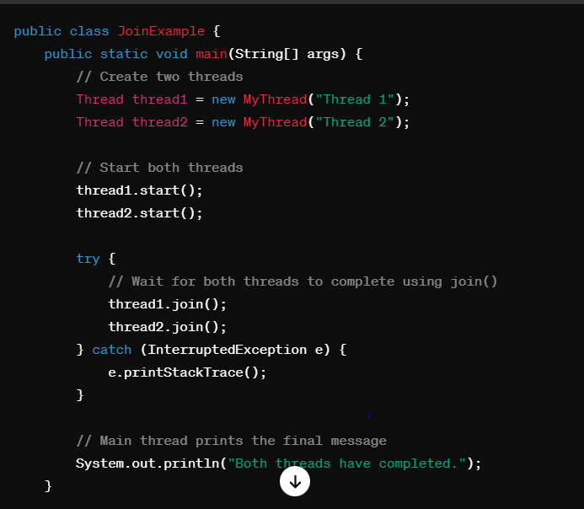

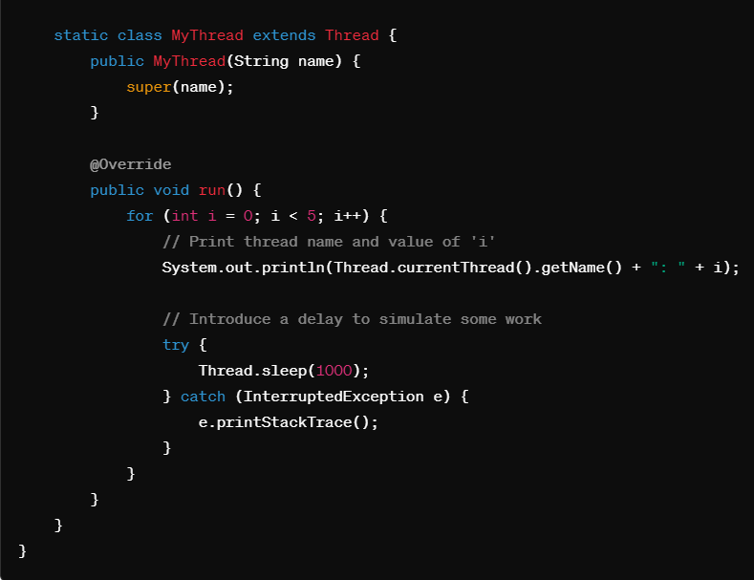

In this example:

* We define a class **JoinExample** with a **main()** method.
* Inside the **main()** method, we create two instances of the **MyThread** class (**thread1** and **thread2**) and start them.
* We then call **join()** on both threads, which causes the main thread to wait until both **thread1** and **thread2** complete execution.
* Inside the **run()** method of the **MyThread** class, each thread iterates five times, printing its name and the current value of **i**.
* After printing each value of **i**, the thread sleeps for 1 second to simulate some work.
* Finally, when both threads complete execution, the main thread prints the final message.

The **join()** method allows one thread to wait for the completion of another thread. In this example, the main thread waits for **thread1** and **thread2** to complete before printing the final message.

**Question 4**

**Object level lock vs class level lock ?**

In Java, you can use synchronized blocks to acquire locks either at the object level or at the class level. Here's an example demonstrating both approaches:

1. **Object Level Lock:**

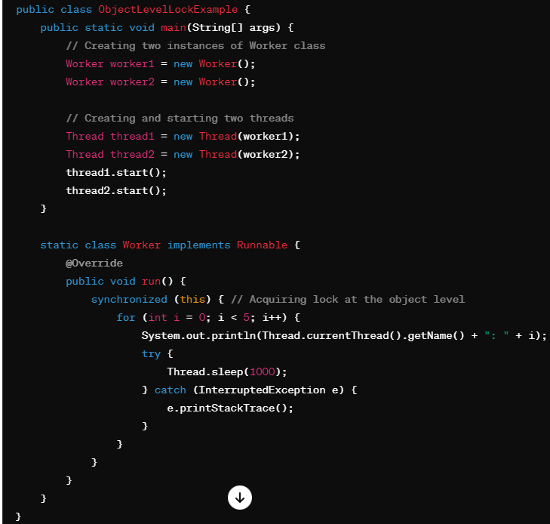

In this example, the **Worker** class implements the **Runnable** interface, and the **run()** method is synchronized on the current instance (**this**) of the **Worker** class. Each thread created from **Worker** class will acquire the lock on its own instance.

1. **Class Level Lock:**

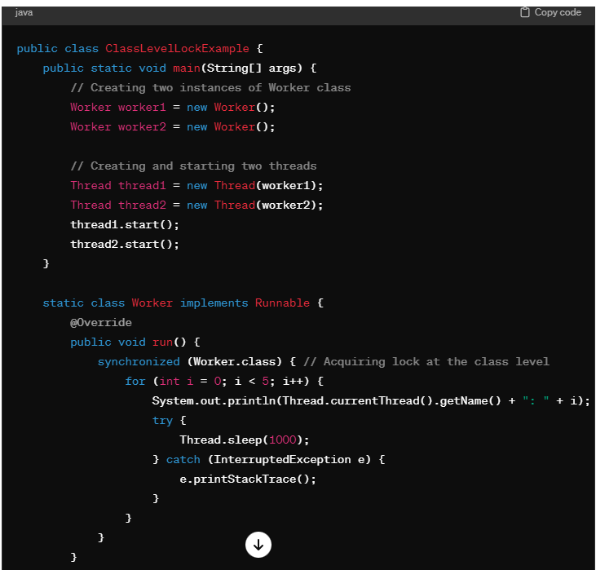

In this example, the **Worker** class implements the **Runnable** interface, and the **run()** method is synchronized on the **Worker.class**. This means that all instances of the **Worker** class will share the same lock, and only one thread will be able to execute the synchronized block across all instances of **Worker** class.

Both approaches achieve synchronization, but the choice between object-level and class-level locks depends on the specific requirements of your application. Object-level locks are useful when different instances of a class need independent synchronization, while class-level locks are useful for global synchronization across all instances of a class.

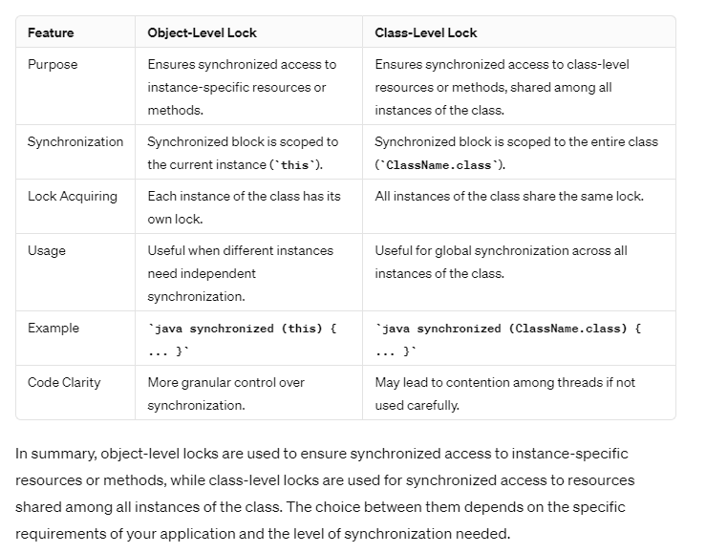

Question 5

What is reentrant lock ?

ReentrantLock is a synchronization mechanism in Java that implements the Lock interface, providing a more flexible and powerful alternative to synchronized blocks. Unlike synchronized blocks, ReentrantLocks allow for more sophisticated locking operations, such as timed waits, polling, and interruptible locks.

Here's an example demonstrating the usage of ReentrantLock:

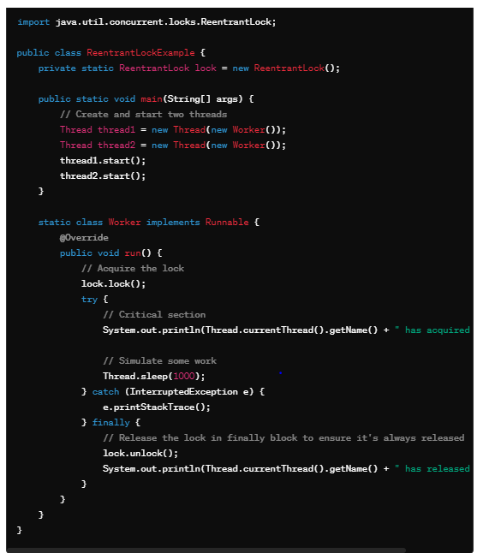

In this example:

* We import **ReentrantLock** from **java.util.concurrent.locks** package.
* We create a static **ReentrantLock** instance named **lock**.
* We define a **Worker** class that implements the **Runnable** interface.
* Inside the **run()** method of the **Worker** class:
  + We acquire the lock using **lock.lock()**.
  + We execute the critical section of code that requires synchronization.
  + We release the lock using **lock.unlock()** in a **finally** block to ensure it's always released, even if an exception occurs.

ReentrantLocks provide additional features such as **tryLock()**, **tryLock(long time, TimeUnit unit)** for timed waiting, **isHeldByCurrentThread()** to check if the current thread holds the lock, and **lockInterruptibly()** for interruptible locking. These features offer more flexibility compared to synchronized blocks.

Question 6

What is try lock ?

The **tryLock()** method is a feature provided by the **ReentrantLock** class in Java, which attempts to acquire the lock without blocking the current thread. It returns a boolean value indicating whether the lock was successfully acquired.

Here's how **tryLock()** works:

* If the lock is available, **tryLock()** acquires the lock and returns **true**.
* If the lock is not available (i.e., another thread holds the lock), **tryLock()** returns **false** immediately without blocking the current thread.

This method is particularly useful when you want to acquire a lock but do not want the current thread to block indefinitely if the lock is not available.

Here's an example demonstrating the usage of **tryLock()**

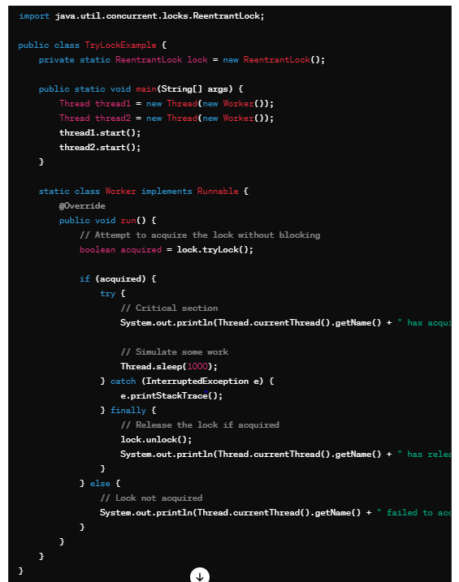

In this example:

* Inside the **run()** method of the **Worker** class, we attempt to acquire the lock using **tryLock()**.
* If **tryLock()** returns **true**, indicating that the lock was successfully acquired, we execute the critical section of code.
* If **tryLock()** returns **false**, indicating that the lock was not acquired, we handle the case where the lock is unavailable without blocking the current thread.

Using **tryLock()** allows for non-blocking acquisition of locks and enables more flexible handling of situations where acquiring a lock may not be immediately possible.

Question 7

What is blocking queue ? explain with example

**BlockingQueue is a java Queue that support operations that wait for the queue to become non-empty when retrieving and removing an element, and wait for space to become available in the queue when adding an element.**

A blocking queue is a type of queue that supports operations that wait for the queue to become non-empty when retrieving an element or wait for space to become available in the queue when adding an element. Blocking queues are useful in concurrent programming scenarios where multiple threads need to communicate and synchronize their operations.

In Java, the **java.util.concurrent** package provides the **BlockingQueue** interface, which defines methods for adding, removing, and inspecting elements in a blocking queue. Some common implementations of **BlockingQueue** include **ArrayBlockingQueue**, **LinkedBlockingQueue**, and **PriorityBlockingQueue**.

Here's an example demonstrating the usage of a **BlockingQueue**:

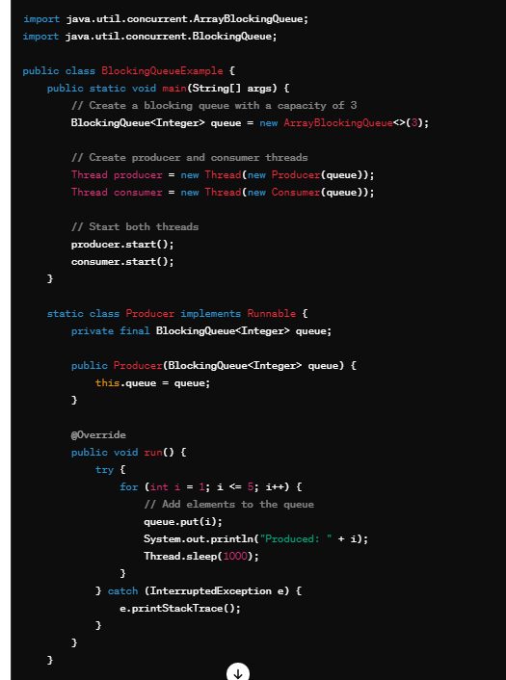

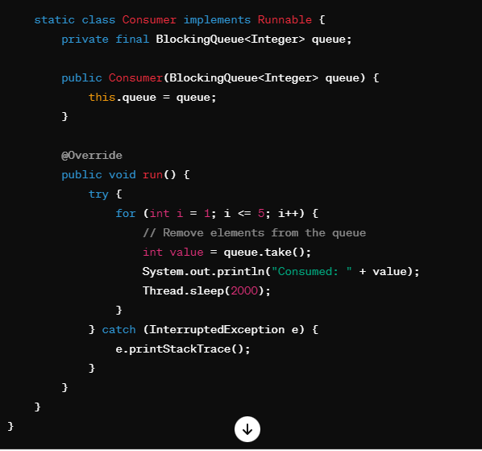

In this example:

* We import **BlockingQueue** from **java.util.concurrent**.
* We create a **BlockingQueue** named **queue** using **ArrayBlockingQueue** with a capacity of 3.
* We define a **Producer** class and a **Consumer** class, both implementing the **Runnable** interface.
* Inside the **run()** method of the **Producer** class:
  + We add elements to the queue using **queue.put(i)**. If the queue is full, this operation will block until space becomes available in the queue.
* Inside the **run()** method of the **Consumer** class:
  + We remove elements from the queue using **queue.take()**. If the queue is empty, this operation will block until an element becomes available in the queue.

This example demonstrates how a **BlockingQueue** facilitates communication and synchronization between producer and consumer threads, ensuring that producers wait when the queue is full and consumers wait when the queue is empty.

Question 8:

Executor framework :

The Executor framework in Java provides a way to manage and execute concurrent tasks asynchronously. It simplifies the process of working with threads by abstracting away the complexities of thread management, such as creating and managing threads manually. The Executor framework provides a higher-level abstraction for executing tasks in a thread pool, which can lead to improved performance and resource management.

Here's a simple example demonstrating the use of the Executor framework:

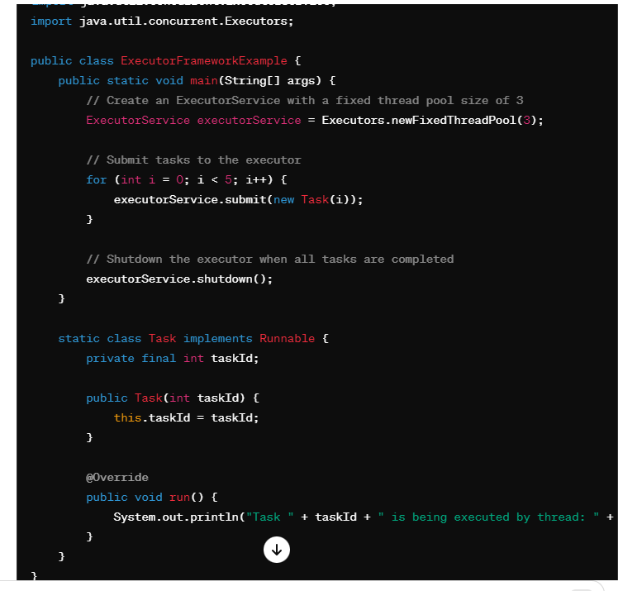

In this example:

* We import **ExecutorService** and **Executors** from **java.util.concurrent**.
* We create an **ExecutorService** using **Executors.newFixedThreadPool(3)**, which creates a thread pool with a fixed size of 3 threads.
* We submit tasks to the executor using **executorService.submit(new Task(i))**. Each task is represented by an instance of the **Task** class, which implements the **Runnable** interface.
* Each task simply prints a message indicating its ID and the name of the thread executing it.
* Finally, we shut down the executor using **executorService.shutdown()** to gracefully terminate the executor after all tasks have completed.

Real-world example:

* Imagine you have a web server that receives requests from clients. Each request represents a task that needs to be processed.
* Instead of creating a new thread for each incoming request (which can be resource-intensive), you can use an ExecutorService to manage a pool of threads.
* When a request comes in, you submit it to the ExecutorService, which assigns it to one of the available threads in the thread pool.
* This way, the server can handle multiple requests concurrently without creating too many threads, leading to better resource utilization and improved performance.

Question 9 :

What is threadpool and its types ?

**A thread pool is a collection of pre-initialized threads that are ready to execute tasks. Instead of creating a new thread for each task, thread pools maintain a pool of reusable threads, which can significantly improve the performance of applications by reducing the overhead of thread creation and destruction.**

Java provides the **ExecutorService** interface and the **ThreadPoolExecutor** class to work with thread pools. There are several types of thread pools, including fixed-size thread pools, cached thread pools, and scheduled thread pools.

Let's explore each type with code examples and discuss their usage:

**Types :**

In Java, the **java.util.concurrent.Executors** class provides several factory methods to create different types of thread pools. Here are some common types of thread pools along with code examples:

### 1. Fixed-size Thread Pool:

A fixed-size thread pool maintains a fixed number of threads in the pool. If a new task is submitted and all threads are busy, it will be placed in a queue until a thread becomes available.

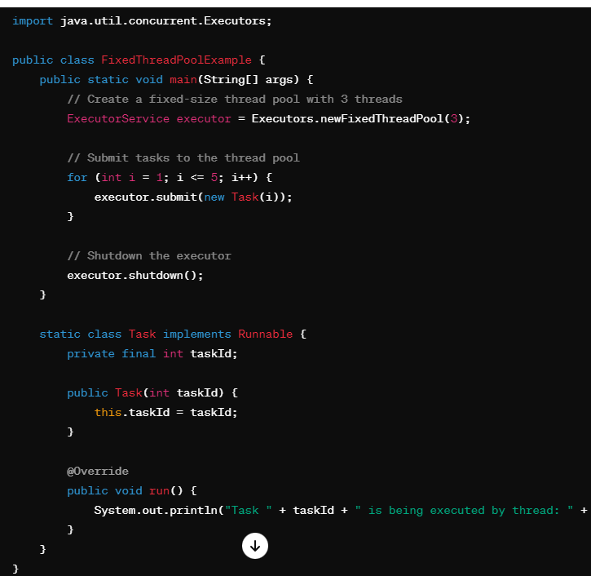

### Cached Thread Pool:

A cached thread pool dynamically adjusts the number of threads in the pool based on the workload. If a new task is submitted and no idle threads are available, a new thread will be created. Threads that have been idle for a certain period may be terminated and removed from the pool.

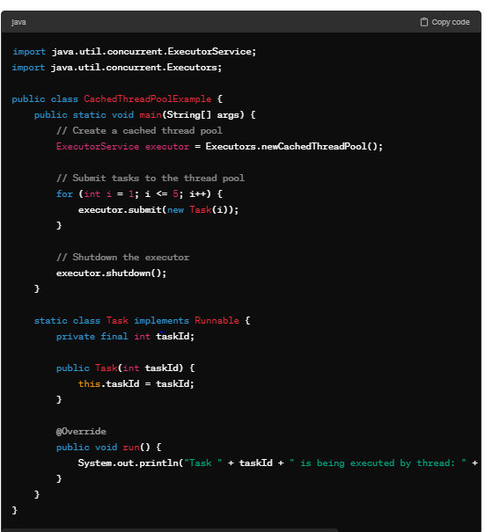

### . Single-threaded Executor:

A single-threaded executor executes tasks sequentially using a single thread. Tasks are guaranteed to be executed in the order they are submitted.

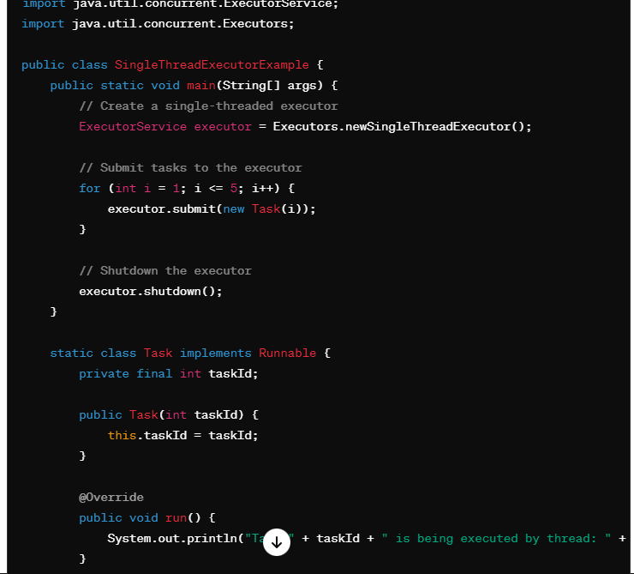

These are some of the common types of thread pools provided by the **Executors** class in Java. Depending on your specific requirements and workload characteristics, you can choose the appropriate type of thread pool to optimize resource utilization and task execution.

Question 10

Producer and consumer problem using wait and notify ?

The producer-consumer problem is a classic synchronization problem where there are two types of threads: producers and consumers. Producers produce items and put them into a shared buffer, while consumers consume items from the buffer. The problem arises when producers and consumers access the buffer concurrently, potentially leading to race conditions, data corruption, or deadlock if not properly synchronized.

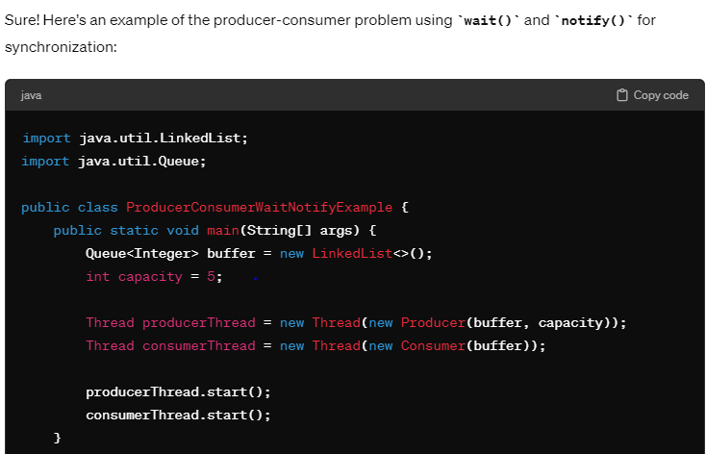

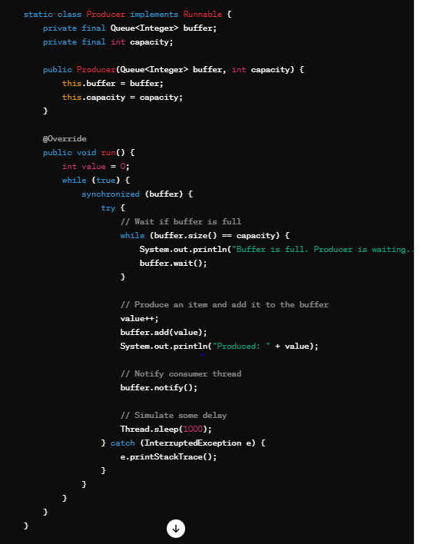

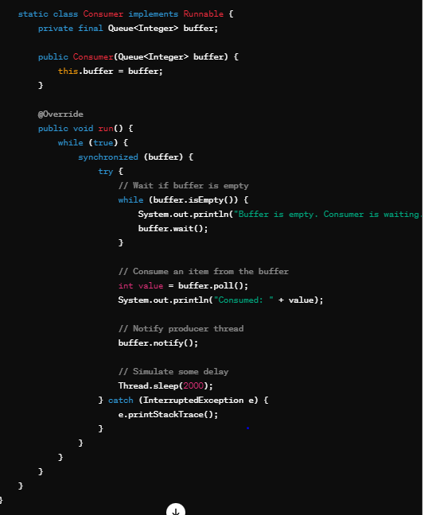

In this example:

* We create a shared buffer as a **LinkedList**.
* We define a **Producer** class and a **Consumer** class, both implementing the **Runnable** interface.
* Inside the **run()** method of the **Producer** class:
  + We synchronize on the buffer and wait if the buffer is full using **buffer.wait()**.
  + We produce an item and add it to the buffer.
  + We notify the consumer thread using **buffer.notify()** after producing an item.
* Inside the **run()** method of the **Consumer** class:
  + We synchronize on the buffer and wait if the buffer is empty using **buffer.wait()**.
  + We consume an item from the buffer and notify the producer thread after consuming an item.
* Both producer and consumer threads run concurrently, and synchronization between them is achieved using **wait()** and **notify()** calls on the shared buffer object.

**Question 11 :--- deadlock example in thread**

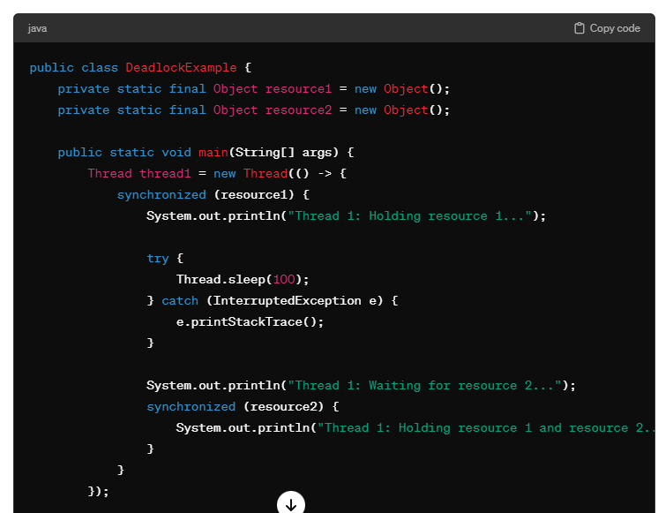

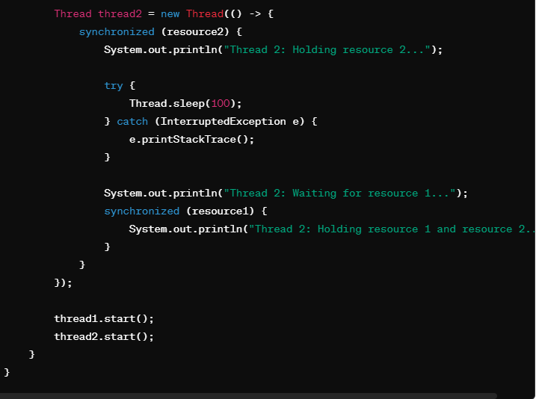

In this example:

* We have two threads (**thread1** and **thread2**), each trying to acquire two resources (**resource1** and **resource2**), but in a different order.
* **thread1** tries to acquire **resource1** first and then **resource2**.
* **thread2** tries to acquire **resource2** first and then **resource1**.
* Both threads hold onto one resource and wait indefinitely for the other resource to become available, resulting in a deadlock situation.

To run this code, execute the **main()** method. You'll notice that the program hangs, and the deadlock situation is detected.

**Question 12 :-**

**Cyclic barrier vs countdown latch**

CyclicBarrier and CountDownLatch are both synchronization utilities provided by the **java.util.concurrent** package in Java, but they serve different purposes and have different characteristics.

### CyclicBarrier:

* CyclicBarrier is a synchronization aid that allows a group of threads to wait for each other to reach a common barrier point before continuing execution.
* It is designed for situations where threads need to wait for each other to perform a certain task and then proceed together.
* Once the specified number of parties (threads) have called the **await()** method, the barrier is tripped, and all waiting threads are released.
* After the barrier is tripped, it can be reused for subsequent cycles.

Here's an example demonstrating the usage of CyclicBarrier:

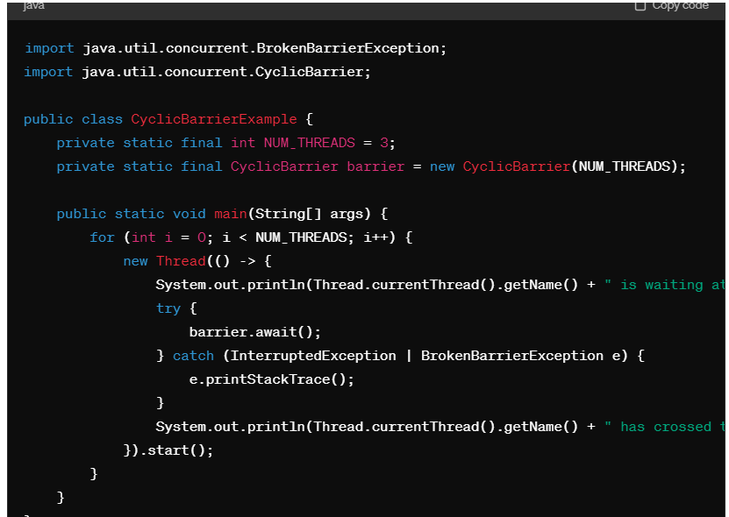

### CountDownLatch:

* CountDownLatch is a synchronization aid that allows one or more threads to wait until a set of operations being performed in other threads completes.
* It is designed for situations where one or more threads need to wait for a set of tasks to be completed before proceeding.
* A CountDownLatch is initialized with a count, and each call to **countDown()** decrements the count. Threads calling **await()** wait until the count reaches zero.
* Unlike CyclicBarrier, a CountDownLatch cannot be reset after the count reaches zero. It can only be used once.

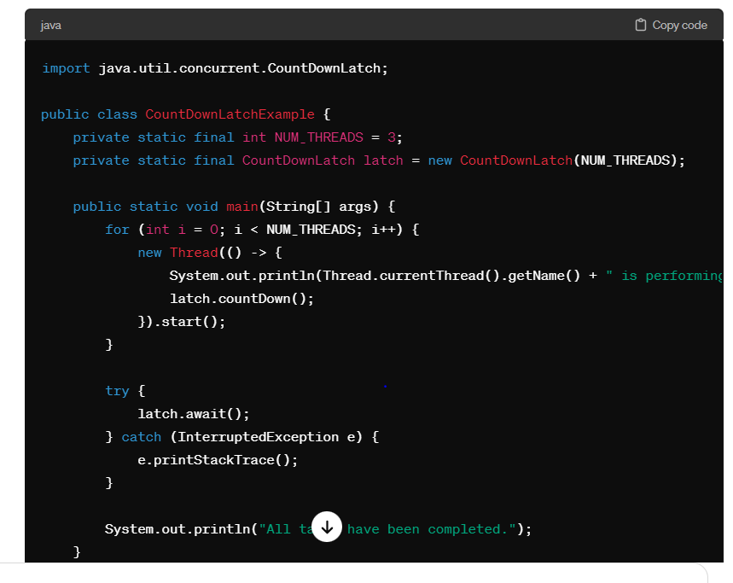

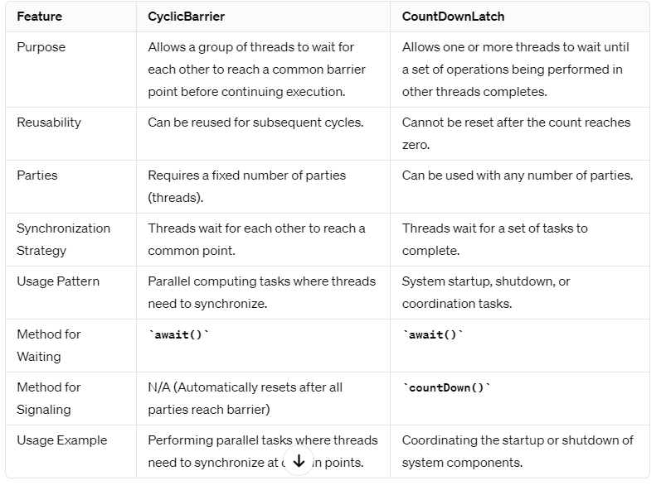

**Real time example :-**

### CyclicBarrier:

**Real-time Example: Team Building Exercise** Imagine a corporate team-building event where employees participate in various activities in groups. At the end of each activity, they gather to discuss their experiences and synchronize their understanding before moving on to the next activity.

* **Application**: In this scenario, each activity represents a task that a group of employees must complete. The CyclicBarrier acts as a meeting point where all groups wait for each other to finish their respective tasks. Once all groups arrive at the meeting point, they synchronize their progress and move on to the next activity together.

### Countdown latch

### Real-time Example: Sports Event Broadcast

Imagine you're organizing a live sports event broadcast, where multiple production teams are responsible for different aspects such as camera setup, audio testing, graphics preparation, and commentator briefing. Before the broadcast starts, all these teams need to complete their setup and preparations.

* **Application**: Each production team represents a thread responsible for a specific task (camera setup, audio testing, etc.). The main broadcast coordinator thread waits for all production teams to finish their setup and preparations before starting the live broadcast.
* **CountDownLatch Usage**: The CountDownLatch is initialized with the count equal to the number of production teams. As each team completes its setup and preparations**, it decrements the latch count**. The main coordinator thread waits at the latch until the count reaches zero, indicating that all teams are ready. Once the latch count reaches zero, the coordinator starts the live broadcast.

**Question 13:**

**Fork and join pool ?**

ForkJoinPool is a special type of ExecutorService introduced in Java 7 that is designed to efficiently execute recursive, divide-and-conquer style algorithms. It is particularly useful for parallel processing tasks where a large task can be broken down into smaller subtasks, which are executed concurrently and then combined to produce the final result.

**Real-life Example**: A real-world application of ForkJoinPool can be seen in parallel sorting algorithms like mergesort or quicksort, where the array is divided into smaller subarrays that are sorted concurrently using ForkJoinPool and then merged to produce the final sorted result. Additionally, parallel image processing tasks, matrix multiplication, and other compute-intensive operations can benefit from ForkJoinPool's parallel execution capabilities, especially on multi-core processors.

Question 14

Queue vs Topic

Certainly! Below is a side-by-side comparison of queues and topics in the context of messaging systems like Apache Kafka or Apache Pulsar:

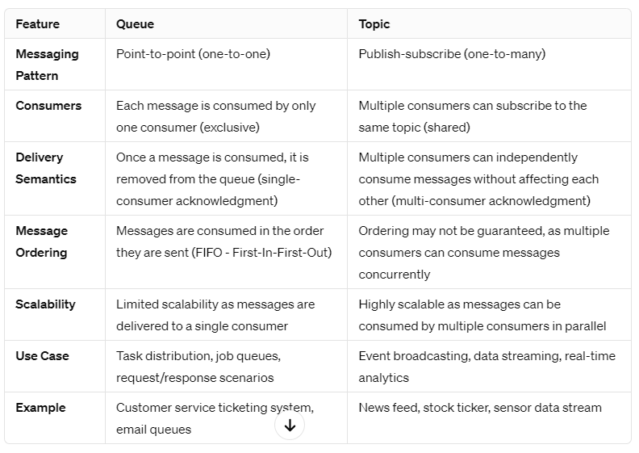

**Question 15**

**What is dead letter queue ?**

**A dead letter queue (DLQ)** is a special type of queue used in messaging systems to handle messages that cannot be delivered to their intended destination for various reasons. Instead of discarding these undeliverable messages, they are sent to the dead letter queue for further analysis and processing.

Here are some common scenarios where messages might be sent to a dead letter queue:

1. **Message Processing Failure**: If a message cannot be processed successfully due to errors in the message content, format, or processing logic, it may be moved to the dead letter queue.
2. **Message Expiry**: Messages that have expired without being consumed or processed within a specified time period may be moved to the dead letter queue.
3. **Unroutable Messages**: Messages that cannot be routed to any destination, such as when the destination queue or topic does not exist, may be sent to the dead letter queue.
4. **Delivery Failure**: Messages that fail to be delivered to the intended destination due to network issues, resource constraints, or other delivery failures may be moved to the dead letter queue.

The dead letter queue serves several purposes:

1. **Error Handling**: It provides a mechanism for handling and analyzing messages that cannot be processed successfully, allowing developers to diagnose and fix issues in message processing logic.
2. **Message Retry**: It allows failed messages to be retried or processed manually to resolve errors and deliver them successfully.
3. **Monitoring and Troubleshooting**: It facilitates monitoring and troubleshooting of message processing pipelines by providing visibility into failed messages and error conditions.

Dead letter queues are commonly used in message-oriented middleware (MOM) systems and message brokers such as Apache Kafka, Amazon SQS, RabbitMQ, and Azure Service Bus. They play a crucial role in ensuring reliable and fault-tolerant message processing in distributed systems.

**Question 16**

**What is retention policy and default retention policy ?**

**Retention policy refers to the strategy used by a messaging system to manage the lifespan of messages stored in its queues or topic**s. It determines how long messages are retained in the system before they are automatically deleted. Different messaging systems offer various retention policies to suit different use cases and requirements.

### Default Retention Policy:

The default retention policy specifies the duration for which messages are retained in the messaging system if no explicit retention policy is configured for a queue or topic. The default retention policy ensures that messages are retained for a reasonable period, even if no specific retention settings are applied.

For example, in Apache Kafka:

* The default retention policy for topics is often set to a finite time period (e.g., 7 days) or infinite retention (i.e., messages are retained indefinitely) depending on the configuration.
* If a topic does not have an explicit retention policy configured, it inherits the default retention policy set at the broker level.

Similarly, in Amazon SQS:

* The default retention policy for messages in standard queues **is set to 4 days.**
* Messages that remain in the queue longer than the retention period are automatically deleted.

### Retention Policy Configuration:

Messaging systems typically allow users to configure custom retention policies based on their specific requirements. Users can specify:

* **Retention Period**: The duration for which messages should be retained before they are deleted. This can be set in terms of time (e.g., hours, days) or size (e.g., maximum message count).
* **Infinite Retention**: Some messaging systems offer the option for infinite retention, where messages are retained indefinitely until explicitly deleted.

For example, in Apache Kafka:

* Users can configure retention policies at the topic level by setting properties like **log.retention.hours** or **log.retention.bytes** in the broker configuration.

In Amazon SQS:

* Users can set the message retention period when creating a queue or modify it later through the queue's attributes.

### Importance of Retention Policy:

The retention policy is crucial for managing message lifecycle, storage usage, and system performance. It ensures that messages are retained for an appropriate duration to meet business requirements while preventing unnecessary accumulation of stale or obsolete messages. By configuring the retention policy appropriately, users can optimize resource utilization, ensure data integrity, and maintain compliance with regulatory requirements.

**Question 17**

**Messaging service configuration, kafka**

Configuring Apache Kafka involves setting various properties to customize its behavior according to specific requirements. Here's an overview of the common configuration options for Kafka:

1. **Broker Configuration**:
   * **broker.id**: Unique identifier for each broker in the Kafka cluster.
   * **listeners**: List of listeners and their corresponding network interfaces and ports.
   * **advertised.listeners**: List of listeners advertised to clients for connection.
   * **num.network.threads**, **num.io.threads**: Number of network and I/O threads for handling client connections and requests.
   * **log.dirs**: Directory path where Kafka stores its data logs (topics partitions).
   * **num.partitions**: Default number of partitions for newly created topics.
2. **Topic Configuration**:
   * **num.replica**: Number of replicas for each partition.
   * **retention.ms**: Retention period for messages in the topic.
   * **cleanup.policy**: Policy for log compaction and deletion (**delete**, **compact**, **delete,compact**).
   * **compression.type**: Compression codec used for message compression (**gzip**, **snappy**, **lz4**, **uncompressed**).
3. **Producer Configuration**:
   * **acks**: Acknowledgment mode for producer requests (**all**, **1**, **0**).
   * **retries**: Number of retries for failed producer requests.
   * **batch.size**: Maximum size of batches in bytes before being sent to the broker.
   * **linger.ms**: Time to wait for accumulating messages in the batch before sending.
   * **compression.type**: Compression codec used for message compression.
4. **Consumer Configuration**:
   * **group.id**: Consumer group identifier.
   * **enable.auto.commit**: Whether to enable automatic offset commit.
   * **auto.offset.reset**: Action to take when there is no initial offset or the current offset is out of range (**earliest**, **latest**, **none**).
   * **fetch.min.bytes**: Minimum bytes of messages to fetch from the broker.
   * **max.poll.records**: Maximum number of records returned in a single poll request.
5. **Security Configuration**:
   * **ssl.keystore.location**, **ssl.keystore.password**, **ssl.key.password**: SSL configuration for secure communication.
   * **sasl.mechanism**, **sasl.jaas.config**: SASL authentication mechanism and configuration.
6. **Performance Configuration**:
   * **num.network.threads**, **num.io.threads**: Number of network and I/O threads for handling requests.
   * **socket.send.buffer.bytes**, **socket.receive.buffer.bytes**: Socket buffer sizes for network I/O.
   * **max.request.size**: Maximum size of a request that the broker will accept.

These are just a few examples of Kafka configuration options. The actual configuration may vary depending on the specific requirements and environment. It's essential to carefully review the Kafka documentation and consider factors such as scalability, fault tolerance, and performance when configuring Kafka for production use.

**Question 18**

**About kafka basics**

[**https://medium.com/nerd-for-tech/a-basic-introduction-to-kafka-a7d10a7776e6**](https://medium.com/nerd-for-tech/a-basic-introduction-to-kafka-a7d10a7776e6)

[**https://medium.com/javarevisited/kafka-partitions-and-consumer-groups-in-6-mins-9e0e336c6c00**](https://medium.com/javarevisited/kafka-partitions-and-consumer-groups-in-6-mins-9e0e336c6c00)

**Question 19 :**

**What is the role of consumer group ?**

The consumer group in Apache Kafka plays a crucial role in facilitating parallel and scalable message consumption from Kafka topics. Here are the key roles of a consumer group:

1. **Parallel Message Processing**:
   * Consumer groups enable parallel processing of messages from Kafka topics by allowing multiple consumer instances to work together within the same group.
   * Each consumer in the group is assigned one or more partitions from the topic, and only one consumer within the group can consume messages from each partition at any given time.
   * By distributing partitions across consumers in the group, Kafka achieves load balancing and high throughput for message consumption.
2. **Scalability**:
   * Consumer groups allow Kafka consumers to scale horizontally by adding more consumer instances to the group.
   * As more consumers join the group, Kafka automatically rebalances the partition assignments across consumers to ensure that each consumer receives an optimal workload.
3. **Fault Tolerance**:
   * Consumer groups provide fault tolerance by allowing consumers to recover from failures and resume processing messages without losing data or interrupting the overall message flow.
   * If a consumer within the group fails, Kafka rebalances the partition assignments to redistribute the workload among the remaining active consumers.
4. **Offset Management**:
   * Each consumer group maintains its own offset for each partition it consumes from. The offset represents the position of the consumer in the partition's message log and indicates the next message to be consumed.
   * Kafka stores the consumer group's offsets in a special Kafka topic named **__consumer_offsets**, ensuring that consumer progress is persisted and can be resumed even in the event of consumer failures or restarts.
5. **Message Ordering**:
   * Within a consumer group, Kafka ensures that messages within each partition are consumed in order, preserving the message ordering guarantees provided by Kafka.
   * However, across partitions, messages may be consumed in parallel by different consumers within the group, allowing for efficient and scalable message processing.

In summary, consumer groups play a critical role in Apache Kafka by enabling parallel, scalable, and fault-tolerant message consumption from Kafka topics. They allow consumers to work together collaboratively within the same group, ensuring efficient utilization of resources and high throughput for message processing in distributed systems.

Question 20

What is partition ?

Topic : In **Kafka, a topic is basically a storage unit where all the messages sent by the producer are stored.** Generally, similar data is stored in individual topics. For example, you can have a topic named “user” where you only store the details of your users, or you can have a topic named “payments” where you only store all the payment-related details.

Partition : A topic can be further subdivided into multiple storage units and these subdivisions of a topic are known as **partitions**.

**Offset**: To keep a track of which events have already been consumed by the consumer, an index pointing to the latest consumed message is stored inside Kafka, this index is called the offset and helps keep a track of which events have already been consumed by the consumer.

In Apache Kafka, topics, partitions, and offsets are fundamental concepts that play crucial roles in organizing, storing, and processing messages within the Kafka cluster.

1. **Topic**:
   * A topic is a logical channel or category to which messages are published by producers and from which messages are consumed by consumers.
   * Topics represent a specific stream of data, and each message published to Kafka is associated with a topic.
   * Topics are divided into partitions to enable horizontal scalability and parallelism.
2. **Partition**:
   * A partition is a unit of parallelism within a Kafka topic, and it represents an ordered, immutable sequence of messages.
   * Each partition is an independent log, and messages within a partition are guaranteed to be ordered based on their offset.
   * Partitions allow Kafka to distribute and scale the data across multiple brokers in a cluster, enabling high throughput and fault tolerance.
   * Kafka guarantees that messages with the same key are always assigned to the same partition, ensuring message ordering and grouping.
3. **Offset**:
   * An offset is a unique identifier assigned to each message within a partition. It represents the position of the message in the partition's log.
   * Offsets are used by consumers to track their progress in reading messages from a partition.
   * Consumers commit offsets to Kafka to indicate the last successfully processed message, allowing them to resume reading from the same position in the event of failure or restart.
   * Kafka stores consumer offsets in a special internal topic called **__consumer_offsets**, ensuring fault tolerance and reliability.

In summary, topics define the streams of data in Kafka, partitions enable parallelism and scalability within topics, and offsets track the progress of consumers within partitions. Together, these concepts provide a robust and scalable foundation for building real-time streaming applications with Apache Kafka.

Question 21

What is the role of zookeeper ?

ZooKeeper plays a crucial role in Apache Kafka as it serves as a distributed coordination service for managing and maintaining the state of the Kafka cluster. Here are the key roles of ZooKeeper in Kafka:

1. **Cluster Coordination**:
   * ZooKeeper maintains metadata about the Kafka cluster, including information about brokers, topics, partitions, and consumer groups.
   * It acts as a centralized repository for storing and updating the state of the cluster, allowing Kafka brokers and clients to discover and coordinate with each other.
2. **Leader Election**:
   * ZooKeeper facilitates leader election for Kafka partitions. Each partition has one leader replica responsible for handling read and write operations, while the remaining replicas act as followers.
   * When a leader fails, ZooKeeper triggers a leader election process to select a new leader from the available replicas, ensuring high availability and fault tolerance.
3. **Broker Registration**:
   * Kafka brokers register themselves with ZooKeeper when they start up. ZooKeeper maintains a list of active brokers in the cluster, along with their metadata such as hostnames, ports, and broker IDs.
   * Clients, producers, and consumers use ZooKeeper to discover and connect to Kafka brokers, ensuring dynamic scalability and fault tolerance.
4. **Topic Management**:
   * ZooKeeper manages metadata about Kafka topics, including the list of partitions for each topic and their leader replicas.
   * It facilitates topic creation, deletion, and reassignment of partitions, ensuring consistency and coordination across the cluster.
5. **Consumer Group Coordination**:
   * ZooKeeper tracks the state of consumer groups and their associated offsets (i.e., the position of the consumer in each partition).
   * It helps manage consumer group membership, partition assignments, and offset commits, ensuring reliable and consistent message consumption.
6. **Configuration Management**:
   * Kafka uses ZooKeeper to store and distribute configuration settings across the cluster, such as broker configurations, topic configurations, and security settings.
   * ZooKeeper notifies Kafka brokers and clients of any changes to the configuration, allowing them to update their state accordingly.

In summary, ZooKeeper serves as the central coordination and synchronization service for Apache Kafka, providing essential functionalities such as cluster management, leader election, metadata storage, and configuration management. It plays a critical role in ensuring the reliability, scalability, and fault tolerance of Kafka clusters.

**Question 22:**

**What is avro in kafka ?**

Avro is a data serialization framework developed by Apache Software Foundation. In the context of Apache Kafka, Avro is often used as a data serialization format for messages. Here's how Avro is used in Kafka:

1. **Schema Definition**: Avro requires a schema to serialize and deserialize data. The schema defines the structure of the data, including field names, data types, and nested structures. Avro schemas are defined using JSON-like syntax.
2. **Compact Binary Format**: Avro uses a compact binary format to serialize data, which results in efficient storage and transmission of messages. Compared to other serialization formats like JSON or XML, Avro's binary format reduces the size of the data, leading to lower network overhead and faster processing.
3. **Schema Evolution**: Avro supports schema evolution, allowing schemas to evolve over time without breaking compatibility with older versions. This is useful in scenarios where the structure of the data may change frequently, such as in evolving applications or microservices.
4. **Integration with Kafka**: In Kafka, Avro messages are typically produced and consumed using the Confluent Schema Registry, which acts as a central repository for storing and managing Avro schemas. Producers serialize messages using Avro and register the schema with the Schema Registry, while consumers deserialize messages using the corresponding schema retrieved from the registry.
5. **Schema Compatibility**: The Schema Registry ensures schema compatibility between producers and consumers by enforcing rules such as backward compatibility (new schema can read data produced by an older schema) and forward compatibility (older schema can read data produced by a new schema). This ensures smooth data evolution and interoperability between different versions of producers and consumers.

**Question 23**

**DB :----All types of join**

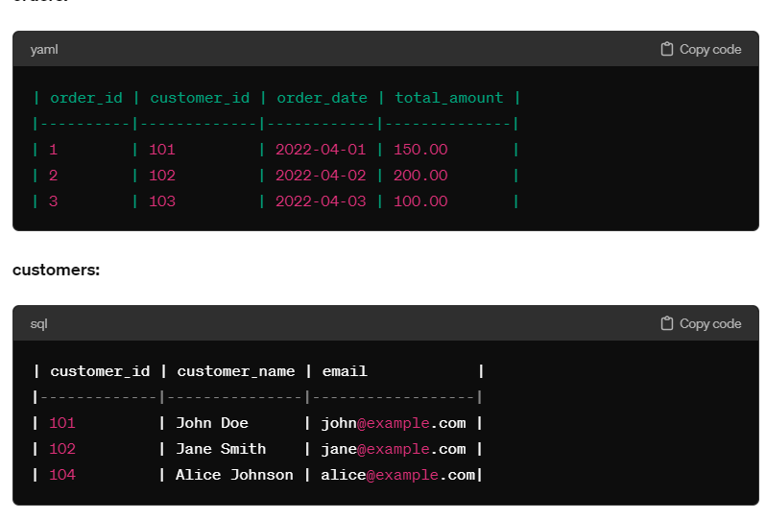

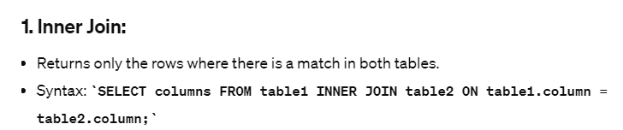

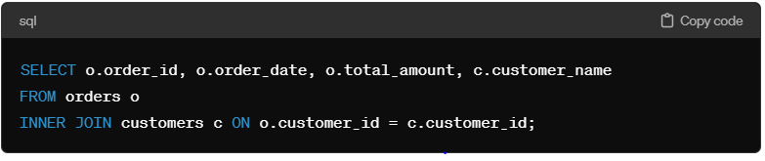

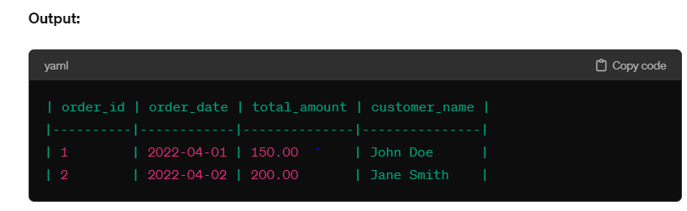

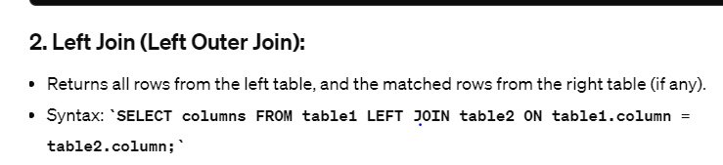

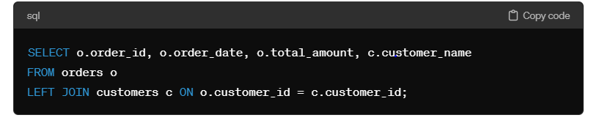

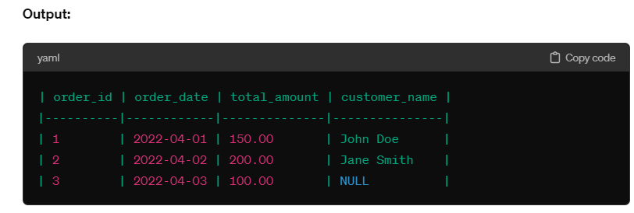

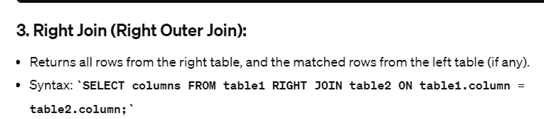

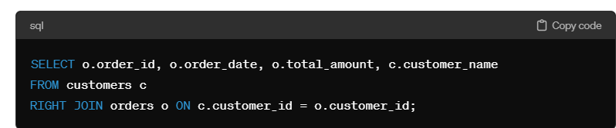

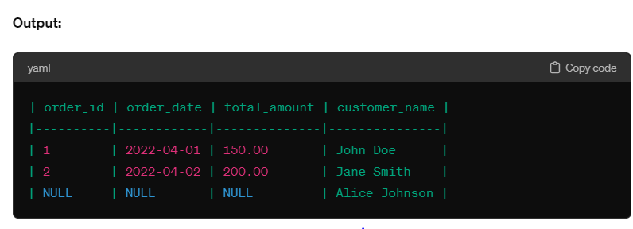

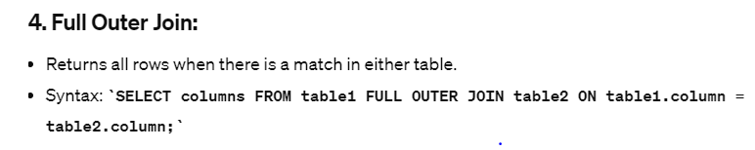

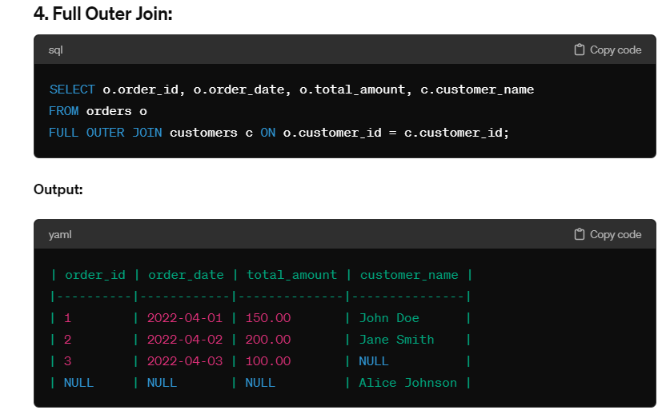

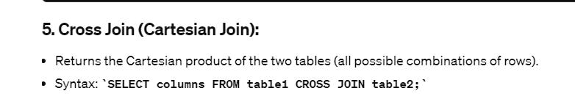

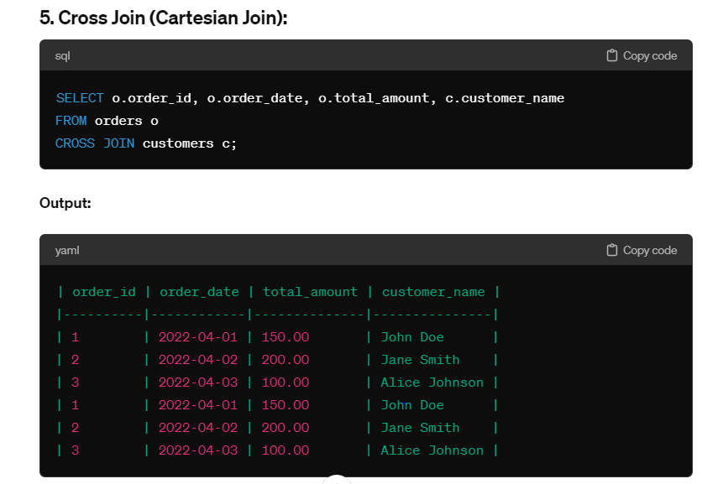

**Question 24**

**What is indexing ?**

## 1. What is Indexing in SQL?

In SQL, indexes are used to improve the performance of queries by allowing the database to quickly locate the data requested by a query. There are two main types of indexes: clustered and non-clustered. It creates a subset of data from a table and stores it to speed up queries being executed. An index is like a phonebook; it has an ordered list of names and their corresponding phone numbers. The phonebook makes it easy to locate a particular person’s phone number quickly, just as an index in SQL helps to locate data quickly.

## 2. Why is Indexing Important?

Without indexing, the database engine would have to search through every row in a table to find the data matching the query’s conditions (Which will slow down the performance of the database query). This can be a time-consuming process, especially at big tables. By creating an index, the database engine can quickly locate the rows that match the search conditions, decreasing the time required to extract data.

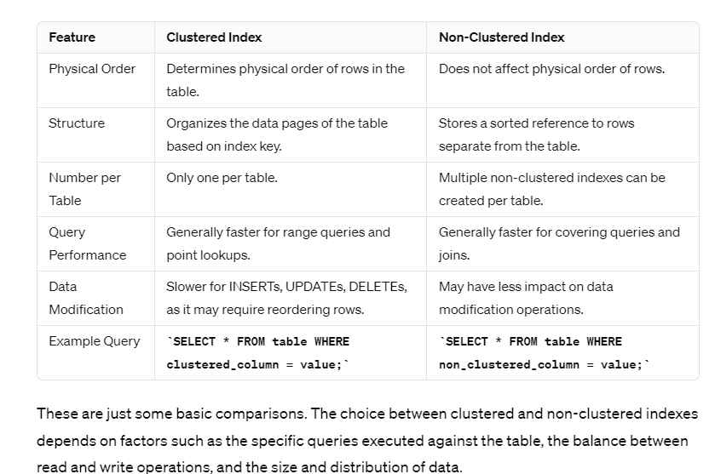

**Question 25**

**Second highest salary ?**

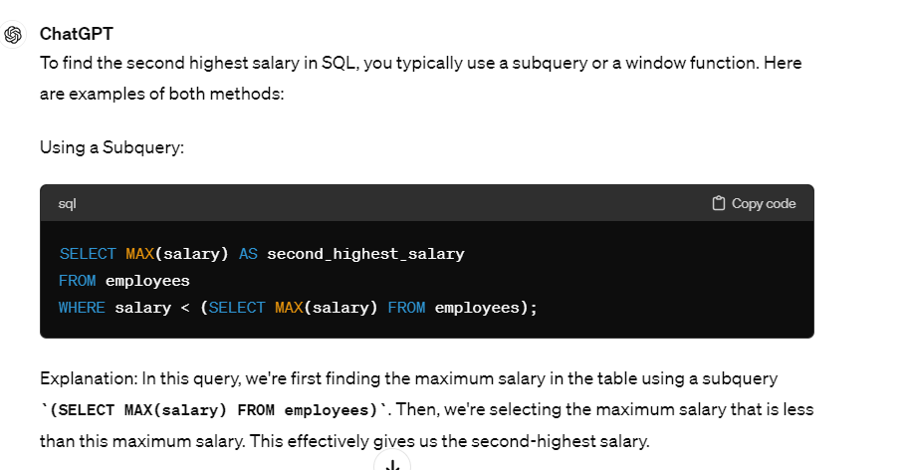

Question 26

**OneTo One mapping**

We can rename foreign key name using joinColumn

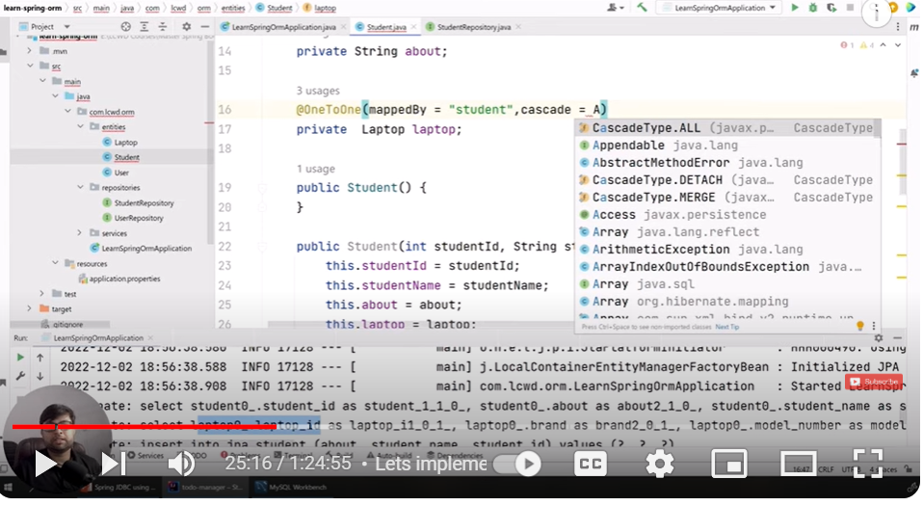

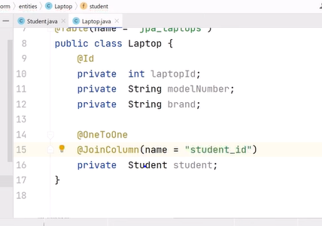

When we save student then laptop will also get saved for this will use **cascadeType.All**

**When**  we perform operation on parent then it will effect on child also.

Example :- when we save parent then child will also get saved.

Now we created student and laptop object and when we save student object then laptop object will get saved automatically.

**Foreign key will create in laptop table**

Advantages of **mappedBy**

**mappedBy :- mapping**  should be done on basic of that field

1. **Avoiding Redundant Foreign Key Columns:** Using **mappedBy** allows you to avoid redundant foreign key columns in the database schema. Instead of having two foreign key columns in each table, one side of the relationship (usually the many side in a one-to-many or many-to-many relationship) will have a foreign key column referencing the other side.

**Question 27**

**cascadesType ?**

The CascadeType.ALL option in JPA allows you to specify that all operations (persist, merge, remove, refresh) should be cascaded from the parent entity to the associated entities.

Here's how CascadeType.ALL works in various scenarios:

1. **Persist (CREATE):** When you persist a parent entity, CascadeType.ALL will cascade the persist operation to all associated entities. This means that if you persist a parent entity, any associated entities that are not yet managed by the EntityManager will also be persisted.
2. **Merge (UPDATE):** When you merge a parent entity, CascadeType.ALL will cascade the merge operation to all associated entities. This means that if you merge a parent entity, any changes made to associated entities will also be merged.
3. **Remove (DELETE):** When you remove a parent entity, CascadeType.ALL will cascade the remove operation to all associated entities. This means that if you remove a parent entity, all associated entities will also be removed from the database.
4. **Refresh:** When you refresh a parent entity, CascadeType.ALL will cascade the refresh operation to all associated entities. This means that if you refresh a parent entity, all associated entities will also be refreshed with the latest data from the database.

It's important to use CascadeType.ALL with caution, especially when dealing with complex object graphs, to avoid unintended side effects such as excessive database operations or circular cascading.

**Example :-**

Sure, here's an example demonstrating the use of CascadeType.ALL in JPA:

Let's consider a simple scenario where we have two entities: **Author** and **Book**, with a one-to-many relationship between them, where one author can have multiple books.

java

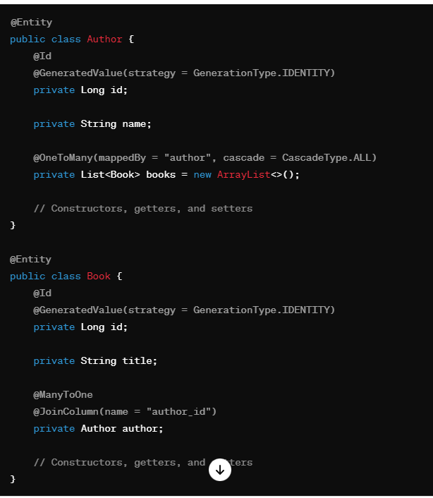

In this example:

* The **Author** class has a one-to-many relationship with the **Book** class. This is represented by the **@OneToMany** annotation on the **books** field in the **Author** class, with **cascade = CascadeType.ALL**.
* The **Book** class has a many-to-one relationship with the **Author** class. This is represented by the **@ManyToOne** annotation on the **author** field in the **Book** class, along with the **@JoinColumn** annotation to specify the foreign key column.

Now, let's see how CascadeType.ALL works in different scenarios:

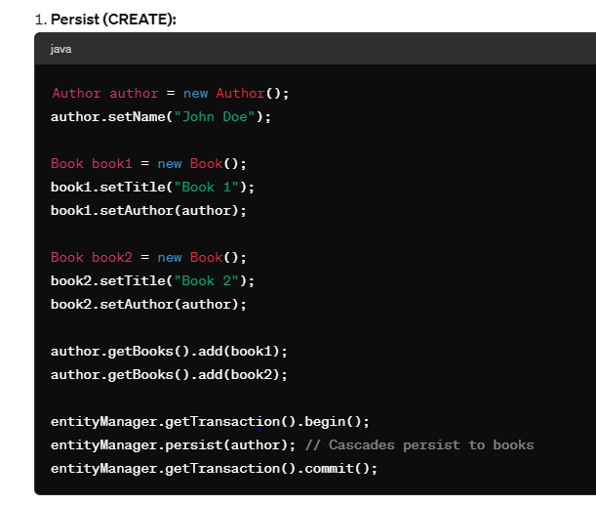

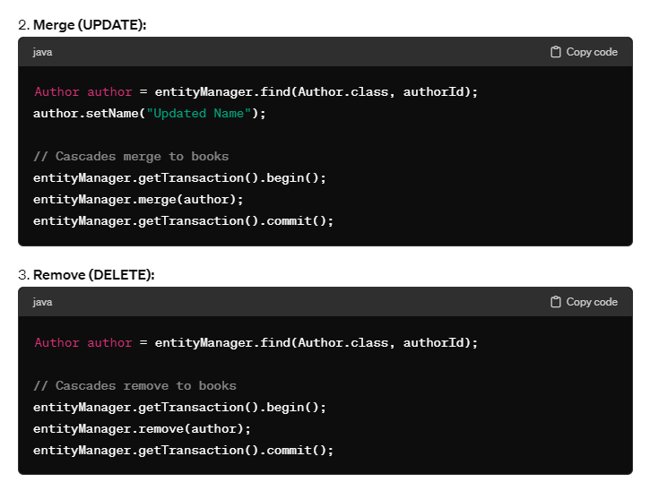

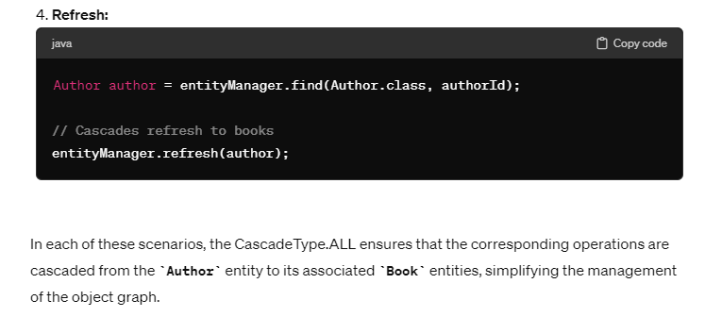

**Question 28:-**

**OneToMany**

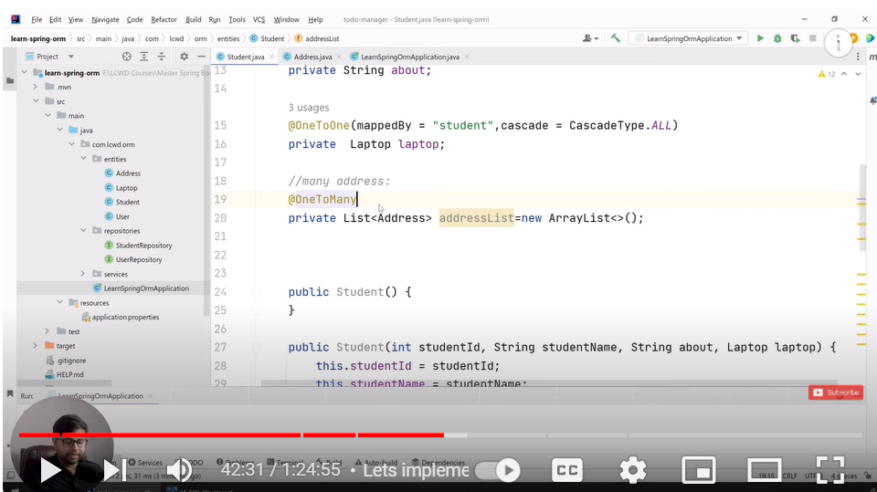

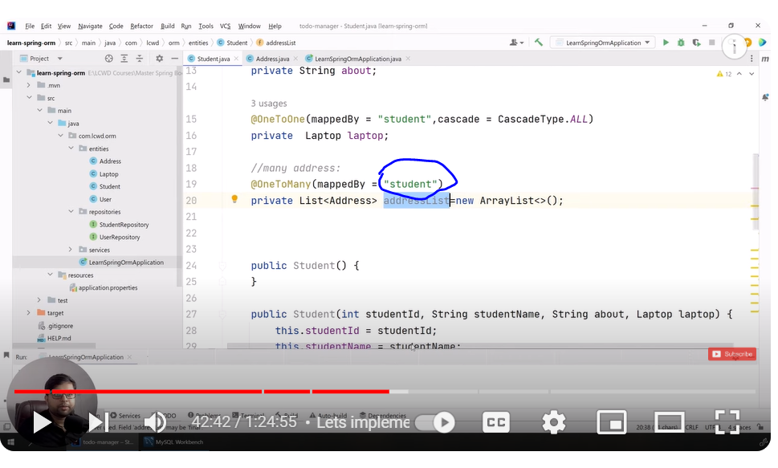

**Mapping should be**  perform on basic of student not on the basic of addressList

Student_is will create as foreign key

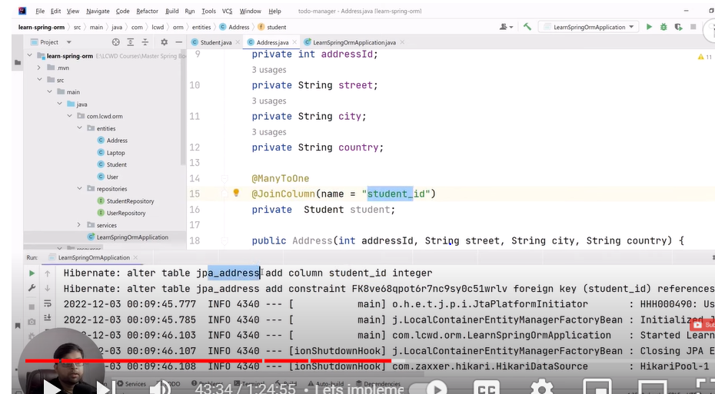

Now mapping will be manage by student Field

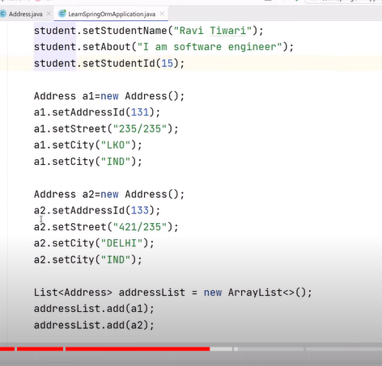

Save both means in student table set address and in address set student. This is bidirectional mapping.

Question 29 :

ManyToMany

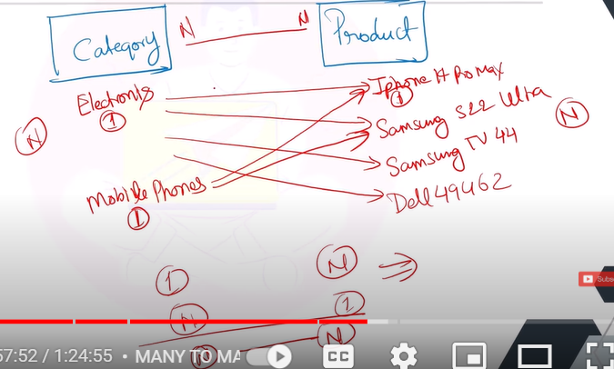

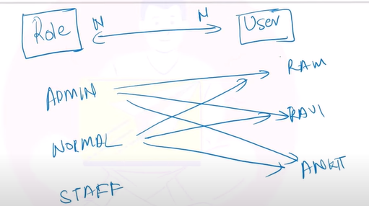

Make only one table to manage categories :------- mappedBy =”categories”

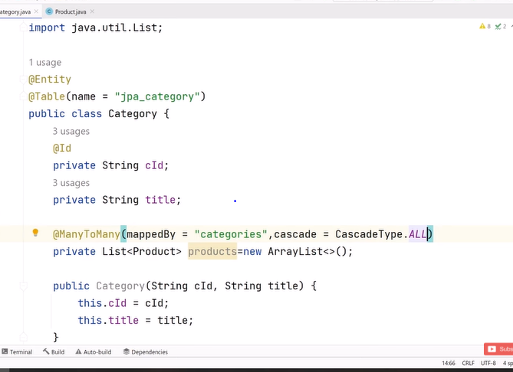

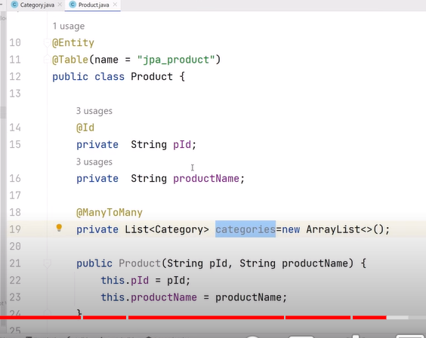

**Three table will create :-**

