Performance and jpa

Q1 : what is object pooling ?

Object pooling is a design pattern and a technique used to manage and reuse objects that are expensive to create or destroy. The main idea behind object pooling is to maintain a pool of pre-initialized objects ready to be used whenever needed, rather than creating new instances from scratch. This can improve performance and reduce memory overhead, especially in scenarios where object creation and destruction are frequent and resource-intensive.

**Benefits of Object Pooling:**

1. **Performance Improvement:** Reusing objects from the pool can eliminate the overhead of object creation and garbage collection.
2. **Resource Management:** Helps manage limited resources (such as database connections, threads) efficiently by limiting the number of concurrently active instances.
3. **Consistency:** Provides a consistent way to acquire and release objects, ensuring they are properly initialized and cleaned up.

### How to Create Object Pooling in Java:

Here’s a basic example of how you can create an object pool in Java using a simple implementation:

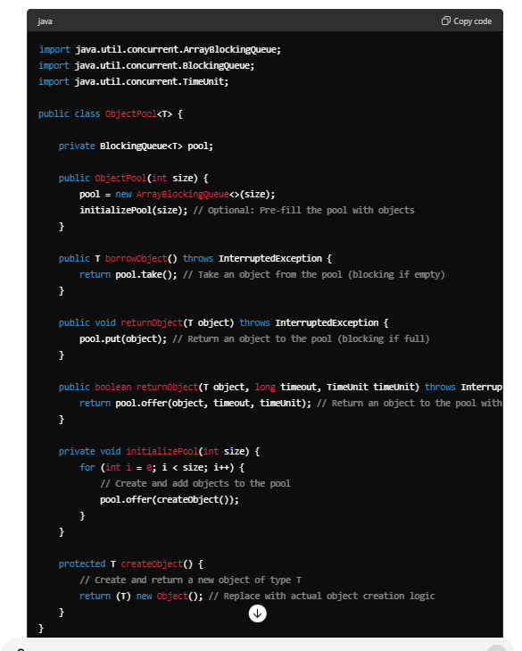

#### Explanation:

* **BlockingQueue (ArrayBlockingQueue):** This is used to hold objects in the pool. It provides thread-safe operations for managing the pool.
* **Constructor (ObjectPool(int size)):** Initializes the pool with a specified number (size) of objects. You can optionally pre-fill the pool by calling initializePool(size).
* **borrowObject() method:** Retrieves an object from the pool. If the pool is empty, this method blocks until an object becomes available.
* **returnObject(T object) method:** Returns an object to the pool. If the pool is full, this method blocks until space becomes available.
* **returnObject(T object, long timeout, TimeUnit timeUnit) method:** Returns an object to the pool with a specified timeout. If the pool is full and the timeout expires, it returns false.
* **createObject() method:** This method is responsible for creating new instances of objects (T). You should replace the simple new Object() with your actual object creation logic.

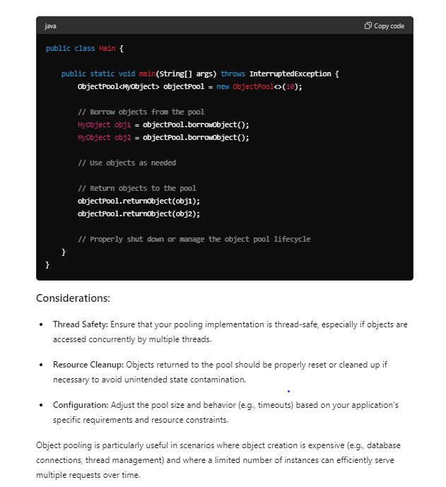

Q2 : what is concurrency ?

Concurrency refers to the ability of an application to execute multiple tasks simultaneously, allowing for efficient utilization of computing resources and improving overall performance. In the context of software development, concurrency typically involves executing multiple threads or processes concurrently within a single program.

Q3 : What are some common performance tuning techniques in Java?

Or

What are the best practices for writing high-performance Java code?

Performance tuning in Java involves optimizing various aspects of Java applications to enhance speed, reduce memory consumption, and improve overall efficiency. Here are some common techniques and strategies used for performance tuning in Java:

**1. Use Efficient Data Structures and Algorithms:**

* Choose the appropriate data structures (e.g., HashMap, ArrayList) and algorithms (e.g., sorting, searching) based on the requirements and expected data sizes.
* Use collections from the java.util.concurrent package for thread-safe operations in concurrent environments.

**2. Memory Management:**

* **Optimize Object Creation**: Minimize unnecessary object creation, especially within loops or frequently accessed methods. Use object pooling or reuse objects where possible.
* **Garbage Collection (GC) Optimization**: Tune GC settings (-Xmx, -Xms, -XX:+UseG1GC, etc.) based on application behavior and memory requirements to minimize pauses and improve throughput.

**3. Concurrency and Multithreading:**

* **Thread Pools**: Use thread pools (ExecutorService) to manage threads efficiently and avoid excessive thread creation overhead.
* **Synchronization**: Minimize synchronization blocks and use non-blocking algorithms or concurrent collections for better scalability.

**4. JVM Tuning:**

* **Heap Management**: Configure heap size (-Xmx, -Xms), garbage collector (-XX:+UseParallelGC, -XX:+UseG1GC) to balance between throughput and pause times.
* **JIT Compilation**: Allow JVM to optimize code with Just-In-Time (JIT) compilation (-XX:+TieredCompilation, -XX:+OptimizeStringConcat).

**5. I/O Operations:**

* **Buffering**: Use buffered I/O streams (BufferedReader, BufferedWriter) to reduce disk I/O operations and improve performance.
* **Asynchronous I/O**: Utilize Java NIO (Non-blocking I/O) for scalable, high-performance I/O operations, especially in network communication.

**6. Profiling and Benchmarking:**

* Use profiling tools (e.g., VisualVM, YourKit) to identify bottlenecks, CPU-intensive methods, memory leaks, and optimize critical paths.
* Benchmark application performance under different loads to measure improvements and validate tuning efforts.

**7. Caching:**

* **Application-Level Caching**: Cache frequently accessed data or results of expensive computations in memory (e.g., using ConcurrentHashMap, Guava Cache) to avoid repeated calculations.
* **Second-Level Caching**: Utilize ORM (Object-Relational Mapping) frameworks like Hibernate for database query caching to reduce database round-trips.

**8. Optimize Code and Algorithms:**

* **Loop Optimization**: Minimize nested loops and optimize loop structures to reduce iteration times.
* **Algorithm Complexity**: Choose algorithms with optimal time and space complexity for the problem at hand (e.g., sorting algorithms, searching algorithms).

**9. Logging and Debugging:**

* **Log Levels**: Use appropriate log levels (DEBUG, INFO, WARN) and avoid excessive logging in performance-critical sections.
* **Debugging**: Use debuggers and logging to identify and resolve performance issues during development and testing phases.

**10. External Resource Management:**

* Properly manage and close external resources like database connections, file handles, network sockets, etc., to prevent leaks and resource exhaustion.

**Conclusion**

Effective performance tuning in Java requires a combination of understanding application requirements, utilizing appropriate tools and techniques for profiling and benchmarking, and continuously monitoring and optimizing critical components. By implementing these techniques, developers can significantly improve the responsiveness, scalability, and efficiency of Java applications in various deployment scenarios.

Q 4: How do you profile a Java application to identify performance bottlenecks?

**9. Document and Monitor**

Document profiling findings, optimizations made, and lessons learned for future reference. Continuously monitor application performance to detect and address new bottlenecks as the application evolves.

**Example Using VisualVM:**

1. **Start VisualVM** and connect to your running Java application.
2. **Profile** CPU usage, memory usage, or threads depending on the area of concern.
3. **Analyze** the profiling snapshots, identify hotspots, memory leaks, or thread contention.
4. **Optimize** your application based on the profiling results.
5. **Monitor** performance to ensure improvements are effective.

Q 5 : What is a memory leak and how can you detect it in a Java application?

A memory leak in a Java application occurs when the application allocates memory for objects but fails to release them properly, even though they are no longer needed. Over time, this can lead to excessive memory consumption, degradation in performance, and eventually, OutOfMemoryError crashes as the available heap space is exhausted.

**Causes of Memory Leaks in Java:**

1. **Improper Object Lifecycle Management**:
   * Objects that are not explicitly dereferenced or cleared when no longer needed.
   * References held unintentionally longer than necessary, preventing garbage collection.
2. **Static References**:
   * Static fields holding references to objects that are not cleared when no longer required, preventing them from being garbage collected.
3. **Incorrect Cache Management**:
   * Caches that hold onto objects indefinitely without implementing eviction policies or clearing stale entries.
4. **Listener or Callback Registration**:
   * Failure to deregister listeners or callbacks can lead to objects being held in memory longer than needed.
5. **Thread Mismanagement**:
   * Threads that are started but not properly terminated can prevent associated objects from being garbage collected.

**Detecting Memory Leaks in Java:**

Detecting memory leaks typically involves using profiling tools and techniques to analyze memory usage patterns and identify areas where memory is not being reclaimed properly. Here are common approaches to detect memory leaks in Java applications:

1. **Profiling Tools**:
   * **VisualVM**: A visual tool bundled with the JDK that provides memory profiling capabilities. Monitor heap usage, object instances, and identify potential memory leaks.
   * **YourKit**: A commercial profiler offering detailed memory usage analysis, object allocation tracking, and heap snapshot comparisons.
   * **Eclipse MAT (Memory Analyzer Tool)**: Analyze heap dumps to identify memory leaks, analyze memory usage trends, and inspect retained objects.
2. **Heap Dump Analysis**:
   * Generate heap dumps using tools like jmap, jcmd, or from within profiling tools.
   * Load heap dumps into memory analysis tools to inspect object retention paths, identify objects consuming excessive memory, and understand relationships between objects.
3. **Memory Leak Patterns**:
   * Look for signs such as continuously growing heap usage over time or frequent garbage collections indicating high object retention.
4. **GC Logs Analysis**:
   * Enable verbose GC logging (-verbose:gc, -Xloggc:<file>) to monitor GC activity and identify abnormal GC behavior such as frequent full GCs or long GC pauses.
5. **Code Review and Analysis**:
   * Review application code for potential memory leak sources such as static references, improper cache management, unclosed resources, or unreleased listeners/callbacks.
6. **Monitor Memory Usage Metrics**:
   * Monitor memory usage metrics (heap size, non-heap size, object counts) over time using monitoring tools or application logs to detect abnormal memory consumption patterns.

**Steps to Mitigate and Fix Memory Leaks:**

Once a memory leak is identified, take the following steps to mitigate and fix it:

* **Refactor Code**: Ensure proper object lifecycle management, correct use of static references, and implement appropriate cache eviction strategies.
* **Fix Resource Handling**: Close resources (FileInputStream, Database Connections) properly using try-with-resources or finally blocks.
* **Clear Unused References**: Set unused references to null when no longer needed to allow them to be garbage collected.
* **Implement Weak References**: Use WeakReference, SoftReference, or PhantomReference for objects that can be reclaimed by the GC when memory pressure is high.
* **Test and Validate**: Validate fixes with automated tests and monitor application behavior post-fix to ensure memory leak resolution.

By leveraging profiling tools, heap dump analysis, and vigilant monitoring, developers can effectively detect, diagnose, and resolve memory leaks in Java applications, ensuring optimal performance and stability over time.

Q 6: How can you optimize the performance of a Spring Boot application?

Optimizing the performance of a Spring Boot application involves various strategies aimed at improving responsiveness, scalability, and resource utilization. Here are key approaches to optimize the performance of your Spring Boot application:

**1. Database Optimization:**

* **Efficient Queries**: Use indexed columns, appropriate SQL queries, and ORM optimizations (like Hibernate) to minimize database load and query execution time.
* **Connection Pooling**: Configure connection pooling (e.g., HikariCP) to reuse database connections efficiently, reducing overhead from connection establishment.

**2. Caching Strategies:**

* **Application-Level Caching**: Utilize caching mechanisms (e.g., Spring Cache Abstraction with providers like EhCache, Redis) to cache frequently accessed data and reduce database or external API calls.
* **Response Caching**: Implement HTTP response caching using annotations (@Cacheable, @CacheEvict) or Spring's CacheControl for static content to reduce server load.

**3. Optimizing Code and Algorithms:**

* **Reduce Object Creation**: Minimize unnecessary object creation within critical sections of code to reduce memory allocation overhead.
* **Optimize Loops and Data Structures**: Use efficient data structures (e.g., HashMap instead of ArrayList for fast lookups) and algorithms (e.g., sorting, searching) with optimal time complexity.

**4. Concurrency Management:**

* **Thread Pooling**: Configure and manage thread pools (e.g., using ThreadPoolTaskExecutor) to handle concurrent requests efficiently without exhausting system resources.
* **Asynchronous Processing**: Utilize Spring's @Async and CompletableFuture for non-blocking asynchronous processing of tasks to improve responsiveness.

**5. JVM and Garbage Collection (GC) Tuning:**

* **Heap Management**: Adjust JVM heap size (-Xmx, -Xms) based on application memory requirements to prevent frequent GC pauses and OutOfMemoryErrors.
* **GC Algorithm**: Choose and tune the appropriate GC algorithm (e.g., G1GC) and parameters (-XX:MaxGCPauseMillis, -XX:+UseConcMarkSweepGC) to balance throughput and pause times.

**6. HTTP Client Optimization:**

* **Connection Pooling**: Configure HTTP client (e.g., RestTemplate, WebClient) connection pooling settings to reuse connections and reduce latency in making external API calls.
* **Timeouts and Retries**: Set appropriate timeouts and retry policies for HTTP requests to handle network latency and transient failures effectively.

**7. Monitoring and Profiling:**

* **Use Profiling Tools**: Utilize tools like VisualVM, YourKit, or built-in Spring Boot Actuator endpoints (/actuator/metrics, /actuator/heapdump) to monitor application performance, memory usage, and identify bottlenecks.
* **Log Analysis**: Analyze application logs for performance metrics, exceptions, and slow query logs to pinpoint areas requiring optimization.

**8. Deployment and Infrastructure Optimization:**

* **Containerization**: Deploy Spring Boot applications as Docker containers for efficient resource isolation and scalability.
* **Auto-Scaling**: Utilize cloud-native features (e.g., AWS Auto Scaling, Kubernetes Horizontal Pod Autoscaler) to automatically scale application instances based on demand.

**9. Security Optimization:**

* **Minimize Overhead**: Implement security measures (e.g., Spring Security) efficiently without impacting performance, using appropriate caching and session management strategies.

**10. Testing and Benchmarking:**

* **Performance Testing**: Conduct load testing (e.g., using JMeter) to simulate production workloads and measure application performance under stress.
* **Benchmarking**: Compare performance metrics before and after optimizations to validate improvements and identify regressions.

**Conclusion:**

Optimizing the performance of a Spring Boot application involves a holistic approach, combining efficient coding practices, strategic use of frameworks and tools, thoughtful deployment strategies, and continuous monitoring and tuning. By systematically applying these strategies, developers can achieve significant improvements in application responsiveness, scalability, and overall user experience.

Q 7: Explain the concept of caching in Java and how it improves performance.

Caching in Java refers to the technique of storing frequently accessed or expensive-to-compute data in a temporary storage area (cache) to accelerate subsequent access. It enhances application performance by reducing the need to repeatedly fetch or compute the same data, thereby saving time and computational resources. Here’s a detailed explanation of caching in Java and its benefits:

### How Caching Works:

1. **Data Storage**: Caches store data in memory (or sometimes on disk) closer to the application, making access faster compared to fetching data from remote sources such as databases or external APIs.
2. **Key-Value Mapping**: Cached data is typically stored in a key-value format, where each piece of data is associated with a unique key. This allows for quick lookup and retrieval.
3. **Expiration and Eviction**: Caches often have mechanisms to control data lifespan (expiration) and manage memory usage by evicting least recently used (LRU) or least frequently used (LFU) entries when the cache reaches its capacity limit.

### Benefits of Caching:

1. **Improved Performance**: By reducing latency associated with fetching data from slower sources (like databases or network), caching speeds up data access operations.
2. **Reduced Resource Consumption**: Caching reduces the load on backend systems (such as databases or APIs), lowering the overall resource consumption and improving scalability.
3. **Enhanced Scalability**: Applications can handle more concurrent users or requests without overloading backend systems, thus scaling more efficiently.
4. **Better User Experience**: Faster response times lead to a smoother and more responsive user experience, especially for applications handling large volumes of data or frequent user interactions.
5. **Cost Efficiency**: Caching reduces operational costs by minimizing the need for expensive computing resources or infrastructure upgrades to handle increased load.

### Types of Caching in Java:

1. **Application-Level Caching**: Implemented within the application using data structures like HashMaps or ConcurrentHashMaps. Frameworks like EhCache, Guava Cache, or Spring’s Cache Abstraction provide more advanced features such as expiration policies, cache eviction strategies, and integration with distributed caching solutions.
2. **HTTP Caching**: Utilized for caching HTTP responses at the client (browser) or intermediate proxies (like CDN). It uses headers like Cache-Control and ETag to control caching behavior.
3. **Distributed Caching**: Maintains caches across multiple nodes or servers in a distributed environment to provide scalability and fault tolerance. Examples include Redis, Memcached, or Hazelcast.

### Example Scenario:

Consider a Spring Boot application that fetches user profiles from a database upon user login. Instead of querying the database on every login request, the application can cache user profiles in-memory for a certain duration (e.g., 5 minutes). Subsequent login requests for the same user within this timeframe can retrieve the profile from the cache, significantly reducing database load and improving login response times.

### Implementation Considerations:

* **Cache Invalidation**: Ensure cached data remains consistent with the backend data source. Implement strategies to invalidate or refresh cache entries when data changes.
* **Cache Size and Memory Management**: Monitor cache size and memory usage to prevent excessive memory consumption. Use eviction policies (LRU, LFU) to manage cache entries efficiently.
* **Concurrency and Thread Safety**: Ensure thread safety when accessing and updating cached data, especially in multi-threaded environments.

### Conclusion:

Caching is a fundamental optimization technique in Java applications that boosts performance by storing frequently accessed data closer to the application, reducing latency and resource consumption. By carefully implementing and managing caches, developers can achieve significant performance improvements and deliver faster, more responsive applications to users.

Q 8:- How do you handle high concurrency in a Java application?

Handling high concurrency in a Java application involves ensuring that the application can efficiently manage and process multiple concurrent requests or operations without compromising performance, scalability, or data consistency. Here are key strategies and techniques to handle high concurrency effectively:

**1. Use Thread Pools:**

* **ExecutorService**: Utilize ExecutorService from java.util.concurrent to manage and reuse threads efficiently. Configure thread pools with appropriate sizes (ThreadPoolExecutor) to balance between resource utilization and responsiveness.

java

Copy code

ExecutorService executor = Executors.newFixedThreadPool(Runtime.getRuntime().availableProcessors());

**2. Thread Safety and Synchronization:**

* Ensure thread safety for shared resources using synchronization mechanisms (synchronized blocks, ReentrantLock, ReadWriteLock) to prevent data corruption and race conditions.

java

Copy code

private final Object lock = new Object();

public void synchronizedMethod() {

synchronized (lock) {

// Critical section

}

}

**3. Use Concurrent Data Structures:**

* Replace traditional collections with concurrent alternatives (ConcurrentHashMap, CopyOnWriteArrayList) when multiple threads need to access or modify shared data concurrently.

java

Copy code

ConcurrentMap<String, Integer> concurrentMap = new ConcurrentHashMap<>();

**4. Asynchronous Processing:**

* Utilize asynchronous programming techniques (CompletableFuture, @Async in Spring) to execute non-blocking operations and improve responsiveness, especially for I/O-bound tasks.

java

Copy code

CompletableFuture<Void> future = CompletableFuture.runAsync(() -> {

// Asynchronous task

});

**5. Optimize Database Access:**

* Use connection pooling (HikariCP, Tomcat JDBC Pool) to efficiently manage database connections and minimize overhead from connection establishment.
* Batch database operations (PreparedStatement.addBatch(), executeBatch()) to reduce round-trips and improve throughput.

**6. Cache Frequently Accessed Data:**

* Implement caching mechanisms (EhCache, Redis) to store and retrieve frequently accessed data from memory, reducing latency and database load.

java

Copy code

@Cacheable("books")

public Book findBookById(Long id) {

// Fetch book from database

}

**7. Avoid Blocking Operations:**

* Minimize or eliminate blocking operations (e.g., I/O operations, long-running computations) in critical code paths to prevent thread contention and improve overall throughput.

**8. Fine-Tune JVM and Garbage Collection:**

* Configure JVM heap size (-Xmx, -Xms) and GC parameters (-XX:+UseG1GC, -XX:MaxGCPauseMillis) to optimize memory management and reduce GC pauses that can impact concurrency.

**9. Use Non-blocking Algorithms:**

* Consider non-blocking algorithms and data structures (e.g., java.util.concurrent.atomic package, java.util.concurrent.locks) for scenarios where lock contention is a concern.

**10. Monitor and Tune:**

* Continuously monitor application performance metrics (e.g., CPU utilization, thread pool metrics, database queries) using monitoring tools and profiling (e.g., VisualVM, Prometheus) to identify bottlenecks and optimize as needed.

**Example Scenario:**

java

Copy code

// Example of using ExecutorService for concurrent task execution

ExecutorService executor = Executors.newFixedThreadPool(10);

for (int i = 0; i < 100; i++) {

executor.submit(() -> {

// Task executed concurrently

});

}

executor.shutdown();

executor.awaitTermination(10, TimeUnit.SECONDS);

**Conclusion:**

Handling high concurrency in a Java application requires careful consideration of threading models, synchronization mechanisms, efficient resource management, and leveraging asynchronous processing and caching. By implementing these strategies effectively, developers can ensure that their applications can scale and perform well under heavy concurrent loads, providing a responsive and reliable user experience.

JPA

Q1: Explain the difference between JPA and Hibernate.

• **JPA** is a standard API specification for ORM in Java, allowing developers to interact with various ORM providers.

• **Hibernate** is one of the most popular ORM frameworks and also implements the JPA specification, providing additional features and optimizations beyond the standard JPA API.

• **Flexibility vs Specificity:** JPA provides flexibility to switch between ORM frameworks by changing providers, while Hibernate refers specifically to the features and optimizations provided by the Hibernate ORM framework.

Q2 : What is the purpose of the @Entity annotation in JPA?

The @Entity annotation in JPA (Java Persistence API) serves a crucial role in defining a Java class as an entity, which can be persisted to a database table. Here’s a detailed explanation of its purpose and significance:

**Purpose of @Entity Annotation:**

1. **Entity Definition:**
   * The primary purpose of the @Entity annotation is to designate a Java class as an entity. An entity in JPA represents a table in a relational database.
   * Each instance of an entity class corresponds to a row in the database table. Therefore, the entity class serves as a blueprint for database interactions, enabling objects to be stored, retrieved, updated, and deleted using JPA.
2. **Mapping to Database Table:**
   * When you annotate a Java class with @Entity, JPA recognizes this class as representing an entity that can be mapped to a database table.
   * The entity's attributes (fields or properties) typically correspond to columns in the database table. Annotations such as @Column, @Id, @GeneratedValue, @JoinColumn, etc., are used in conjunction with @Entity to define the mapping details.
3. **Metadata for Persistence Context:**
   * The @Entity annotation marks the class for inclusion in the persistence context, allowing JPA to manage its lifecycle (such as managing transactions, caching, and relationships with other entities).
   * It ensures that the entity is eligible for persistence operations (like insert, update, delete) using JPA’s EntityManager API.

Q 3: explain the concept of lazy loading ?

Lazy loading is a fundamental feature of Hibernate that enhances performance by fetching associated entities or collections from the database only when needed. It optimizes memory usage and reduces unnecessary database queries, contributing to efficient data retrieval and improved application responsiveness. Understanding and appropriately configuring lazy loading in Hibernate is essential for developing scalable and performant applications that interact with relational databases