**Interview Question**

**Question 1**

**Difference between GetMapping and RequestMapping ?**

In Spring Framework, **@RequestMapping** and **@GetMapping** are **both used to map HTTP requests to handler methods** in your Spring MVC controllers, but they have some differences:

1. **Purpose**:
   * **@RequestMapping**: This annotation is a general-purpose annotation used to map HTTP requests to handler methods. It can be used to handle any HTTP method (GET, POST, PUT, DELETE, etc.).
   * **@GetMapping**: This is a specialized version of **@RequestMapping** that specifically maps HTTP GET requests to handler methods. It's a shortcut **for @RequestMapping(method = RequestMethod.GET).**
2. **Readability and Expressiveness**:
   * **@GetMapping** is more expressive and concise when you specifically want to handle GET requests. It makes the code more readable by indicating the intent clearly.

**Question 2**

**Which is more efficient xml based or annotation based ?**

In Spring Framework, both XML configuration and annotation-based **@Autowired** can be efficient, but each has its own advantages and disadvantages:

1. **XML Configuration**:
   * **Pros**:
     + Explicit configuration: XML configuration provides a clear, explicit definition of dependencies and their injection points.
     + Easier to understand for some developers: Especially for developers familiar with XML configuration or for larger projects with complex dependency graphs, XML can offer a clearer overview of the application's wiring.
   * **Cons**:
     + More verbose: XML configuration tends to be more verbose compared to annotation-based configuration, which can lead to larger configuration files and potentially more maintenance overhead.
     + Less type safety: XML configuration doesn't provide compile-time checks for dependencies, so errors in configuration may only be detected at runtime.
2. **Annotation-based @Autowired**:
   * **Pros**:
     + Concise and expressive: Annotations such as **@Autowired** reduce boilerplate code and provide a more concise and expressive way to configure dependencies.
     + Compile-time safety: Since annotations are processed by the compiler, dependency issues like missing beans or incorrect types are caught at compile time, reducing the chances of runtime errors.
   * **Cons**:
     + Implicit configuration: While annotations make the code more concise, they can also make the dependency wiring less explicit, especially for developers new to the codebase or for larger projects where it might be harder to trace dependencies.

**Efficiency**:

* **In terms of runtime performance, there's usually negligible difference between XML configuration and annotation-based @Autowired**. Both approaches result in similar dependency injection mechanisms once the application context is created.
* However, in terms of developer efficiency and readability, the choice between XML and annotation-based configuration often comes down to personal preference, team conventions, or specific project requirements.

Question 3

What is aware interface?

In the Spring Framework, an "Aware" interface is a set of marker interfaces that allow beans to obtain references to certain resources or services provided by the Spring container. These interfaces provide a way for beans to interact with the container and access container-managed features without directly depending on the container itself.

"Aware" interfaces typically follow a naming convention where the interface name ends with "Aware". Beans implement these interfaces to signal their interest in obtaining specific services or resources from the container.

Here are some commonly used "Aware" interfaces in Spring:

1. **ApplicationContextAware**: Allows beans to obtain a reference to the ApplicationContext, enabling access to other beans and application context metadata.
2. **BeanFactoryAware**: Allows beans to obtain a reference to the BeanFactory, which is the core container interface responsible for managing beans and their dependencies.
3. **BeanNameAware**: Allows beans to obtain their own bean name within the container.
4. **ResourceLoaderAware**: Allows beans to obtain a ResourceLoader, which can be used to load external resources such as files or URLs.
5. **EnvironmentAware**: Allows beans to obtain the Environment, which provides access to properties and configuration settings.
6. **MessageSourceAware**: Allows beans to obtain a MessageSource, which is used for internationalization (i18n) and localization (l10n) support.

By implementing one or more of these "Aware" interfaces, beans can gain access to container-managed resources or services. Spring will automatically detect beans that implement these interfaces and inject the corresponding resources or services when instantiating the beans.

For example, if a bean needs access to the application context, it can implement the ApplicationContextAware interface and define a method to receive the ApplicationContext reference. Spring will automatically inject the ApplicationContext when instantiating the bean, allowing it to access other beans or application context features as needed

**Question 4**

**Creating customize ioc container ?**

Creating a fully functional and complete IoC container from scratch would be quite extensive, but here's a more expanded version of the previous example demonstrating a simple IoC container with basic dependency injection and bean lifecycle management:

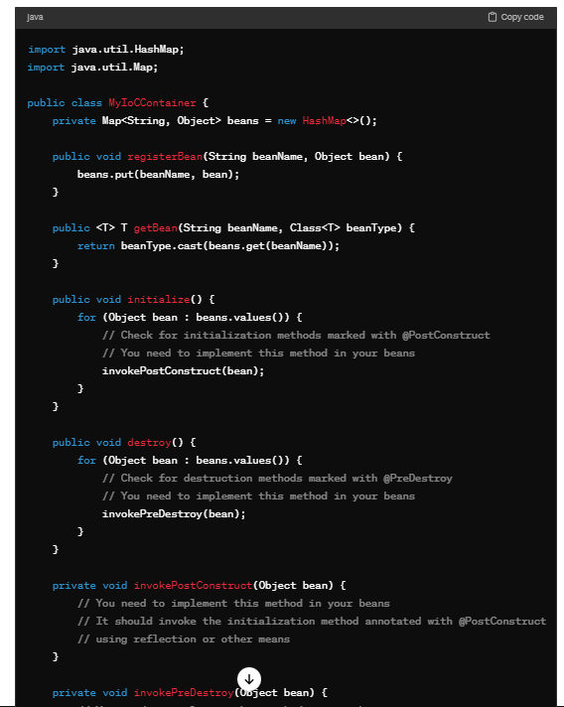

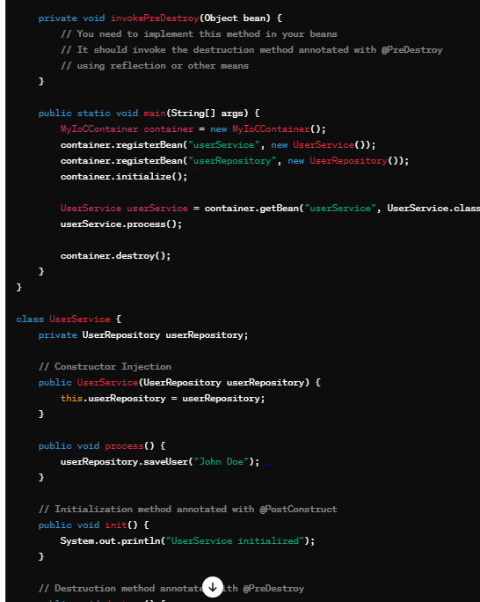

This code demonstrates the basic principles of an IoC container:

1. **MyIoCContainer** registers beans and provides methods for retrieving beans by name.
2. The **UserService** class demonstrates constructor injection of the **UserRepository** dependency.
3. **UserService** and **UserRepository** have initialization and destruction methods annotated with **@PostConstruct** and **@PreDestroy**, respectively. You need to implement the logic for invoking these methods using reflection or other means.
4. The **main** method in the **MyIoCContainer** class demonstrates the usage of the container to wire dependencies and manage bean lifecycles.

Remember, this is a simplified example. A real-world IoC container would need to handle many additional features and edge cases, such as different bean scopes, circular dependencies, property injection, autowiring, configuration, aspect-oriented programming, and more. Building a fully-featured IoC container is a non-trivial task and requires a deep understanding of both Java and the Spring Framework.

**Question 5**

**Exception handling in spring level ?**

Exception handling in Spring can be managed at various levels, including:

1. **Controller Advice**: Spring provides the **@ControllerAdvice** annotation, which allows you to define global exception handling logic for all controllers or specific controller packages. You can annotate methods within a class marked with **@ControllerAdvice** with **@ExceptionHandler** to handle specific types of exceptions. These methods can return a ResponseEntity to customize the HTTP response.

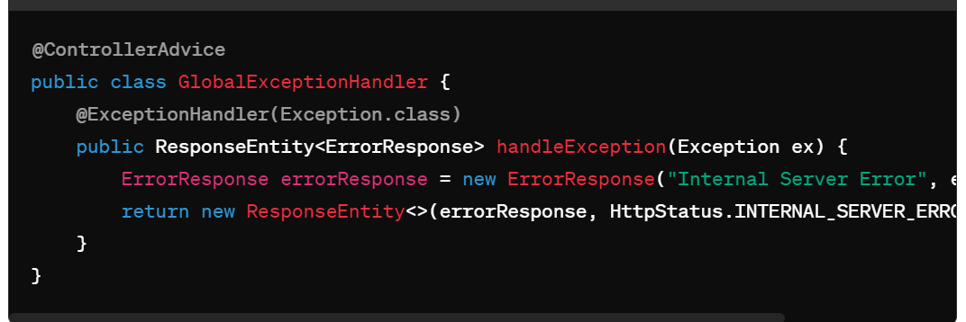

**Controller-specific Exception Handling**: You can also define exception handling logic directly in your controllers by annotating methods with **@ExceptionHandler**. This approach allows you to handle exceptions specific to a particular controller.

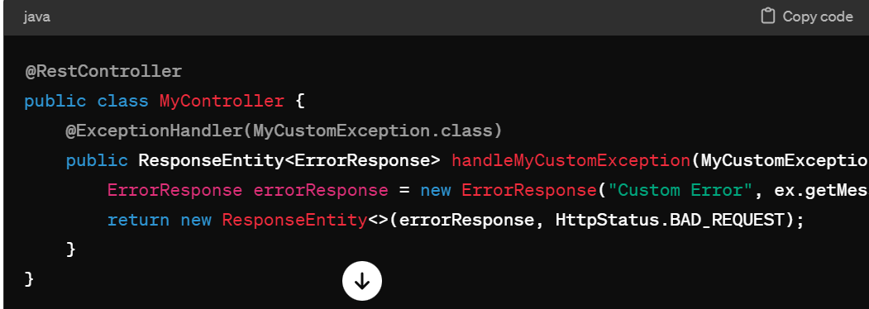

**3 Default Exception Handling**: Spring provides default exception handling mechanisms that apply if no specific exception handler is defined. By default, Spring converts exceptions into an HTTP status code and returns an error response.

**Question 6:**

**Handle out of memory error ?**

Handling an OutOfMemoryError in Java, which occurs when the Java Virtual Machine (JVM) runs out of memory, is challenging because it typically indicates a serious problem with the application or the environment. Here are some strategies to deal with it:

1. **Increase JVM Memory**: One immediate solution is to increase the memory allocated to the JVM using the **-Xmx** option. However, this is often just a temporary fix and may not address the root cause of the problem.

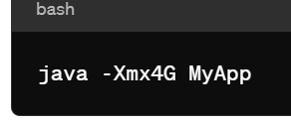

1. **Identify Memory Leaks**: Use tools like VisualVM, jconsole, or YourKit to monitor memory usage and identify memory leaks. Memory leaks occur when objects are not properly released by the garbage collector, leading to excessive memory consumption over time.
2. **Heap Dump Analysis**: When an OutOfMemoryError occurs, you can generate a heap dump using tools like jmap or VisualVM. Analyze the heap dump to identify which objects are consuming the most memory and causing the error.

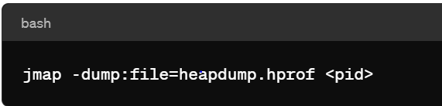

1. **Profiling**: Use profiling tools like YourKit or JProfiler to analyze memory usage and identify bottlenecks in the application.
2. **Code Review**: Review your code for potential memory leaks, inefficient data structures, or excessive object creation. Consider optimizing data structures and algorithms to reduce memory usage.
3. **Implement Memory Management**: Implement memory management techniques such as object pooling, lazy loading, or caching to reduce memory consumption.
4. **Graceful Shutdown**: If an OutOfMemoryError occurs, it may be advisable to gracefully shut down the application to prevent further damage or data corruption.

**Question 7**

**Insert million records in db efficiently ?**

Certainly! Here's a simple example of how you can insert millions of records into a database efficiently using Spring Boot, specifically using JPA (Java Persistence API) for database operations:

First, ensure you have your Spring Boot application set up with the necessary dependencies in your **pom.xml** file. You'll need dependencies for Spring Boot, Spring Data JPA, and your database driver.

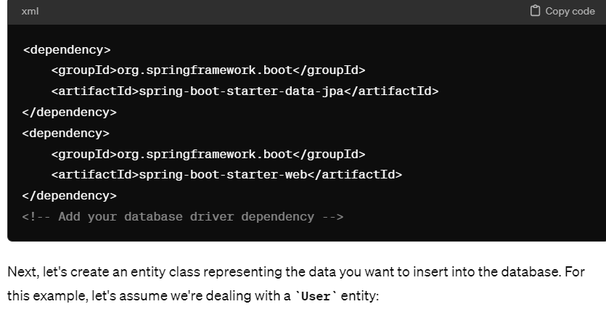

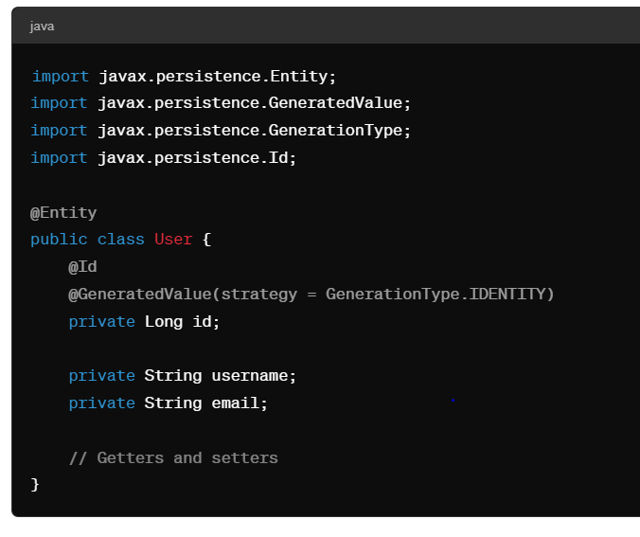

Now, let's create a service class that will handle the insertion of millions of **User** records. We'll use batch insertion for improved performance.

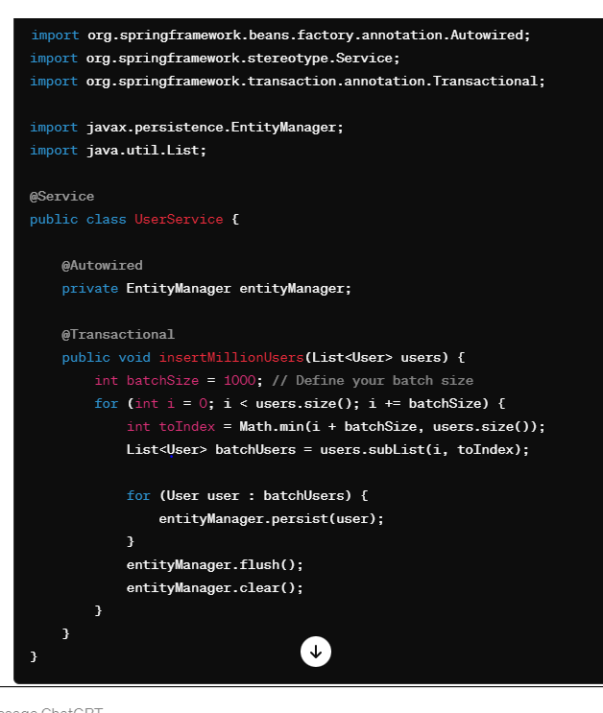

In this service class:

* We use the **@Transactional** annotation to ensure that the insertion operation is transactional, and if an exception occurs, the transaction will be rolled back.
* We use the **EntityManager** to interact with the database. **persist()** is used to save each **User** entity.
* We flush and clear the **EntityManager** after each batch insertion to release memory and improve performance.

Finally, you can inject and use this service class in your controller or any other component where you want to trigger the insertion process. Populate a list with millions of **User** objects and pass it to the **insertMillionUsers()** method.

Remember to configure your database connection details in your **application.properties** or **application.yml** file.

This setup will efficiently insert millions of records into your database using Spring Boot and JPA. Adjust the batch size and other parameters as needed based on your specific requirements and environment constraints.

**Question 8:**

**Oauth concept using real world example ?**

OAuth (Open Authorization) is an open standard for access delegation commonly used as a way for Internet users to grant websites or applications access to their information on other websites but without giving them the passwords. OAuth is widely used for secure authentication and authorization in microservices architectures, allowing users to access multiple services without sharing their credentials with each service individually.

Let's consider a real-time example to understand OAuth in a Spring Boot microservices architecture:

**Scenario**: Imagine a microservices-based application called "SocialMediaApp" where users can sign in, post updates, and view their friends' updates.

**Components**:

1. **Authentication Service**: Responsible for handling user authentication and issuing access tokens.
2. **User Service**: Manages user profiles and friendships.
3. **Post Service**: Handles posting updates and fetching posts.
4. **Client Application**: A web or mobile application that interacts with the microservices.

**Flow**:

1. **User Authentication**:
   * When a user wants to sign in to the "SocialMediaApp," they are redirected to the Authentication Service's login page.
   * The user provides their credentials (username/password) to the Authentication Service.
   * If the credentials are valid, the Authentication Service generates an access token representing the user's identity and permissions.
2. **Access Token Issuance**:
   * The Authentication Service issues an access token to the client application.
   * The access token contains information about the user's identity, permissions (scopes), and expiration time.
3. **Accessing Protected Resources**:
   * When the client application wants to access protected resources (e.g., user profile, posts), it includes the access token in the request headers.
   * The microservices (User Service, Post Service) validate the access token with the Authentication Service.
   * If the access token is valid and authorized for the requested resource, the microservice fulfills the request.
4. **Token Refresh**:
   * Access tokens have a limited lifespan. When an access token expires, the client application can request a new access token using a refresh token.
   * The refresh token is sent to the Authentication Service, and if valid, a new access token is issued without requiring the user to log in again.

**Question 9**

**Explain JWT**

JWT (JSON Web Token) is a compact, URL-safe means of representing claims to be transferred between two parties securely. It's commonly used for authentication and authorization in web applications and microservices architectures. Let's explore JWT with a real-world example:

**Scenario**: Consider a web application called "E-commerce Store" where users can browse products, add them to their cart, and make purchases. The application needs to authenticate users and authorize their access to certain resources (e.g., product catalog, shopping cart).

**Components**:

1. **Authentication Service**: Responsible for user authentication and generating JWTs.
2. **Resource Server**: Provides protected resources (e.g., product catalog, shopping cart) and validates JWTs.
3. **Client Application**: A web or mobile application that interacts with the Authentication Service and Resource Server.

**Flow**:

1. **User Authentication**:
   * When a user wants to log in to the "E-commerce Store," they provide their credentials (username/password) to the Authentication Service.
   * The Authentication Service verifies the credentials and generates a JWT containing user information (claims), such as user ID and roles.
2. **JWT Generation**:
   * The Authentication Service signs the JWT with a secret key and includes expiration time and other metadata.
   * The JWT is returned to the client application as part of the authentication response.
3. **Accessing Protected Resources**:
   * When the client application wants to access protected resources (e.g., product catalog, shopping cart), it includes the JWT in the request headers.
   * The Resource Server validates the JWT's signature and ensures that it hasn't expired.
   * If the JWT is valid and authorized for the requested resource, the Resource Server provides the requested data.
4. **Token Refresh (Optional)**:
   * JWTs have a limited lifespan. If needed, the client application can request a new JWT by exchanging a refresh token with the Authentication Service.
   * The Authentication Service verifies the refresh token and issues a new JWT without requiring the user to log in again.