- Total Record
SELECT COUNT(*) AS Total_Records FROM healthcare_data;


- Unique Patient
SELECT COUNT(DISTINCT patient_id) AS UniquePatient FROM healthcare_data;
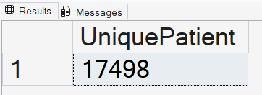

- Distinct Department
SELECT DISTINCT department FROM healthcare_data;
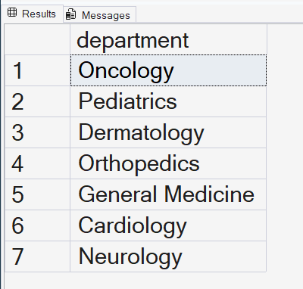

- Distinct Diagnosis
SELECT DISTINCT diagnosis FROM healthcare_data;


- Patient Count by department
SELECT department,COUNT(*) AS Patient_Count FROM healthcare_data
GROUP BY department ORDER BY Patient_Count DESC
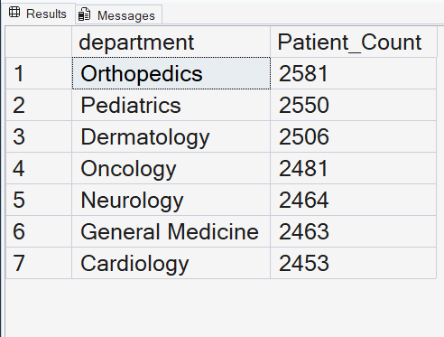

- Revenue By Department
SELECT department,ROUND(SUM(bill_amount),2) AS total_revenue
FROM healthcare_data GROUP BY department ORDER BY total_revenue DESC
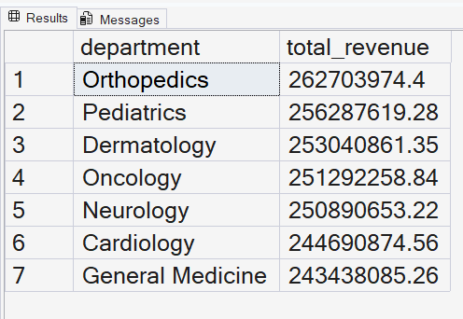

- Patient count by Status
SELECT status,COUNT(*) AS Patient_count FROM healthcare_data
GROUP BY status ORDER BY Patient_count DESC
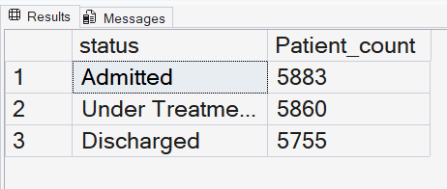

- Patient Count according age_group
SELECT
CASE
WHEN age<=18 THEN '0-18'
WHEN age<=30 THEN '16-30'
WHEN age<=45 THEN '31-45'
WHEN age<=60 THEN '46-60'
ELSE '61+'
END AS age_group,
COUNT(*) AS Patient_count
FROM healthcare_data
GROUP BY
CASE
WHEN age<=18 THEN '0-18'
WHEN age<=30 THEN '16-30'
WHEN age<=45 THEN '31-45'
WHEN age<=60 THEN '46-60'
ELSE '61+'
END
ORDER BY age_group;
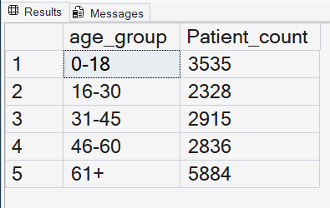

We found invalid date in admission_date and discharge date

select Count(*) as invalid_date from healthcare_data
where discharge_date<admission_date

I Found all column data is correct, may be admission_date exchange with discharge_date so we get invalid dates. I will swap admission date with discharge_date where discharge_date<admission_date. Before exchange we create a back table

select *
into healthcare_data_backup
from healthcare_data;

We exchange it under Transaction
BEGIN TRANSACTION;
UPDATE healthcare_data
SET
admission_date = discharge_date,
discharge_date=admission_date
WHERE
discharge_date<admission_date;

Now check again invalid dates in updated table

select Count(*) as invalid_date
from healthcare_data
where discharge_date<admission_date

Commit Transaction;

- Length of Stay
SELECT patient_id, admission_date, discharge_date, DATEDIFF(DAY,admission_date,discharge_date) AS lenght_of_stay
FROM healthcare_data;

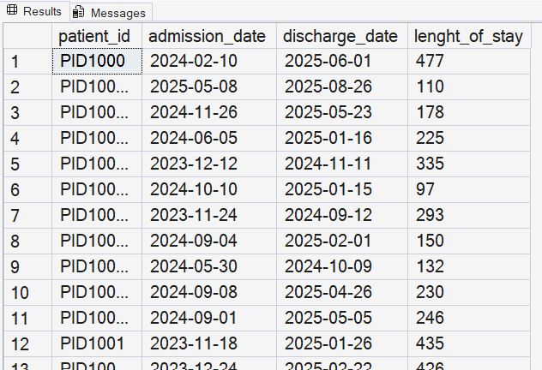

- An advanced SQL query to analyze departmental performance. First, we establish a Common Table Expression or CTE called DepartmentRevenue to calculate the total billings grouped by each specific department. Then, in the main select statement, we apply a Window Function using RANK() OVER.
WITH DepartmentRevenue AS
(
Select
department,
ROUND(SUM(bill_amount),2) AS Revenue
FROM healthcare_data
GROUP BY department
)
SELECT
department,
Revenue,
RANK() OVER(
ORDER BY Revenue
) AS Revenue_Rank
FROM DepartmentRevenue;

