Name -Saurya Tripathi
Roll number: 2400290100281
Department : CSE,sec-d

MSE-1-AIOPS EXAM DOCUEMENTATION

## 1. Operational Data, Logs, and Metrics

This shows the input data that is being analysed. It includes timestamps, service name, response time, CPU, memory, log level, and message.

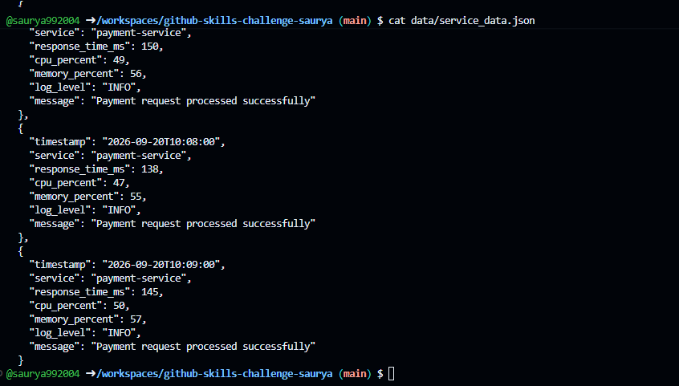

## 2. Anomaly Detection Results

This command runs the detector against all records and prints only the records identified as anomalies.

command:

PYTHONPATH=src python -c "import json; from anomaly_detector import AnomalyDetector; data=json.load(open('data/service_data.json', encoding='utf-8')); detector=AnomalyDetector(); [print(detector.detect(record)) for record in data if detector.detect(record)]"
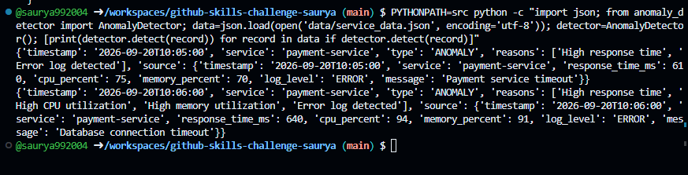

## 3. Event Generation

This command checks that the detector creates an event for an anomalous record.

command:

PYTHONPATH=src python -c "import json; from anomaly_detector import AnomalyDetector; record=json.load(open('data/service_data.json', encoding='utf-8'))[5]; event=AnomalyDetector().detect(record); print('Event generated:', event is not None); print(event)"
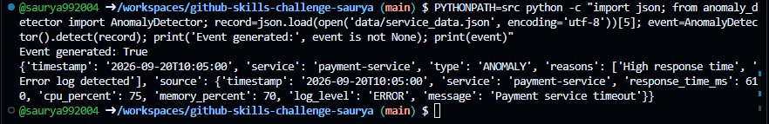

## 4. Producer to Topic to Consumer Flow

This command uses the provided producer, topic, and consumer classes. It creates one anomaly event, publishes it, reads it back, and prints each stage.

command:

PYTHONPATH=src python - <<'PY'
import json
from anomaly_detector import AnomalyDetector
from event_consumer import EventConsumer
from event_producer import EventProducer
from event_topic import EventTopic

record = json.load(open("data/service_data.json", encoding="utf-8"))[5]
event = AnomalyDetector().detect(record)
print("1. Event created:", event is not None)

topic = EventTopic("anomaly-events")
producer = EventProducer(topic)
consumer = EventConsumer(topic)

print("2. Producer published:", producer.publish(event))
print("3. Messages in topic:", len(topic.get_messages()))
received = consumer.consume()
print("4. Consumer received:", len(received))
print("5. Received event:", received[0])
PY

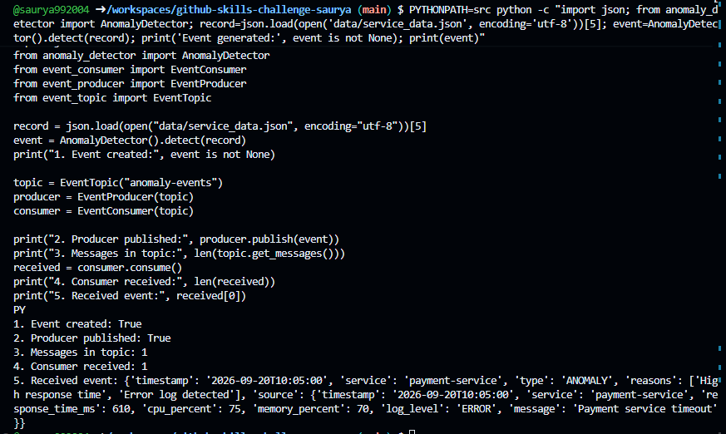
## 5. Final AIOps Output

This runs the complete application pipeline.

Run this command:

python src/aiops_pipeline.py

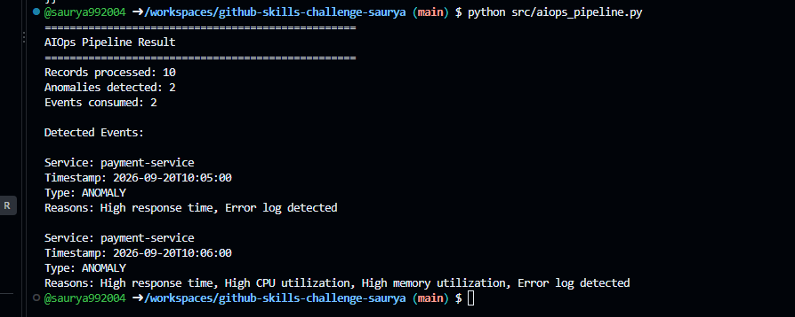

## 6. Validation and Tests

This runs the provided tests:

python -m pytest

