Azure CLI for VMSS – Quick create VMSS

# Scenario - Quick create a VM, attach an extension and delete the VMSS

1. Quick Create a VMSS using the following command

*> azure vmss quick-create --resource-group-name %rgname% --name %vmssname% --location %locname% --admin-username %admin-username% --admin-password %admin-password% -- image-urn %publisherName:offer:skus:version%*

Example: > *azure vmss quick-create -g testrg -n test -l westus -Q MicrosoftWindowsServer:WindowsServer:2008-R2-SP1:2.0.20151022 -u usr -p pwd*

1. View the VMSS you just created

> azure vmss list-all

> azure vmssvm list --resource-group-name %rgname% --virtual-machine-scale-set-name %vmssname%

1. Attach a Docker extension to your VMSS

Create a parameter-file <name>.json and copy paste the following OR simply use the

101-VMSS- QuickCreate-Input.json in the repository

Update the name of the VMSS and location in the file

{

"virtualMachineProfile": {

"extensionProfile": {

"extensions": [

{

"autoUpgradeMinorVersion": false,

"extensionType": "DockerExtension",

"protectedSettings": "",

"provisioningState": "",

"publisher": "Microsoft.Azure.Extensions",

"settings": "",

"typeHandlerVersion": "1.0",

"name": "test",

"location": "westus"

}

]

}

},

"name": "<Your VMSS name>",

"location": "<Location of your VMSS>"

}

Run the following command:

> *azure vmss create-or-update --resource-group-name %rgname% --parameter-file %filename%*

Navigate to this [link](https://resources-staging.azure.com) to view your resource group and then go all the way down to the VMSS you just created to see the extension added. Please see below.

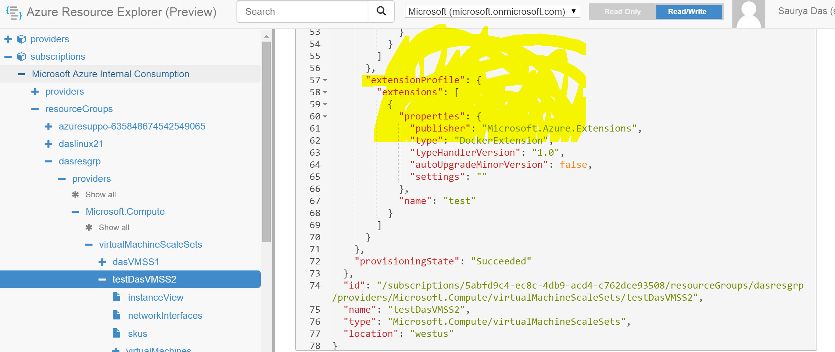

1. Delete a VM

> *azure vmss delete --resource-group-name %rgname% --vm-scale-set-name %vmssname%*