FlexDocs

System Design

STATUS  Proposed |  | OWNER  Repository owner |  | LAST UPDATED  September 22 2026

Authors | Codex
Reviewers | Repository maintainer
Related docs | Documentation reliability review and Recovery guide in docs/
Scope | Reliable document editing, access control, bootstrap and recovery

1. Abstract
Keep the Next.js application and strengthen its documentation core. Writes, recovery snapshots and tags commit together in PostgreSQL. Version checks reject stale edits. Role and organization checks control access; only admins can download database backups.
This design covers the root TypeScript application and its Docker deployment. It supports document authors and organization readers. Production traffic, recovery objectives and service targets still need measurement. The separate Go implementation is outside this change.

2. Goals and Non-Goals
Goals | Non-goals
Preserve each distinct overwritten document state. | Automatic merging or offline draft storage.
Reject stale writes from the web editor. | Real-time collaborative editing.
Protect bootstrap credentials and database backups. | A security certification of every integration.
Prove changes with isolated tests before deployment. | Changing live account passwords or production data.

3. Background and Problem Statement
The audit found backup downloads available to every signed-in user, non-atomic document saves, missing revision permissions and a broken restore URL. Passing baseline tests did not exercise these paths. Public bootstrap passwords and privileged Docker defaults increased deployment risk.
The browser owns the draft and last observed version. API routes authenticate and authorize requests. A shared transaction helper locks the document, checks its version, preserves the prior state and writes the change. PostgreSQL is authoritative; uploads and encryption keys require separate recovery copies.

4. Proposed Architecture

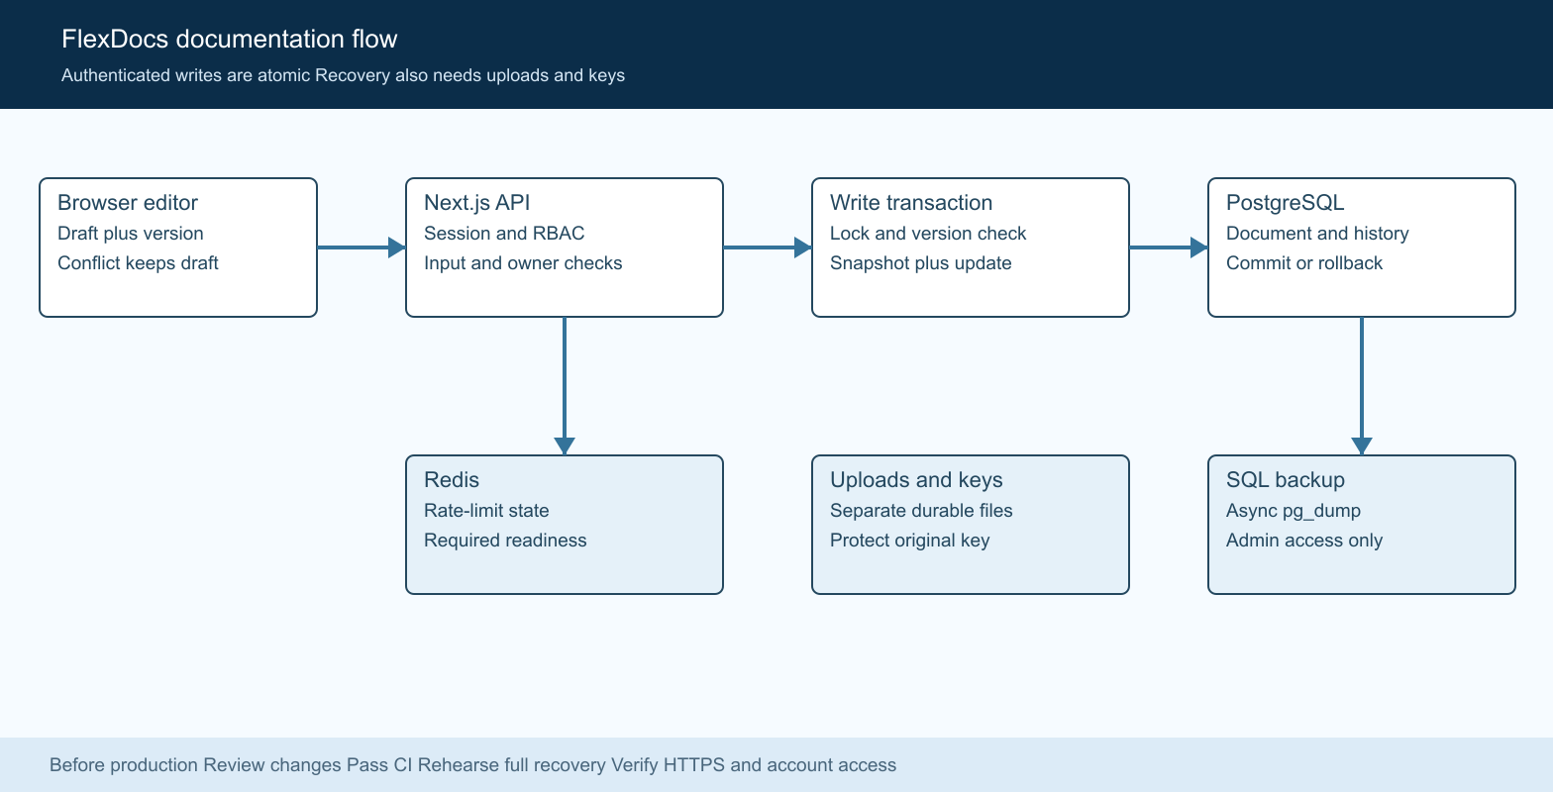
Figure 1. FlexDocs documentation and recovery boundaries.

Core components

Component | Responsibility | Primary storage | Failure behavior
React editor | Hold draft and send versioned saves. | Open browser tab | Keep draft visible on errors.
Next.js API | Validate input, roles and organization access. | Sessions and org membership | Reject unauthorized or invalid requests.
Write helper | Lock document and commit content with history. | PostgreSQL | Roll back the transaction on failure.
Backup runner | Run pg_dump asynchronously; publish completed SQL. | Backups volume | Remove partial file; return failure.
Readiness | Check database and configured Redis. | DB and Redis | Return HTTP 503 when required services fail.

5. Request Lifecycle
- Editor sends document fields and expectedUpdatedAt to PUT /api/documents/:id.
- API authenticates the session, checks document.update and validates the payload.
- Load the owned document under a row lock; check folder ownership when supplied.
- Compare the submitted version with updatedAt; reject a stale request with HTTP 409.
- Snapshot the prior title, content and category before changing document fields and tags.
- Commit the transaction before reporting success; do not automatically retry conflicts.
- Return the new timestamp. The editor marks only the submitted draft as saved; audit is best effort.

6. API and Data Contracts

Primary data contract

Field | Type | Required | Description
title | String | On create | Nonblank; at most 500 characters.
content | String | No | Markdown; at most 2 million characters.
expectedUpdatedAt | Timestamp | Editor sends | Last observed version; mismatch returns 409.
folderId | ID or null | No | Folder must belong to the writer.
visibility | Enum | No | private or org; org requires an organization.
tags | String array | No | At most 100 names; trim and deduplicate.
reviewDate | Date or null | No | Valid review date; null clears the value.

Contract guarantees

- Snapshots, content and tag changes commit or roll back as one transaction.
- A document row lock serializes revision allocation; updatedAt advances monotonically.
- Revisions retain author, title, content, category, version and creation time.
- Revision history does not restore attachments, tags, folders or sharing settings.
The checked-in contract is maintained in
src/lib/document-write.ts and prisma/schema.prisma.

7. Consistency, Idempotency, and Replay

The editor uses optimistic version checks inside a locked transaction. Legacy clients that omit the version remain last-write-wins, with prior content captured. Creation is not idempotent: a repeated POST can create another document. Backup requests share one in-flight operation per process, not across replicas.
Scenario | Expected behavior | Reasoning
Repeated stale save | 409; preserve local draft. | The server version has advanced.
Snapshot or write fails | Transaction rolls back. | Content cannot commit without its history.
Backup process fails | No completed SQL file published. | Partial file is removed; failure is reported.
Concurrent edit or restore | Lock, then compare version. | Avoid reading a stale state before overwriting.

8. Security and Privacy Considerations

- Signed sessions authenticate users. Mutations require role permission and ownership. Org-visible content is readable only within the permitted scope.
- Database backups are sensitive and admin-only. Logs must not contain credentials or vault plaintext; AI context remains metadata-only for secrets.
- Fresh installs require a unique bootstrap password. Setup writes secrets to a private .env; existing account passwords are preserved.
- Database and Redis host ports bind to loopback. Docker socket discovery is an explicit privileged override; HTTPS remains an operator responsibility.
- History is retained without automatic pruning. Document deletion remains permanent. Define retention and a trash workflow before expanding usage.

9. Operational Readiness
Signal | SLO or alert | Owner | Launch gate
Correctness | All unit and live reliability checks pass. | Maintainer | Required
Latency | Measure save and backup latency in staging. | Operator | Target pending
Availability | Readiness returns 503 for dependency failure. | Operator | Required
Deployment drift | Apply migrations; seed failures stop startup. | Maintainer | Required
Recovery integrity | Restore SQL plus uploads and keys in isolation. | Operator | Required
Rollout constraint: review branch changes, require green CI, then stage a full recovery drill before any production promotion.

10. Alternatives Considered

Alternative | Why it was considered | Why it was not selected
Rewrite in Go | A separate Go tree already exists. | A rewrite expands scope before reliability is proven.
Always overwrite | Simple client and server behavior. | Silently loses edits made in another tab.
Throttle snapshots | Reduces history storage. | Discards recovery points during rapid edits.
Synchronous backup | Simple process handling. | Blocks Node.js while pg_dump runs.

11. Open Questions
- What recovery point and recovery time objectives should production meet?
- How long should revisions and deleted documents be retained?
- Will deployment use one application process or multiple replicas?
- Who owns offsite backup storage, restore drills and legacy account rotation?

12. Decision and Next Steps
Proceed with the reliability branch, review the full diff and require green CI. Then validate a staging installation with a database, upload and key recovery drill. Limit the first production rollout to the operator team; expand only after recovery and monitoring targets are agreed and verified.
Milestone | Deliverable | Exit criteria
M1 | Atomic saves, working restore and role checks. | Unit, API and browser checks pass.
M2 | Secure bootstrap and nonblocking backups. | Fresh install and existing-account tests pass.
M3 | Staging recovery and exposure review. | Files, history and vault test records recover.
M4 | Controlled production rollout. | Monitoring targets agreed; rollback rehearsed.

SQL backups contain database records only. Uploaded file bytes and the original encryption key must be recovered separately.

