PeoplePulse
Architecture, delivery pipeline and operations on AWS
From a git push to a running application on Amazon EKS
Author: Saket Saurabh
Date: October 2026
Environment: DEV · AWS account 866934333672 · region us-west-1 (N. California)
Repository: github.com/sausa001/csv-records-api

Contents

1. Executive summary
PeoplePulse is a small employee-records application: a React dashboard and a FastAPI REST API over a PostgreSQL database. It was built in stages, starting from an API over a CSV file and ending with a fully automated deployment to Amazon EKS on AWS.
The value of the project is less in the application itself than in the path it takes to production. Every part of that path is defined in code and repeatable:
- Infrastructure: Terraform creates the network, Kubernetes cluster, database, registry, identities, alarms and budget, about 70 resources, in roughly 20 minutes.
- Delivery: a Jenkins pipeline tests, builds, publishes, deploys and verifies every change, with a manual approval gate and automatic rollback.
- Security: no secrets in Git, least-privilege IAM, private database subnets, encryption at rest and in transit, and a hard lock to one AWS account.
- Cost control: every resource is tagged with its owner, a monthly budget sends early warnings, and the environment is destroyed when not in use (about $7 per day while running).

Outcome. One push to GitHub produces a tested, versioned, approved and verified release on AWS, and any release can be rolled back with one command.

2. Purpose of PeoplePulse

2.1 The name
People + Pulse: a live view of an organisation's workforce. The dashboard is the pulse: head-count, active and inactive staff, salary ranges and the spread across departments and cities, always current.

2.2 The problem it addresses
In many teams, employee information lives in spreadsheets and CSV files that are copied, emailed and edited in parallel. Nobody is sure which copy is current, duplicate entries creep in, and there is no simple way for other systems to read the data.

2.3 Goals
- One source of truth. Store employee records in a real database with validation, such as unique e-mail addresses and valid salaries and dates.
- Self-service. Give people a dashboard to search, filter, add, edit and export records, and give systems a documented REST API.
- Production-grade delivery. Demonstrate the complete lifecycle a real product follows: source control, automated tests, container images, infrastructure as code, a CI/CD pipeline, Kubernetes, managed cloud services, security, monitoring and cost governance.
- Learn and showcase. Serve as a reference implementation that can be presented, extended to more environments (UAT, PROD) and ported to another cloud.

2.4 Audience
- HR and team leads who need a quick, trustworthy view of employee data.
- Developers and integrators who consume the REST API.
- Engineering and DevOps reviewers assessing architecture, automation and operational practice.

3. Application overview

3.1 Features
Feature | Description
Live dashboard | Total, active and inactive employees, average salary, salary range, counts by department and city
Search and filter | Free-text search on name, e-mail and role; filters for department, city, status and salary range
Record management | Add, edit and delete employees with server-side validation
CSV export | Download the current filtered view
REST API | Documented with Swagger UI at /docs
Protected writes | An optional API key protects POST, PUT, PATCH and DELETE

3.2 Technology stack
Layer | Technology
User interface | React 19, Vite, served by nginx (unprivileged) which also proxies /api
API | Python, FastAPI, Pydantic v2
Data access | SQLAlchemy 2.0, psycopg 3; CSV backend kept for quick local runs
Database | PostgreSQL 16 (Amazon RDS in AWS, a StatefulSet in Minikube)
Tests | pytest (more than 120 test cases across CSV, SQLite and PostgreSQL backends), Vitest for the UI
Packaging | Multi-stage Dockerfiles; arm64 images
Orchestration | Kubernetes (Amazon EKS), Helm chart
Infrastructure | Terraform with the AWS provider v6
CI/CD | Jenkins (in Docker), GitHub as source

3.3 API endpoints
Method | Path | Purpose
GET | /health | Liveness, version, record count and storage type
GET | /records | Paged list with search and filters
GET | /records/stats | Aggregates for the dashboard
GET | /records/export | CSV download
GET | /departments | Distinct departments
GET | /records/{id} | One record
POST | /records | Create (API key if configured)
PUT / PATCH | /records/{id} | Replace or partially update
DELETE | /records/{id} | Delete

Through the load balancer the UI reaches the same endpoints under the /api prefix, for example /api/health.

4. Architecture
The diagram shows the full system: the delivery path on the left and the AWS environment on the right. The numbered steps follow one change from the developer's laptop to a user's browser.
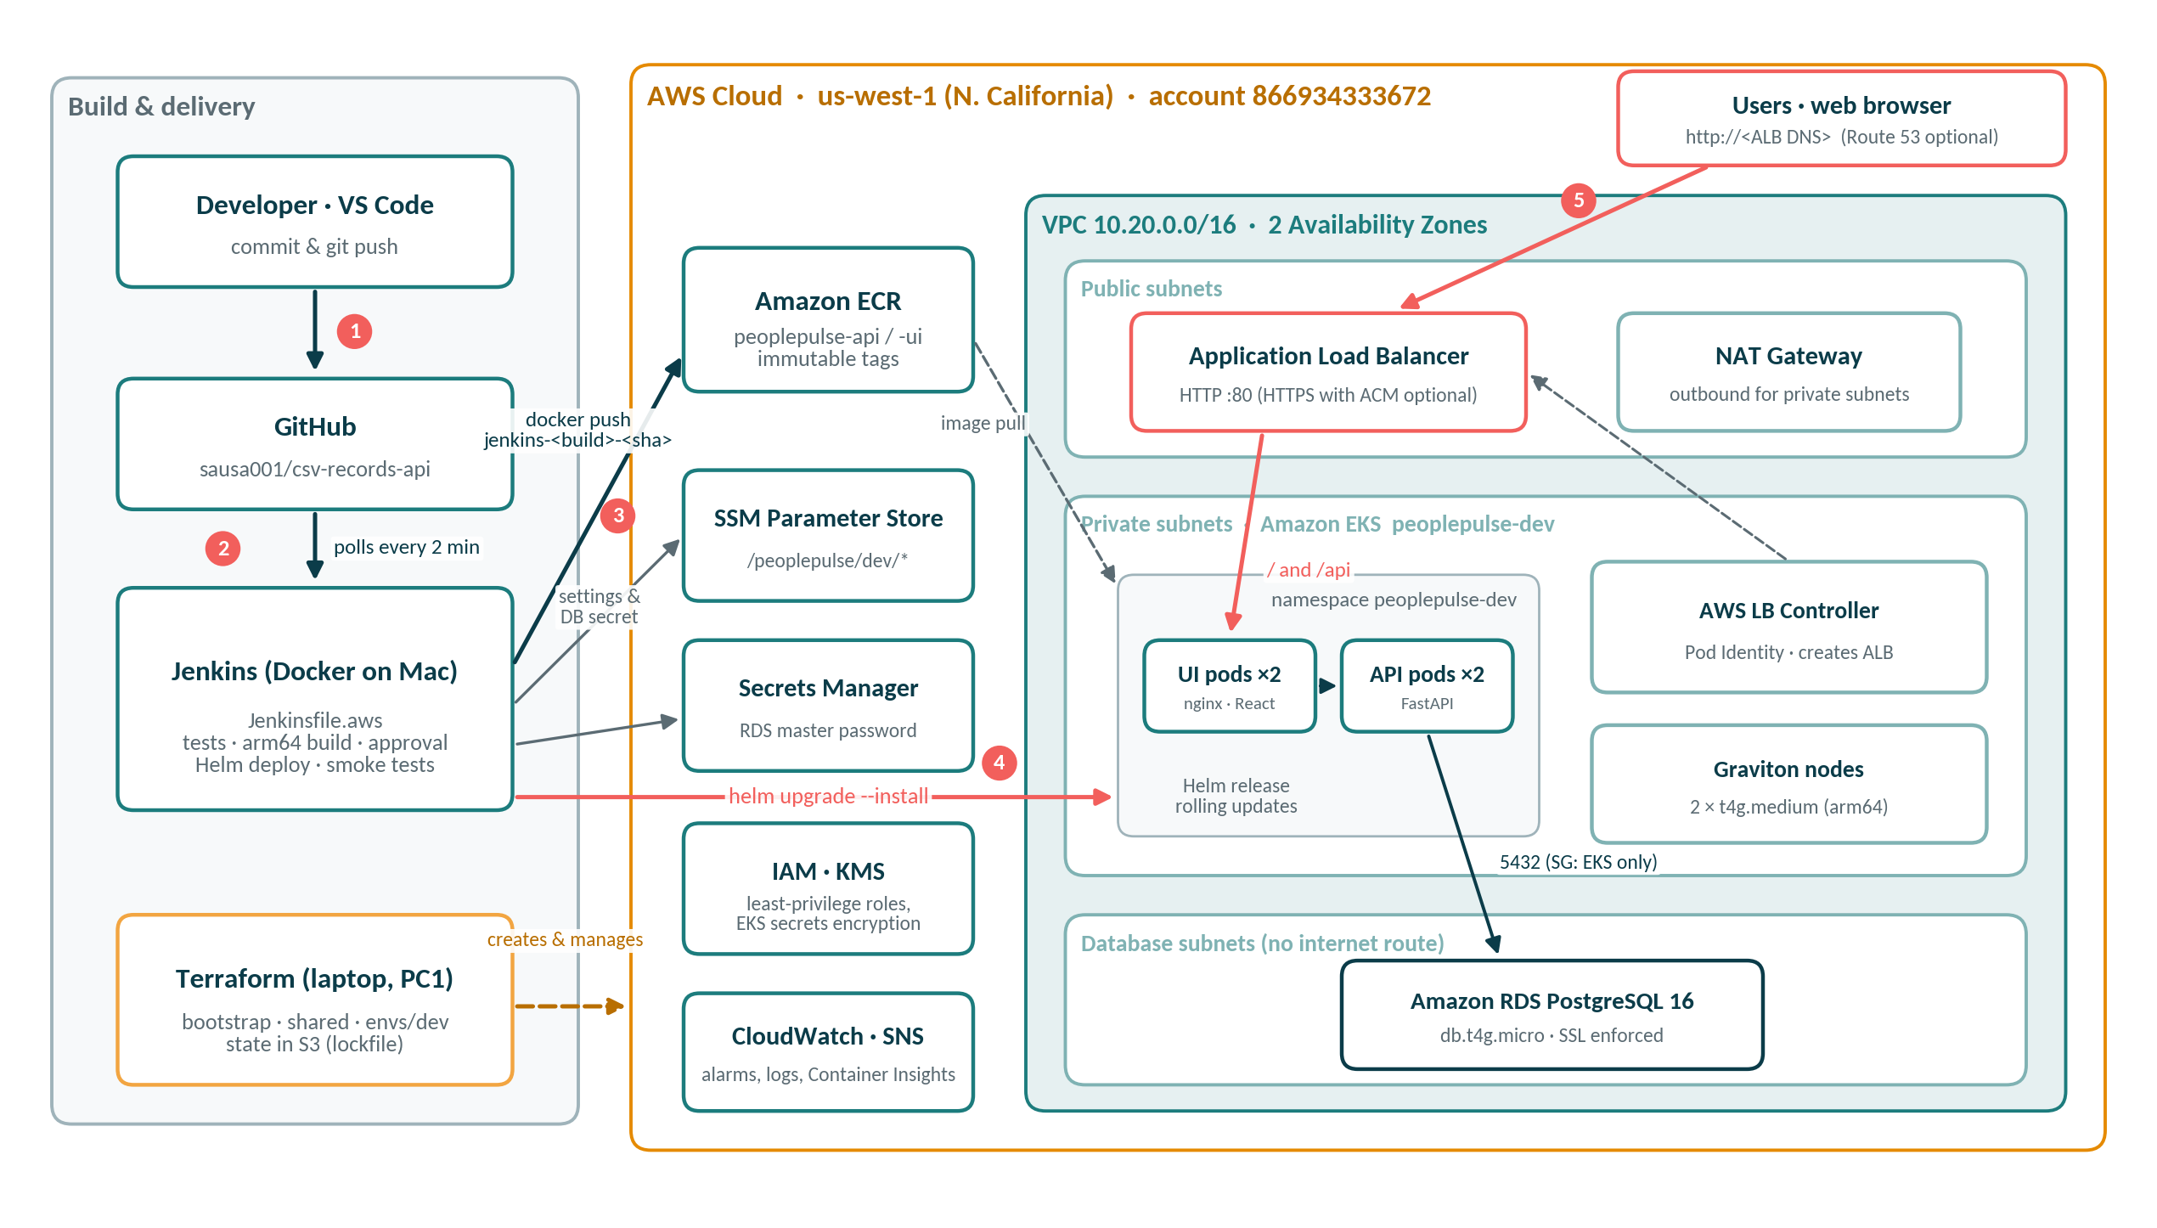
Figure 1. PeoplePulse end-to-end architecture on AWS
- The developer commits in VS Code and pushes to GitHub.
- Jenkins, running in Docker on the developer's Mac, polls GitHub every two minutes and starts the pipeline.
- Jenkins runs the tests, builds arm64 images and pushes them to Amazon ECR with an immutable tag.
- Jenkins reads environment settings from SSM Parameter Store and the database password from Secrets Manager, then deploys with helm upgrade into EKS.
- Users reach the application through the Application Load Balancer.

4.1 Components
Component | Role | Key settings
Amazon VPC | Private network | 10.20.0.0/16, 2 AZs, public / private / database subnets
Application Load Balancer | Single public entry point | Created by the AWS Load Balancer Controller from a Kubernetes Ingress
Amazon EKS | Runs the containers | Kubernetes 1.35, API access mode, KMS-encrypted secrets
Managed node group | Compute for pods | 2 × t4g.medium Graviton (arm64), AL2023, IMDSv2
UI pods | Serve React, proxy /api | 2 replicas, nginx-unprivileged
API pods | Business logic | 2 replicas, FastAPI, readiness probe on /health
Amazon RDS | Database | PostgreSQL 16, db.t4g.micro, SSL enforced, managed password
Amazon ECR | Image registry | peoplepulse-api and peoplepulse-ui, immutable tags, scan on push
Secrets Manager | Database credentials | Generated and rotated by RDS
SSM Parameter Store | Pipeline settings | /peoplepulse/dev/* written by Terraform
CloudWatch + SNS | Monitoring and alerts | Container Insights, log groups, alarms to e-mail
IAM + EKS Pod Identity | Access control | Least-privilege roles for nodes, controller and Jenkins
AWS Budgets | Cost guard | $100 per month on the Owner tag, alerts at 80% and 100%

4.2 Request flow
Browser → ALB (public subnets) → nginx UI pod → /api is forwarded to the API service → FastAPI pod → RDS PostgreSQL over SSL in the database subnets. The UI tier never holds database credentials; only API pods mount the database secret.

5. Source-to-deployment process
The whole delivery process is one declarative Jenkins pipeline, Jenkinsfile.aws, stored in the same repository as the code. Nothing account-specific is hard-coded in it: the cluster name, registry URLs, database host and secret ARN are read at run time from SSM Parameter Store, where Terraform writes them.
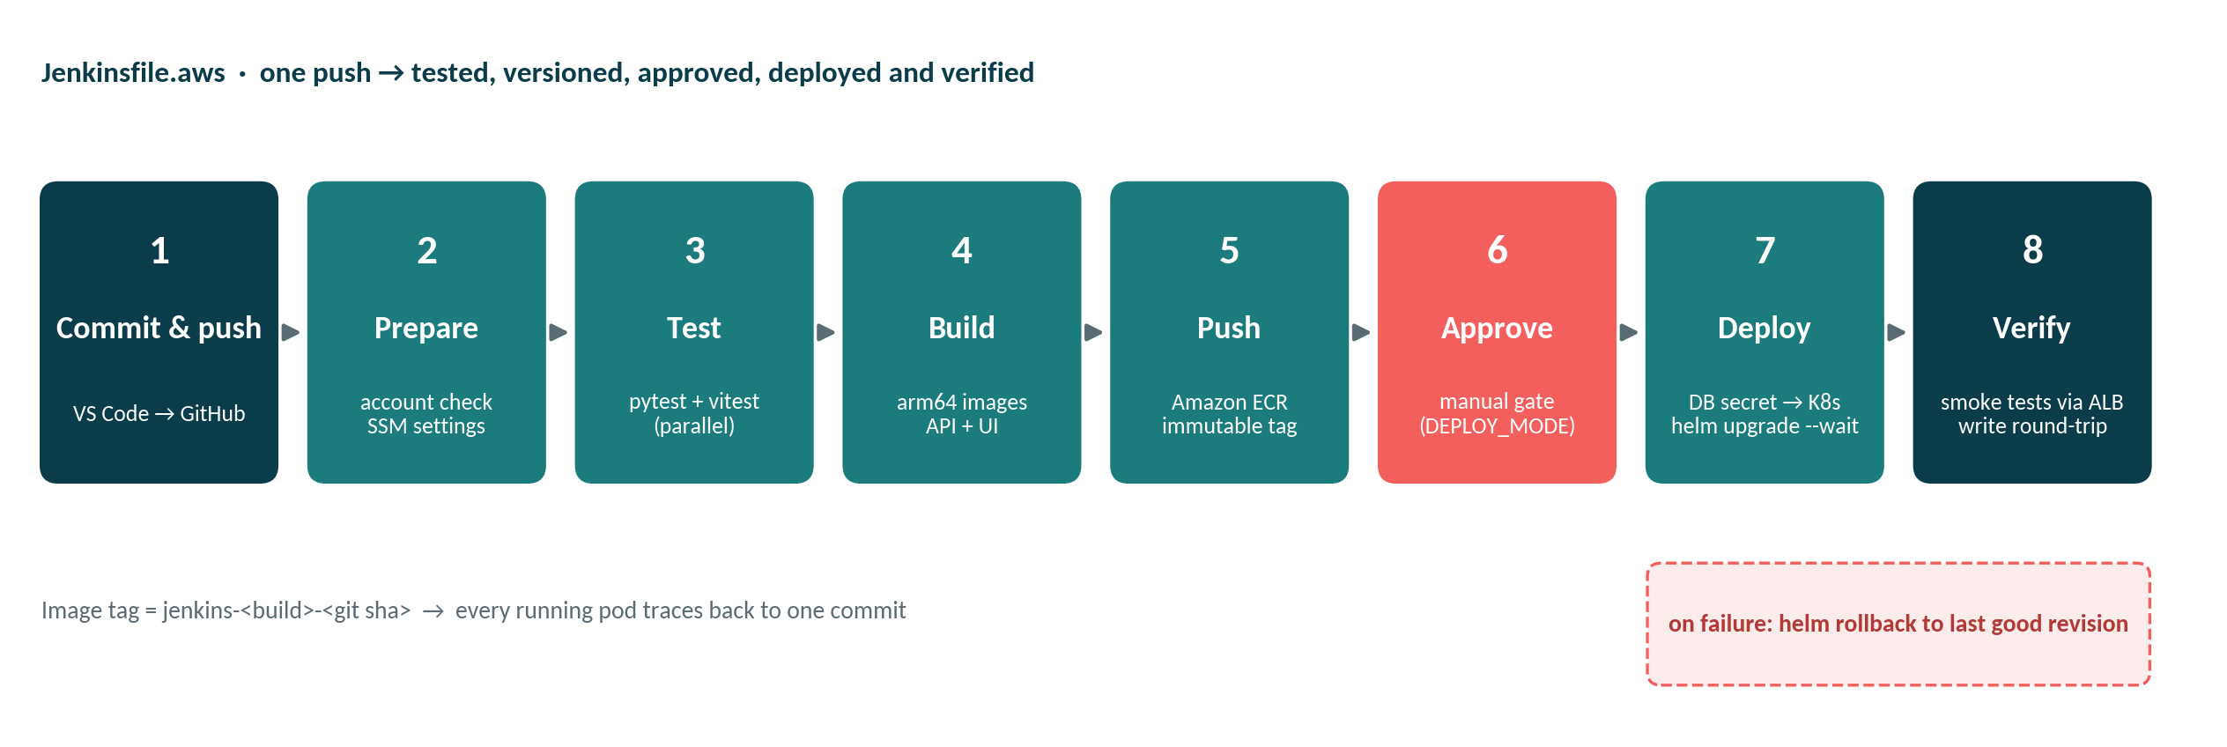
Figure 2. Stages of Jenkinsfile.aws
# | Stage | What happens | Why it matters
1 | Commit & push | Developer pushes to main on GitHub | Git is the single trigger
2 | Prepare | Checks the AWS account is 866934333672; loads /peoplepulse/dev/* from SSM | Cannot deploy to the wrong account; no hard-coded values
3 | Test | pytest and Vitest run in parallel inside Docker build stages | Broken code never becomes an image
4 | Build | Multi-stage builds for linux/arm64, labelled with the git commit | Matches Graviton nodes; small runtime images
5 | Push | Images pushed to ECR as jenkins-<build>-<sha> | Immutable, traceable versions
6 | Approve | Pipeline pauses for a person to click Deploy (DEPLOY_MODE=manual) | Human gate before changing the environment
7 | Deploy | DB password copied from Secrets Manager to a K8s secret; helm upgrade --install --wait | Zero-downtime rolling update
8 | Verify | Smoke tests through the real ALB: UI, /api/health, stats, and a create-read-delete round trip | Proves the release works end to end
– | On failure | helm rollback to the previous revision | Bad releases undo themselves

5.1 Traceability
Every running pod can be traced to one commit: the image tag contains the Jenkins build number and the git SHA, ECR refuses to overwrite a tag, and Helm keeps a numbered history of every release.
kubectl -n peoplepulse-dev get deploy peoplepulse-api \
-o jsonpath='{.spec.template.spec.containers[0].image}'
helm -n peoplepulse-dev history peoplepulse

5.2 Local and cloud from one repository
Aspect | Local (Minikube) | Cloud (AWS)
Pipeline | Jenkinsfile | Jenkinsfile.aws
Registry | Docker Hub | Amazon ECR
Cluster | Minikube on Docker Desktop | Amazon EKS on Graviton nodes
Database | PostgreSQL StatefulSet | Amazon RDS PostgreSQL 16
Entry point | NodePort | Application Load Balancer
Secrets | Jenkins credential | AWS Secrets Manager
Helm values | values-minikube.yaml | values-aws-dev.yaml
Cost | Free | ≈ $7 per day while running

6. Infrastructure as code
All AWS resources are created by Terraform from the terraform/ folder. State is split into three roots so that the expensive environment can be created and destroyed independently of the long-lived parts.
Root | Creates | Lifetime
bootstrap | S3 bucket peoplepulse-tfstate-866934333672 for Terraform state: versioned, encrypted, private, 90-day history | Once; kept
shared | ECR repositories peoplepulse-api and peoplepulse-ui; IAM group and user peoplepulse-jenkins with ECR push rights | Kept (cents per month)
envs/dev | VPC, EKS cluster and nodes, RDS, load balancer controller identity, EKS access entries, SSM settings, Jenkins deploy policy, CloudWatch alarms, SNS, budget, optional ACM and Route 53 | Created and destroyed per working session

6.1 Modules
- network: VPC, three subnet tiers in each Availability Zone, Internet and NAT gateways, route tables, optional flow logs.
- eks: cluster, KMS key, control-plane logs, node group with a launch template (tags and IMDSv2), add-ons, load balancer controller IAM and Pod Identity, access entries.
- rds: subnet group, security group, parameter group with force_ssl, PostgreSQL instance with an AWS-managed master password.

6.2 Guard rails in the code
- Account lock: every provider sets allowed_account_ids = ["866934333672"], so Terraform refuses to run with credentials for another account.
- Validation: the plan stops if the Kubernetes API allow-list is still the placeholder or 0.0.0.0/0, or if az_count is not 2 or 3.
- Default tags: Project, Environment, Owner and ManagedBy are applied to every resource.
- State locking: the S3 backend uses use_lockfile, so two applies cannot run at once.

6.3 Network layout
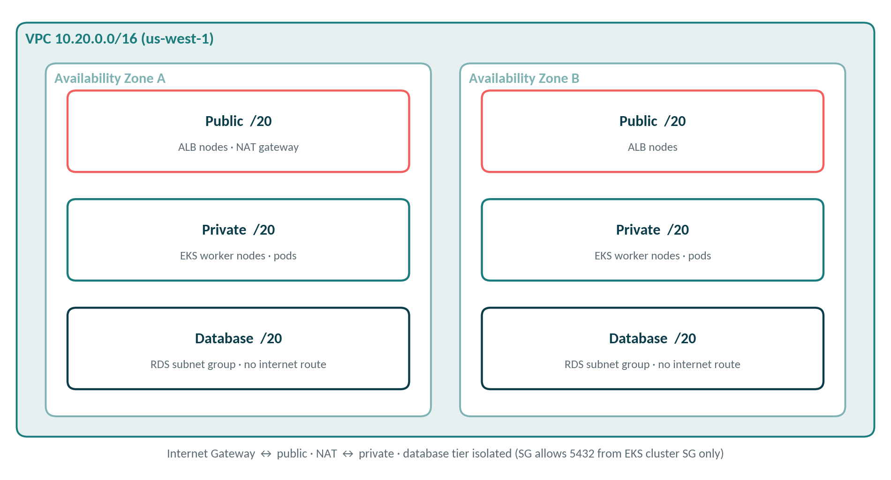
Figure 3. VPC subnet tiers across two Availability Zones
Tier | Contents | Internet access
Public /20 × 2 | ALB nodes, NAT gateway (one, for DEV) | In and out via Internet Gateway
Private /20 × 2 | EKS worker nodes and pods | Outbound only, via NAT
Database /20 × 2 | RDS subnet group | None

7. Security
Area | Control
Account safety | Terraform allowed_account_ids; pipeline checks the caller account before doing anything; separate CLI profile PC1
Identity | Jenkins IAM user can push to ECR, read its SSM path and DB secret, and edit only the peoplepulse-dev namespace through an EKS access entry
Pod permissions | Load balancer controller receives AWS rights through EKS Pod Identity, not node credentials
Secrets | RDS master password created and stored by AWS in Secrets Manager; copied into a Kubernetes secret at deploy time without being printed; nothing in Git
Encryption | KMS envelope encryption of Kubernetes secrets; SSL forced on RDS; S3 state encrypted; storage encrypted
Network | Database has no internet route; RDS accepts 5432 only from the EKS cluster security group; Kubernetes API public endpoint limited to one /32 address
Images | Immutable ECR tags, scan on push, non-root containers, IMDSv2-only nodes (hop limit 2)
Audit | EKS control-plane logs and CloudTrail; aws:createdBy records who created each resource

8. Data layer
- Table employees with a case-insensitive unique index on e-mail, enforced by PostgreSQL itself.
- On first start against an empty database, the API creates the table and loads 12 sample employees from the seed CSV. This runs in a single transaction holding a PostgreSQL advisory lock, so several replicas starting together never race.
- The API retries the connection while RDS is starting, so pod start order does not matter.
- Duplicate e-mails return a clear 409 error, including when two requests race.
- Automated RDS backups are enabled; deletion protection and Multi-AZ are switches for PROD.

9. Observability and cost governance

9.1 Monitoring
- Amazon CloudWatch Container Insights add-on collects node, pod and application logs.
- CloudWatch alarms: RDS CPU, RDS free storage, node CPU and ALB 5xx errors, sent through an SNS topic to e-mail.
- Kubernetes readiness probes and the /health endpoint; the pipeline smoke tests check that storage reports postgresql.

9.2 Cost
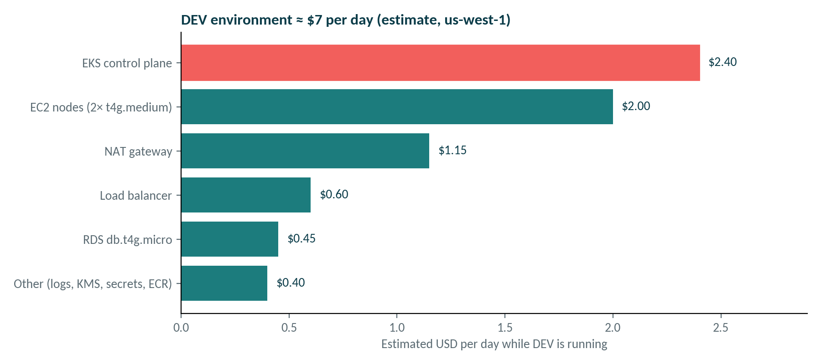
Figure 4. Estimated daily cost of the DEV environment in us-west-1
Figures are estimates for planning. Cost Explorer shows the actual amounts, usually with a delay of up to 24 hours.

9.3 Knowing who spent what
Mechanism | How it is used
Owner / Project / Environment tags | Applied by Terraform and the ALB ingress; activated as cost allocation tags; filter Cost Explorer by Owner
aws:createdBy | AWS-generated tag recording the IAM identity that created each resource; group Cost Explorer by it to see cost per person
Linked account | Group by account to compare accounts in the organisation
AWS Budgets | peoplepulse-dev-owner-monthly: $100 per month, e-mail at 80% actual and 100% forecast
Destroy when idle | terraform destroy each evening; re-create in about 25 minutes

10. Operations runbook

10.1 Every terminal
export AWS_PROFILE=PC1
aws sts get-caller-identity # Account 866934333672
cd ~/Desktop/Local_Project/csv-records-api

10.2 Create the environment (about 25 minutes)
cd terraform/envs/dev
# if your IP changed, update eks_public_access_cidrs in terraform.tfvars
curl -s https://checkip.amazonaws.com
terraform apply
aws eks update-kubeconfig --name peoplepulse-dev --region us-west-1
helm upgrade --install aws-load-balancer-controller \
eks/aws-load-balancer-controller -n kube-system \
--set clusterName=peoplepulse-dev --set region=us-west-1 \
--set vpcId=$(terraform output -raw vpc_id) \
--set serviceAccount.create=true \
--set serviceAccount.name=aws-load-balancer-controller
kubectl create namespace peoplepulse-dev
Then run the peoplepulse-aws job in Jenkins and approve the deployment.

10.3 Deploy a change
- Change code in VS Code; run pytest and npm test locally (optionally docker compose up --build).
- git add, commit and push to main.
- Jenkins starts within two minutes (or click Build with Parameters); click Deploy at the approval step.
- Check the new image tag and Helm history, then refresh the browser.

10.4 Check the system
NS=peoplepulse-dev; PP=peoplepulse
ALB=$(kubectl -n $NS get ingress $PP \
-o jsonpath='{.status.loadBalancer.ingress[0].hostname}')
curl -s http://$ALB/api/health
kubectl -n $NS get pods -o wide
kubectl -n $NS logs deploy/$PP-api --tail 50
helm -n $NS history $PP

10.5 Roll back
helm -n peoplepulse-dev history peoplepulse
helm -n peoplepulse-dev rollback peoplepulse <REVISION> --wait

10.6 Destroy (end of day, about 15 minutes)
helm -n peoplepulse-dev uninstall peoplepulse # removes the ALB first
helm -n kube-system uninstall aws-load-balancer-controller
kubectl delete namespace peoplepulse-dev
cd terraform/envs/dev && terraform destroy
Order matters. The ALB is created by Kubernetes, not Terraform. Uninstall the Helm release first, or terraform destroy cannot delete the VPC.

11. Challenges and resolutions
Problem | Root cause | Resolution
Terraform plan failed: "Invalid for_each argument" in the RDS module | Security group IDs are only known after apply, so the set of keys could not be computed at plan time | Pass a map with a fixed key: { eks_cluster = <sg id> }
API replicas crashed on first start | Two pods created the table at the same time | Schema creation and seeding in one transaction under a PostgreSQL advisory lock
Commands ran against the wrong AWS account | Two accounts configured plus a default profile | Named profile PC1, default profile removed, Terraform account lock and pipeline check
Jenkins could not use Docker | Docker socket owned by the root group | Run the Jenkins container with --group-add 0
Local tests failed with missing sqlalchemy | Old virtual environment created before PostgreSQL support | pip install -r requirements.txt -r requirements-dev.txt
nginx could not write its config | Template permissions in the image | COPY --chmod=0755 in the UI Dockerfile

12. Roadmap
Item | What it adds | Effort
HTTPS on a custom domain | Route 53 record and ACM certificate (already in Terraform; set domain_name) | Low
UAT and PROD environments | Copies of envs/dev with Multi-AZ RDS, one NAT per zone, deletion protection | Medium
GitOps with Argo CD | Cluster state synced from Git; pipeline only builds and publishes | Medium
Autoscaling | Horizontal Pod Autoscaler and Karpenter for nodes | Medium
Security scanning | Trivy image scan and SonarQube quality gate in the pipeline | Low
Second cloud | Azure AKS with the same images and Helm chart | High

Appendix A. Repository structure
csv-records-api/
├── app/ FastAPI app (API, config, models, data)
├── tests/ pytest suites (API, CSV, SQL, config)
├── frontend/ React + Vite UI, nginx config, Dockerfile
├── data/employees.csv seed data
├── Dockerfile API image (test and runtime stages)
├── docker-compose.yml local stack: PostgreSQL + API + UI
├── k8s/ plain manifests for Minikube
├── helm/peoplepulse/ Helm chart (values-minikube, values-aws-dev)
├── jenkins/Dockerfile Jenkins with Docker CLI, kubectl, AWS CLI, Helm
├── Jenkinsfile pipeline: Minikube
├── Jenkinsfile.aws pipeline: AWS EKS
└── terraform/
├── bootstrap/ state bucket
├── shared/ ECR + Jenkins IAM user
├── modules/ network, eks, rds
└── envs/dev/ DEV environment

Appendix B. Useful references
- Cost Explorer: Billing and Cost Management → Cost Explorer; filter Tag Owner, or group by Tag aws:createdBy.
- Budgets: Billing and Cost Management → Budgets → peoplepulse-dev-owner-monthly.
- Logs: CloudWatch → Log groups → /aws/containerinsights/peoplepulse-dev/application.
- Swagger UI: kubectl -n peoplepulse-dev port-forward svc/peoplepulse-api 8000:80, then http://localhost:8000/docs.

