Proposal

  - SWE 3643-01: Software Testing QA
  - Group 7

JXPath Source and Documentation
Official Site: https://commons.apache.org/proper/commons-jxpath/
GitHub: https://github.com/apache/commons-jxpath

What is JXPath?
JXPath takes the XML search features of XPath and extends them to Java object graphs, enabling the retrieval and modification of nested data via simplified syntax and single-string expressions. JXPath is popular as middleware for framework developers but is useful for anyone that wants to use Java logic with XML data or program the query of data without consideration for the runtime data structure.

Link to Unit Tests in JXPath Repository
https://github.com/apache/commons-jxpath/tree/master/src/test/java/org/apache/commons/jxpath

Example of Testing Pipeline in Action
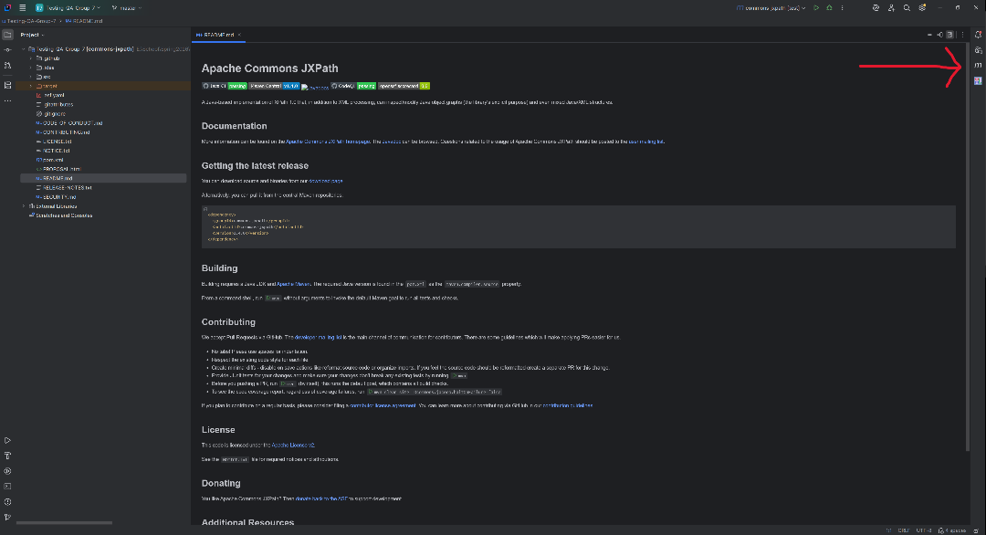
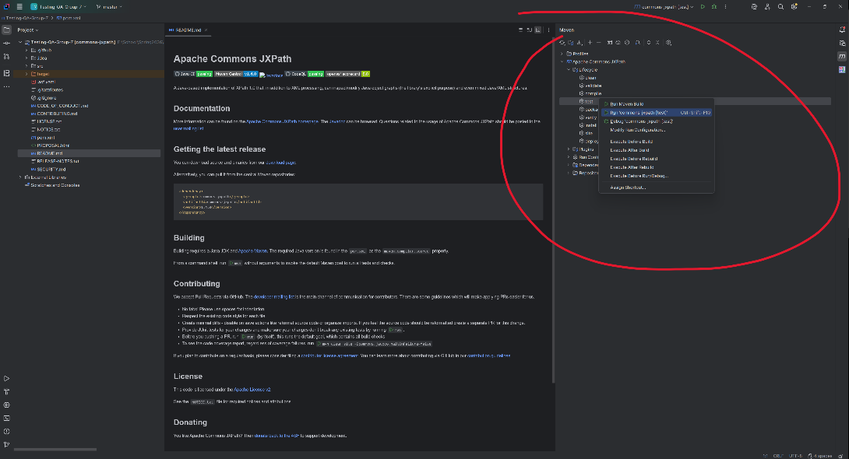
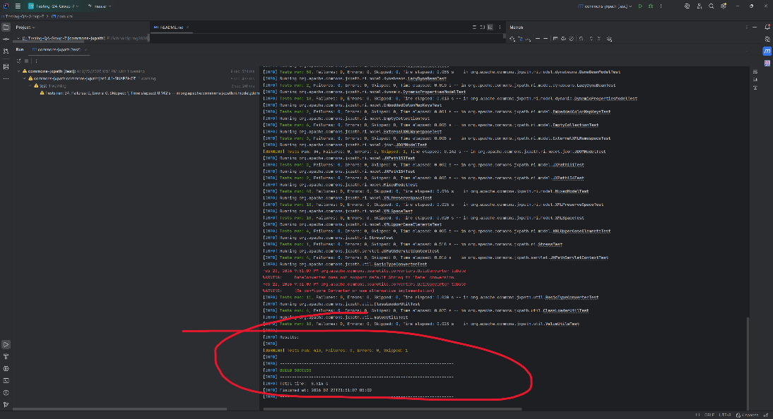

Brief discussion of what feature/workflow you intend to test

Make sure to confirm it’s not already being tested!

