PURPOSE: The purpose of this procedure is to explain the overall process of the 550 Unit

REFERENCE: Material Safety Data Sheets and LCCC Environmental Procedures

SAFETY:

Material or Chemical | Personal Protective Equipment Required*
C2 Alcohol | Required PPE
C4 Alcohol
C6+ Crude Alcohol
Ammonia
Therminol 66
*PPE required for this procedure only. Refer to MSDS for other applications.

DISCUSSION: The purpose of 550 section is to produce straight chain alcohol and alumina powder. Basically, three processing systems are used to accomplish this purpose. These three areas are dependent upon each other for the production of quality products. The three processing systems are as follows:

Hydrolysis (Reaction)
Alcohol Fractionation
Alumina Purification

APPROVED: _________________________ Operations Superintendent _______ Date

Hydrolysis Process

Aluminum alkoxide reacts with water to form ALFOL® alcohol and alumina slurry. Crude alcohol’s produced as a result of this reaction contains approximately 10 weight percent water. Alumina produced from this reaction is in a slurry with approximately 80 weight percent water and 10 percent entrained and dissolved alcohol.

Solvent free aluminum alkoxide is pumped from an intermediate storage tank. The alkoxide is then pumped into the Hydrolysis Reactor, DC-551, through a small diameter nozzle, which increases turbulence. The alkoxide enters the reactor in a slurry phase between the agitator’s two impellers. The alkoxide reacts rapidly with condensate and ammonia to form crude alcohol and alumina.

Condensate is used as hydrolysis water to prevent process contamination of the alumina product. Hydrolysis water is pumped from the hydrolysis water tank, FB-551, and combined with recycle water from the fractionation system. The combined water stream is heated in the steam ring heater, PA-551, by direct steam injection.

After heating, the hydrolysis water flows to the hydrolysis reactor. An ammonia concentration is required in the hydrolysis water to prevent the formation of emulsions in downstream equipment. This concentration is maintained by recycling ammonium hydroxide, which is recovered from the fractionation system and sent to FB-551. As make-up hydrolysis water is needed, ammonium hydroxide is available from tank D6-529.

A wet butanol stream is recycled from the extraction system to DC-551. This stream enters the slurry phase to enhance removal of heavier alcohol from the slurry.

The alcohol and the alumina produced from the hydrolysis reaction are both insoluble with the exception of ethanol and butanol. The hydrolysis reactor, DC-551, was therefore designed as a separator to divide the wet crude alcohol phase from the alumina phase upon leaving the reactor. These intermediate chemical phases can then be collected for further processing.

A nitrogen pressure of approximately 80 psig is maintained on the hydrolysis reactor to enable transfer of the slurry by pressure. The alumina slurry is transferred directly to the alumina purification system. The alcohol is pressured directly to the wet crude storage tank, FB-553.

Alcohol Fractionation

Crude alcohol containing about 7 to 9 weight percent water is fed to the Dehydrator Tower, DA-551, from the alcohol tank, FB-553. Prior to entering the tower, the feed is processed as follows:

FILTERED in FD-551 (to remove entrained alumina particles)
HEATED in EA-555

NOTE: A knockout drum exists between filter, FD-551, and the feed preheater as an added measure to remove water from the alcohol feed.

The Dehydrator tower removes water, forming essentially an azeotropic mixture of butanol/water along with ethanol and ammonia. An azeotropic mixture is one, which distills, using heat from a reboiler, without a change in composition or temperature. High purity butanol from the butanol tower is refluxed to the top tray of this tower to minimize 6+ alcohol carryover.

Water free crude alcohol bottoms from the dehydrator tower are fed to the butanol tower, DA-553. A 99+ percent butanol product is distilled overhead in the butanol tower. The butanol tower overhead product provides reflux to the dehydrator tower and supplements the recycle butanol needed in the Alumina Purification Section. The net make butanol is sent to storage for sales. The butanol free tower bottoms are transferred to section 600.

The dehydrator tower overhead is condensed, sub-cooled to 135°F, and combined with the butanol stripper overhead (also at 135°F). The combined stream enters the dehydrator tower overhead accumulator, FA-555, and separates into an alcohol phase and an aqueous phase. The aqueous phase is pumped to the steam ring heater, PA-551, for recycle to the hydrolysis reactor. The alcohol phase from the dehydrator is fed to the ethanol tower, which removes the net make ethanol and minimizes ethanol recycle to the hydrolysis extraction system. Low ethanol recycle rates reduce emulsion formation in the hydrolysis reactor. The ethanol tower recovers approximately 91 percent ethanol product, contaminated with light hydrocarbons and ammonia.

The ethanol tower sidedraw recovers a pure cut of ethanol, which is filtered and transferred to storage in FB-506C for sales, or to be burned in BA-802 heater. The side draw removes excess ethanol from the system. If the ethanol were not removed, the system would become overloaded. If the system is overloaded, it is very difficult to remove all of the ethanol from the tower bottoms (recycle butanol). This presents a problem in the purification in the hydrolysis section.

The top ten trays of the ethanol tower removes excess ammonia from the ethanol product. The overhead vapor consists of most of the ethanol, water, and essentially all of the ammonia. The ammonia is partially condensed in EA-560 and enters the overhead accumulator, FA-558. The vapor in the accumulator, FA-558, is vented to another partial condenser, EA-562, and an absorber, DA-555. The partial condenser cools the vent stream and condenses most of the ethanol vapor which gravity flows back to FA-558.

The ammonia vapor is absorbed with condensate in DA-555 and returned to the suction of the hydrolysis water feed pump. This maximizes ammonia recovery while minimizing the ethanol recycle to the reactor.

The liquid in accumulator FA-558 is used to reflux the ethanol tower. The ethanol bottoms (butanol and water) are cooled to 150°F in EA-558 and transferred to the recycle butanol tank. This stream should be free of hexanol (C₆) if the dehydrator tower overhead was properly controlled to prevent hexanol carry over.

Alumina Purification

The alumina/water (slurry) phase output from the hydrolysis reactor contains dissolved and entrained alcohol. This alcohol must be removed for the Alumina Purification for the following reasons:

Unacceptable Carbon Content
Alcohol Production Losses
Air Emission

Butanol (C₄) can be easily removed from the slurry by steam stripping, but the C₆₊ alcohol require a two step process for removal. The C₆₊ alcohol is removed in a two-stage counter flow extraction operation that uses butanol to extract the C₆₊ alcohol. Then, the butanol can be removed by steam stripping.

As mentioned in the hydrolysis reactor process description, alumina slurry is nitrogen pressured from the hydrolysis reactor, DC-551, to the first stage-mixing drum, FA-553. In FA-553 the slurry is mixed with the butanol stream that is flowing counter currently to the slurry stream. This is the butanol phase from the second stage separator, FA-554. The effluent from the first stage mixer is phase split in the first stage separator, FA-552.
The alcohol phase from separator FA-552 is pumped to the hydrolysis reactor. The alumina slurry is pressured to the second stage-mixing drum, FA-551. In FA-551 the slurry is mixed with the fresh butanol from the recycle butanol tank, (FB-552). In order to maintain the alumina slurry at 185°F, the recycle butanol is preheated to at least 170°F in EA-552. The alcohol/slurry mixture from the second stage mixer is transferred to the second stage separator, FA-554. The alcohol phase from this separator is pumped to the first stage-mixing drum. The slurry is pressured by nitrogen to the butanol stripper, DA-554.

The slurry is fed to the top tray of the butanol stripper. Steam, at 27 psig, desuperheated in desuperheater, PA-552, is used to strip all butanol (as a butanol/water azeotropic mixture) and lighter components from the slurry. The cyclone, FA-560, is provided in the butanol stripper overhead vapor stream to remove any entrained alumina particles. The overhead is condensed and sub-cooled to 135°F in EA-565 and combined with the dehydrator tower overhead stream.

The alcohol free slurry is pumped from the butanol stripper using a positive displacement pump with variable speed drive. This slurry first enters X8-042, X8-043 (north and south spiral coolers where it is cooled temperature to condition of run. Following this the slurry is sent to X8-029 slurry cooler if needed and then routed to the alumina slurry surge tank, FB-554.

NOTE: To avoid contamination, stainless steel materials are required for all vessels and piping coming in contact with the slurry.

DRAWINGS: Hydrolysis Reactor, DC-551

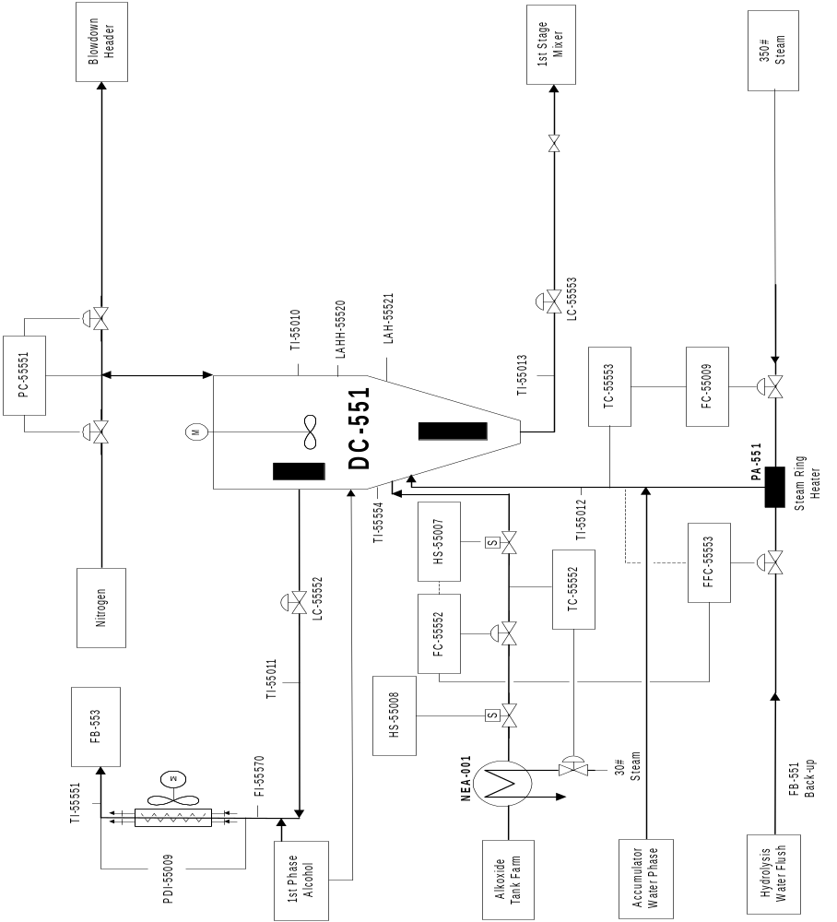

DRAWINGS: 1st Stage Separator (FA-552) and 2nd Stage Separator (FA-554)

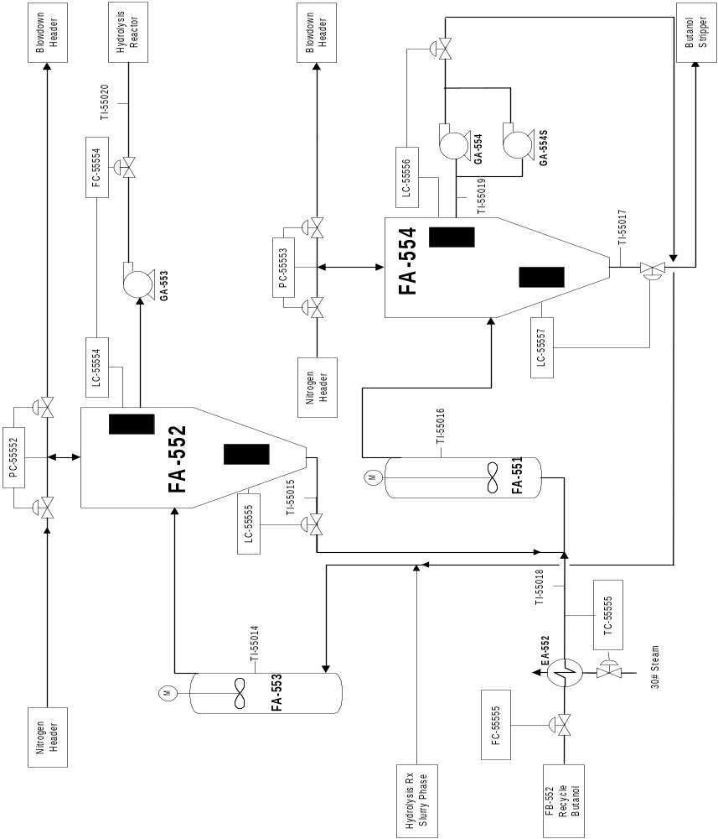

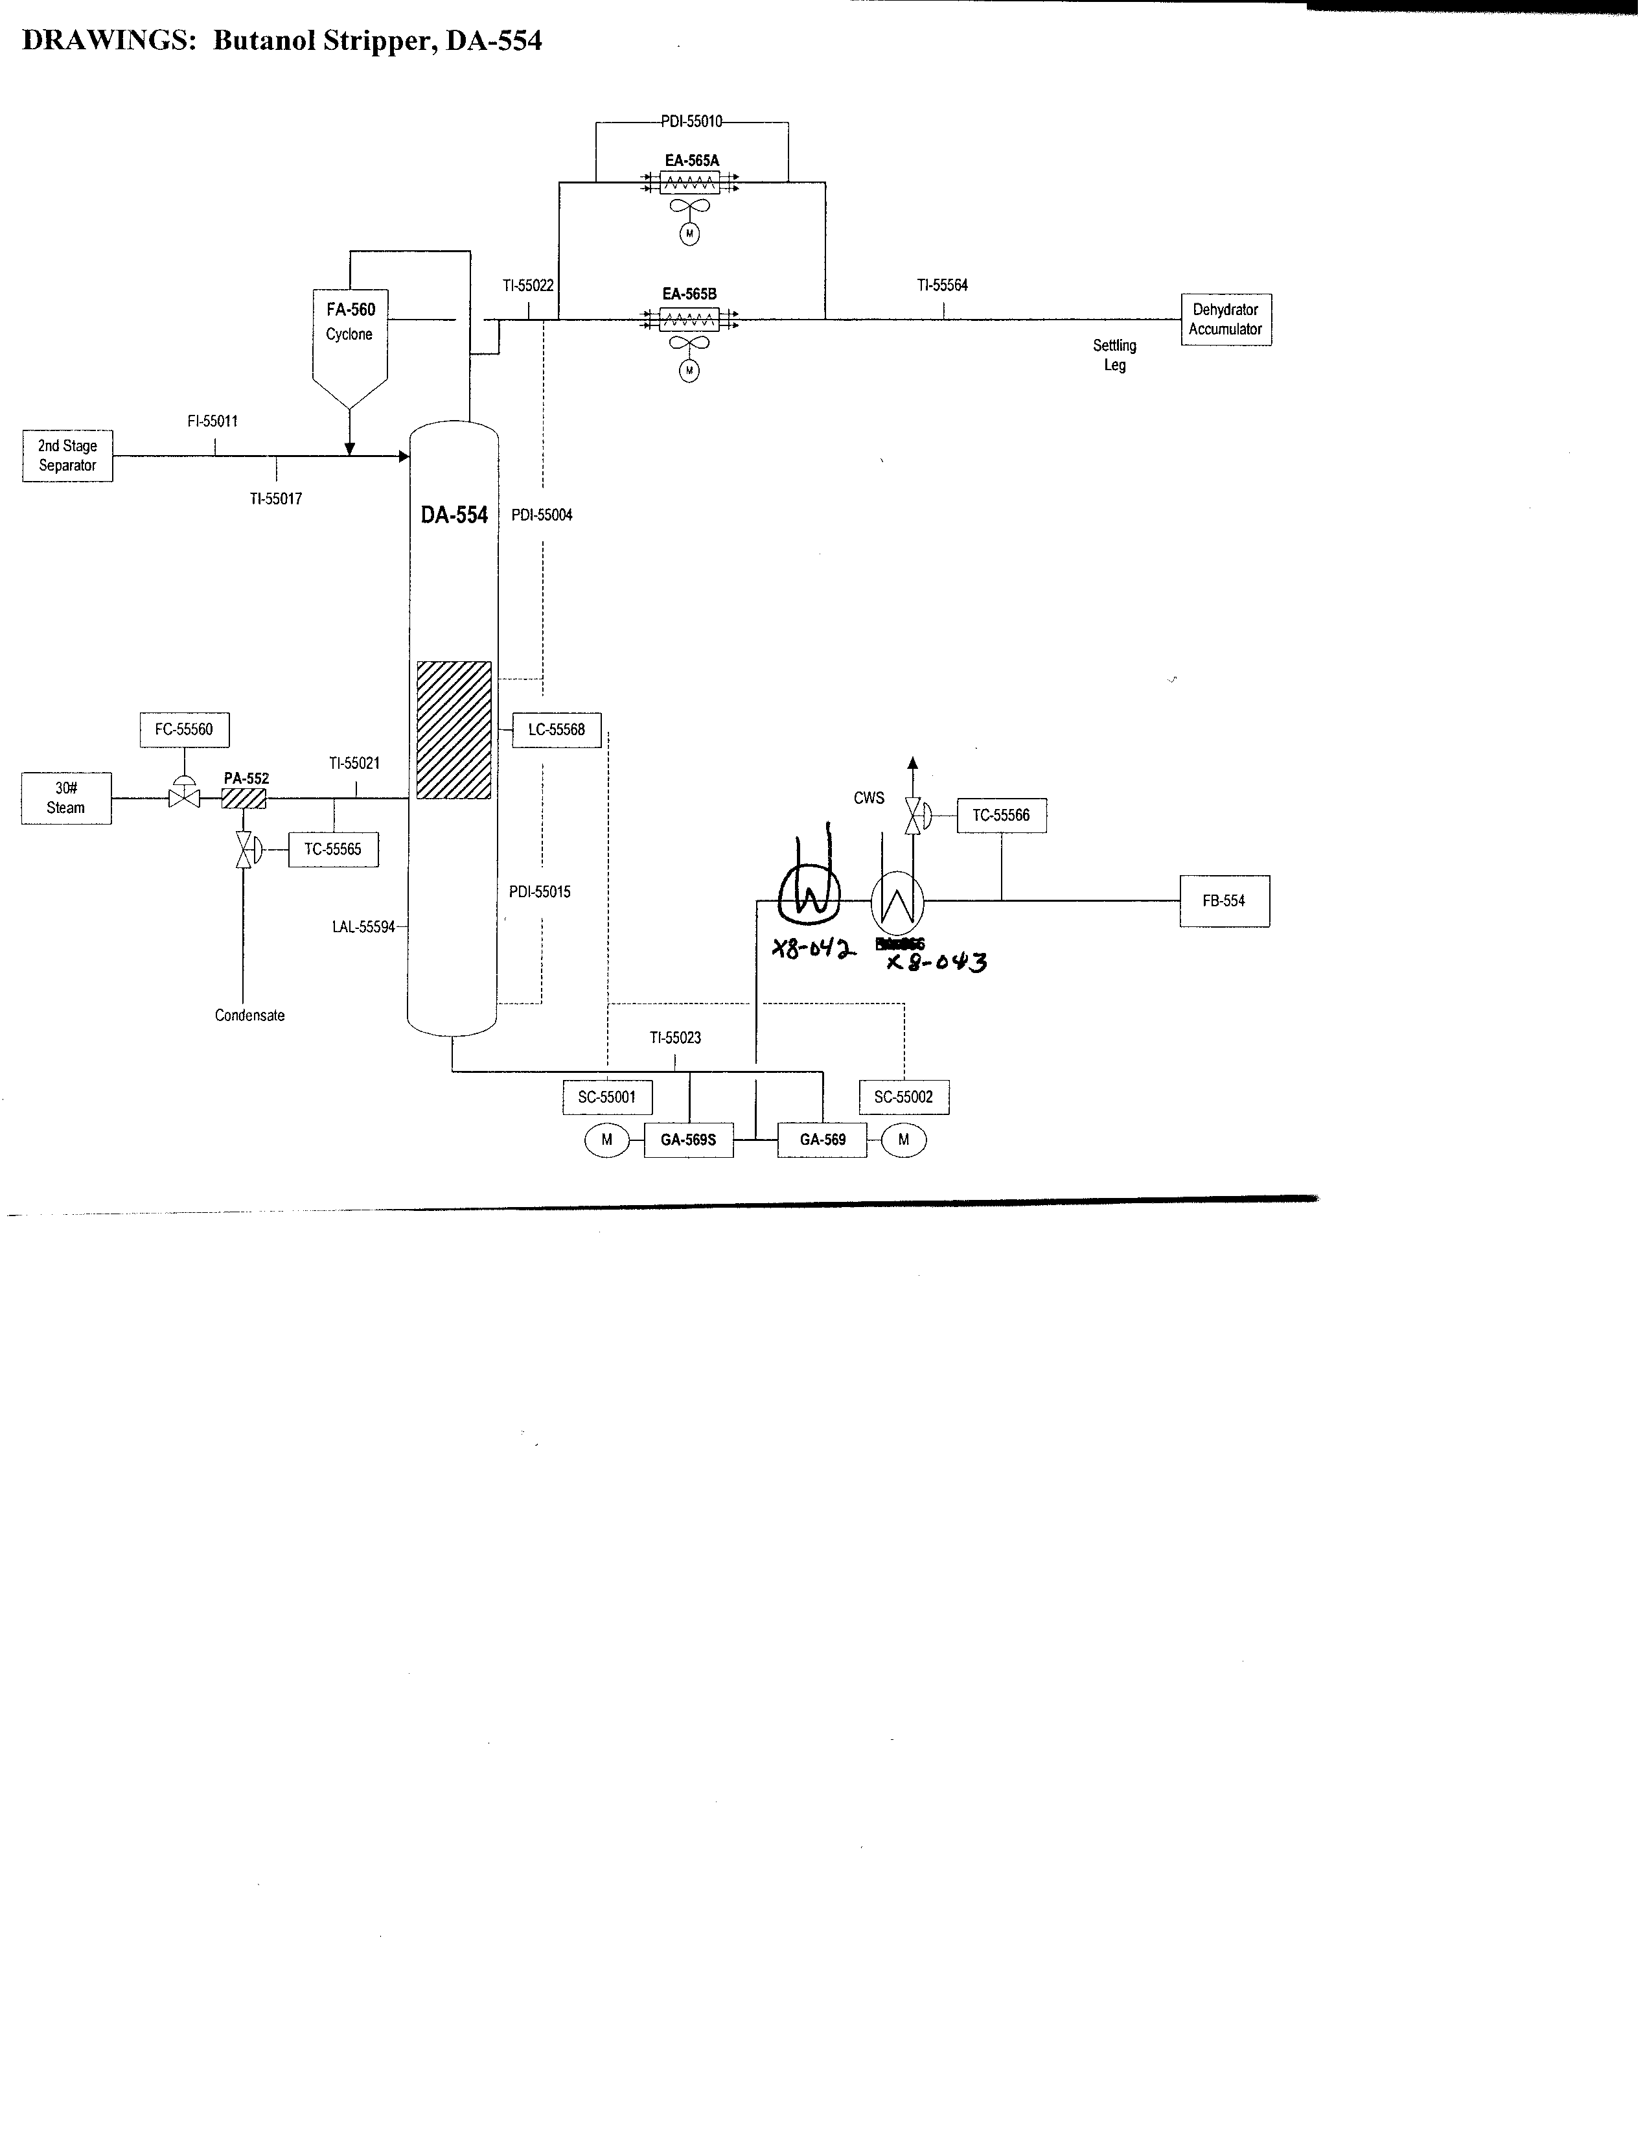DRAWINGS: Dehydrator Tower, DA-551
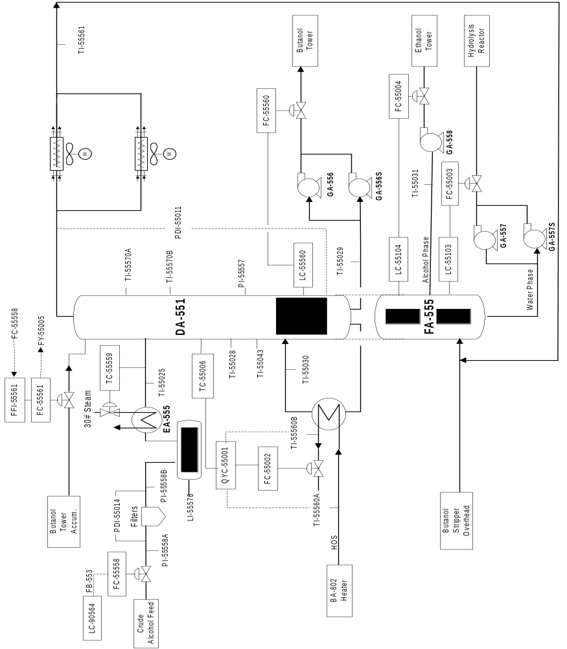

DRAWINGS: Ethanol Tower, DA-552

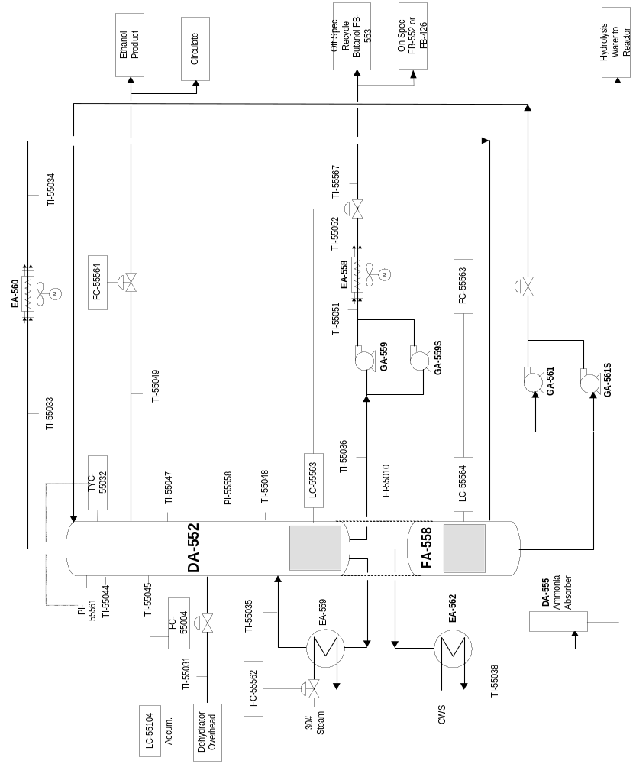
DRAWINGS: Butanol Tower, DA-553
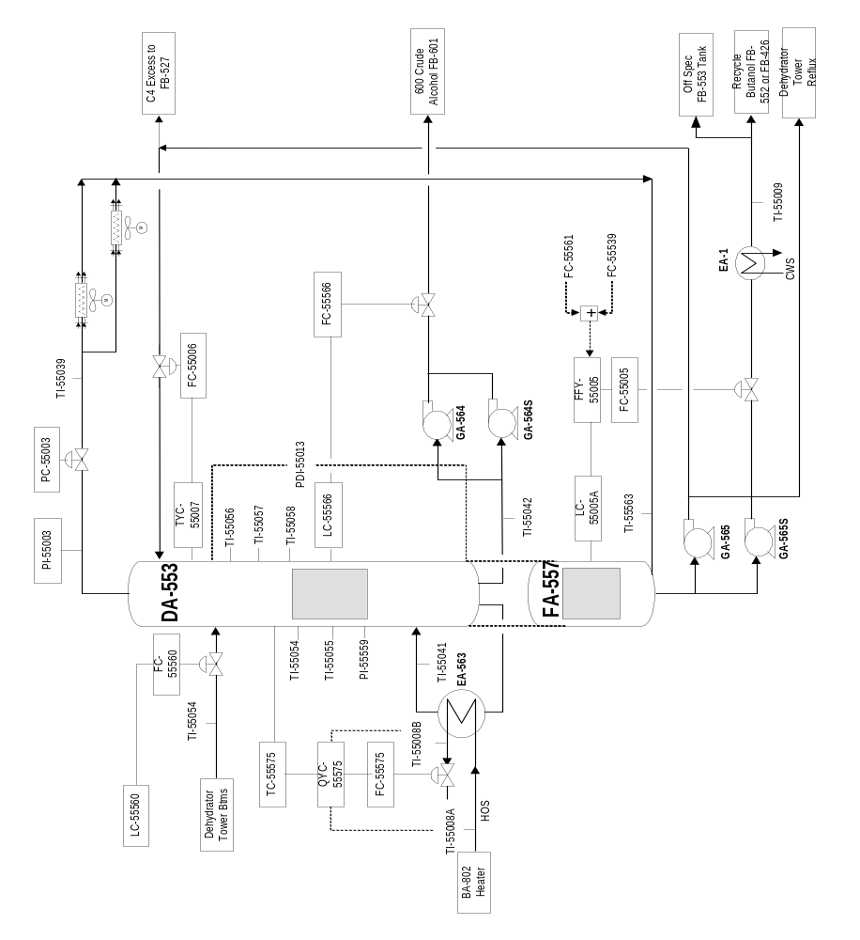

Procedure Criticality Assessment
Please review each of the criteria below to determine the level of criticality.
Check the appropriate box to the right of the criteria.
If any question is answered with YES, a procedural hazard analysis of that procedure will be conducted.
Criteria | Yes | No
- Will this procedure be claimed as a safeguard in a PHA/HAZOP? |   | X
- Is this an infrequently-utilized activity (non-routine task) that can result in a significant injury, fire, explosion, or environment event? |   | X
- Does execution of the procedure require complex or highly sensitive sequencing? |   | X
- Will failing to follow the procedure alone (with mitigations in place, ex: PRVs and SIS), result in a significant injury, fire, explosion, or environmental event? |   | X

