GENERAL UNIT OVERVIEW

Stripped alkoxide from FB-658 tank and water from the dehydrator tower overhead accumulator, and/or FB-551, hydrolysis water feed tank is reacted in the hydrolysis reactor. Alumina slurry and crude alcohol is produced from this reaction.

The crude alcohol from the hydrolysis overhead can go direct to FB-553 tank (dehydrator feed tank). Water and ethanol is removed in the dehydrator, the ethanol is processed in the ethanol tower. The bottoms from the dehydrator go to the butanol tower; butanol is removed in the overhead; 6+ alcohol is the bottom product. This stream is further processed in the 600 Unit distillation towers.

The alumina slurry is the bottom product from the hydrolysis. The slurry is washed in the purification section using recycle butanol to remove 6+ alcohol. The butanol stripper removes the butanol from the slurry stream using low pressure steam (27#).

APPROVED:_______________________________Operations Supervisor

DRAWING: Hydrolysis Section

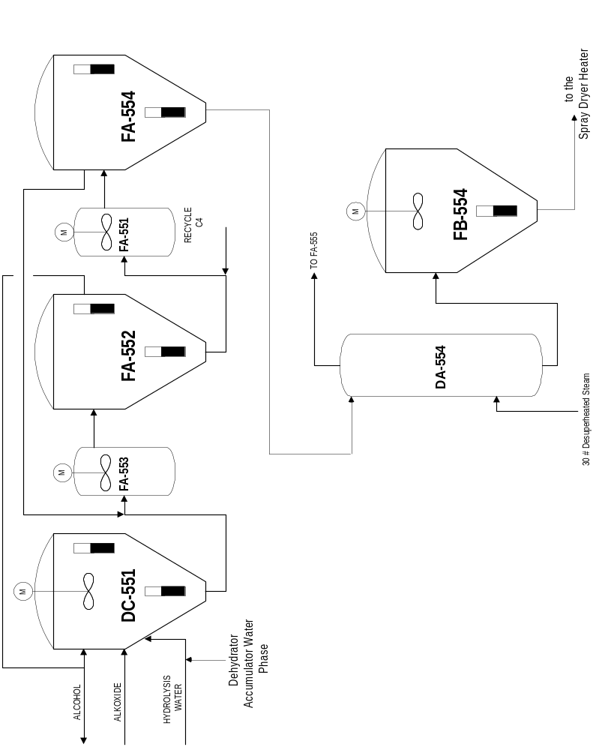
DRAWING: Fractionation Section

