USER MANUAL

Q-CITY CORE BANKING



TO LOGIN FOR VARIOUS MENUS : Enter the valid details of the person on the login screen
Valid Customer Representative login


Invalid Customer Representative login

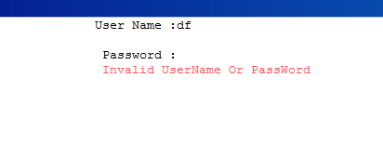
Valid Clerk login

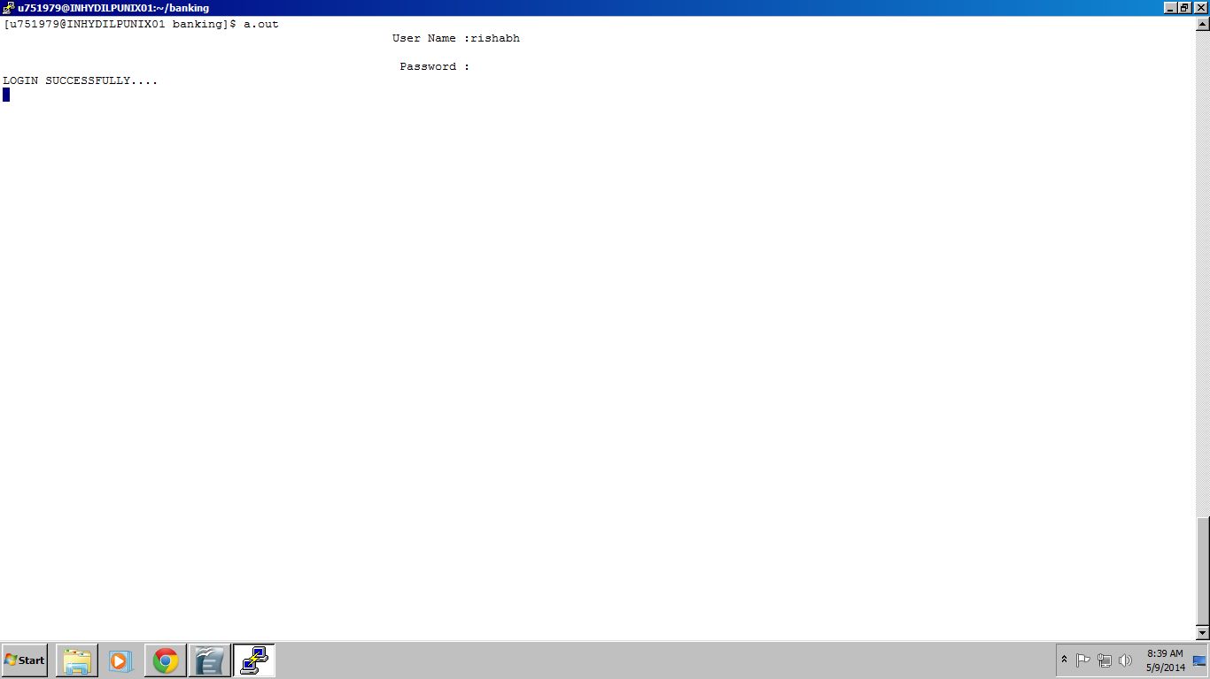
Invalid Clerk login
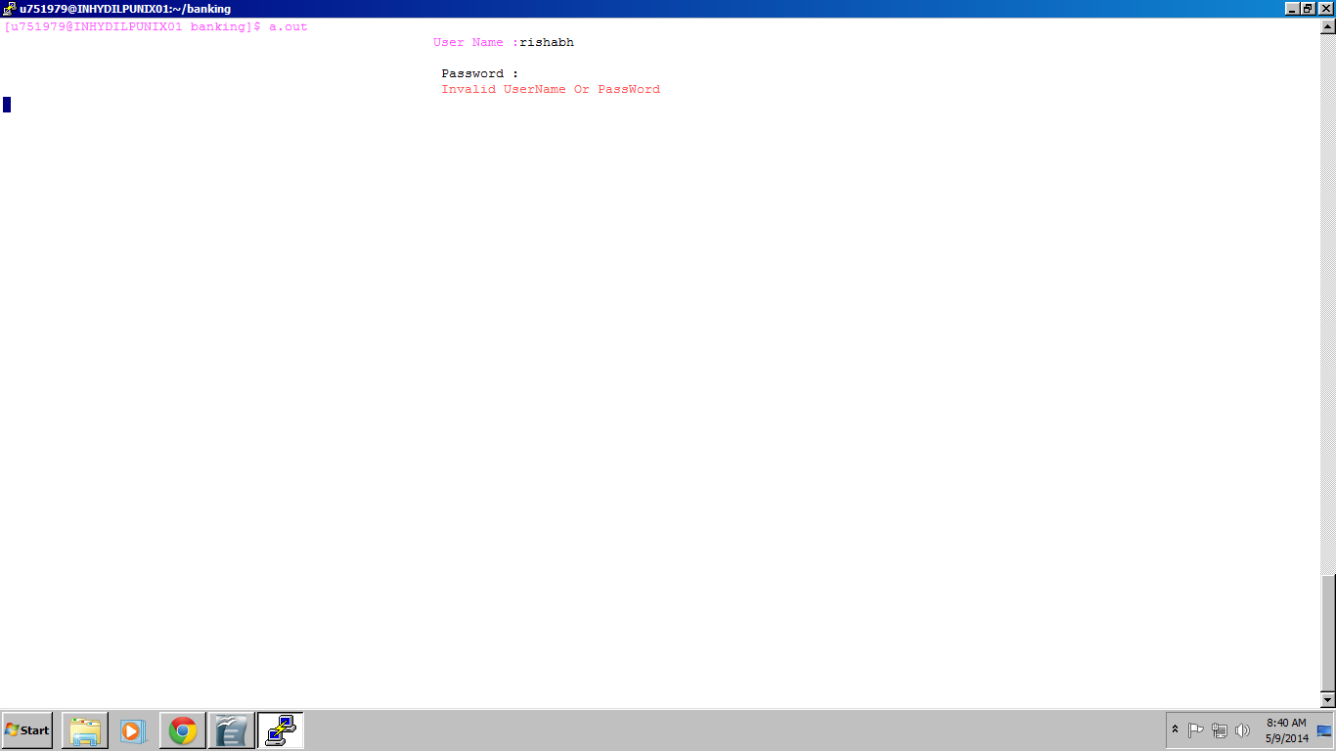
Valid Manager login



Invalid Manager login
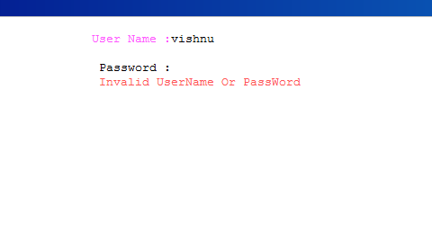

ACCESSING MENUS : After Customer Representative login is successful Customer Representative menu is displayed
now options are asked
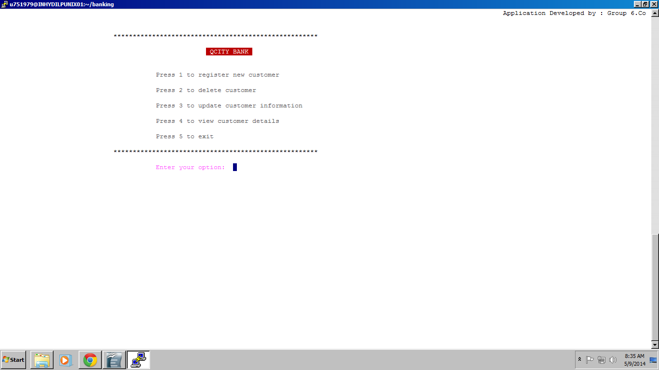
now options are asked and user enters a choice
if choice invalid
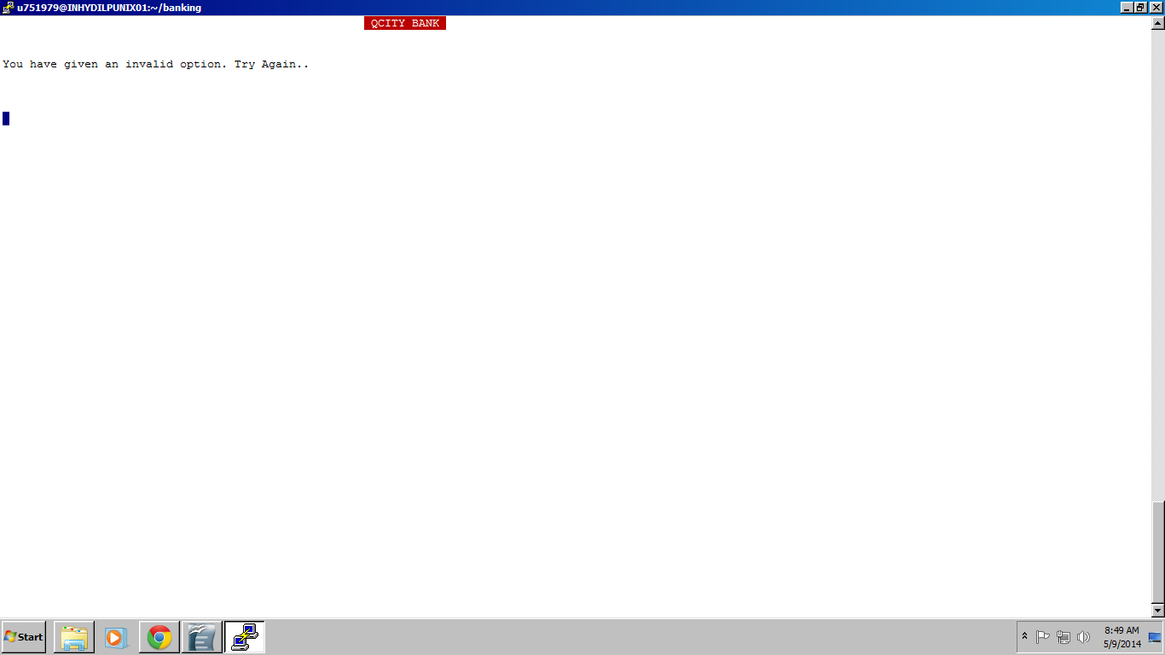
if choice valid it proceeds with the entered option

if entered option is 1 it navigates to the screen registering customer

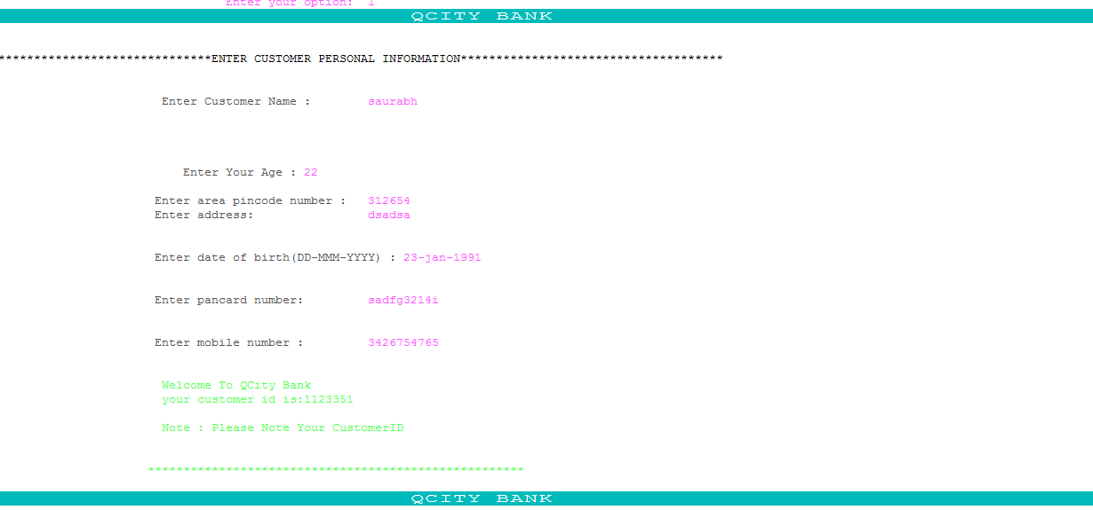
details are entered and system generates a unique customer id for the customer

if entered option is 2 it navigates to the screen where customer id is asked and after that customer is deleted
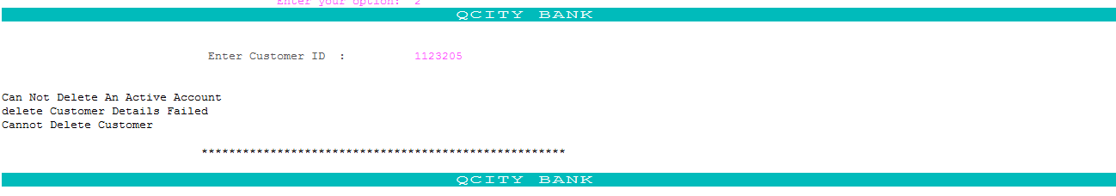

since the user has an active account so it cant be deleted

if entered option is 3 it navigates to the screen where customer id is asked and after that customer details are updated

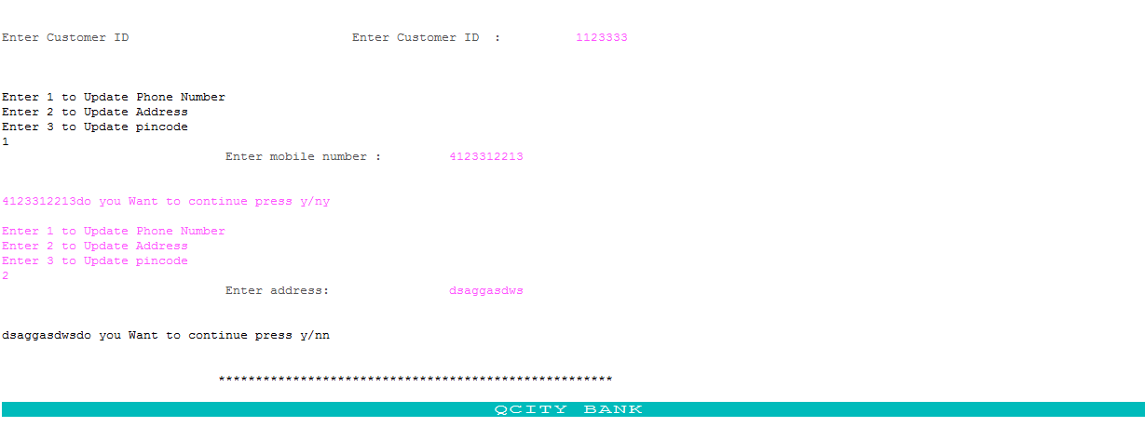
if entered option is 4 it navigates to the screen where customer id is asked and after that particular customer details are displayed
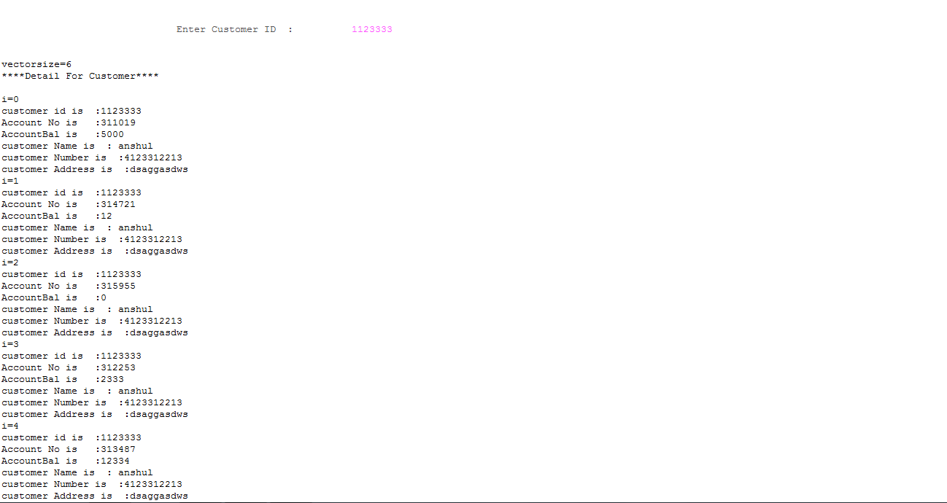

pressing option 5 takes user out of the system

After Clerk login is successful Clerk menu is displayed
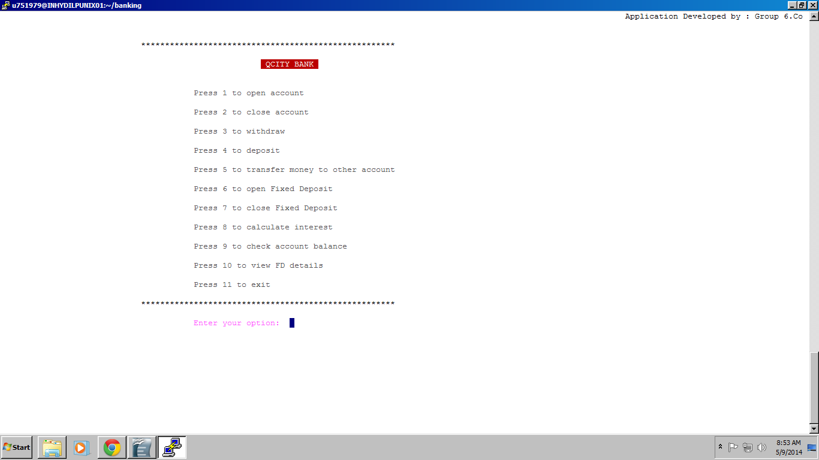
now options are asked and user enters a choice
if choice invalid

if choice valid it proceeds with the entered option
if entered option is 1 it navigates to the screen for opening account
if entered option is 2 it navigates to the screen for closing account
if entered option is 3 it navigates to the screen for withdrawing amount
if entered option is 4 it navigates to the screen for depositing amount
if entered option is 5 it navigates to the screen for transfer money
if entered option is 6 it navigates to the screen for opening fixed deposit
if entered option is 7 it navigates to the screen for closing fixed deposit
if entered option is 8 it navigates to the screen for calculate interest
if entered option is 9 it navigates to the screen to check account balance
if entered option is 10 it navigates to the screen registering customer
if entered option is 11 it exits

After Manager login is successful Manager menu is displayed
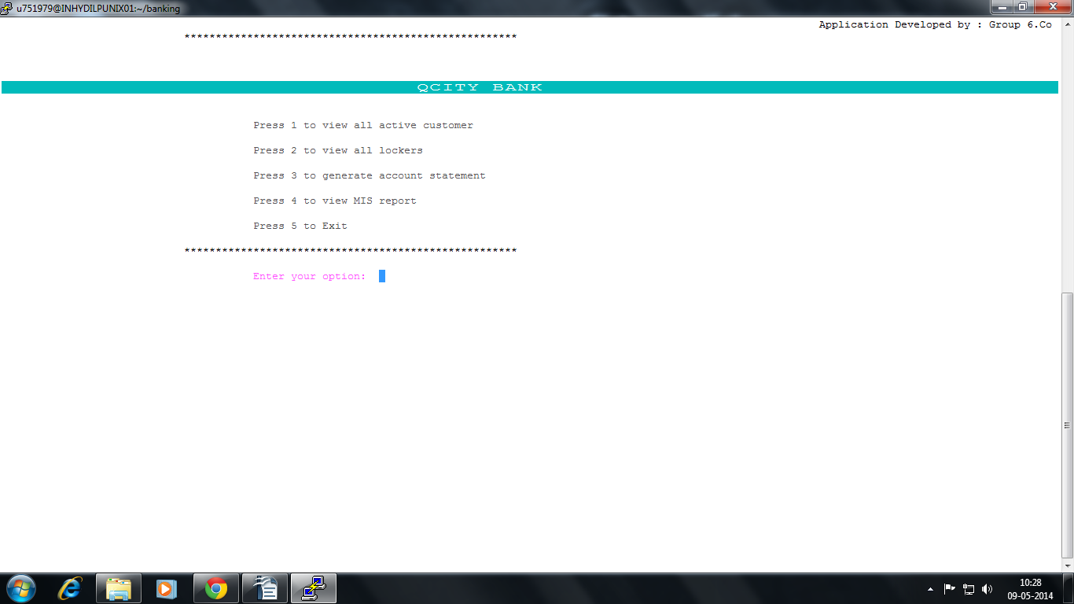
now options are asked and user enters a choice
if choice invalid

if choice valid it proceeds with the entered option
if entered option is 1 it will display All customer
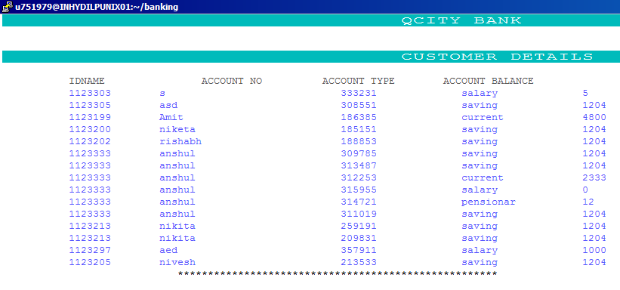
if entered option is 2 it will display All Lockers
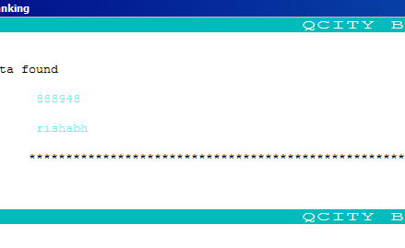

if entered option is 3 it will first ask account number and thenGenerate account Statements
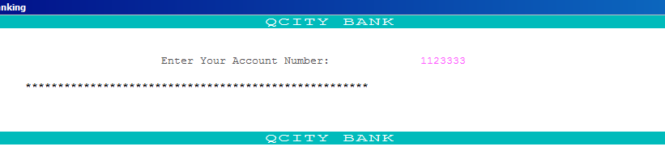
if entered option is 4 it will show MIS report
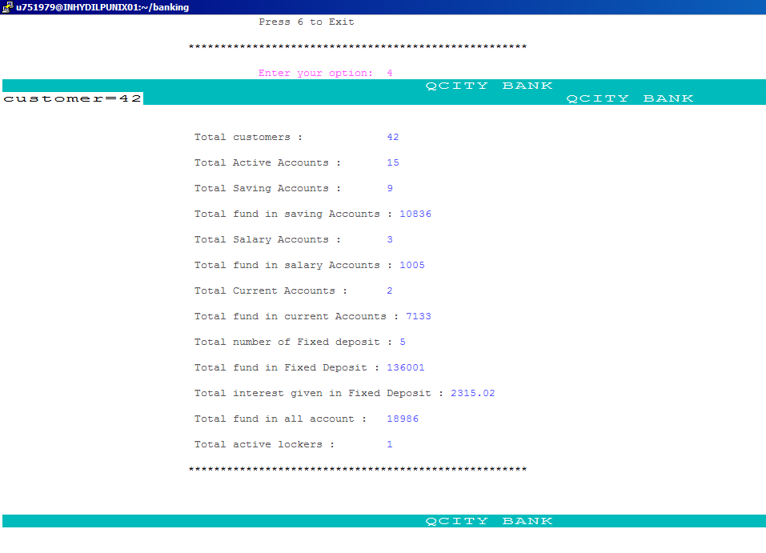

if entered option is 5 it will show All Fixed Deposits
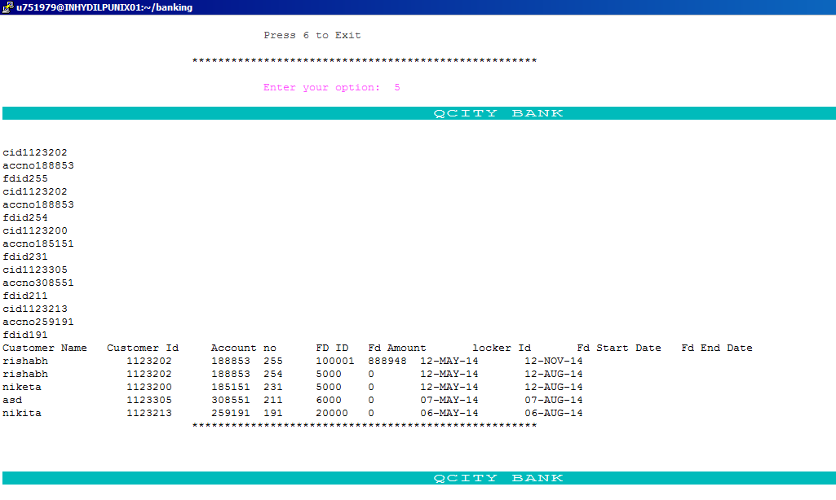

if entered option is 6 it will exit From Menu



