TreeTrace: An AI-Powered Smart Geo-Spatial Tree Inventory System



DAVAO DEL NORTE STATE COLLEGE
Institute of Computing
New Visayas, Panabo City

A Capstone Project Present by:

ARABELLA P. GELLA
SHAINA L. MA-ANO
CHRISZEL ANN D. SAUZA

March 2026

CHAPTER 1
INTRODUCTION

Background of the Project

The primary motivation for this research lies in the urgent need to transition from traditional, manual tree management to integrated digital systems using GIS and GPS technologies[1]. Historically, the management of complex botanical assets has relied on fragmented, paper-based records, which leads to inconsistent data regarding tree health, distribution, and economic value[1][2]. Globally, deforestation and forest degradation remain critical drivers of the climate crisis, yet individual tree accounting is almost nonexistent, making it difficult to execute and verify selective logging or conservation efforts[3][4].
Nationally, the Philippines has experienced significant forest loss and degradation, with forest cover declining from approximately 17 million hectares in 1930 to just 5.8 million hectares by 2000[1]. This has exacerbated environmental hazards such as flooding and landslides[1][2]. On an organizational level, agroforestry entities face technical challenges in long-term monitoring and the socioeconomic viability of their restoration projects[3][4]. Smallholder participation in carbon markets is currently hindered by the lack of scalable, low-cost Measurement, Reporting, and Verification (MRV) systems[5]. This project addresses these multi-level issues by deploying high-fidelity digital monitoring and AI-driven diameter estimation to bridge the gap between complex environmental data and practical, cost-effective management solutions[5][6].
The study is aligned with the United Nations 2030 Sustainable Development Goals (SDGs), specifically SDG 13 (Climate Action) and SDG 15 (Life on Land), by facilitating nature-based solutions that enhance carbon sequestration and preserve biodiversity[1][2]. Furthermore, it aligns with the Davao del Norte State College (DNSC) Research, Development, and Extension (RDE) Agenda, which emphasizes the creation of innovative solutions and technologies to empower communities towards sustainable development[3][4]. Specifically, the project supports the mission of utilizing information technology to address "pain points" in human capital development and harmonized, SDG-based research[5].
Insights from a Problem Tree Analysis identify the core issue as the manual and fragmented nature of tree monitoring within organizational settings, caused by high survey costs and a lack of scalable digital tools[1][2]. The resulting effects include poor post-planting survival rates and the exclusion of small-scale producers from economic opportunities in carbon markets[2][3]. Conversely, a Solution Tree Analysis identifies the focal objective: an AI-powered geospatial inventory system. By providing digital tools for non-contact measurements, the system serves as a means to achieve the goal of standardized environmental valuation and inclusive forest management[2][4].
The study focuses on the operational landscapes managed by Agroforestry Organizations, which integrate trees, crops, and livestock on the same land units[1]. These organizational landscapes are characterized by high structural diversity and multifunctionality, which are essential for soil conservation, water retention, and climate resilience[1][2]. However, these systems are often subject to disturbances such as illegal cutting and encroachment due to limited oversight[3]. By focusing on these organizational environments, the proponents aim to implement a monitoring system that balances economic agricultural productivity with environmental stewardship at a farm or plot scale[2][4].
TreeTrace is an integrated flora inventory system designed to digitize the management of woody perennial plants within agroforestry contexts. It leverages a cloud-based architecture and a web interface to provide a "digital twin" of monitored sites, enabling real-time data retrieval and growth tracking[1][2]. The project utilizes smartphone-based AI to allow organization members to perform professional-grade measurements without specialized hardware, facilitating participatory monitoring and local ownership of data[3][4].

Objectives of the Study
This study aims to develop TreeTrace, an integrated AI-powered geo-spatial flora inventory system and mobile application that utilizes precision mapping and machine learning to automate health assessment and carbon sequestration monitoring for urban and agroforestry sites.
Specifically, the study aims to accomplish the following objectives within a ten-month development and implementation period:
1. Input Phase: Data Acquisition and Infrastructure
1.1 Compile a comprehensive digital repository of flora species data by integrating high-precision GPS coordinates and GIS mapping layers for target urban and agroforestry locations.
1.2 Establish a standardized dataset of plant images and physiological parameters to train the AI models for growth detection and health classification.
2. Process Phase: System Development and Algorithmic Integration
2.1 Design and train a machine learning engine capable of real-time plant health assessment and species identification using image processing and Augmented Reality (AR) technology.
2.2 Formulate an automated biomass calculation module that applies improved allometric models to estimate aboveground biomass and carbon sequestration potential for tropical trees.
2.3 Develop a digital tracking framework using QR code integration to ensure long-term traceability and monitoring of reforestation progress.
3. Output Phase: Deployment and Validation
3.1 Launch an interactive, cross-platform interface (TreeTrace) that provides the community and stakeholders with real-time access to botanical data and spatial insights.
3.2 Validate the accuracy of the system’s AI-driven health assessments and biomass estimations against manual field measurements to ensure a reliability rate of at least 90%.

Significance of the Study
The deployment of TreeTrace creates a multi-layered value chain, transforming raw botanical data into actionable intelligence for the following sectors:
- For Local Government Units (LGUs): It provides a scalable geospatial tool to manage green assets efficiently, allowing for better budget allocation and evidence-based decision-making in urban and rural planning.
- For Environmental Researchers: It offers a high-fidelity digital inventory and standardized health protocols that serve as a baseline for longitudinal studies on biodiversity, species classification, and climate resilience.
- For Agroforestry Organizations: It streamlines the Measurement, Reporting, and Verification (MRV) process, reducing operational costs and increasing transparency across the seed and seedling value chain through digital traceability.
- For Policy Makers: It delivers quantified data on carbon sequestration and ecosystem services, supporting the integration of field data into National Determined Contributions (NDC) reports and international restoration portals.
- Community / Citizens: Raises environmental awareness and encourages participation in tree monitoring and conservation efforts
- For Future Researchers: It establishes a technical precedent for integrating deep learning (e.g., semantic segmentation) and GIS in botanical studies, serving as a foundation for more complex smart-agriculture modules.

Scopes and Limitations
The scope of this study centers on the design and implementation of TreeTrace, an integrated system utilizing Geographic Information Systems (GIS) and Web-based Dashboard technology for urban forestry management. The inventory is strictly delimited to woody perennial plants and significant tree species within the jurisdiction of Panabo City. Consequently, the study excludes ephemeral flora, such as seasonal grasses or minor undergrowth, to focus on long-term canopy contributors.
The operational framework of the system is built upon four primary processes: precise Geolocation via mobile GPS for coordinate mapping; AI-driven Measurements using deep-learning segmentation for automated Diameter at Breast Height (DBH) estimation; Data Centralization through secure cloud storage of botanical attributes; and longitudinal Monitoring using periodic photo-based follow-ups to track survival and growth rates.
Conversely, certain processes remain outside the current functional capacity of the system. TreeTrace does not incorporate real-time physiological sensing, such as IoT-based sap flow, soil moisture analysis, or automated environmental sensor networks. Although the system includes AI-assisted species identification, AI-generated results are treated as preliminary suggestions only and do not fully replace expert taxonomic verification. Official tree inventory records and unknown species submissions still require validation by authorized personnel or expert reviewers to maintain data accuracy. Furthermore, the assessment is limited to ground-based visual conditions and excludes soil or subterranean analysis. Finally, while the system is capable of calculating carbon sequestration metrics, it does not facilitate automatic carbon payouts or manage financial transactions related to carbon credit sales.
REVIEW OF RELATED LITERATURE AND WORKS

Introduction
This chapter critically examines existing literature and systems related to digital tree inventory management, focusing on GPS integration, real-time monitoring, and QR code applications. It addresses the research gaps in cost-effective solutions for Philippine LGUs, synthesizing themes from global and local studies to justify TreeTrace's development[27].

Related Literature

Overview of Existing Literature
Tree inventory practices have transitioned from manual field surveys to digital geospatial systems amid rising deforestation pressures[27]. In the Philippines, forest cover dropped from 17 million hectares in 1934 to 5.8 million by 2000 due to logging and agriculture, highlighting the need for scalable monitoring[30]. Globally, urban forestry studies emphasize GPS-enabled inventories for precise mapping, replacing paper logs prone to errors and loss[31].

Historical Context and Key Approaches
Early systems used PDAs for arboriculture inventories, enabling digital data capture in forests[28]. Recent advancements incorporate mobile GIS for real-time tree plotting, as seen in Fulcrumapp's guidebook stressing GPS accuracy over 5 meters for urban trees[29]. Philippine contexts reveal manual National Forest Inventory methods persisting despite GIS potential in mangrove monitoring[30].
Synthesis of Key Themes
Common findings across studies include GPS reducing survey costs by 60-80% versus professional services (₱5,000-15,000/day)[29] and cloud databases enabling multi-user access[36]. AI-driven DBH estimation via semantic segmentation achieves 90% accuracy with reference objects[34], while allometric equations link diameter to biomass[32]. QR codes emerge as low-cost identifiers, linking physical trees to digital records in 70% faster retrieval times[33].

Identification of Gaps
Literature gaps include limited real-time features for small LGUs, lacking QR-GPS hybrids tailored to Philippine agroforestry, and no integrated systems under ₱1,000 initial setup[40]. Conflicting findings on mobile GPS precision (3-10m) underscore needs for validation protocols[29], while most studies exclude community-level deployment[30].

Related Works
Related works comprise digital platforms mirroring TreeTrace's mobile-web architecture for tree management.

Tabular Comparison of Related Works
Table 1. Comparative
System | GPS mapping | Real- time updates | QR codes | Cloud DB | AI DBH est. | Philippines focus | Accuracy | Key diff. from TreaTrace
TreePlotter INVENTORY | ✓ | ✓ |  | ✓ |  |  | 95% GPS match | Lacks QR; enterprise pricing
GIS Cloud Mobile | ✓ | ✓ |  | ✓ |  |  | <5m GPS | No QR/local adaptation
Groundzy App | ✓ |  | ✓ | ✓ |  |  | 92% AI ID | AI species only; no real-time
ArborStar | ✓ | ✓ |  | ✓ |  |  |  | Commercial; high cost
My Farm Tress | ✓ | ✓ |  | ✓ | ✓ | ✓ | 88% biomass | Blockchain heavy; no QR
TreeTrace | ✓ | ✓ | ✓ | ✓ | ✓ | ✓ | Target: 90%+ | QR+GPS+AI; low-cost local

Similarities: All use GPS/cloud for mapping; real-time in 4/5.
Differences: TreeTrace uniquely integrates QR for instant access and targets Philippine LGUs with AI DBH under budget constraints .

Definition of Terms
- Allometric Equations: Mathematical models relating tree diameter to biomass/volume, used in TreeTrace for carbon estimation from DBH measurements.
- DBH (Diameter at Breast Height): Standard 1.3m tree trunk measurement; TreeTrace estimates via AI segmentation for non-contact field use.
- Geo-Spatial Inventory: GPS-mapped database of tree locations; TreeTrace's core for precise Panabo City plotting.
- GPS Tagging: Assigning coordinates to trees; enables TreeTrace's real-time mapping with <5m accuracy.
- QR Code Identification: Scannable markers linking to tree data; TreeTrace feature for instant retrieval via mobile scan.
- Real-Time Monitoring: Cloud-synced updates; TreeTrace allows instant condition changes across users.
- Semantic Segmentation: AI algorithm isolating tree trunks in photos; powers TreeTrace's DBH estimation with reference objects.

CHAPTER 2
METHODOLOGY

This chapter describes how the TreeTrace system was planned, developed, and implemented to address the challenges in manual tree inventory and monitoring. It explains the processes, methods, and tools used by the proponents in designing and developing the system. The chapter also presents the System Development Life Cycle (SDLC) model used, along with its phases and how each phase was applied in the project. Furthermore, this chapter follows the PADIM structure—Planning, Analysis, Design, Implementation, and Maintenance—to clearly illustrate the step-by-step development of the TreeTrace system.

Software Development Lifecycle

The proponents adopted the Waterfall Model as the SDLC approach for the development of the TreeTrace system. The Waterfall Model is a linear and sequential approach where each phase must be completed before proceeding to the next [26]. This model was chosen because the system requirements were clearly defined at the early stage of the project, making it suitable for structured development [26].

Figure 1. The Waterfall Model for the TreeTrace System SDLC

Planning

In the planning phase, the proponents identified the inefficiencies of manual tree inventory systems, such as paper-based records, data inconsistency, and difficulty in monitoring. The team defined the objectives of the TreeTrace system, identified the target users (LGUs, researchers, and organizations), and determined the features such as GPS tagging, QR code identification, and centralized cloud storage.

The proponents also prepared the project plan, including the Project Team Organization, Work Breakdown Structure (WBS), and Gantt Chart to guide the development timeline and activities.

Analysis

The analysis phase focused on understanding how users interact with the system and how data flows within it. The proponents analyzed system requirements, including functional requirements such as adding tree records, scanning QR codes, and viewing maps, and non-functional requirements such as system reliability, usability, and performance.

System models such as the Use Case Diagram, Context Flow Diagram (Level 0 DFD), and Level 1 DFD were used to visualize user interactions and system processes.

Design

During the design phase, the proponents created the system architecture, database design, and interface layout of TreeTrace. The system follows a client-server architecture consisting of a mobile application for field data collection and a web dashboard for monitoring and management.

The database structure was defined using the Entity Relationship Diagram (ERD) and Data Dictionary, ensuring proper organization and relationship of data such as users, trees, locations, and monitoring logs. The design phase also included the selection of technologies such as SQL database, GPS integration, QR code system, and cloud storage.

Implementation

In the implementation phase, the proponents developed the TreeTrace system based on the design specifications. The mobile application was built to allow users to record tree data, capture GPS coordinates, and scan QR codes, while the web dashboard was developed for administrators to manage and monitor the system.

System testing was conducted to ensure that all functionalities work correctly, including data entry, real-time updates, QR code retrieval, and map visualization. Errors and bugs identified during testing were corrected to improve system performance.

Maintenance

The maintenance phase focuses on improving and sustaining the performance of the TreeTrace system after development. The proponents conducted system updates, fixed errors, and ensured the reliability of database storage and system functions.

Additionally, knowledge transfer was provided to designated personnel to enable them to manage, operate, and maintain the system. This ensures the long-term usability and sustainability of the TreeTrace system.

System Planning
The planning phase began with the identification of the problem experienced in manual tree inventory and monitoring. The team observed that paper-based recording of tree data is inefficient, prone to errors, and difficult to update. This motivated the development of TreeTrace as a digital solution for recording, tracking, and managing tree information in a centralized system.
During planning, the team defined the objectives of the project, determined the scope and limitations, identified the target users, and selected the features to be included in the system. The team also discussed the feasibility of using mobile devices, GPS, QR codes, and cloud storage to support real-time data management. Through brainstorming and consultation, the project was shaped into a geo-spatial inventory system that can assist organizations in managing tree records more efficiently.

Project Team Organization
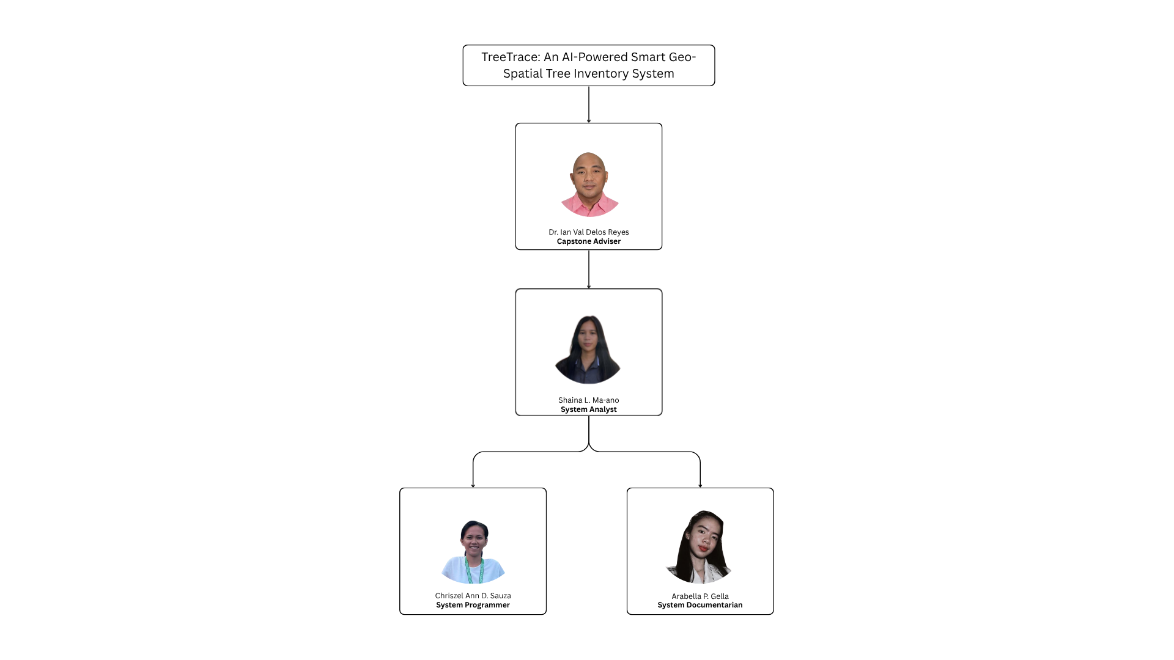
Figure 2. Project Team Organization Chart

This section outlines the roles of the project team. Figure 2 illustrates the project team's organizational chart. The Capstone Adviser provides guidance and ensures the system meets academic and development standards. The project manager leads discussions and decision-making, while the system analyst oversees the planning phase. The system designer and developer are responsible for designing and coding both the front-end and back-end of the system. The technical writer conducts research and interviews to define system requirements and workflows.

Work Breakdown Structure
This section describes the fundamental component of project management, the Work Breakdown Structure (WBS), as shown in Figure 2, which provides a comprehensive breakdown of project tasks and deliverables. It serves as a visual representation and hierarchical organization of the project's work scope, enabling effective planning, coordination, and monitoring of project activities. In this section, the WBS outlines the project's work breakdown structure in a systematic and logical manner. It breaks down the project into manageable components, allocating resources, estimating timelines, and tracking progress more easily.
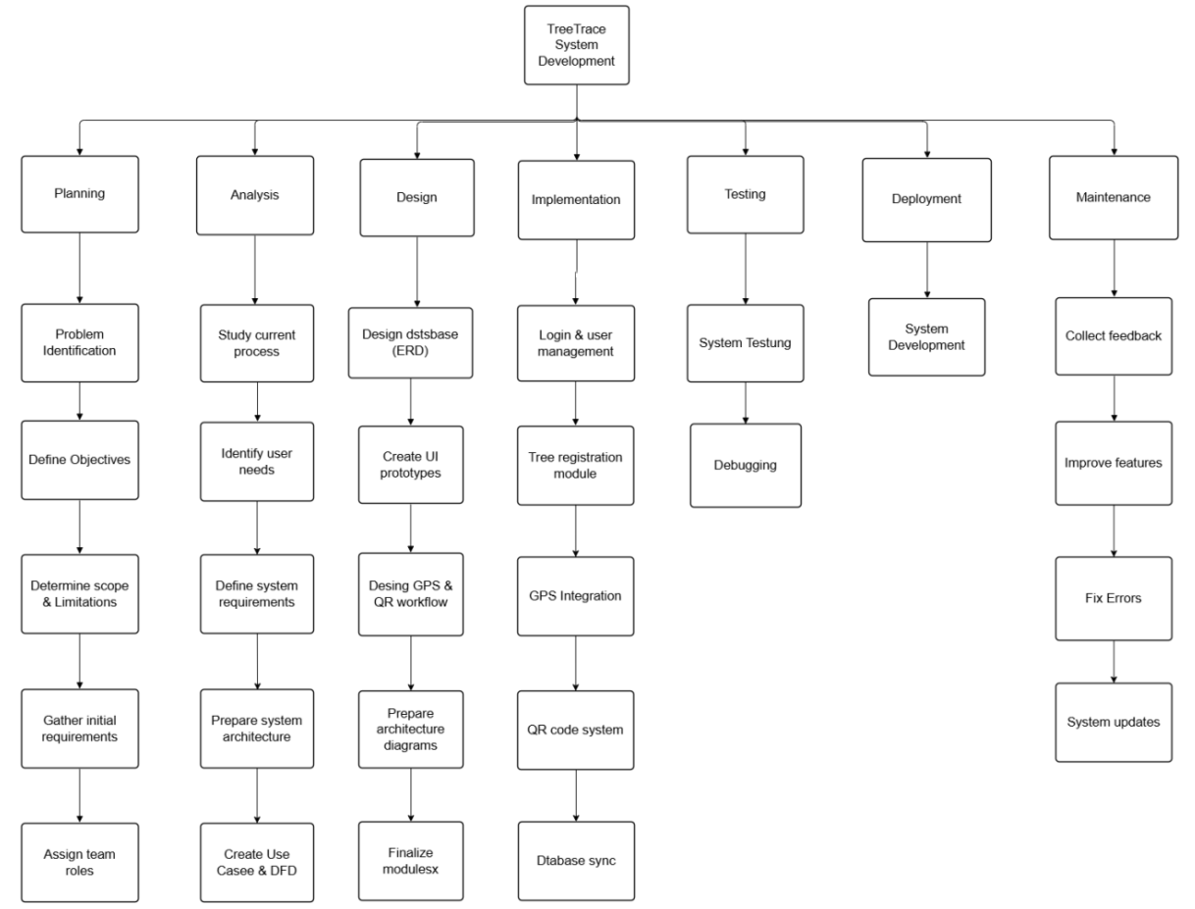

Figure 3. Work Breakdown Structure

Gantt Chart
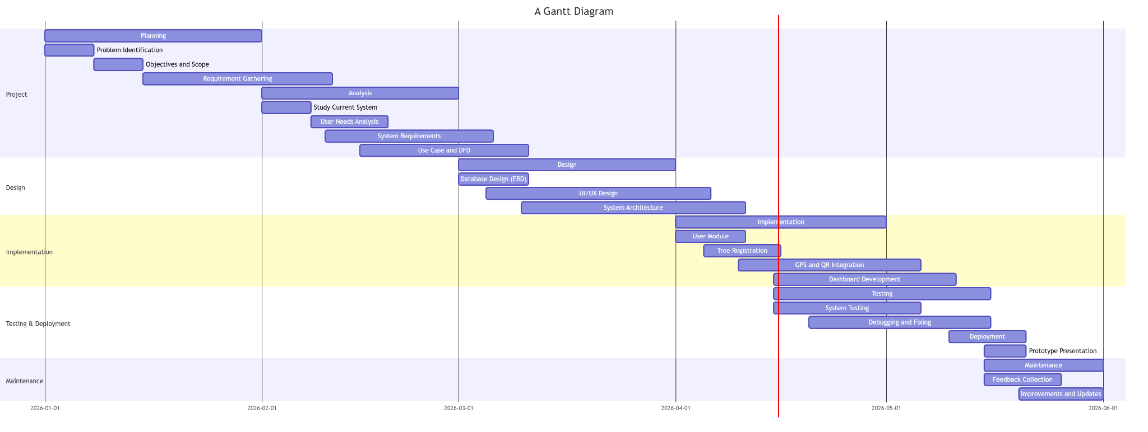
Figure 4. Gantt Chart showing the complete breakdown of development process

Figure 4 above shows a full breakdown of each development process. The chart illustrates the timeline of each sub-process in the development process, including previous, current, and future work. This is often valuable to keep assignments on track when there's a huge group and different partners, when the scope changes [24].

System Analysis

This section discusses how the proponents created diagrams that provide a detailed analysis of the process. First, the definition of the system’s requirements is discussed to identify the system's features. The interaction of actors will be scrutinized to build a Use Case diagram. The proponents also define the system's general and detailed processes, as shown by the Context Data Flow Diagram and Data Flow Diagram. Lastly, they identify the different technologies and tools used in creating the system and meeting its requirements.

System Architecture
This section describes the TreeTrace system architecture, including its hardware, software, and data components, integrating the mobile app, web dashboard, and a cloud-based centralized database. It also incorporates an AI-powered module for DBH estimation and carbon computation, enabling real-time monitoring, analysis, and visualization of tree data.

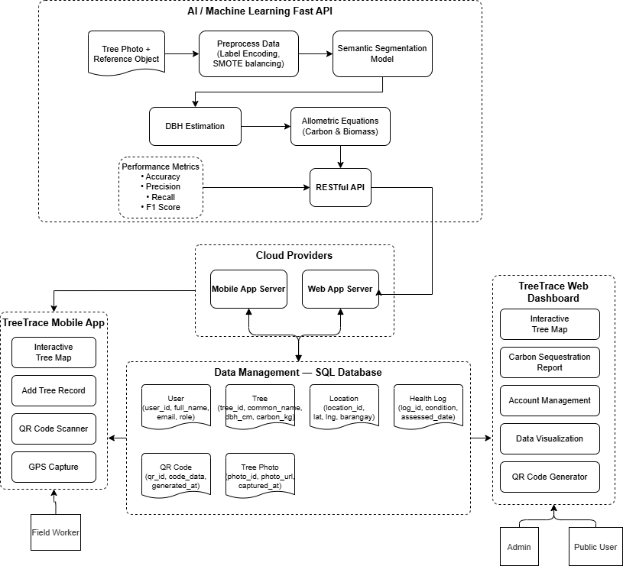
Figure 5. System Architecture
Figure 5 presents the implemented TreeTrace architecture as a connected mobile, web, backend, and cloud database system. Field workers and administrators use the Flutter mobile application and React web dashboard to manage official tree inventory records. Citizens use the public portal to view the tree map, scan QR tags, run limited AI identification, and submit unknown species for expert review. All application requests pass through the FastAPI backend, which validates accounts, applies role-based permissions, stores records in the cloud database, and returns synchronized data to both web and mobile clients.

Implemented Architecture Layers

Architecture Data Flow
The system flow begins when a user logs in or opens the public portal. Authenticated users send requests from the Flutter app or web dashboard to the FastAPI backend. The backend checks the user role, processes the request, stores or retrieves records from PostgreSQL, and returns structured JSON data to the client. For AI scanning, the uploaded image is sent to the AI identification module through the backend; the result is returned to the user and may be submitted as an unknown species record when expert review is needed. For QR access, each tree profile is linked to a public route so scanned QR labels can open the correct verified tree profile.
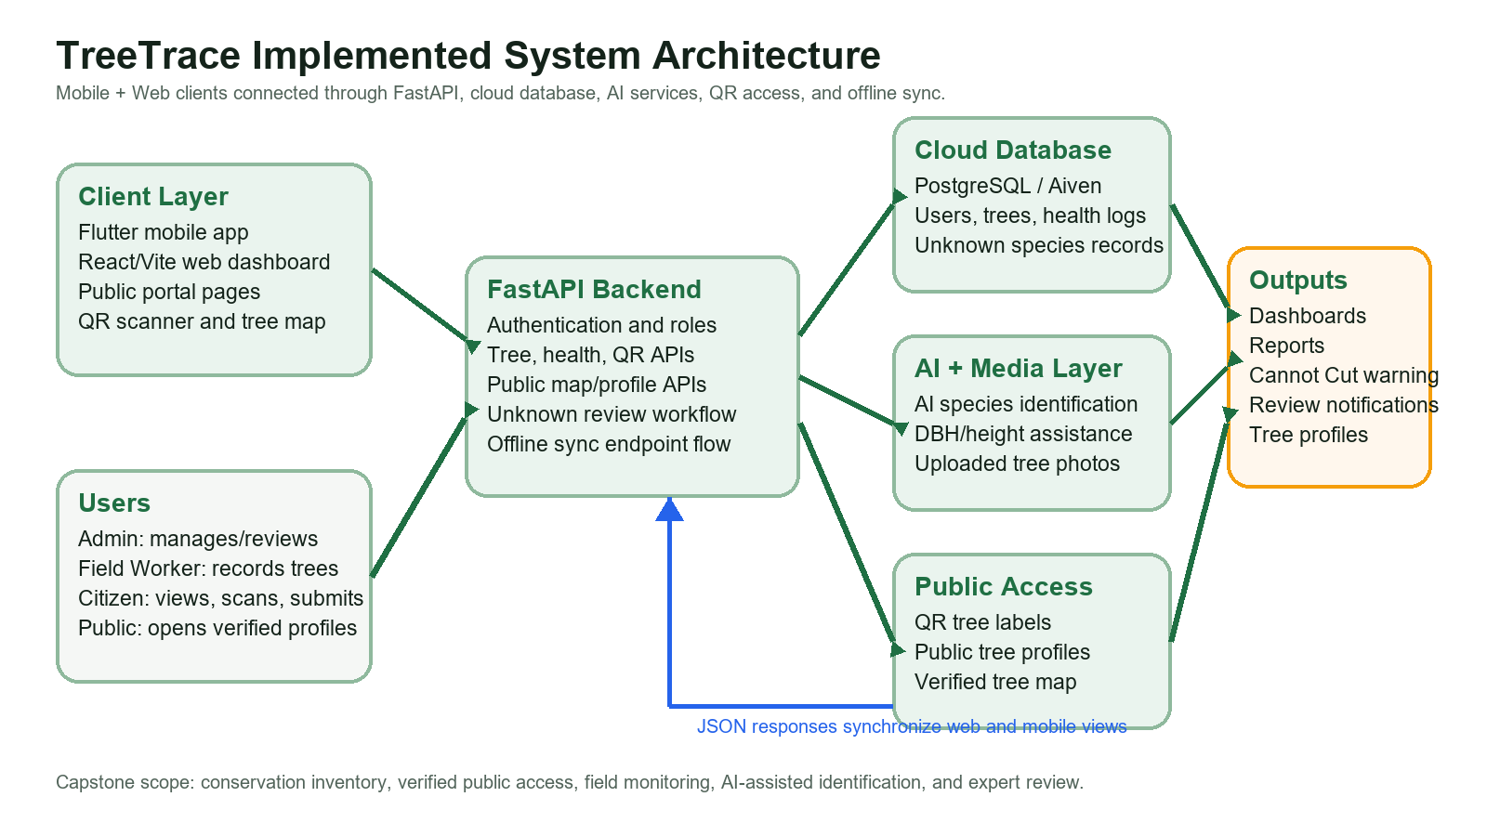
Figure 5.1. Implemented client-server architecture of the TreeTrace system
Layer | Current System Component | Purpose in TreeTrace
Client Layer | Flutter mobile app and React/Vite web frontend | Provides mobile field collection, public portal access, admin dashboard, QR scanning, map viewing, AI scanning, and user management.
API Layer | FastAPI backend hosted locally during development and deployable through Render | Receives requests from web/mobile, authenticates users, validates roles, serves public tree data, processes reports, and coordinates AI and storage operations.
Data Layer | PostgreSQL cloud database through Aiven or local database during development | Stores users, tree records, health logs, QR-linked tree profiles, unknown species submissions, and review status.
AI and Media Layer | AI identification service, DBH/height estimation workflow, and uploaded tree photos | Supports tree species identification, rough DBH/height assistance, health-related interpretation, and unknown species review evidence.
Public Access Layer | QR tags, public tree profiles, and public map portal | Allows citizens and visitors to access verified tree information without editing official inventory records.

Functional Requirements
The functional requirements describe what the system should do. For TreeTrace, the following functions are expected:
- The system shall allow users to register and log in securely.
- The system shall allow users to add tree records with species, condition, and location.
- The system shall capture GPS coordinates automatically.
- The system shall generate QR codes for each tree record.
- The system shall allow QR code scanning for quick retrieval of tree details.
- The system shall store and update tree data in real time.
- The system shall display tree locations on a map.
- The system shall allow administrators to manage and update records through a dashboard.
- The system shall allow users to search and view tree information.
- The system shall support centralized data storage and retrieval.
The system shall restrict official tree inventory creation and editing to administrators and field workers only.
The system shall allow citizens to submit unknown tree species for expert review without directly modifying official inventory data.
The system shall provide a Cannot Cut warning when a protected or endangered species is identified.
The system shall support offline field data queuing and synchronization when connectivity becomes available.
The system shall provide dashboards for community structure, species distribution, trees per barangay, health monitoring, and carbon stock summary.
The system shall allow administrators to review unknown species submissions and update their review status.
The system shall provide QR label generation and public QR-based access to verified tree profiles.

Non-Functional Requirements
The non-functional requirements describe the quality standards of the system.
- The system shall be easy to use and understand.
- The system shall provide fast data access and response time.
- The system shall maintain data accuracy and consistency.
- The system shall ensure secure user authentication and data storage.
- The system shall support real-time synchronization.
- The system shall be reliable for continuous use in field and office settings.
- The system shall be compatible with common mobile devices and web browsers.
- The system shall be scalable for future enhancement.
- The system shall minimize data loss through cloud-based storage.
- The system shall remain accessible with stable internet connectivity.

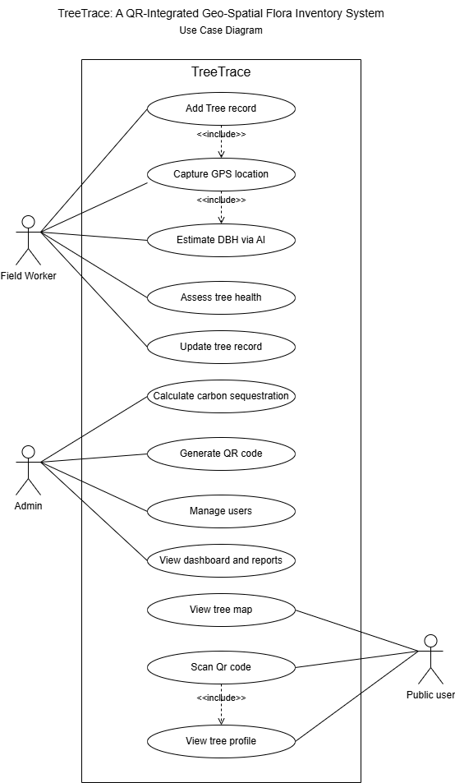
Use Case Diagram

Figure 6. Use Case Diagram for the TreeTrace System

Figure 6 utilized a case graph to summarize the details of a framework and the users within that framework. It generally appeared as a graphic delineation of intelligence among different components in a system. Utilized case graphs indicated the events in a system and how those events flowed; however, using the case chart did not describe how those events were executed. The Use Case Diagram showed the graphical representation of use cases and actors. It demonstrated the interaction and relationship between system users and the various instances in which they were involved [25].

In this diagram, there are three major actors: Admin, Field Worker, and Public User or Citizen. The Admin manages user accounts, reviews unknown species submissions, generates QR labels, views reports, monitors dashboards, and maintains official tree records. The Field Worker records and updates verified tree inventory data, captures GPS location, adds health assessments, scans QR tags, uses AI-assisted identification, and synchronizes field records. The Public User can open the public portal, view the public tree map, scan QR tags, open public tree profiles, use AI identification within the allowed system limits, and submit unknown species for expert review. Citizens are intentionally separated from official inventory editing to preserve data quality and expert validation.

Context Flow Diagram

This section discusses the basic sketch meant to define an entity based on this study’s scope, boundaries, and relation to external components.
Level 0 Data Flow Diagram

This section outlines how data moves between a system and its external entities, providing a basic understanding of the system’s interactions and boundaries.

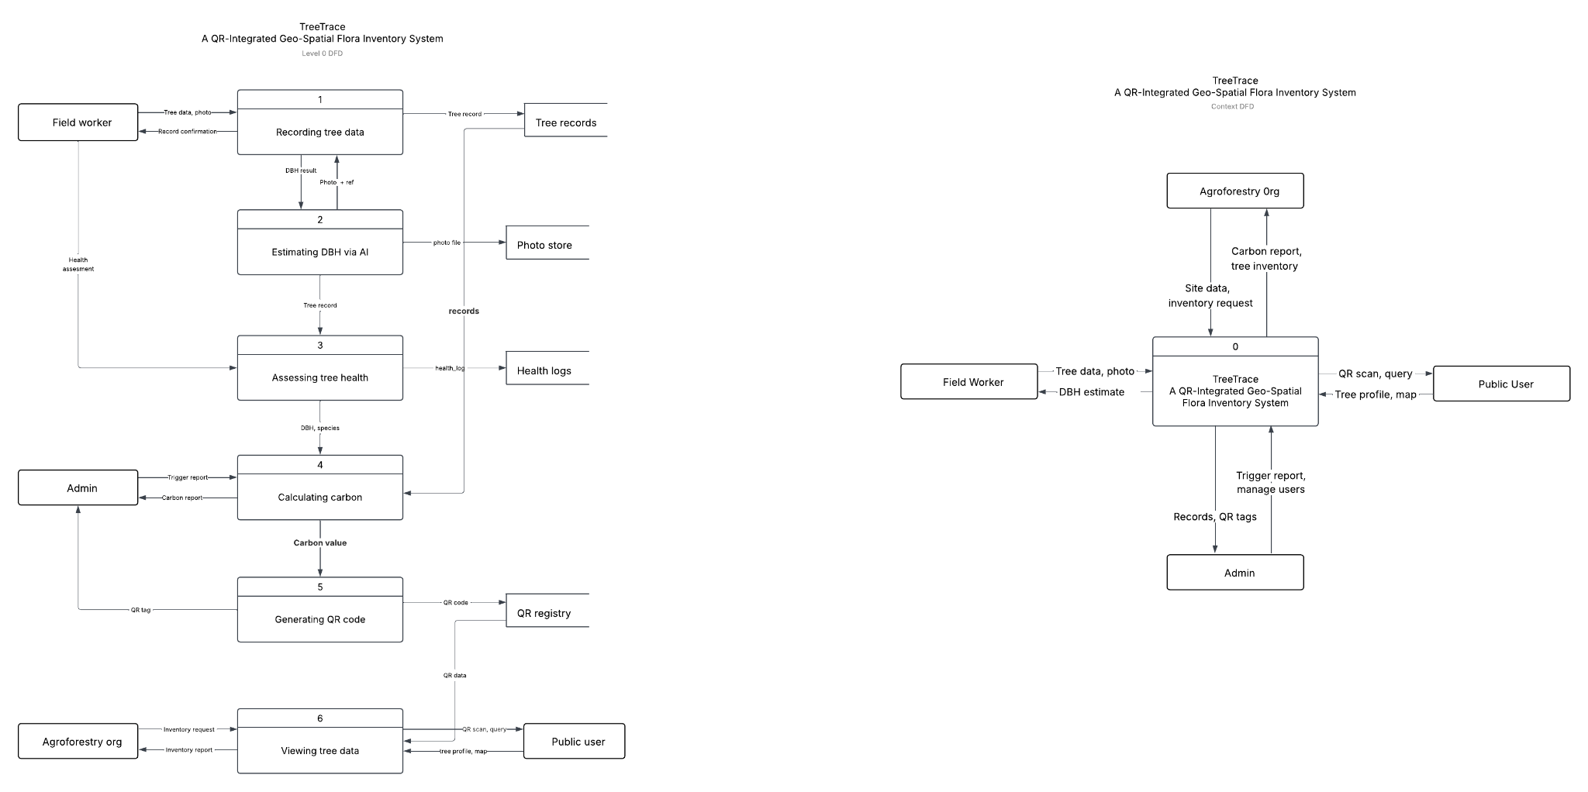

Figure 7. Context Diagram (Level 0 DFD) of the TreeTrace System

Figure 7 presents the Level 0 Data Flow Diagram of TreeTrace. The external entities include the Admin, Field Worker, Public User, AI identification service, and cloud database. The Admin and Field Worker provide authenticated management inputs such as tree records, health logs, QR labels, review decisions, and report requests. The Public User provides public access requests, QR scan requests, AI scan images, and unknown species submissions. The TreeTrace backend processes these inputs, applies access control, communicates with the AI service when image analysis is required, and stores or retrieves records from the centralized database.

Level 1 Data Flow Diagram
This section provides a detailed breakdown of a system's processes and data flows, offering insights into how information flows within the system.
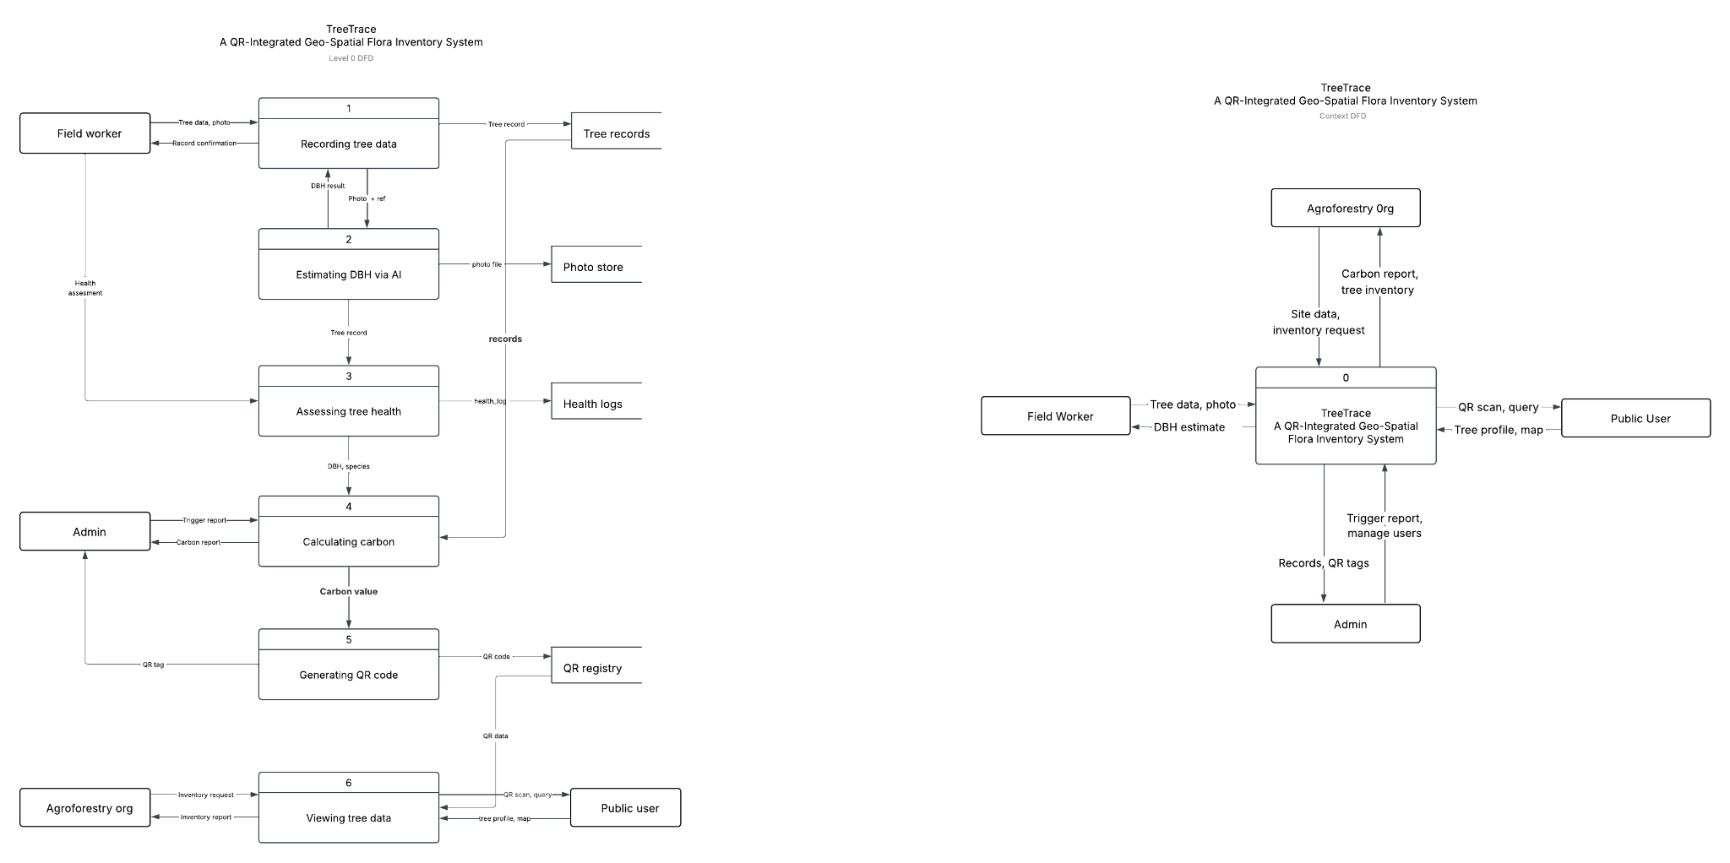
Figure 8. Level 1 Data Flow Diagram (DFD) of the TreeTrace System

Figure 8 depicts the Level 1 Data Flow Diagram of TreeTrace, showing the system as separate but connected processes: account management, tree inventory management, GPS and map visualization, QR profile access, AI identification, unknown species review, health monitoring, reporting, and offline synchronization. Each process exchanges data with the centralized database through the backend API. This design ensures that the mobile application and web dashboard use the same source of truth and that public users only receive approved tree information.

System Design
In this section, diagrams illustrate the processes and gathering of requirements. The team of developers then transforms the gathered requirements into a detailed system architecture. Those requirements help developers identify the processes and layouts of the system; they also assist in classifying functions for each entity. The system design phase also includes JSON schema diagrams and a data dictionary to provide the logical structure of the database that will be used in the system.

Implemented System Modules
Module | Primary Users | Function
Authentication and Roles | All registered users | Login, account validation, and separation of admin, field worker, and citizen access.
Tree Inventory | Admin and Field Worker | Create, update, view, and manage verified tree records with GPS and condition data.
Public Portal and Map | Citizen and public visitors | View verified trees, search records, open map markers, and access public tree profiles.
QR Scanning and Labels | All users for scanning; admin/field worker for labels | Connect physical tree tags to public digital tree profiles.
AI Identification | Citizen, field worker, admin | Analyze uploaded tree images and provide species/condition assistance with conservation warnings.
Unknown Species Review | Citizen submits; admin reviews | Allow community submissions while keeping official records expert-validated.
Health Monitoring | Admin and Field Worker | Record and view tree health assessments over time.
Reports and Analytics | Admin and Field Worker | Generate inventory summaries, community structure charts, species distribution, barangay counts, and carbon stock summaries.

Entity Relationship Diagram
The Entity Relationship Diagram (ERD) shows the relationship among the major data entities of TreeTrace. The implemented database stores users, trees, health logs, unknown species submissions, QR-linked public profiles, and supporting location or community data. Users are connected to the records they create or review. Tree records store species, location, health, DBH, height, carbon-related values, QR information, and public visibility. Health logs are linked to specific trees. Unknown species submissions are linked to the citizen or user who submitted them and to the admin review decision.
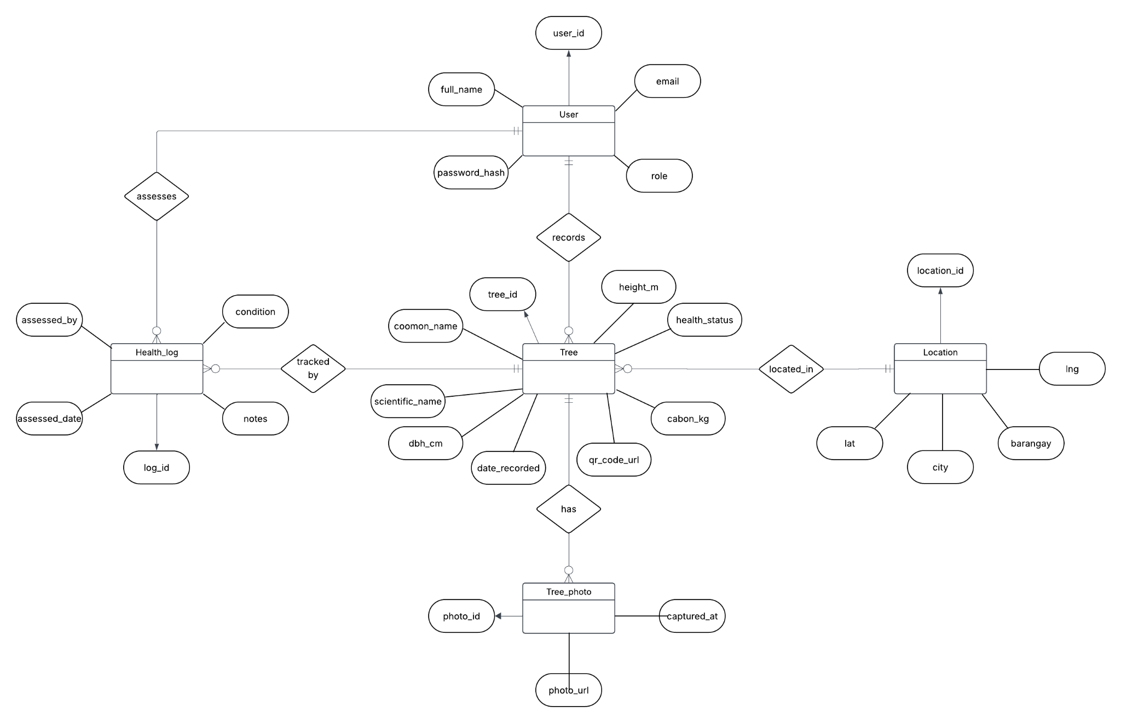
Figure 9. Entity Relationship Diagram (ERD) for the TreeTrace System

JSON Schema Diagram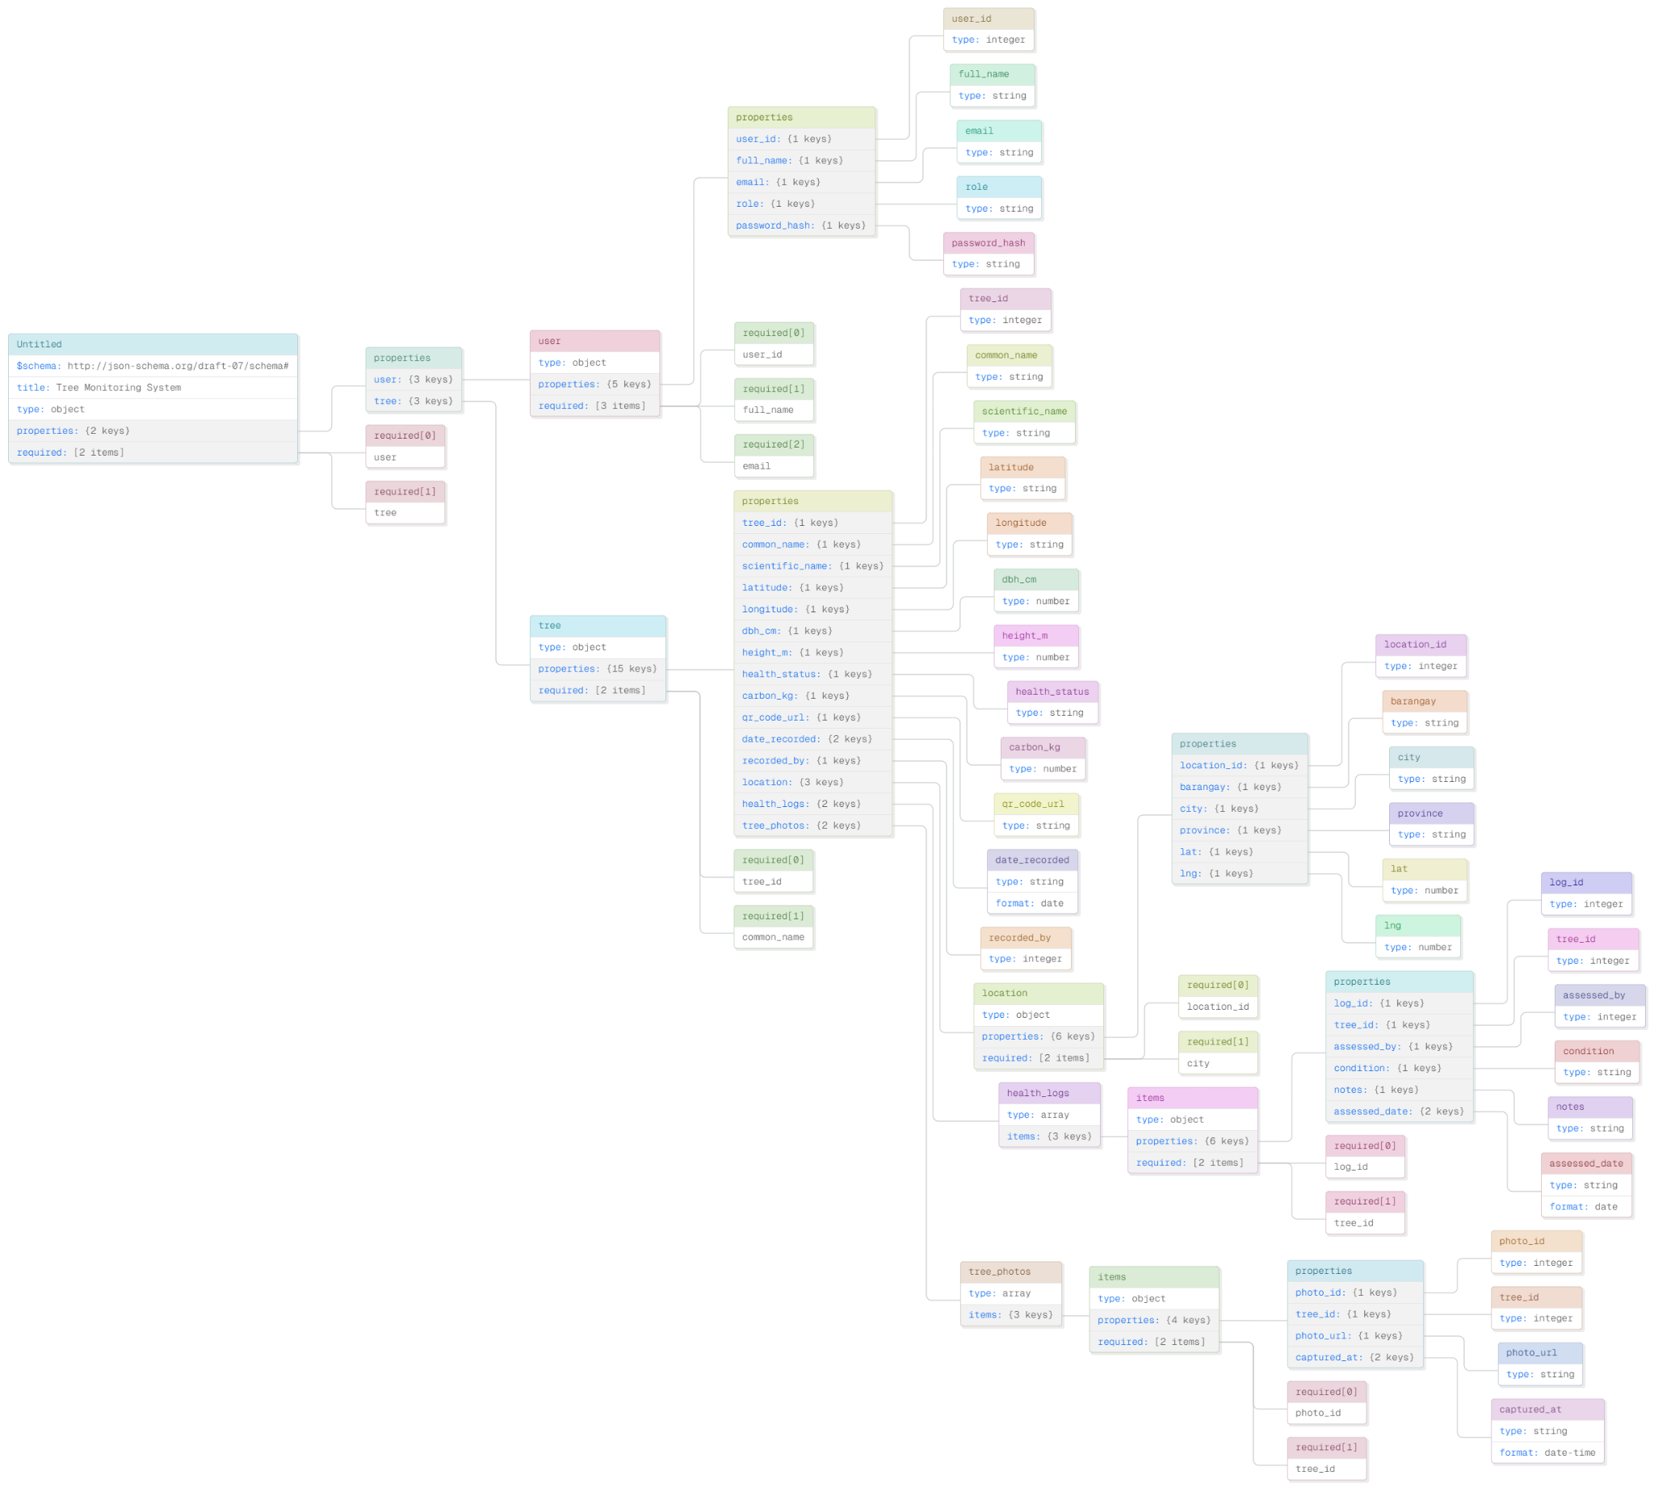
Figure 10. JSON Schema Diagram

Figure 10 presents the JSON Schema of the TreeTrace system, specifically for the User entity, which defines the structure of user-related data stored in the system. It includes fields such as user_id, full_name, email, password_hash, role, created_at, and is_active, which are used for authentication, account management, and role-based access within the system.

Data Dictionary

This data dictionary defines all database tables, fields, data types, constraints, and descriptions for the TreeTrace system. It serves as the reference document for database design and system development.

Table 1.1 User
Field Name | Data Type | Key Type | Description
user_id | INT | PK | Unique identifier for each system user. Primary key of the User table.
full_name | VARCHAR(100) |  | Complete name of the user (first, middle, last name).
email | VARCHAR(150) |  | Email address used for login and notifications. Must be unique across all users.
role | VARCHAR(30) |  | Role of the user in the system. Values: "admin" or "field_worker".
password_hash | VARCHAR(255) |  | Hashed password string stored securely using bcrypt or SHA-256.
created_at | DATETIME |  | Timestamp when the user account was created in the system.
is_active | TINYINT(1) |  | Indicates if the account is active. 1 = active, 0 = deactivated.

Table 1.2 Location
Field Name | Data Type | Key Type | Description
location_id | INT | PK | Unique identifier for each location record. Primary key of the Location table.
barangay | VARCHAR(100) |  | Name of the barangay where the tree is located within Panabo City.
city | VARCHAR(100) |  | Name of the city. Defaults to Panabo City for all inventory records.
province | VARCHAR(100) |  | Name of the province. Defaults to Davao del Norte.
lat | DECIMAL(10,7) |  | Latitude coordinate of the tree location captured via mobile GPS. Stored up to 7 decimal places for precision.
lng | DECIMAL(10,7) |  | Longitude coordinate of the tree location captured via mobile GPS. Stored up to 7 decimal places for precision.

Table 1.3 Tree
Field Name | Data Type | Key Type | Description
tree_id | INT | PK | Unique identifier for each tree record. Primary key of the Tree table.
user_id | INT | FK | References the field worker who recorded this tree. Links to User table.
location_id | INT | FK | References the geographic location of the tree. Links to Location table.
common_name | VARCHAR(100) |  | Common or local name of the tree species (e.g., Narra, Molave, Mahogany).
scientific_name | VARCHAR(150) |  | Formal scientific/taxonomic name of the species (e.g., Pterocarpus indicus). Based on expert verification.
dbh_cm | DECIMAL(6,2) |  | Diameter at Breast Height measured in centimeters. Measured manually at 1.3 meters above ground level.
height_m | DECIMAL(6,2) |  | Estimated height of the tree in meters. Recorded during field survey.
health_status | VARCHAR(20) |  | Current health condition of the tree. Values: "Healthy", "Fair", or "Poor".
qr_code_url | VARCHAR(255) |  | URL or file path pointing to the generated QR code image for this tree record.
date_recorded | DATE |  | Date when the tree was first recorded in the system by the field worker.
notes | TEXT |  | Optional additional observations or remarks made by the field worker during data collection.

Table 1.4 HealthLog
Attributes | Data Type | Key Type | Description
log_id | INT | PK | Unique identifier for each health assessment log entry. Primary key of the HealthLog table.
tree_id | INT | FK | References the tree being assessed. Links to Tree table.
assessed_by | INT | FK | References the user who performed the health assessment. Links to User table.
condition | VARCHAR(20) |  | Health condition of the tree at time of assessment. Values: "Healthy", "Fair", or "Poor".
notes | TEXT |  | Detailed observations about the tree condition, visible damage, pests, diseases, or physical changes noted.
assessed_date | DATE |  | Date when the health assessment was conducted in the field.

Table 1.6 QRCode
Field Name | Data Type | Key | Description
qr_id | INT | PK | Unique identifier for each QR code record. Primary key of the QRCode table.
tree_id | INT | FK | References the tree this QR code belongs to. One tree has exactly one QR code. Links to Tree table.
code_data | VARCHAR(255) |  | Encoded data embedded in the QR code, typically the tree profile URL or unique tree identifier string.
generated_at | DATETIME |  | Exact timestamp when the QR code was generated by the system.
printed | TINYINT(1) |  | Indicates whether the QR code has been printed and physically affixed to the tree. 1 = printed, 0 = pending.

The data dictionary section discusses the database tables used in the TreeTrace system. The User table stores account information and role-based access data. The Tree table stores official inventory records, including common name, scientific name, conservation status, health status, DBH, height, carbon estimate, coordinates, barangay, photo URL, and QR-related information. The HealthLog table stores assessment records linked to a tree. The UnknownSpecies table stores citizen or field submissions that require expert review. QR-related data connects verified trees to public tree profile pages.

Summary of Implemented Data Entities
Entity/Table | Main Data Stored | System Use
User | Full name, email, password hash, role, active status, usage counters | Authentication, role-based access, dashboard permissions, and audit linkage.
Tree | Species, conservation status, DBH, height, health status, carbon estimate, coordinates, barangay, photo, QR code | Official tree inventory, map markers, public profiles, reports, and Cannot Cut warning.
HealthLog | Tree ID, condition, notes, assessor, date assessed | Tree monitoring history and recent health assessment display.
UnknownSpecies | Photo URL, possible name, AI candidates, submitter, barangay, review status, identified name, review notes | Citizen/community submission queue for expert validation.
QRCode/Public Profile | Tree identifier and public profile route | QR scanning and public access to verified tree data.

System Development and Testing

The system development process for TreeTrace followed a structured approach to ensure the successful creation of a comprehensive tree inventory and monitoring system with GPS tagging and QR code integration. The prototyping methodology was employed, which allowed for iterative development and continuous feedback from stakeholders. This approach was particularly suitable for TreeTrace, as it accommodated evolving requirements and ensured the final product met the needs of its intended users, including students, local government units, environmental groups, and researchers. The development lifecycle began with requirement analysis, where the team conducted environmental scanning and identified key problems to be addressed. This phase involved extensive consultations with target users to understand their challenges, including the lack of a centralized tree record system, difficulty in tracking tree locations, and the absence of a reliable method for retrieving tree data in the field.

During the design stage, the gathered requirements were translated into a detailed blueprint that outlined the system's functionalities, user interface, data flow, and technical specifications. This phase laid the groundwork for the actual development, ensuring all stakeholders had a clear vision of the final product. The prototyping phase followed, where a working prototype of TreeTrace was developed based on the design blueprint. This prototype featured core functionalities, including tree data encoding, GPS location tagging, QR code generation, real-time database storage, map display, and record retrieval. The prototype was then subjected to user evaluation, where target users tested its functionality and provided feedback. This iterative process of refining the prototype continued until all user requirements were satisfied, culminating in a final system ready for deployment.

The System Test Plan verifies the connected operation of TreeTrace across the Flutter mobile application, React web dashboard, FastAPI backend, AI identification workflow, QR scanning, map visualization, and PostgreSQL database. The test scope includes login and registration, role-based permissions, public map access, official tree record creation, health log recording, QR profile retrieval, AI identification, unknown species submission and review, report export, and offline synchronization.

The testing phase uses functional, integration, usability, and security testing. Functional testing checks whether each feature produces the expected result. Integration testing checks whether mobile, web, backend, database, QR, AI, and map modules exchange data correctly. Usability testing checks whether admins, field workers, and citizens can complete their tasks without confusion. Security testing checks login behavior, token-protected routes, role restrictions, and prevention of unauthorized inventory edits.

The expected testing outputs include successful authentication, accurate role-based screen access, correct tree marker display on the map, working QR scan redirection to public tree profiles, proper Cannot Cut warning display for protected species, successful unknown species review updates, accurate report export behavior, and successful synchronization of queued offline actions once internet connection is restored.

The system evaluation will document whether TreeTrace meets its functional requirements, how effectively it supports field inventory and public tree access, whether the architecture remains reliable under web and mobile use, and what refinements are needed before final deployment. The results will guide final debugging, interface improvements, and documentation updates before capstone presentation.
Systems Implementation Plan
This section discusses the implementation phase of the system's development, as it is necessary to thoroughly test the system's functionality and consistently track errors and bugs throughout the deployment period. Since TreeTrace has not yet reached this stage, all activities are described in future tense.
The process will begin with the Pre-deployment Defense, where the proponents will present the fully developed system to panels and advisers for evaluation. Upon approval, an endorsement letter will be issued to the target organization, authorizing user testing and deployment. To facilitate seamless adoption, the proponents will provide user manuals and video tutorials offering step-by-step guidance on system operation. The deployment period will span several weeks, during which target users will actively use the system. Weekly progress reports will be documented to track user feedback, identify bugs, and implement necessary enhancements.
During the first week, TreeTrace will be formally deployed, with a handover to the designated personnel and a demonstration of core functionalities including tree data encoding, GPS tagging, QR code generation, and map display. Comprehensive training sessions will be conducted to ensure proper navigation of the system, accurate data input, and effective use of QR code and GPS features.
In the succeeding weeks, any bugs or errors reported by users will be diagnosed and resolved by the proponents. Issues related to GPS accuracy, QR code retrieval, data synchronization, and interface performance will be prioritized and addressed promptly. Each fix will be confirmed by users before the next deployment cycle proceeds.
Following the deployment period, system performance will be evaluated by users utilizing an assessment scale based on a Likert rating system ranging from 1 to 5, where responses are anchored between poor performance and excellent performance. This scaling system will enable quantitative measurement of user satisfaction and system effectiveness across various performance metrics.
Systems Test Plan
This section discusses the system test plan for TreeTrace. After developing the system, the proponents will conduct thorough alpha and beta testing to ensure its stability and reliability. The system will then be deployed over a scheduled period, during which users will have the opportunity to evaluate the system using structured evaluation tools. During the testing phase, the proponents will enhance the system to ensure that it meets all required processes expected by the target users. Bugs and errors will be identified and addressed before the system is released, ensuring that it is fully functional and reliable.
The system will undergo rigorous testing across all functional modules to validate security, usability, and compliance with operational requirements. For user authentication, the login process will be tested for valid credentials, invalid inputs, and security threats. Valid users will be redirected to the dashboard upon successful authentication, while invalid credentials will trigger real-time error notifications. SQL injection attempts on input fields will be neutralized through input sanitization, preventing unauthorized access. The sign-out functionality will reliably terminate sessions and confirm logout via notifications.
Tree record management workflows will be validated for authorized and unauthorized users. Users with valid accounts will be able to create, edit, and retrieve tree records that are stored and reflected accurately in the database and map display. Unauthorized actions will be denied with appropriate alerts. The GPS tagging feature will be tested to verify that location coordinates are captured accurately and displayed correctly on the map interface. QR code generation and scanning will be validated to ensure that each code links correctly to its corresponding tree record and retrieves accurate data upon scanning.
For dashboard and search functionalities, filters and search queries will be tested to confirm that results are returned accurately based on input parameters. Invalid queries will return no matches, ensuring data integrity. Data synchronization between the mobile and web components will be tested to confirm that updates are reflected in real time across all connected devices and platforms.
All tests will confirm the system's robustness in handling edge cases, adhering to security standards, and delivering reliable tree inventory and monitoring capabilities. The successful validation of functionalities — from user authentication to GPS tagging and QR code retrieval — will demonstrate readiness for deployment.
System Maintenance
This section will discuss the maintenance of the TreeTrace system, which restores the system to its required functions and enhances its capabilities by incorporating improvements aligned with its geospatial inventory and monitoring features. The proponents were responsible for maintaining the TreeTrace system to ensure its efficiency and reliability in managing tree records using GPS, QR code, and cloud-based technologies. Additionally, the proponents were responsible for performing regular database backups to support data recovery and maintain the integrity of centralized tree inventory data in case of technical issues. Suppose any bugs and errors result in the system's deficiency. In that case, the proponents are responsible for fixing the system, improving functionalities such as real-time monitoring, QR code retrieval, and data synchronization, ensuring its effectiveness, making it more applicable for LGU and organizational use, and enhancing its adaptability to environmental monitoring needs.
The proponents should transfer the knowledge to the designated LGU personnel who are responsible for the system's future development and operation. The maintenance was conducted three times, and after that, the proponents no longer managed the system's maintenance. Afterward, the proponents arranged a meeting with the designated LGU personnel to transfer knowledge, including system operation, database management, and troubleshooting procedures, to empower the organization with the necessary expertise to assume full ownership and responsibility for the TreeTrace system.
Systems Security Plan
This section will discuss system security in TreeTrace, a crucial aspect of the system’s development and deployment. It involves protecting the system from potential threats such as unauthorized access, data manipulation, loss of geospatial information, and intentional or unintentional damage to tree inventory records. To ensure the system's privacy and integrity, the proponents must have a robust security plan in place that aligns with centralized data management and cloud-based storage. This plan should be designed to prevent unauthorized access and improper utilization of the system, especially in managing sensitive environmental and location-based data. The proponents should also collect and incorporate security requirements into the system authorization process to support system functions such as user access, data entry, monitoring, and record management. One logical control measure that can be implemented is the use of a secure authentication system. This helps limit access to the system to only authorized users who have the necessary credentials to log in, including account verification and controlled user roles. Furthermore, the system utilizes secure database management and cloud storage practices to protect stored data and ensure reliable access across devices. The system applies essential security measures such as password encryption, controlled access permissions, and input validation to prevent unauthorized actions. These features help to ensure the system's security by preventing unauthorized access and protecting against potential data-related risks. Overall, the security plan for TreeTrace has been designed and implemented effectively, ensuring the protection of geospatial and inventory data against potential threats. The developers have implemented logical control measures, identified security requirements, and applied appropriate security practices to deliver a secure and reliable system for users.

REFERENCES
[1] F. Namwamba et al., "GIS/GPS-technology based tree inventory and spatial modeling training," in Proc. ESRI Education User Conf., 2005.
[2] ScienceDaily, "Economic value of city trees: Science of quantifying the benefits," 2015. [Online]. Available: https://www.sciencedaily.com
[3] C. Zhang et al., "Advancements in remote sensing for urban forest monitoring," MDPI - Animals, 2024.
[4] A. Budiman et al., "Developing a smart urban forestry management system," E3S Web Conf., vol. 482, 2024.
[5] ResearchGate, "The application of augmented reality (AR) technology in urban greening plant growth state detection," 2023. [Online]. Available: https://www.researchgate.net
[6] Taylor & Francis, "Innovations in geo-spatial flora tracking and public accessibility," Cogent Eng., 2025.
[7] GoldNCloud Publications, "IRJAEM: Precision mapping and QR integration in botanical studies," 2024.
[8] ISA Arboriculture, Methods of Tree Inventory and Health Assessment, 1986, rev. 2024.
[9] "Low-cost geospatial mapping for urban green space management," Int. Arch. Photogramm. Remote Sens. Spatial Inf. Sci., vol. XLII-4/W18, 2020.
[10] J. M. V. Salac, "Socio-economics assessment of agroforestry interventions in selected National Greening Program (NGP) sites in Laguna, 2019," B.S. thesis, Univ. Philippines Los Baños, 2021.
[11] "Agroforestry and biodiversity conservation in the Philippines: A comparative review," Asian J. Res. Agric. Forestry, vol. 11, no. 4, 2025.
[12] "National Greening Program in the Philippines: A thematic review," Int. J. Environ. Climate Change, 2025.
[13] Global Forest Watch, "Panabo City tree cover loss by dominant driver," 2024. [Online]. Available: https://www.globalforestwatch.org
[14] D. Buckler, "Updated tree inventory requirements," Wisconsin DNR Urban Forest Assessment, Aug. 18, 2023.
[15] "Forests and trees as a nature-based conservation solution," in Land System and Sustainability Science, 2023.
[16] "Geographic Information System and Analytics Center," DNSC REP Centers, 2024.
[17] "Application of GIS technology in the assessment and monitoring of mangrove forest changes in Panabo City," Int. J. Eng. Technol. Res. Manage., Dec. 2024.
[18] E. I. Amoah, P. McCloskey, R. S. Ouedraogo, J. Chelal, and C. Akuleut, "AI-powered measurement verification and reporting system for agroforestry trees to estimate carbon sequestration potential," Sustain. Environ., vol. 12, no. 1, Art. no. 2607826, 2025.
[19] "My Farm Trees: Digital traceability and blockchain for forest restoration," Alliance of Bioversity International and CIAT, 2025.
[20] "How artificial intelligence is reshaping forest management: Digital twins," American Forest Management, 2025.
[21] J. Chave et al., "Improved allometric models to estimate the aboveground biomass of tropical trees," Global Change Biol., 2014.
[22] "Digital agroforestry: GIS, drones and decision support systems in tree-based farming," Int. J. Res. Agronomy, vol. 8, no. 7S, pp. 83-93, 2025.
[23] "Tree inventory and related services: ANSI protocols," Davey Resource Group, 2024.
[24] M. Grant, "Gantt chart: Definition, benefits, and how it’s used," Investopedia, Dec. 21, 2023. [Online]. Available: https://www.investopedia.com/terms/g/gantt-chart.asp
[25] E. Gupta, "All about use case diagram," Shiksha Online, Mar. 22, 2024. [Online]. Available: https://www.shiksha.com/online-courses/articles/use-case-diagram/
[26] P. Kirvan, B. Lutkevich, and S. Lewis, "What is the waterfall model? Definition and guide," TechTarget, 2024. [Online]. Available: https://www.techtarget.com/searchsoftwarequality/definition/waterfall-model
[27] ISA Arboriculture, Methods of Tree Inventory and Health Assessment, rev. ed., 2024.
[28] F. Namwamba et al., "GIS/GPS-technology based tree inventory and spatial modeling training," in Proc. ESRI Education User Conf., 2005.
[29] Fulcrum, "Tree inventory guidebook: Location-based data (GPS)," 2022. [Online]. Available: https://github.com/fulcrumapp/tree-inventory-guidebook/blob/master/01-location-based-data-gps.md
[30] "Application of GIS technology in the assessment and monitoring of mangrove forest changes in Panabo City," Int. J. Eng. Technol. Res. Manage., Dec. 2024.
[31] D. Buckler, "Updated tree inventory requirements," Wisconsin DNR Urban Forest Assessment, Aug. 18, 2023.
[32] C. Chave et al., "Improved allometric models to estimate the aboveground biomass of tropical trees," Glob. Change Biol., 2014.
[33] GoldNCloud Publications, "IRJAEM precision mapping and QR integration in botanical studies," 2024.
[34] C. Zhang et al., "Advancements in remote sensing for urban forest monitoring," MDPI, 2024.
[35] PlanIT Geo, "TreePlotter INVENTORY - tree inventory software," 2021. [Online]. Available: https://planitgeo.com/treeplotter-inventory/
[36] GIS Cloud, "Improving tree inspections with mobile apps for arborists," Feb. 20, 2022. [Online]. Available: https://www.giscloud.com/blog/arborist-use-case-tree-inventory-and-inspection/
[37] Groundzy, "Tree mapping app with GPS & AI species ID." [Online]. Available: https://www.groundzy.com/tree-mapping-software
[38] ArborStar, "Tree mapping & inventory software | GPS tree management." [Online]. Available: https://arbostar.com/arborist-software/tree-mapping
[39] Alliance of Bioversity International and CIAT, "My Farm Trees: Digital traceability and blockchain for forest restoration," 2025.
[40] A. Budiman et al., "Developing a smart urban forestry management system," E3S Web Conf., vol. 482, 2024.

