All Towers Route (2022) Quick Tutorial
By Arna

Hello there ! Welcome to this doc where i’ll be explaining the basics of the current all towers route. This category is divided in two parts
-The great plateau where you beat it as fast as possible while activating the tower
-And the activation of all the towers of Hyrule

This is a category with a lot of blss so make sure to be confortable with this trick before going into the learning.

1/The Great Plateau
The plateau is basically any% except that we activate the tower between bombs and mag. Make sure to grab the hammer in stasis it will be useful for the akkala tower segment.
There are also a few places where you can grab some backup food, take what you need :
At boko camp after SOR clip=>6 chilis/1 steak/5 shrooms
Behind mag after completing the shrine=>5 hyrule herbs
Before tree wb=>2 apples on a tree close to the wb spot

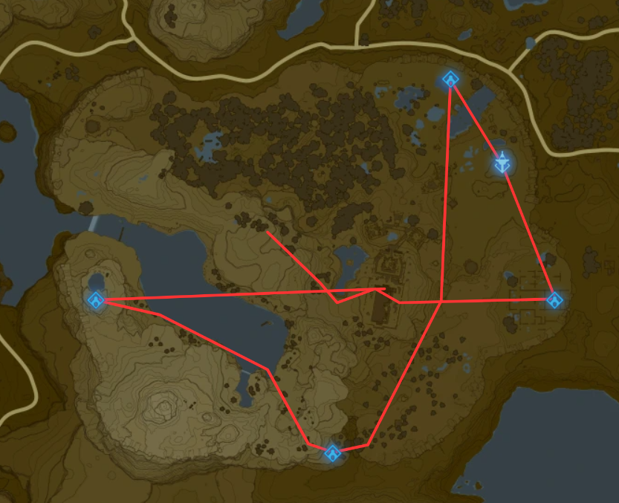
Here’s what the route looks like :

2/The rest of the towers
From the run is basically doing a blss from a tower to another except a few spots :

A/Faron tower

Before doing a wb up to the tower you need to grab at least 7-8 durians in this area close to the tower (make sure to use the throw sprint to avoid the lizalfos noticing you) :
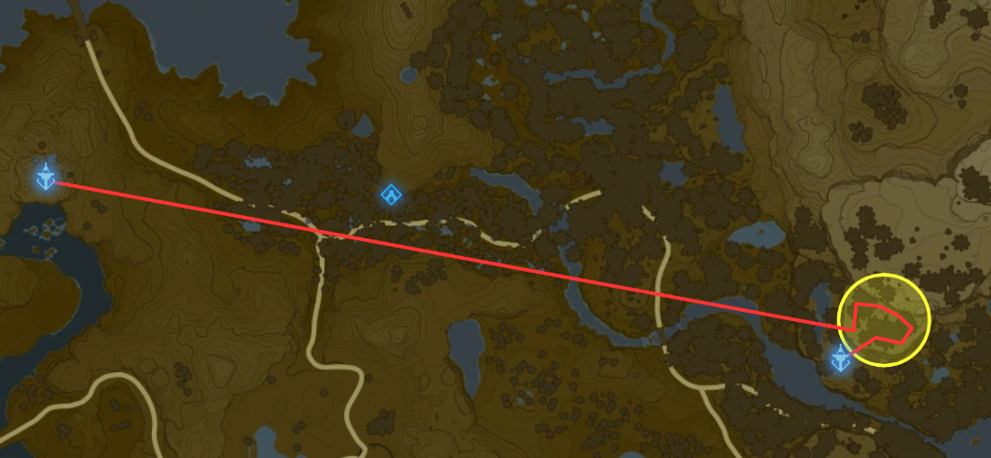
B/Akkala Tower

In this segment we need to get from the lanayru tower to the akkala tower but the problem is that the lanayru one is much lower than our objective. So you need to start a blss as usual all the way to a certain spot and then doing a wb chain to get to metal box to finally perform a stasis launch into a midair wb. This this one of the hardest if not the hardest segment of the run but with enough practice you’ll get it whithout any problem !
Here’s a link of a video showing the complete segment so you can base your run on that and learn the movements :

https://youtu.be/hzEM3R4y0Mo

Conclusion :
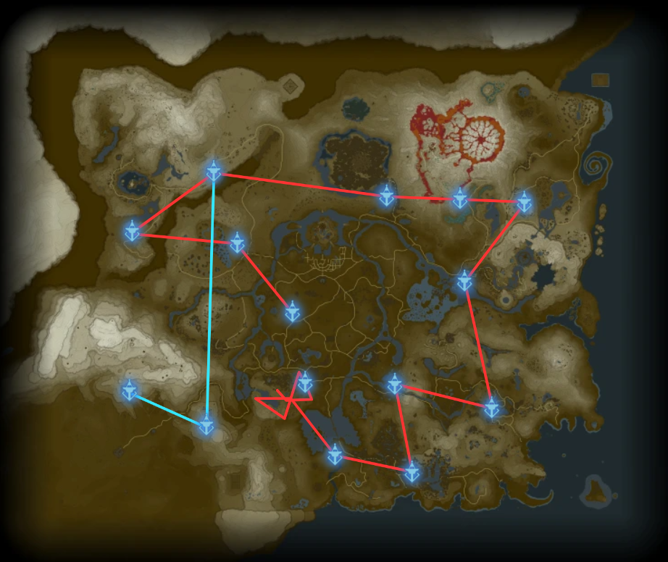
To finish here is the full current All Towers route :
=>Red Branch first and blue branch second
=>Make sure to be at full health when flying to Wasteland, tabantha and Gerudo tower

That’s all for this quick tutorial I hope it’ll helps and keep having fun speedruning botw !

