Donn Villaruz

Jose Huizar

Jeremy Savage

Michelle Gutierrez

Dhruvkumar Patel

**Homepage**

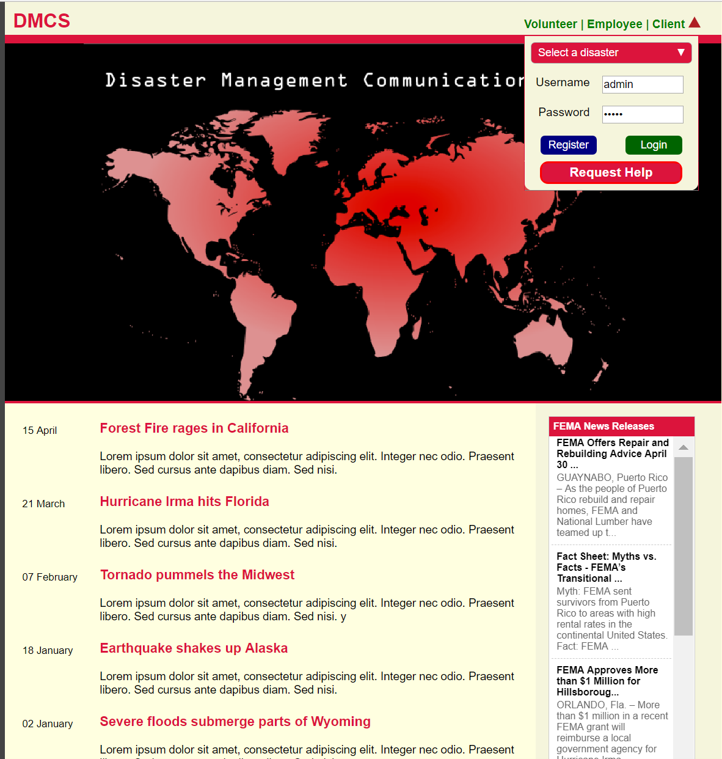

Homepage – A volunteer can log in or register and a client, or employee can log in. Also there are news articles listed as well as FEMA News Release feed that keeps us up to date on FEMA news.

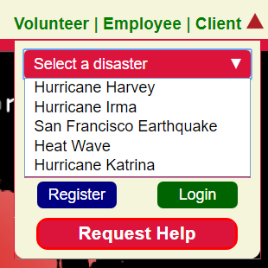

Before one logs in or requests help, they must select a disaster first. Selecting a disaster will give the user the appropriate information regarding the disaster selected. Also a volunteer can register.

**Request Help**

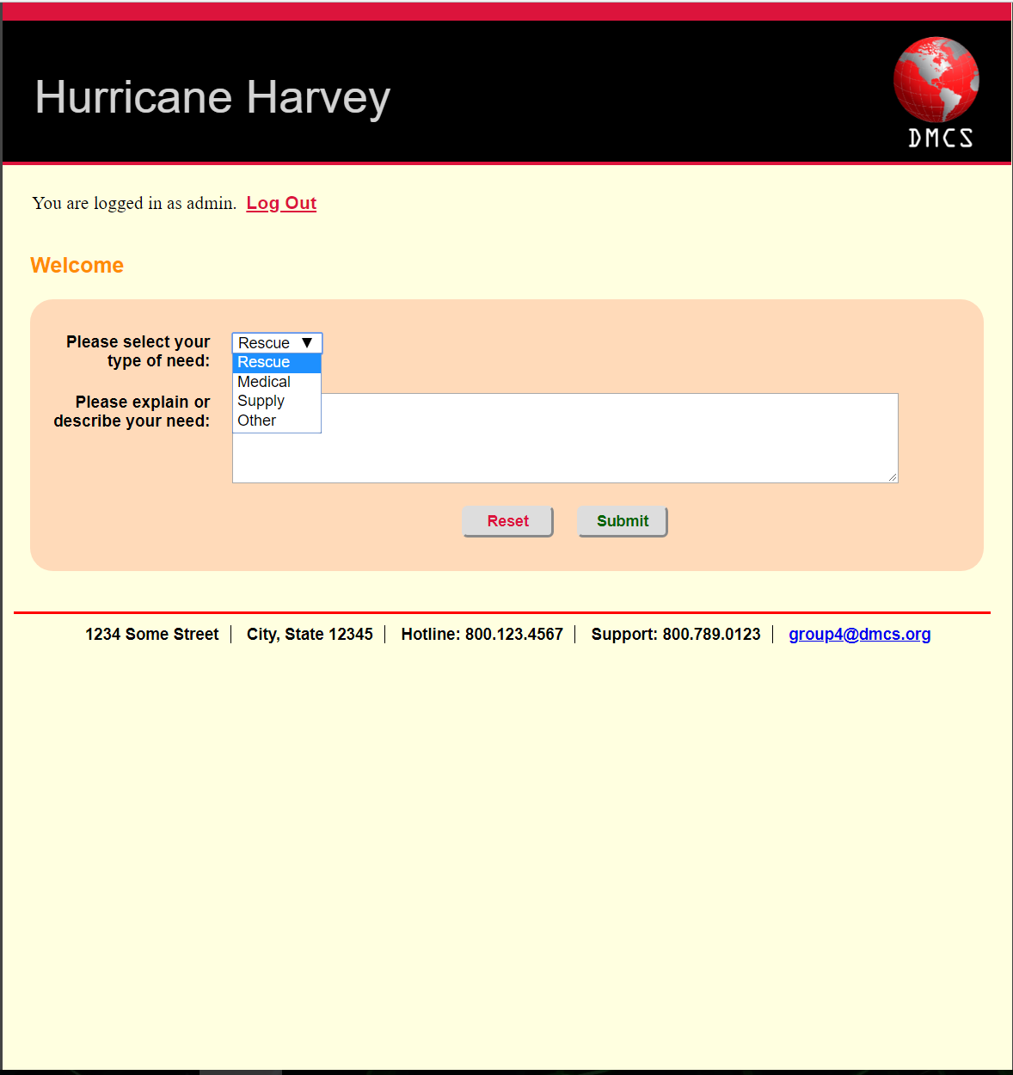

Request Help- After the user clicks on request help they can select rescue, medical, supply or other as their type of need. Then the user explains or describes their need.

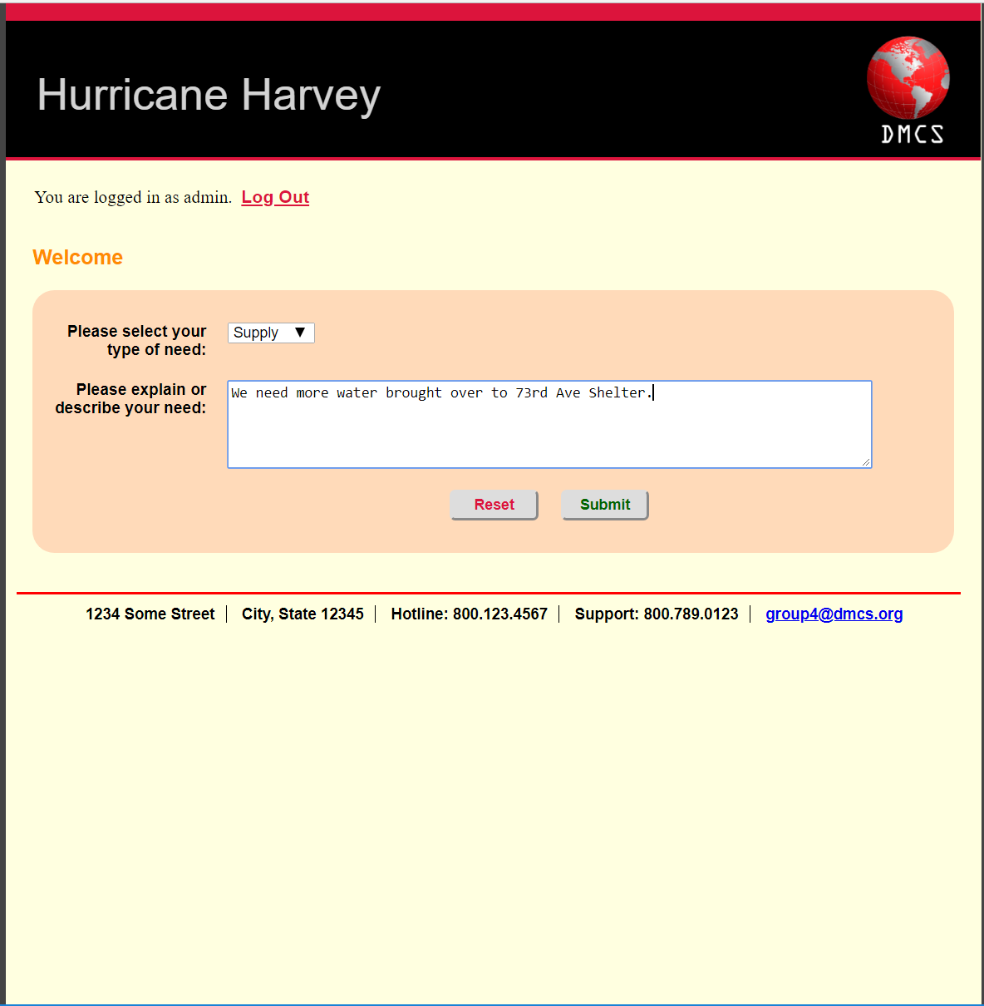

In this example the user selects supply as their type of need and is requesting water.

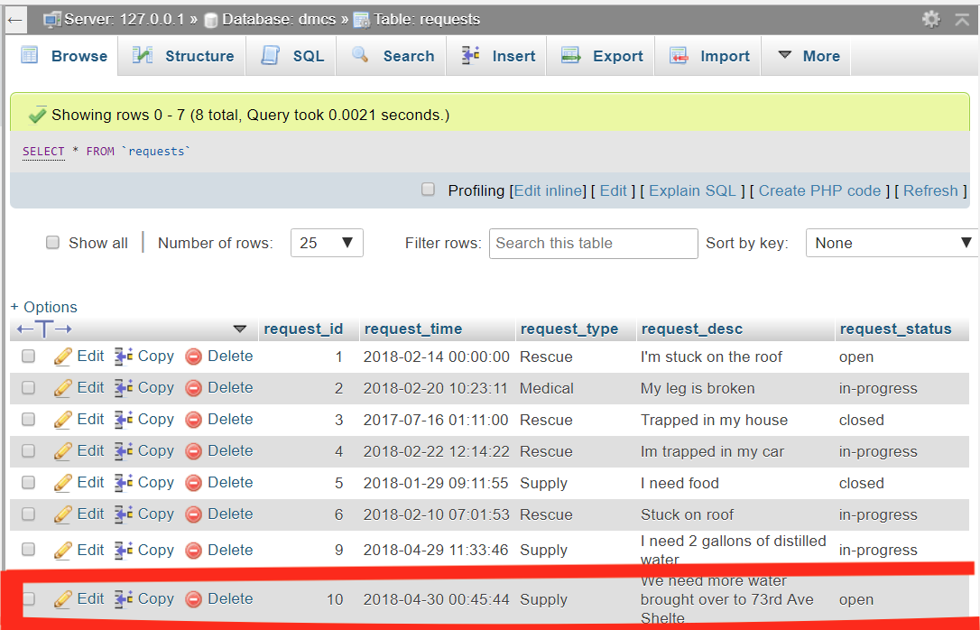

When we submit the previous request the request table updates

**Volunteer Registration**

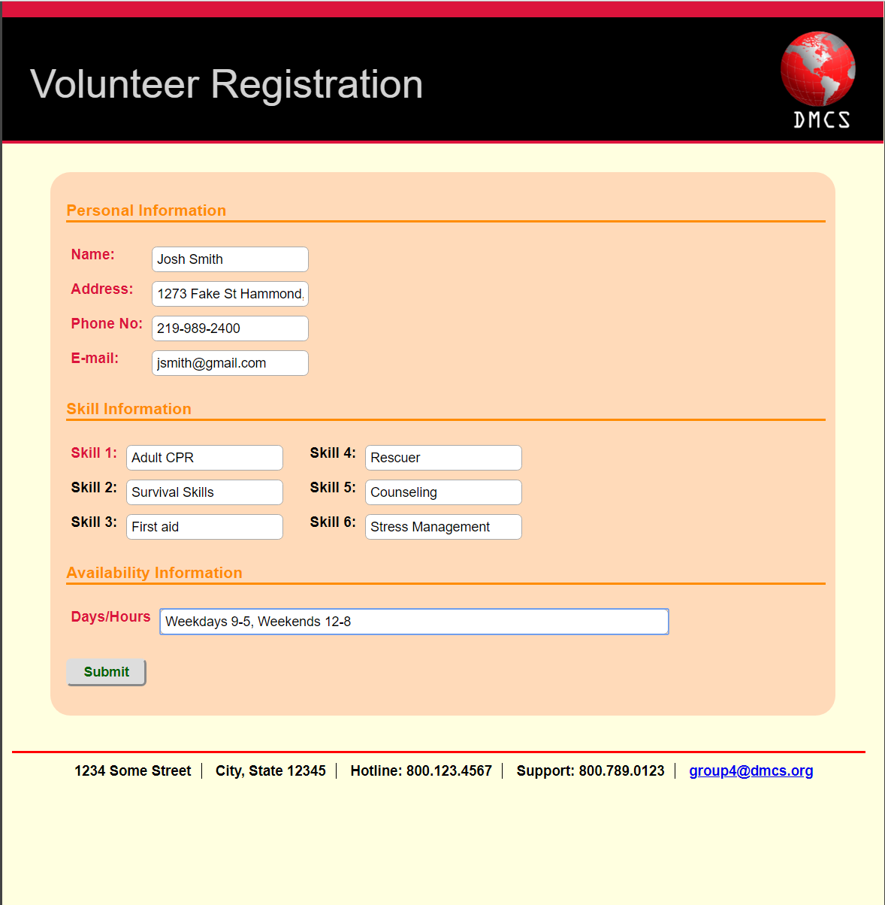

Volunteer Registration – This is the form a volunteer uses to register. The personal information section gets inserted into the person table. The skill information gets inserted into volunteer_skills table. The availability information gets inserted into volunteer table.

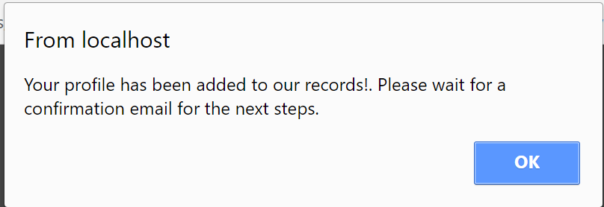

After volunteer fills out the form a popup box displays telling the volunteer that their profile has been added and they will receive a confirmation via email.

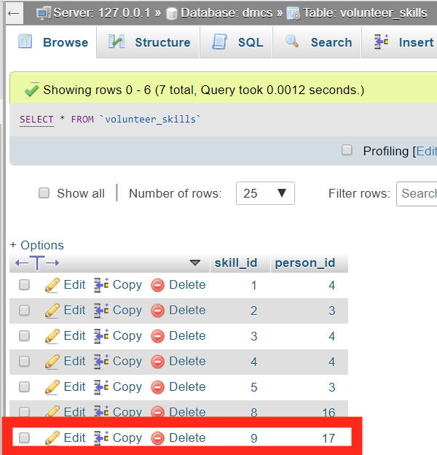

volunteer_skills table updated

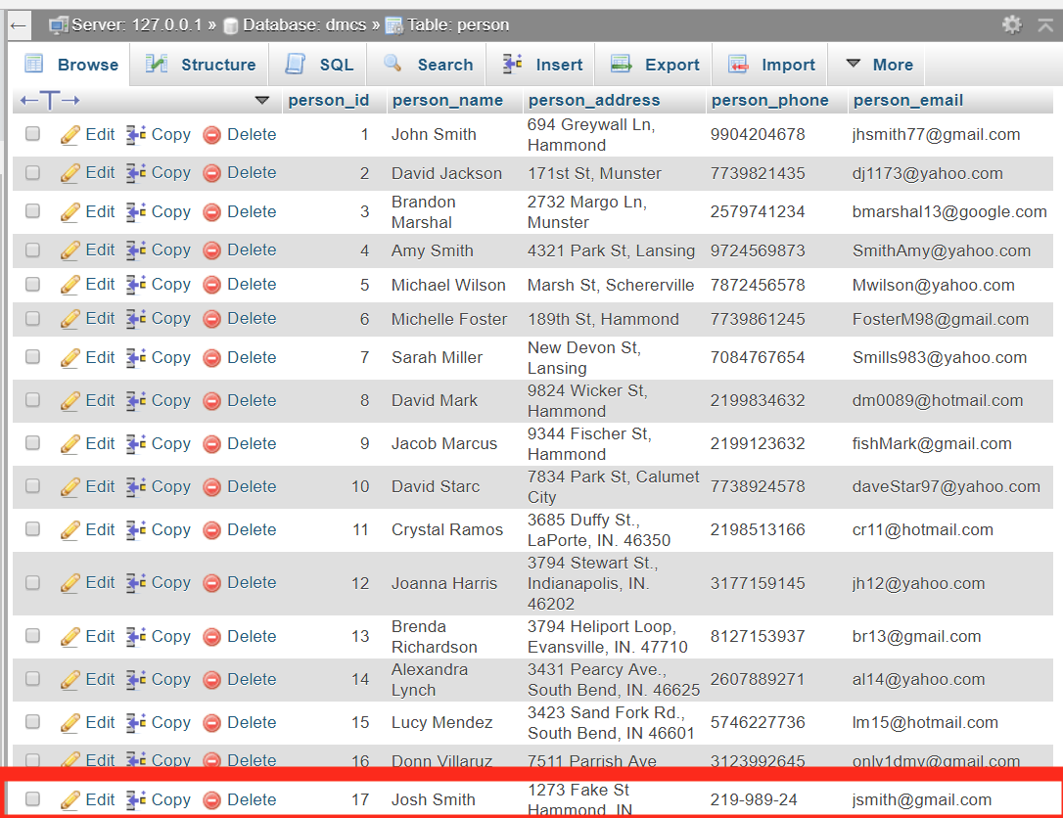

Person table updated

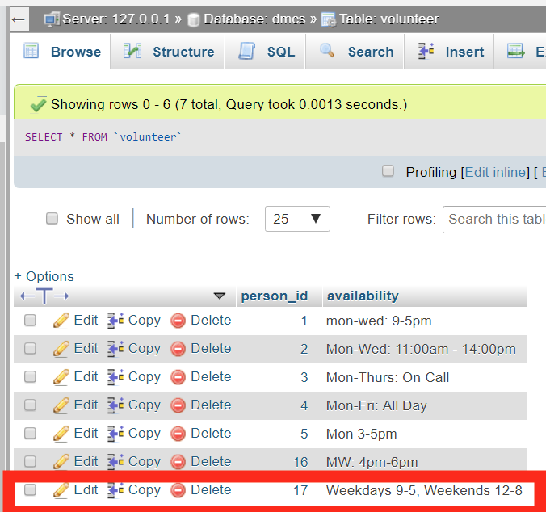

Volunteer table updated.

**Requests**

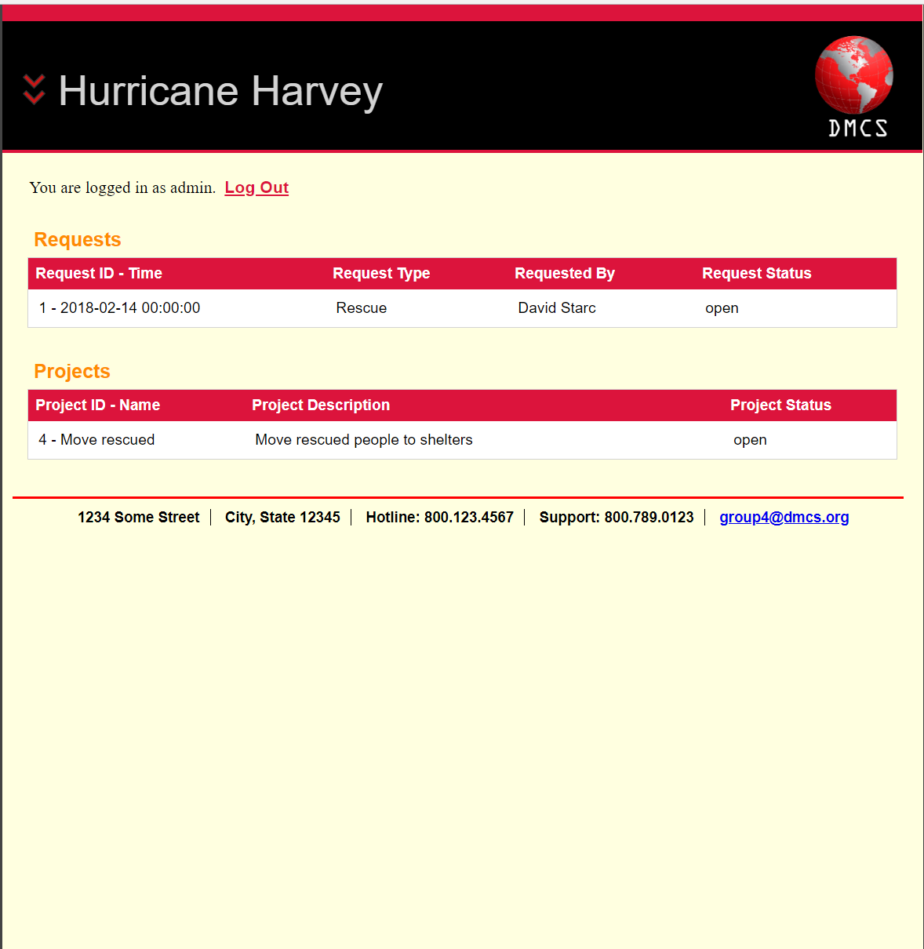

After the user selects “Hurricane Harvey” as a disaster and logs in requests and projects table are displayed.   
  
The requests table displays open, closed, or in progress requests. It also displays the request ID, request type, requested by, and request status. Which corresponds with what’s in our database.  
  
 The projects table displays open, closed, or in progress projects. It also displays the project ID, project description, and project status. Which corresponds with what’s in our database.

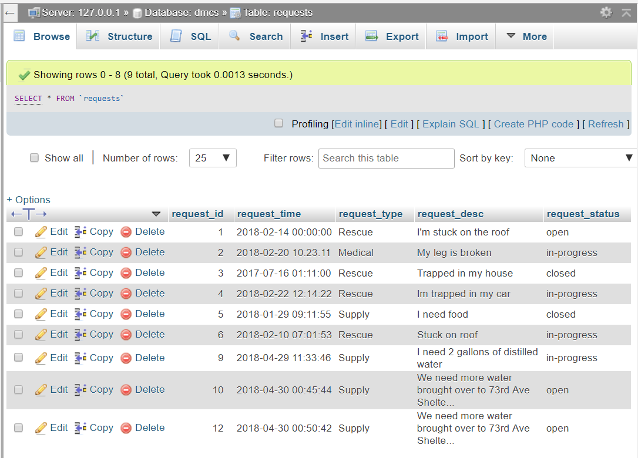

Request table which corresponds with what’s displayed on the DMCS site.

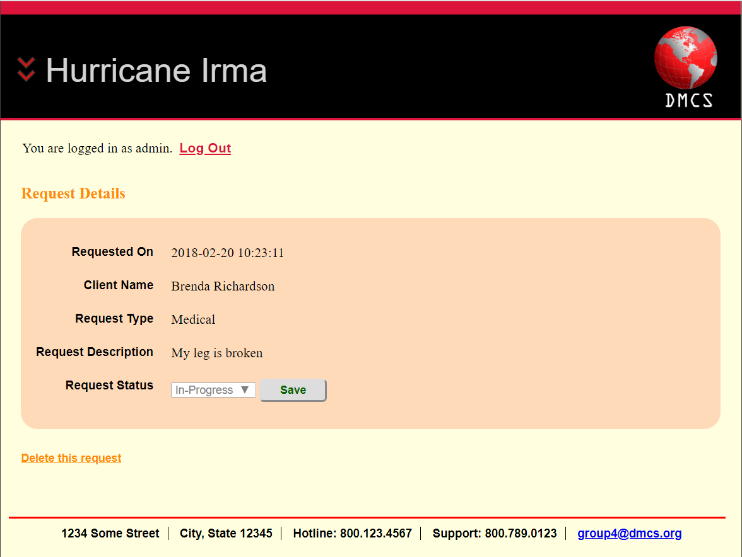

After selecting the Request with request ID(2) the request details are displayed. Here we can see the request date, the client’s name, the request type, the request description, and the request status.

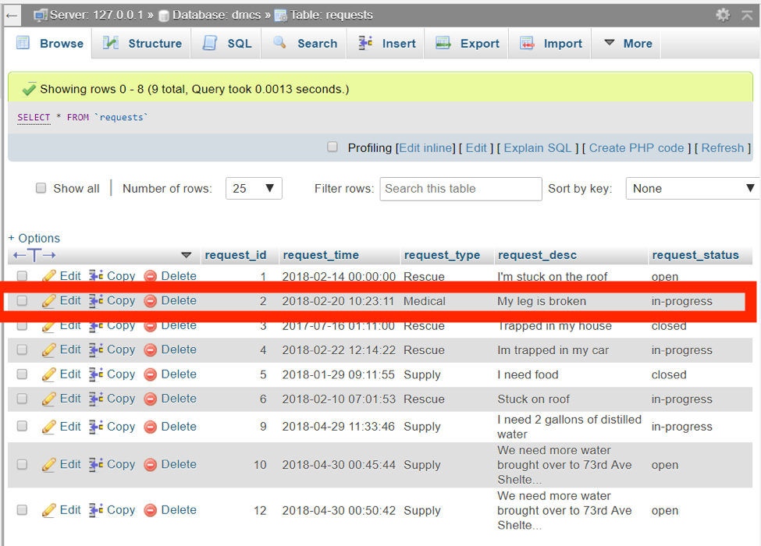

In the Request Table request_id 2 that corresponds with what’s on DMCS site.

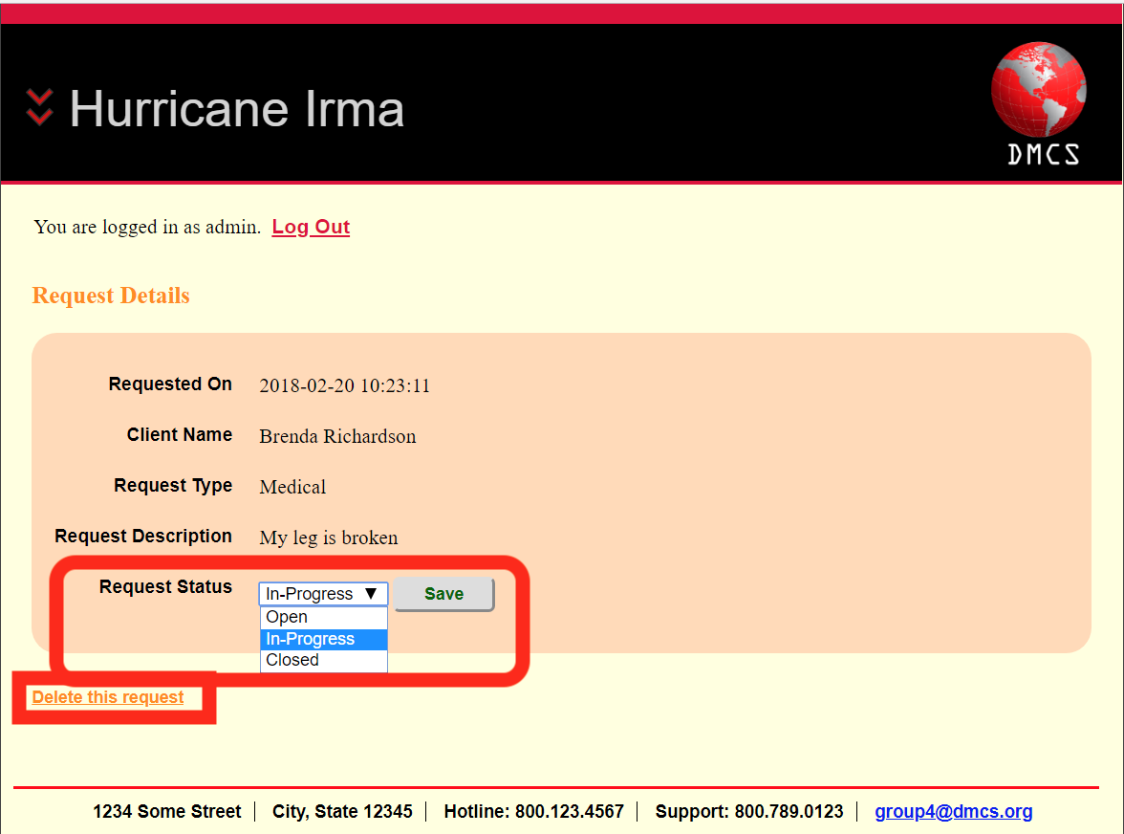

We have the ability to change the status to In-progress, open, or closed. We also have the ability to delete the request which will also delete what’s inserted into our database.

**Project**

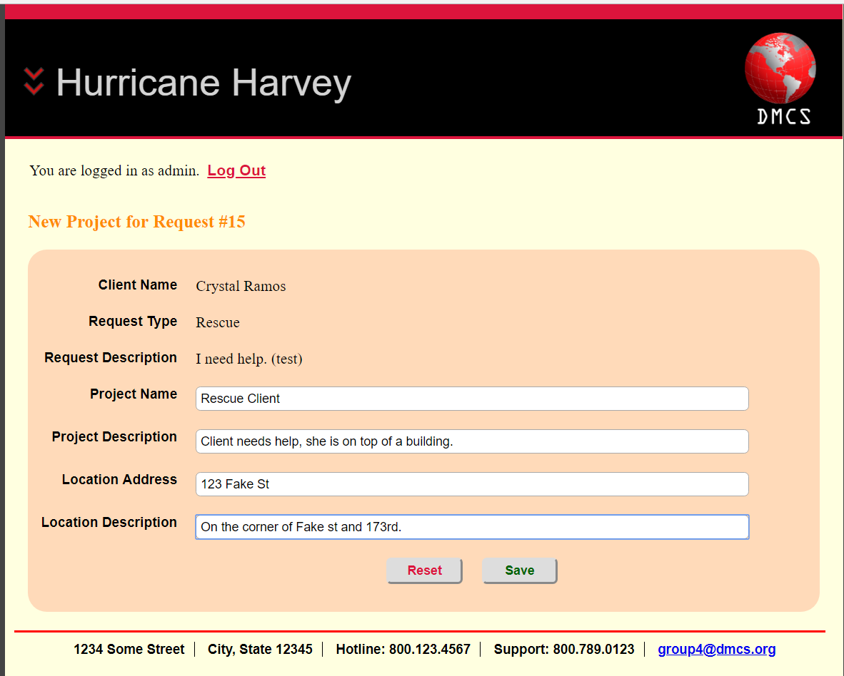

This form inserts a project into our database.

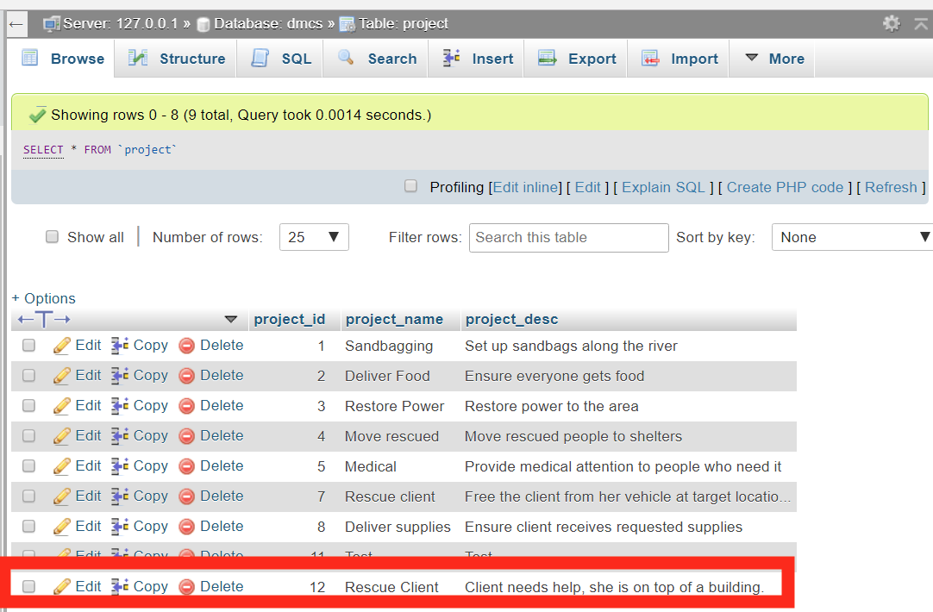

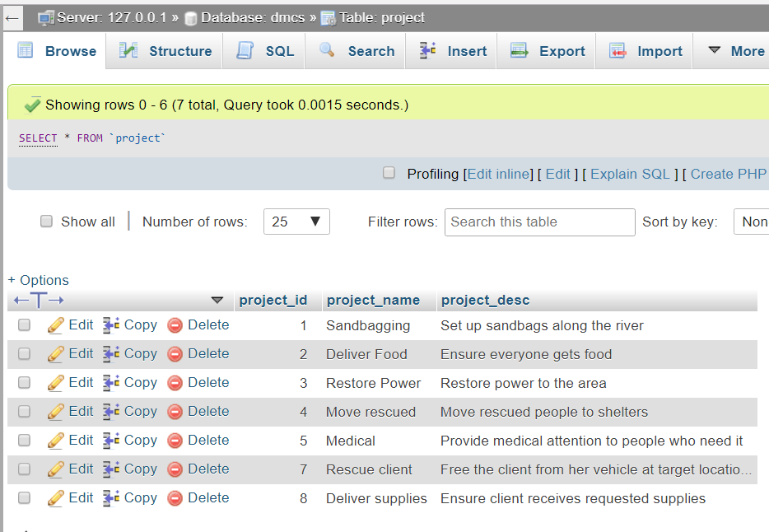

Project table which corresponds with what’s displayed on the DMCS site.

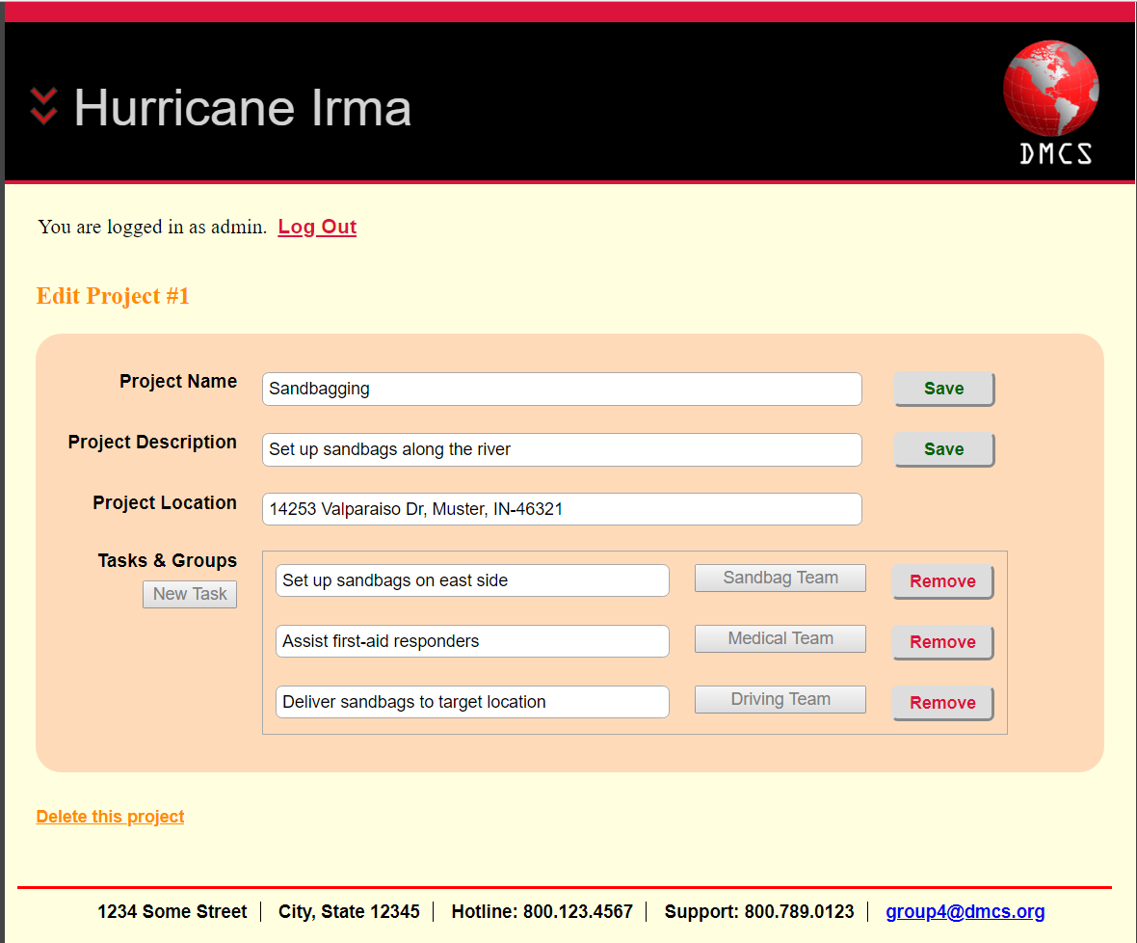

After selected the project with ID(1) the project name, project description, project location, tasks and groups are displayed. Which also correspond with what’s in our database.

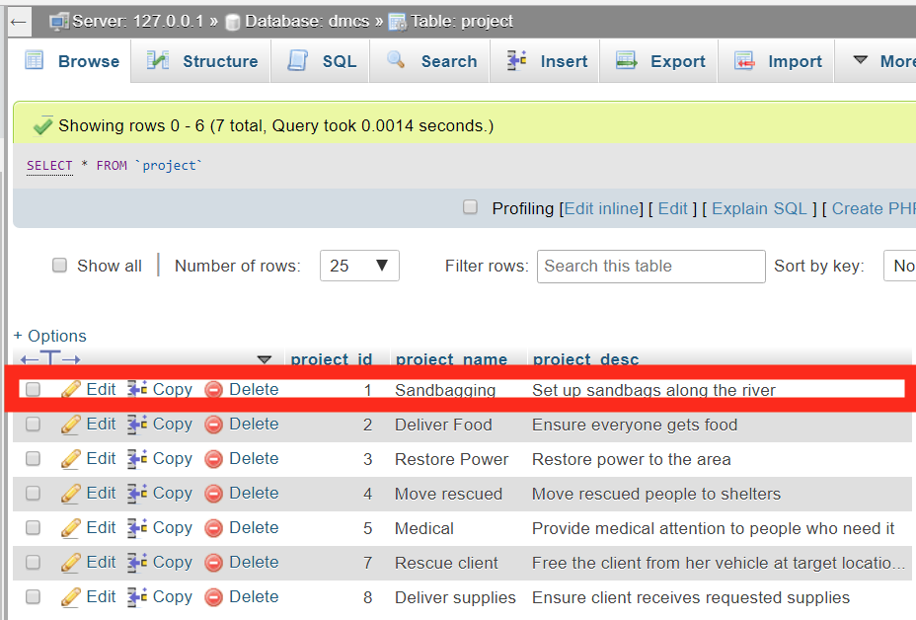

In the Project table project_id 1 corresponds with what’s on the DMCS site.

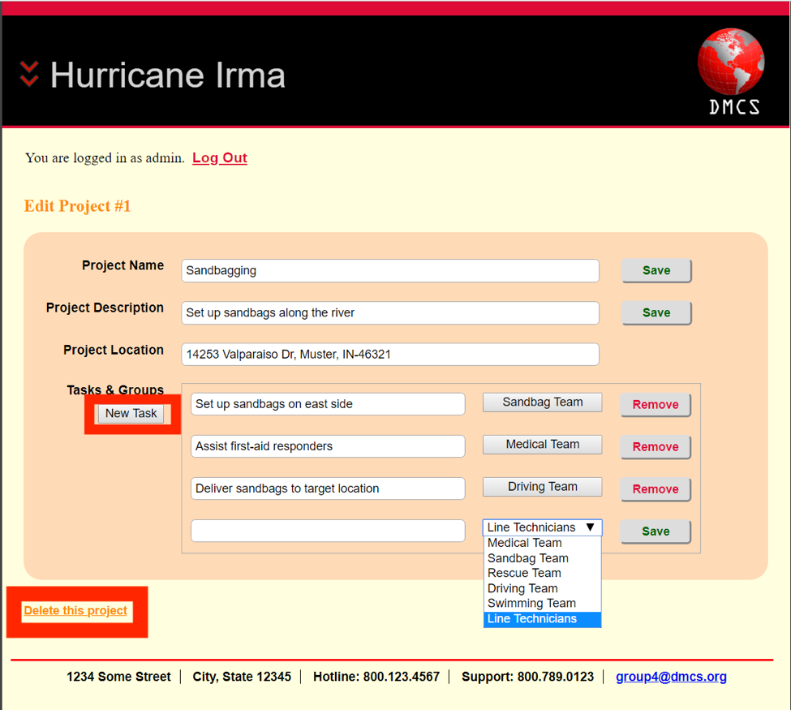

By clicking on New Task we get a new textbox that appears, in this textbox we can create a new task and assign a group to that certain task. When we click save the task is inserted into our database,  
  
Also there is an option to delete this project and it will delete from the database.

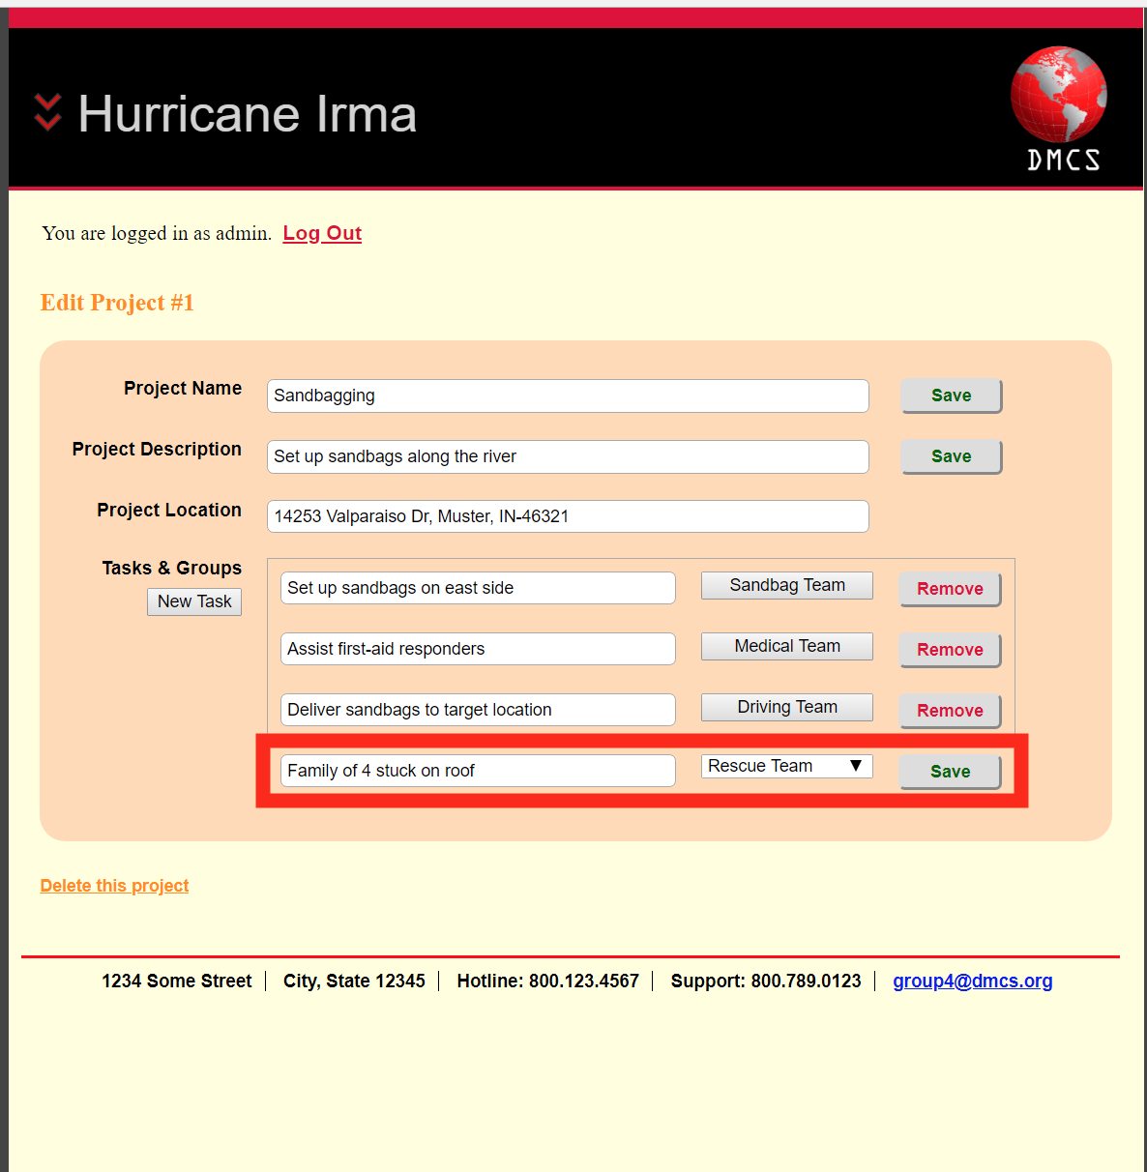

Example of creating a new task.

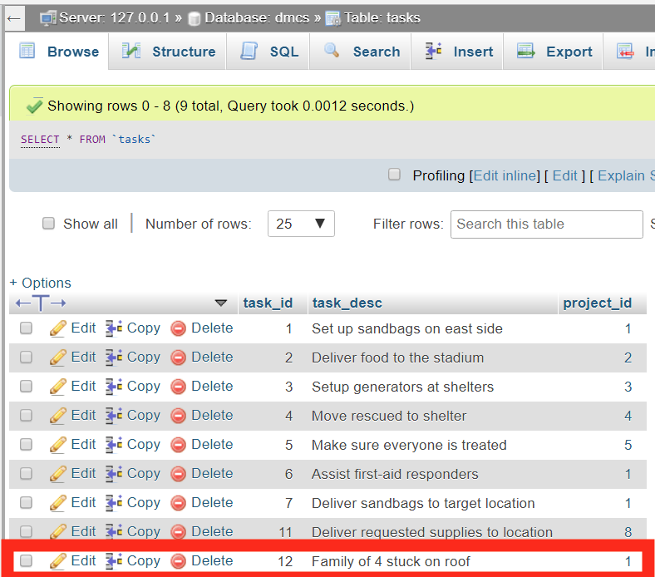

After clicking on save when creating a new task our database is now updated and corresponds with what was entered previously.

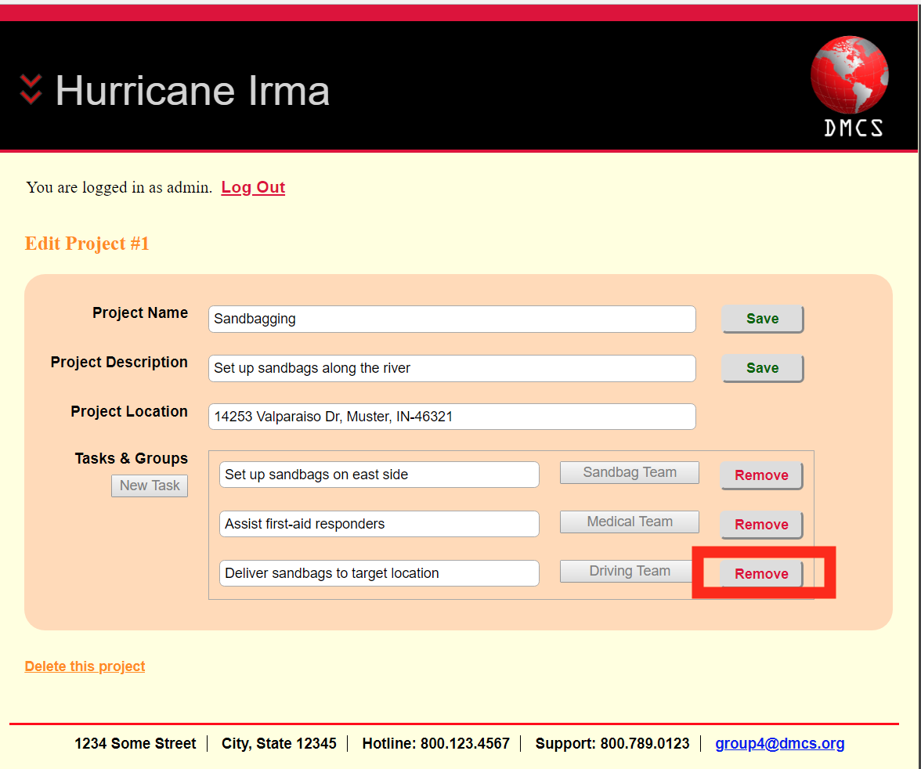

There is also a remove button that will delete the task from the task table in our database.

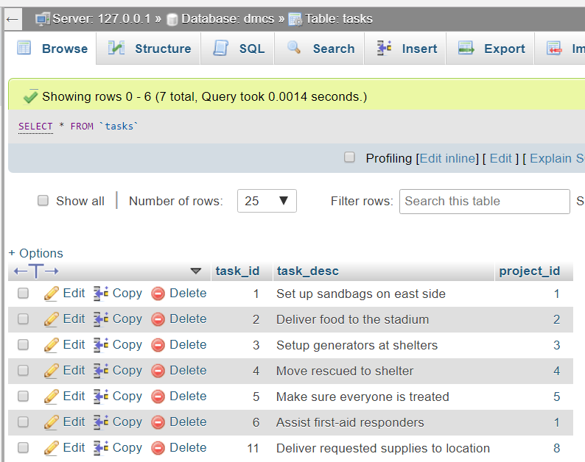

After removing the task “Deliver sandbags to target location” it is deleted from our database.

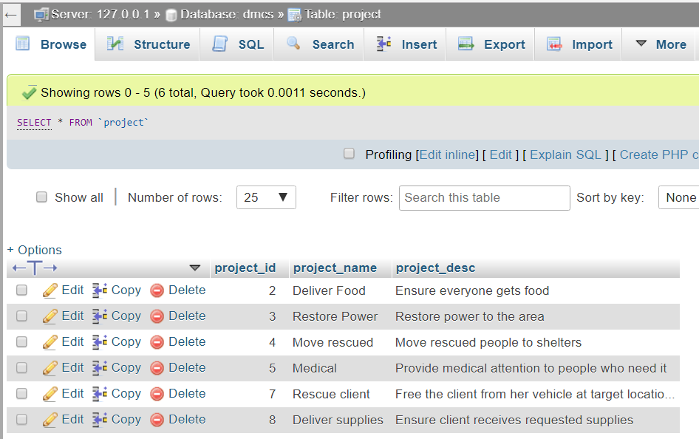

After delete project with ID(1) it is deleted from out database.

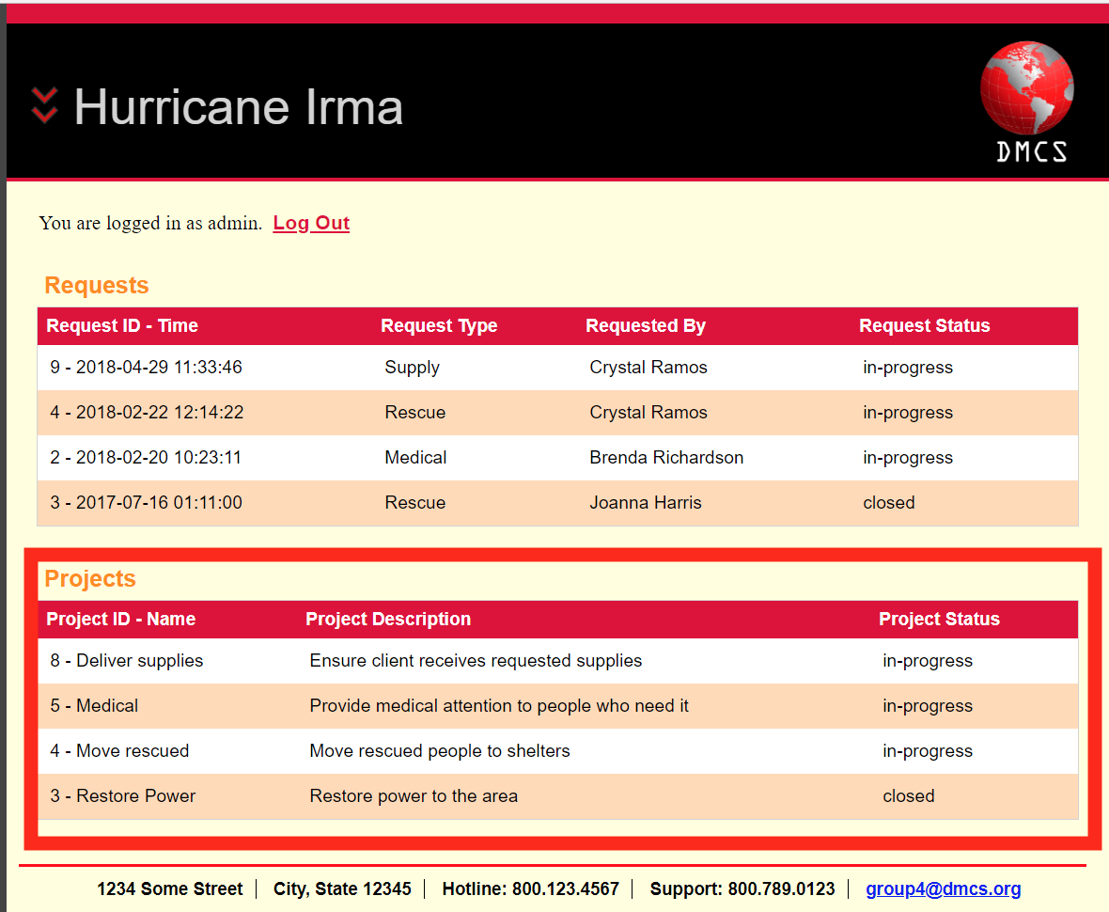

Project with ID(1) is deleted from DMCS site as well.