Donn Villaruz

Jose Huizar

Jeremy Savage

Michelle Gutierrez

Dhruvkumar Patel

**Disaster Management Communication System**

**User View Form**

|  |  |
| --- | --- |
| **Name:** Homepage (dmcs_index.php) | **Number:** 1 |

|  |
| --- |
| **Description:** The homepage of our website, allows users to register and login. Admins can also log in and view projects and requests. Disasters are selected at the top. |

|  |  |  |
| --- | --- | --- |
| **User View Type** | | |
| *Select one of the options below:(Please specify other when chosen)* | | |
| **Report** |  |  |
| **Form** |  |  |
| **Other** |  | ___________________________________________________ |

**Criteria** (Leave blank if no criteria required)

|  |  |
| --- | --- |
| **1.** Employee or user needs to access the site |  |
|  |  |

|  |
| --- |
| **Sorting** (Leave blank if no sorting required) |
| **1.** |

|  |
| --- |
| **Data Elements Required**  **Attributes**: disaster_id and disaster_name.  **Table**: disaster |

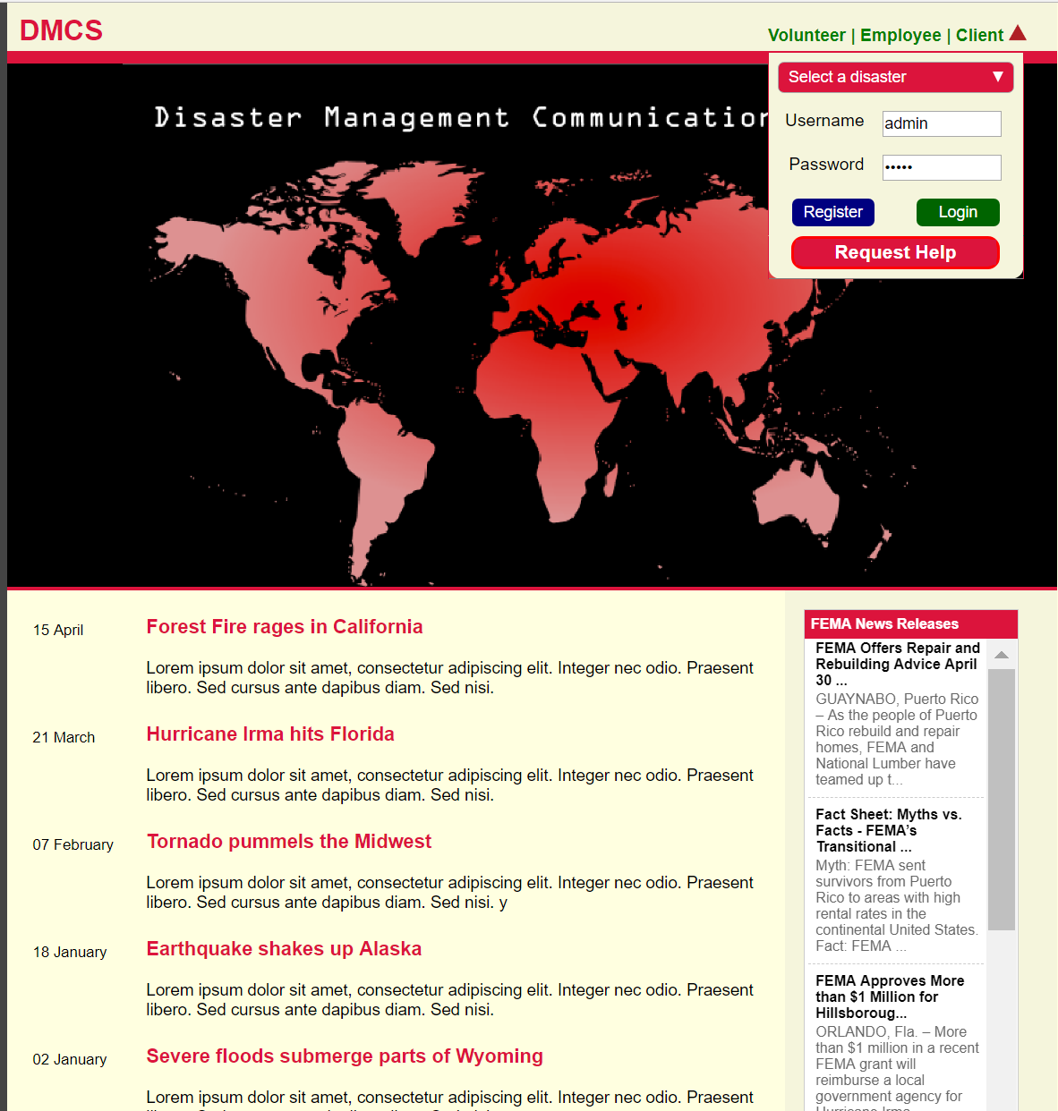

Homepage – A volunteer can log in or register and a client, or employee can log in. Also there are news articles listed as well as FEMA News Release feed that keeps us up to date on FEMA news.

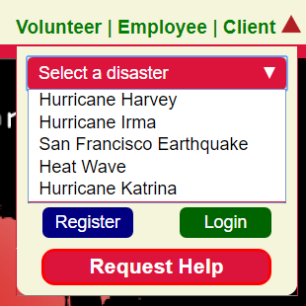

Before one logs in or requests help, they must select a disaster first. Selecting a disaster will give the user the appropriate information regarding the disaster selected. Also a volunteer can register.

**Disaster Management Communication System**

**User View Form**

|  |  |
| --- | --- |
| **Name:** Request Help(req_help.php) | **Number:** 2 |

|  |
| --- |
| **Description:** Allows clients to request help. |

|  |  |  |
| --- | --- | --- |
| **User View Type** | | |
| *Select one of the options below:(Please specify other when chosen)* | | |
| **Report** |  |  |
| **Form** |  |  |
| **Other** |  | ___________________________________________________ |

**Criteria** (Leave blank if no criteria required)

|  |  |
| --- | --- |
| **1.** User needs to request help |  |
|  |  |

|  |
| --- |
| **Sorting** (Leave blank if no sorting required) |
| **1.** |

|  |
| --- |
| **Data Elements Required** |

**Attributes:** request_id, request_desc, request_status, disas_id, person_id, project_id.

**Tables:** requests, person, disaster, encounter.

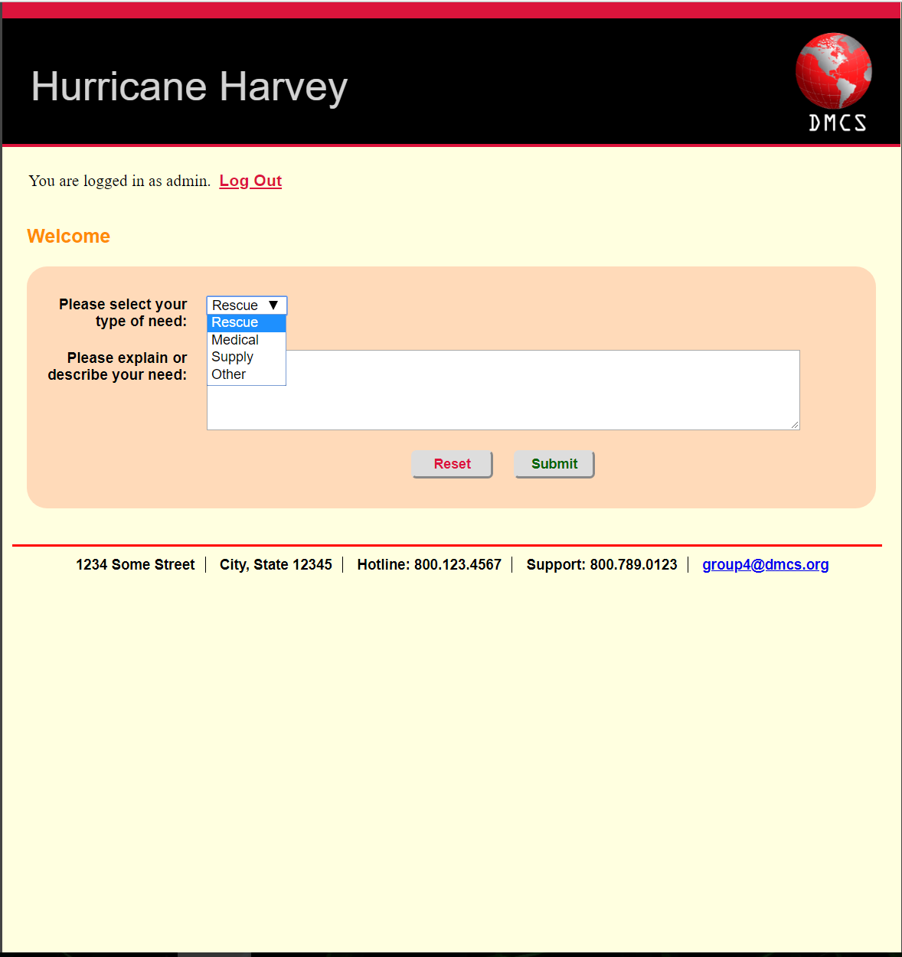

Request Help- After the user clicks on request help they can select rescue, medical, supply or other as their type of need. Then the user explains or describes their need.

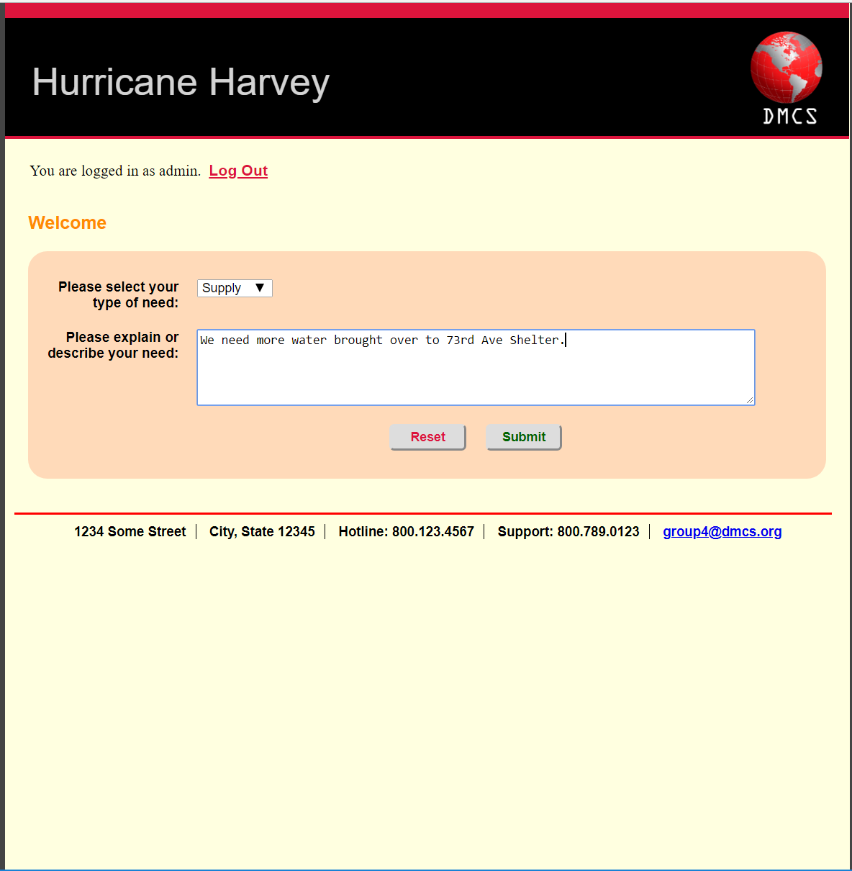

In this example the user selects supply as their type of need and is requesting water.

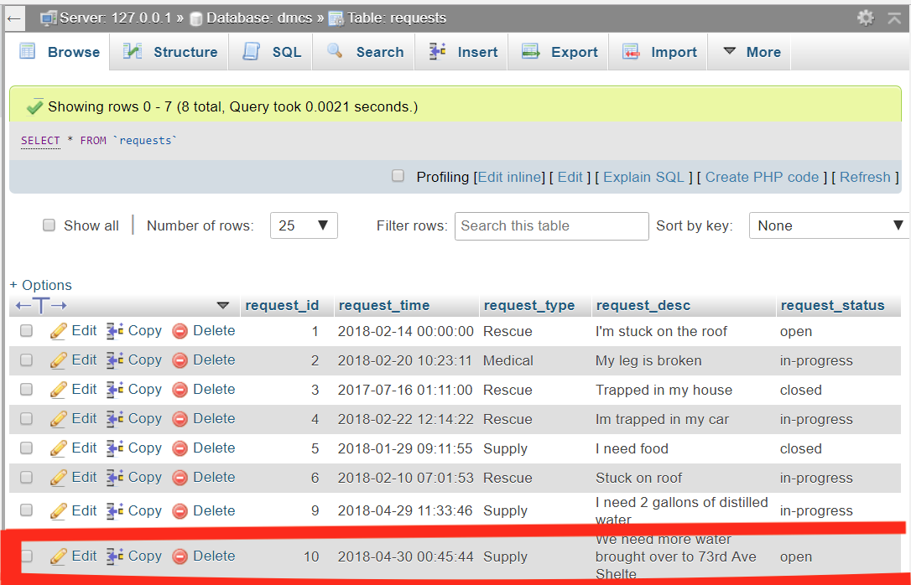

When we submit the previous request the request table updates

**Disaster Management Communication System**

**User View Form**

|  |  |
| --- | --- |
| **Name:** volunteer registration(vol_register.php) | **Number:** 3 |

|  |
| --- |
| **Description:** Allows a user to register. |

|  |  |  |
| --- | --- | --- |
| **User View Type** | | |
| *Select one of the options below:(Please specify other when chosen)* | | |
| **Report** |  |  |
| **Form** |  |  |
| **Other** |  | ___________________________________________________ |

**Criteria** (Leave blank if no criteria required)

|  |  |
| --- | --- |
| **1.** User needs to request help |  |
|  |  |

|  |
| --- |
| **Sorting** (Leave blank if no sorting required) |
| **1.** |

|  |
| --- |
| **Data Elements Required** |

**Attributes**: person_id, person_name, person_address, person_phone, person_email, volunteer_skills, skill_desc, availability.

**Tables:** person, volunteer, skills, volunteer_skills

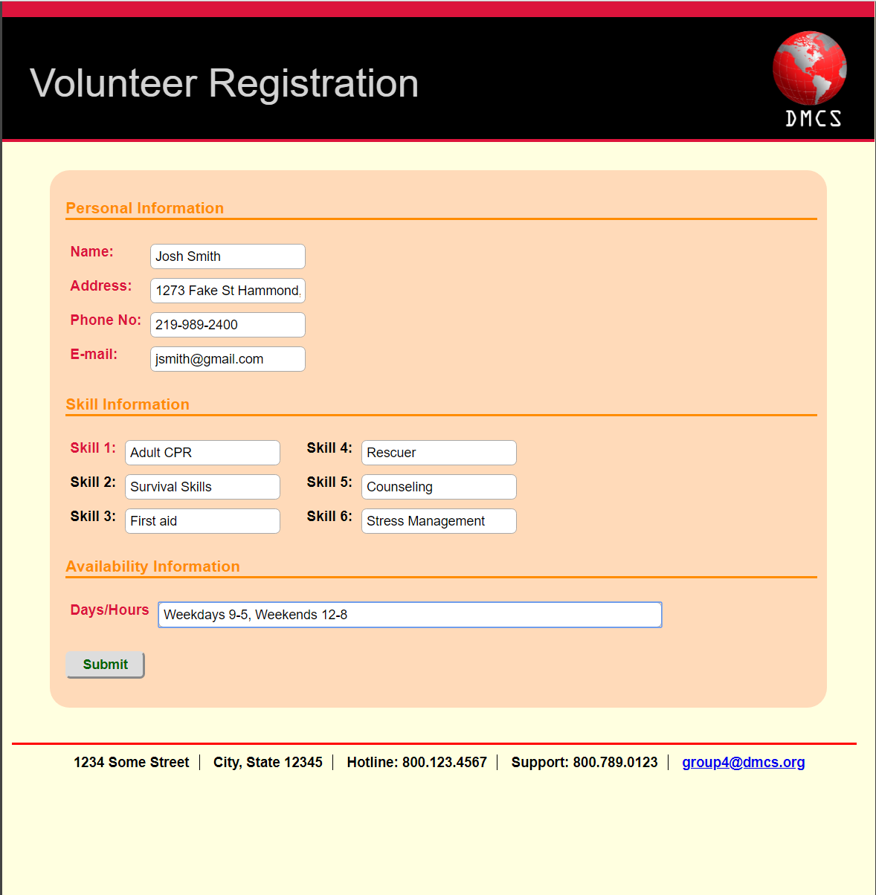

Volunteer Registration – This is the form a volunteer uses to register. The personal information section gets inserted into the person table. The skill information gets inserted into volunteer_skills table. The availability information gets inserted into volunteer table.

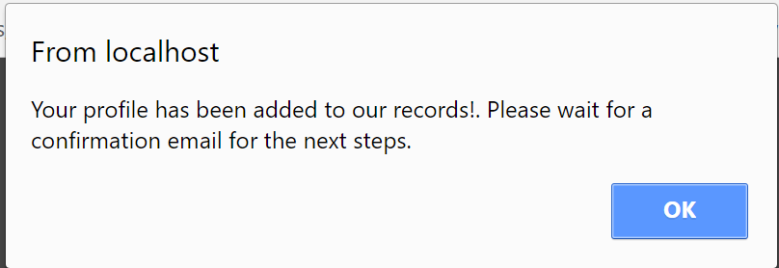

After volunteer fills out the form a popup box displays telling the volunteer that their profile has been added and they will receive a confirmation via email.

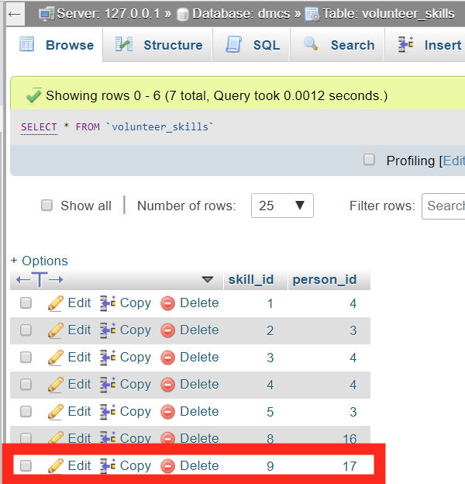

volunteer_skills table updated

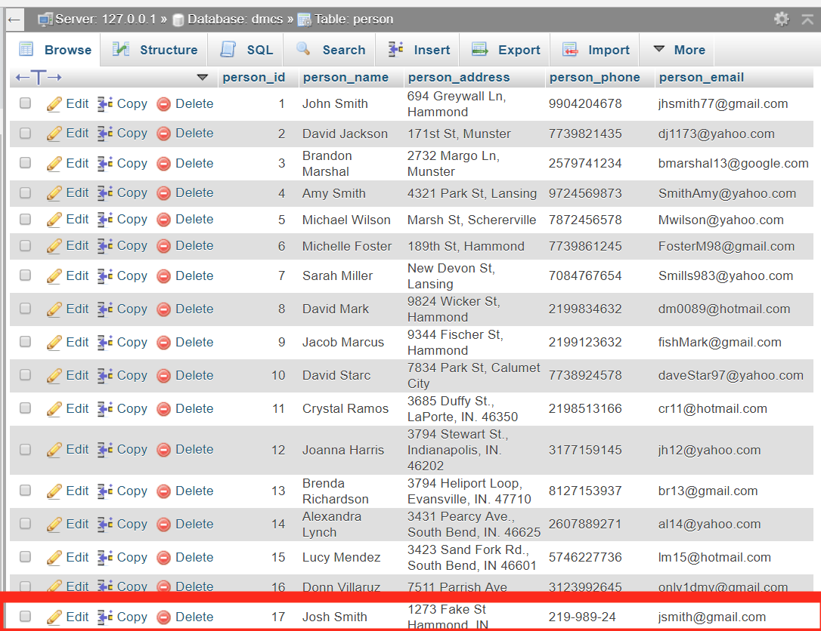

Person table updated

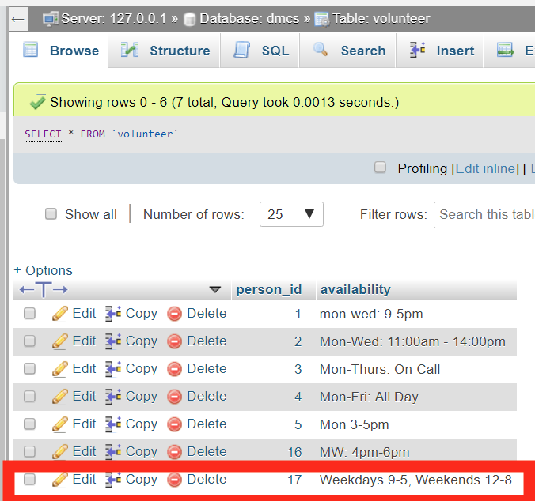

Volunteer table updated.

**Disaster Management Communication System**

**User View Form**

|  |  |
| --- | --- |
| **Name:** projects and requests(project_index.php) | **Number:** 4 |

|  |
| --- |
| **Description:** Viewing and managing the requests and projects. Can create projects based off of requests if the request is open. |

|  |  |  |
| --- | --- | --- |
| **User View Type** | | |
| *Select one of the options below:(Please specify other when chosen)* | | |
| **Report** |  |  |
| **Form** |  |  |
| **Other** |  | ___________________________________________________ |

**Criteria** (Leave blank if no criteria required)

|  |  |
| --- | --- |
| **1.** Admin can view projects and requests. |  |
|  |  |

|  |
| --- |
| **Sorting** (Leave blank if no sorting required) |
| **1.** |

|  |
| --- |
| **Data Elements Required** |

**Attributes:** disaster_id, request_id, request_status, request_date, request_desc, project_id, project_name, project_desc, project_status

**Tables:** requests, disaster, project

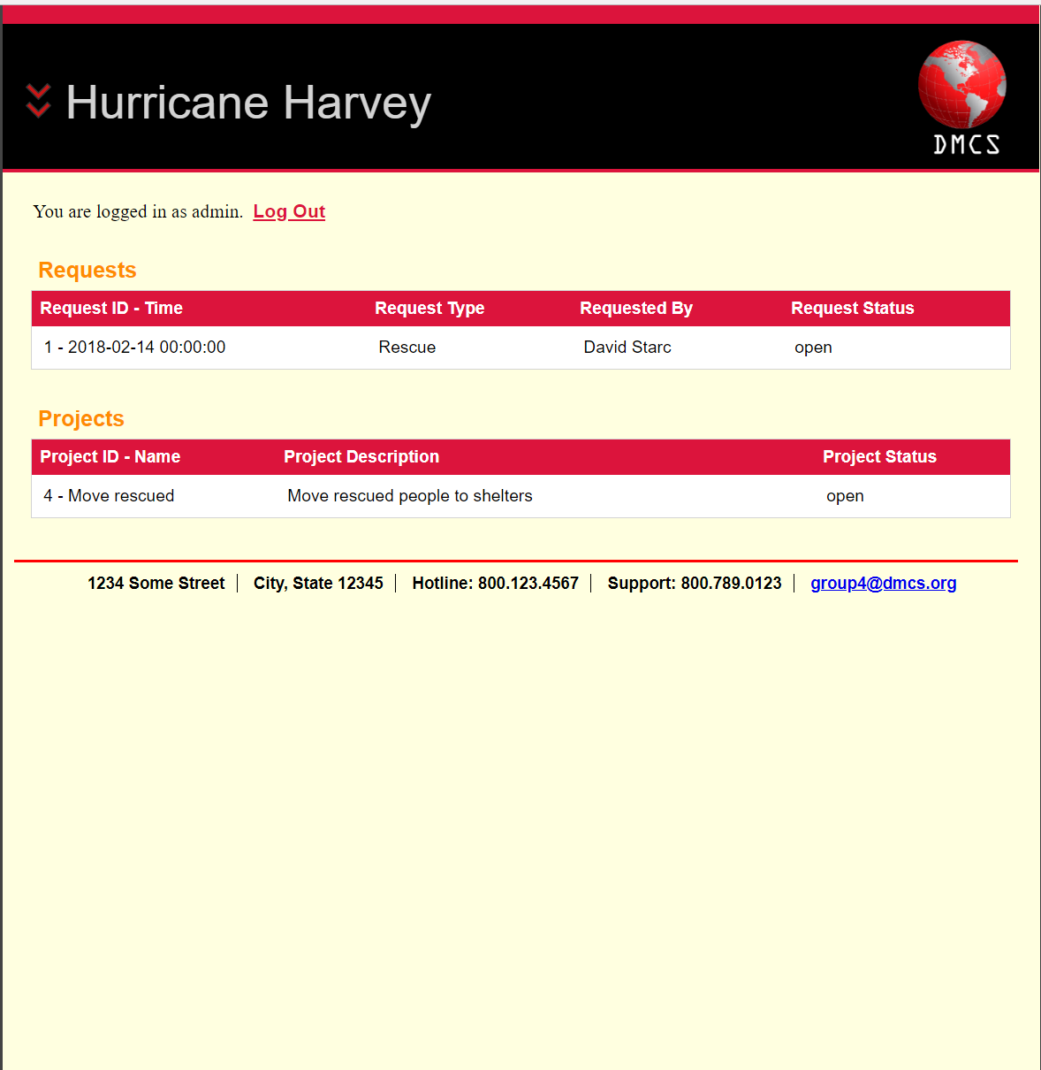

After the user selects “Hurricane Harvey” as a disaster and logs in requests and projects table are displayed.   
  
The requests table displays open, closed, or in progress requests. It also displays the request ID, request type, requested by, and request status. Which corresponds with what’s in our database.  
  
 The projects table displays open, closed, or in progress projects. It also displays the project ID, project description, and project status. Which corresponds with what’s in our database.

**Disaster Management Communication System**

**User View Form**

|  |  |
| --- | --- |
| **Name:** creating projects(newProj.php) | **Number:** 5 |

|  |
| --- |
| **Description:** Allows the admin to create a new project based off of an open request. |

|  |  |  |
| --- | --- | --- |
| **User View Type** | | |
| *Select one of the options below:(Please specify other when chosen)* | | |
| **Report** |  |  |
| **Form** |  |  |
| **Other** |  | ___________________________________________________ |

**Criteria** (Leave blank if no criteria required)

|  |  |
| --- | --- |
| **1.** Admin can create a new project |  |
|  |  |

|  |
| --- |
| **Sorting** (Leave blank if no sorting required) |
| **1.** |

|  |
| --- |
| **Data Elements Required** |

**Attributes:** disaster_id, request_id, request_status, request_date, request_desc, project_id, project_name, project_desc, project_status

**Tables:** requests, disaster, project

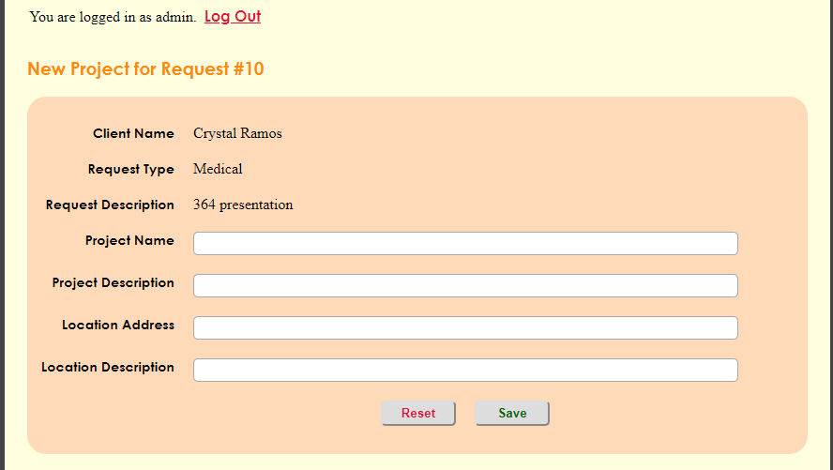

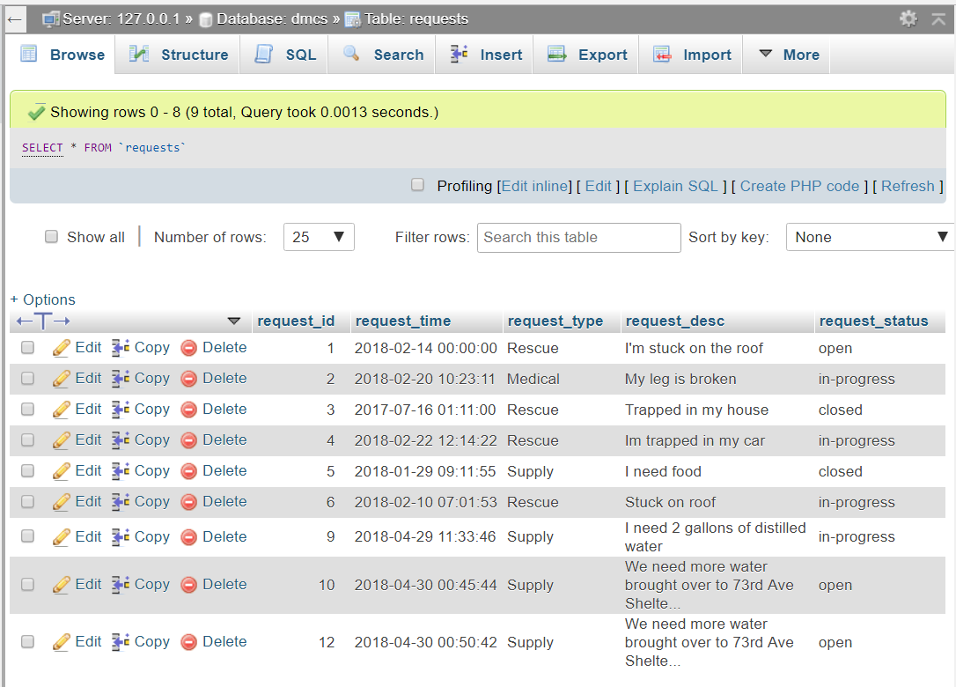

Request table which corresponds with what’s displayed on the DMCS site.

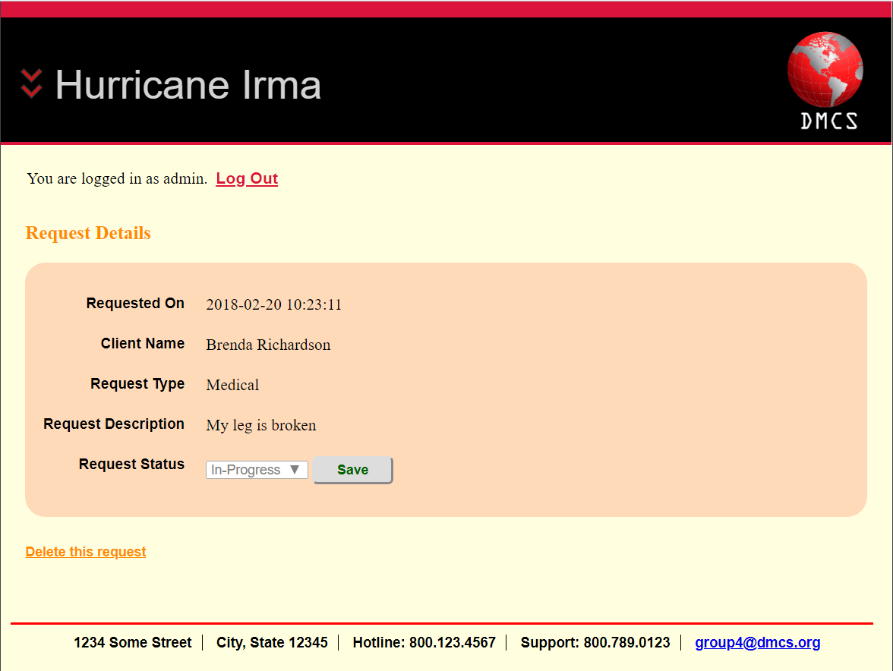

After selecting the Request with request ID(2) the request details are displayed. Here we can see the request date, the client’s name, the request type, the request description, and the request status.

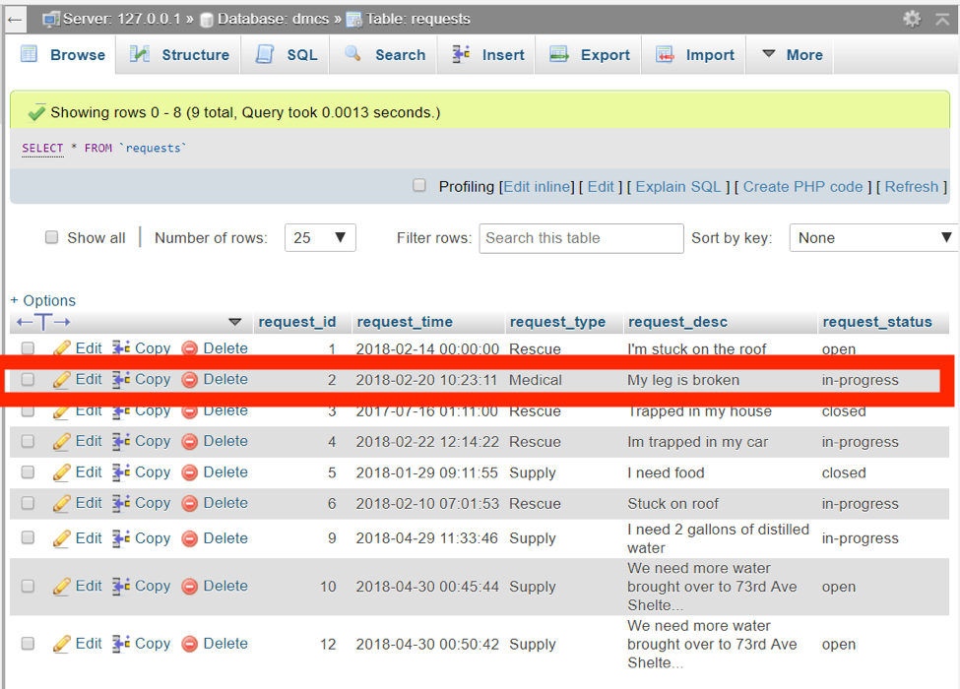

In the Request Table request_id 2 that corresponds with what’s on DMCS site.

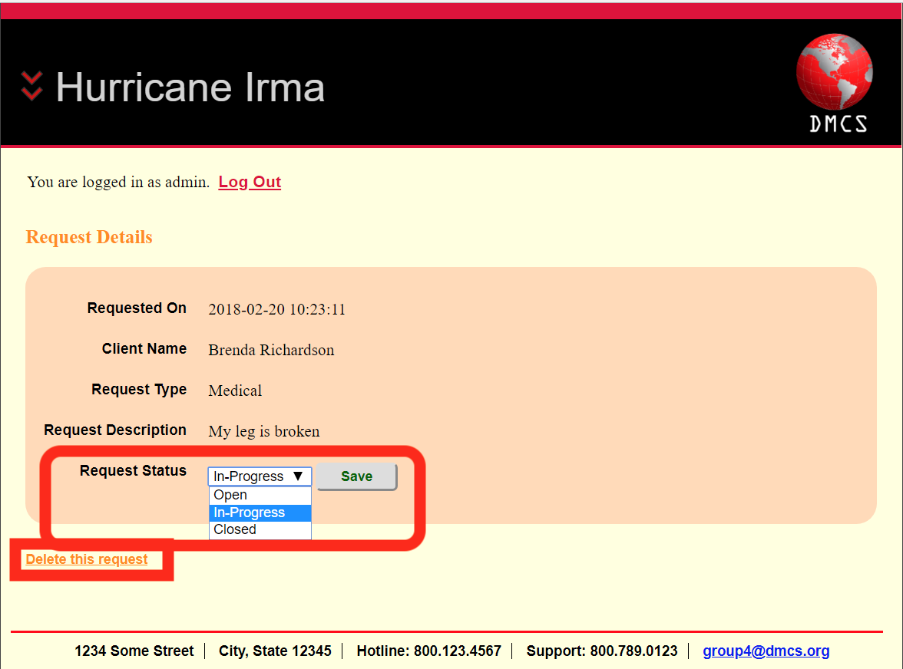

We have the ability to change the status to In-progress, open, or closed. We also have the ability to delete the request which will also delete what’s inserted into our database.

**Project**

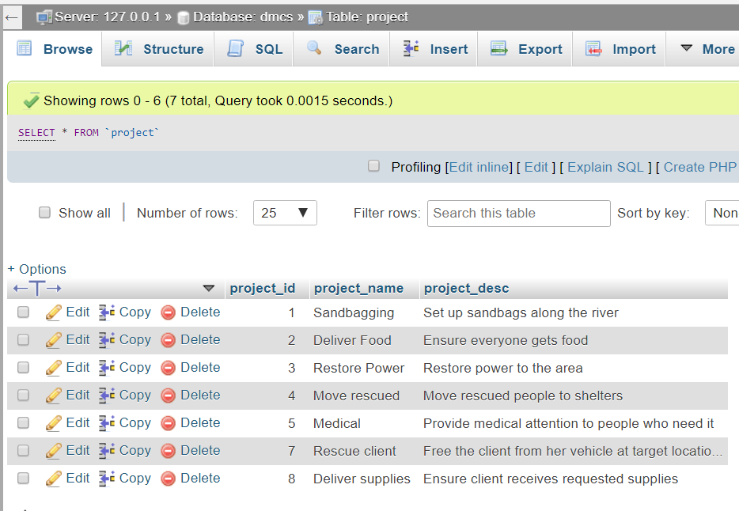

Project table which corresponds with what’s displayed on the DMCS site.

|  |  |
| --- | --- |
| **Name:** Project Info(proj_info.php) | **Number:** 6 |

|  |
| --- |
| **Description:** allows the admin to edit the project information assign tasks and groups. |

|  |  |  |
| --- | --- | --- |
| **User View Type** | | |
| *Select one of the options below:(Please specify other when chosen)* | | |
| **Report** |  |  |
| **Form** |  |  |
| **Other** |  | ___________________________________________________ |

**Criteria** (Leave blank if no criteria required)

|  |  |
| --- | --- |
| **1.** Admin can create a new project |  |
|  |  |

|  |
| --- |
| **Sorting** (Leave blank if no sorting required) |
| **1.** |

|  |
| --- |
| **Data Elements Required** |

**Attributes**: proj_id, task_id, task_desc, proj_id, group_id, proj_name, proj_desc.

**Tables**: tasks, project, groups, volunteers, volunteer_groups, group_tasks

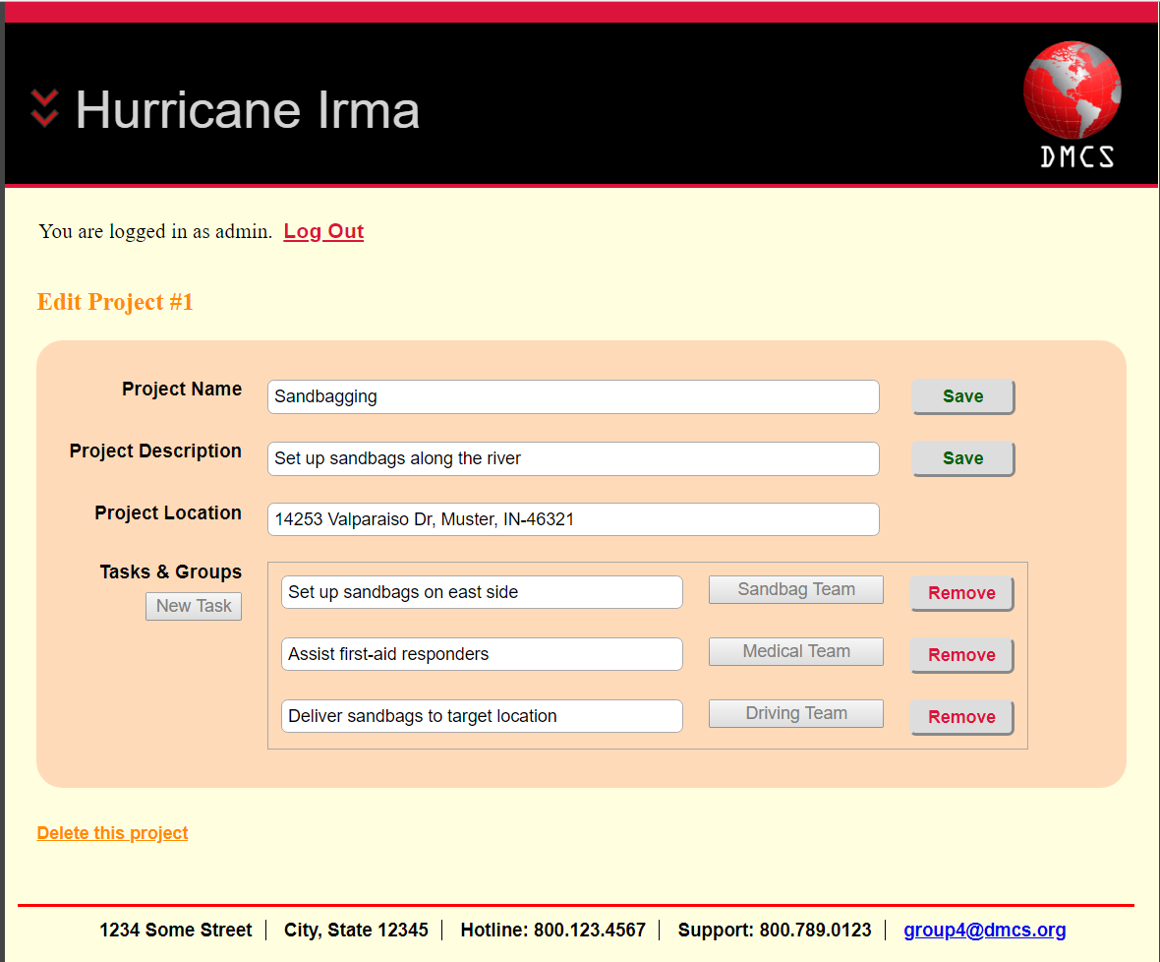

After selected the project with ID(1) the project name, project description, project location, tasks and groups are displayed. Which also correspond with what’s in our database.

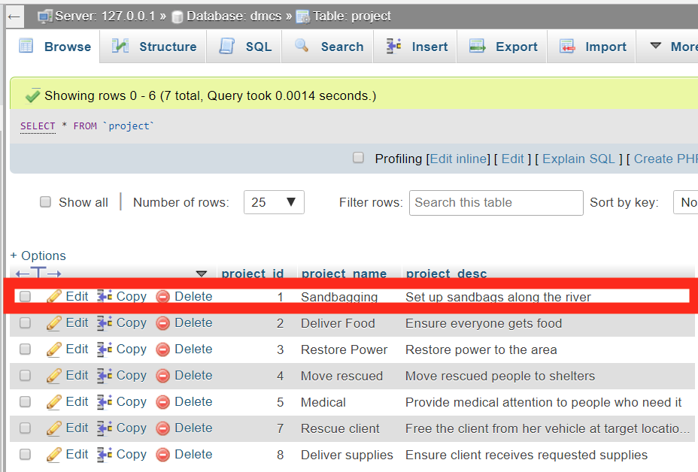

In the Project table project_id 1 corresponds with what’s on the DMCS site.

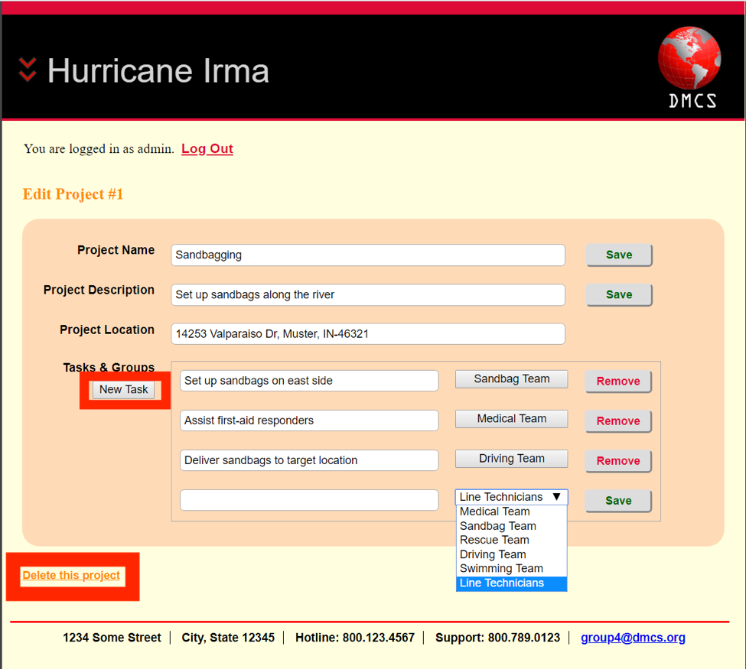

By clicking on New Task we get a new textbox that appears, in this textbox we can create a new task and assign a group to that certain task. When we click save the task is inserted into our database,  
  
Also there is an option to delete this project and it will delete from the database.

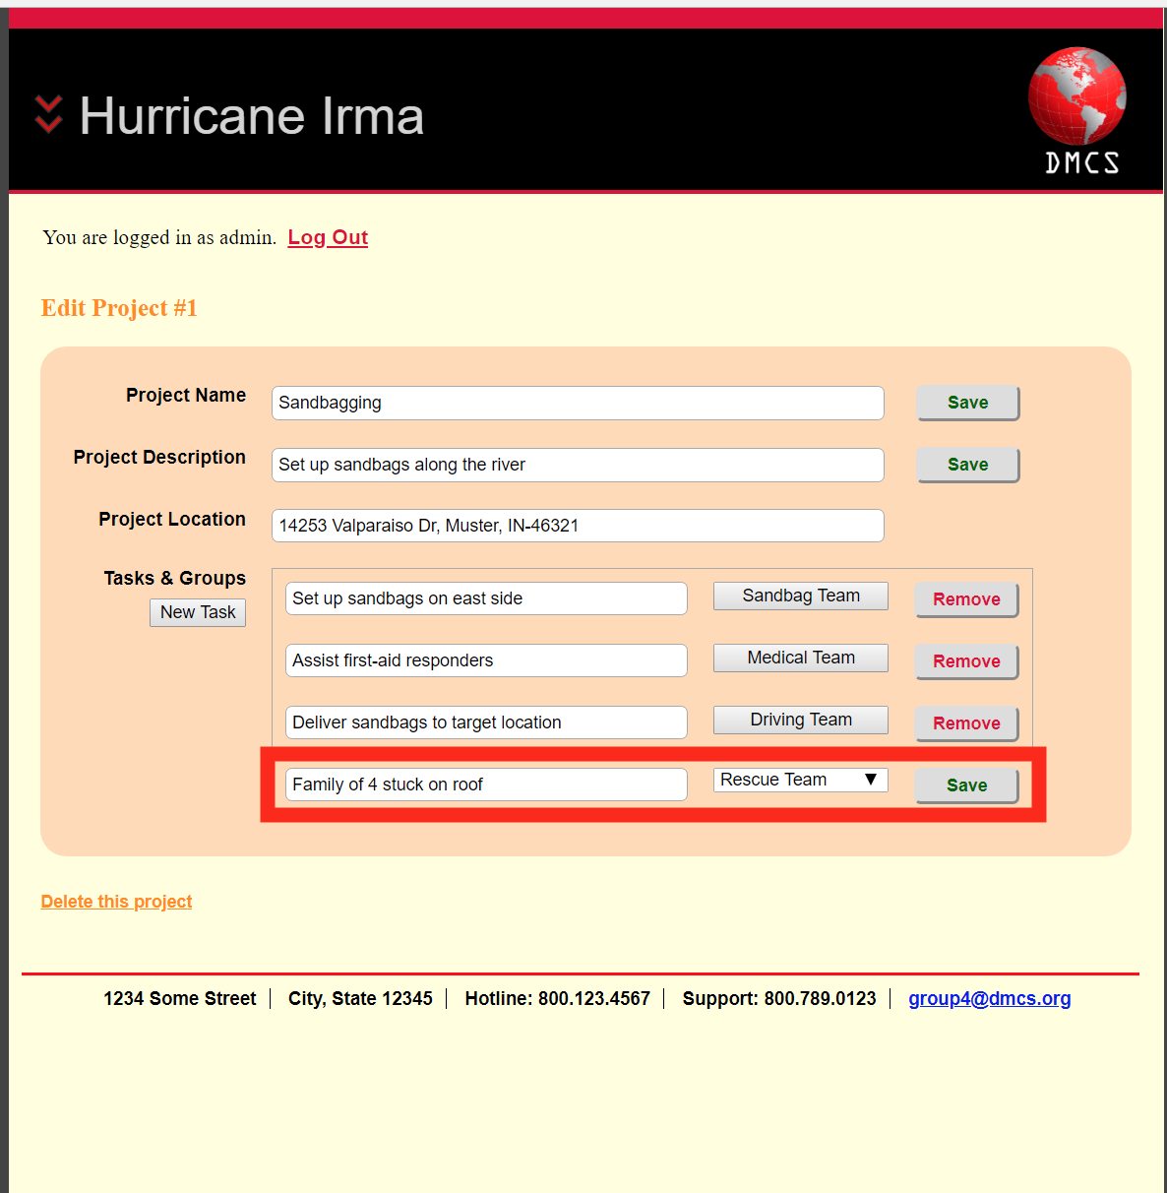

Example of creating a new task.

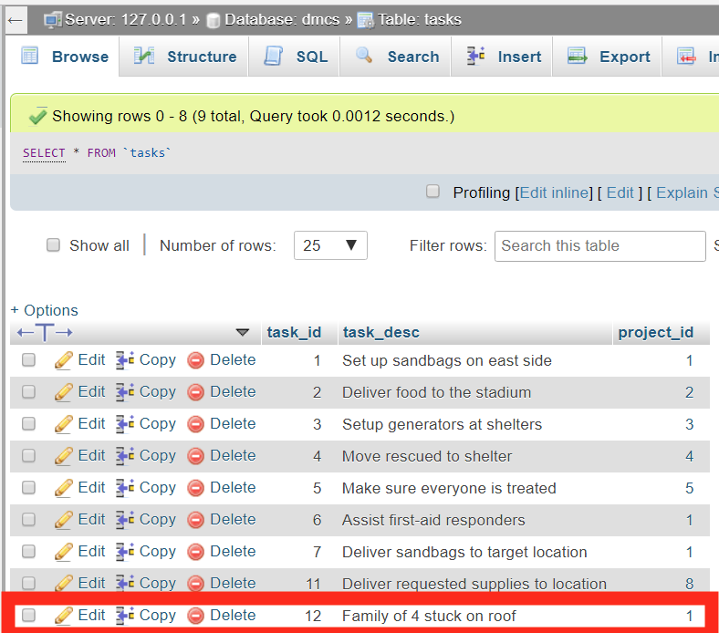

After clicking on save when creating a new task our database is now updated and corresponds with what was entered previously.

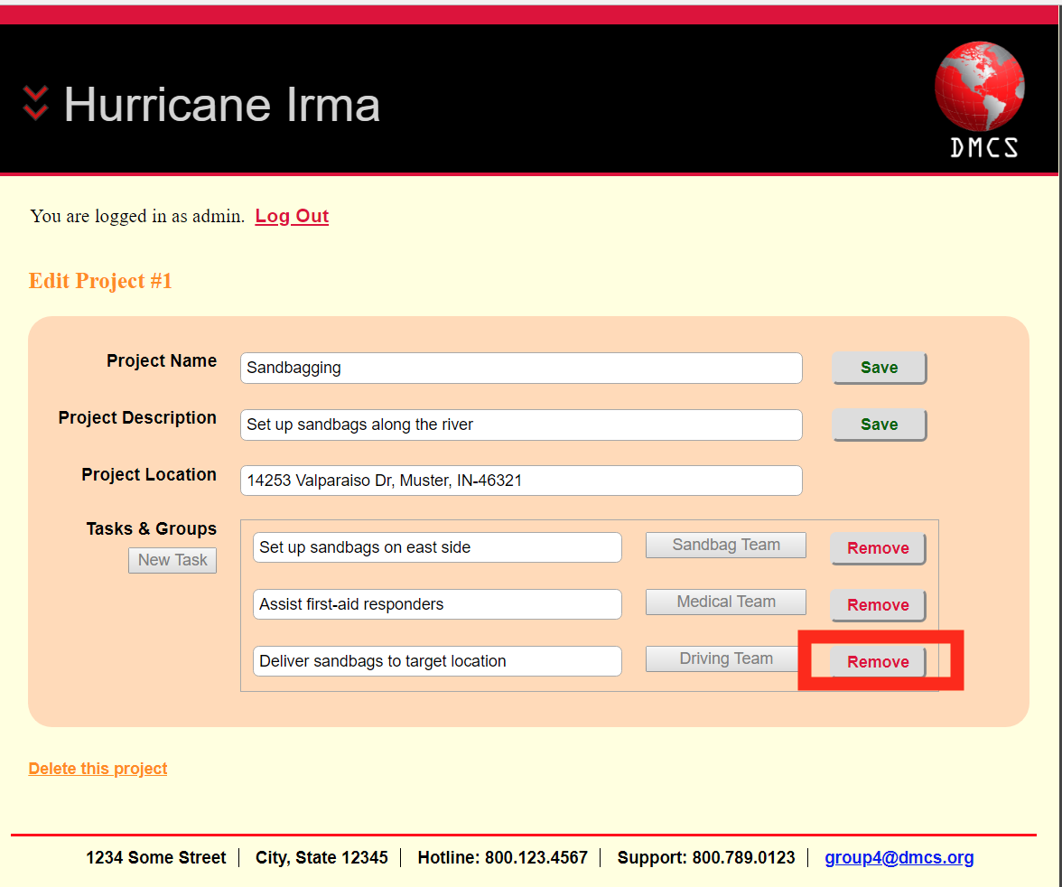

There is also a remove button that will delete the task from the task table in our database.

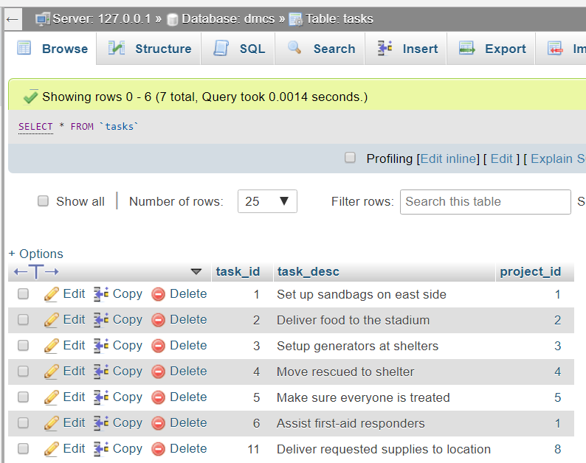

After removing the task “Deliver sandbags to target location” it is deleted from our database.

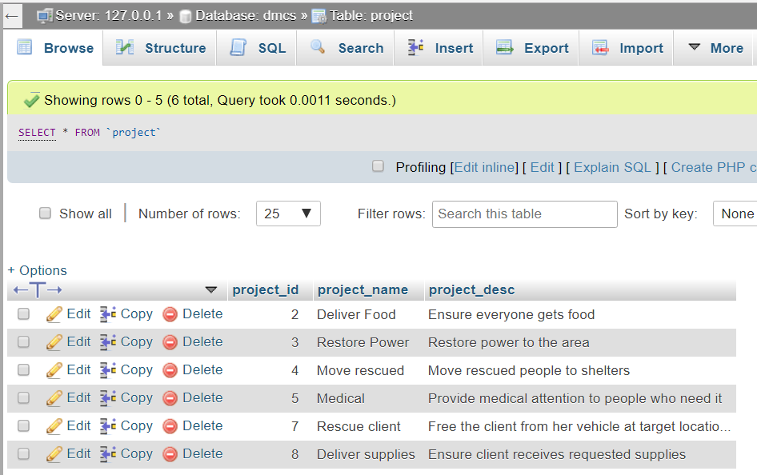

After delete project with ID(1) it is deleted from out database.

**Disaster Management Communication System**

**User View Form**

|  |  |
| --- | --- |
| **Name:** Project and Request (proj_index.php) | **Number:** 7 |

|  |
| --- |
| **Description:** This view Requests and Projects page displays the current requests and projects weather it is open, closed, or in progress. The request id, time, request type, requested by, request status are displayed for requests. For projects the project id/name, project description, project status are displayed. |

|  |  |  |
| --- | --- | --- |
| **User View Type** | | |
| *Select one of the options below:(Please specify other when chosen)* | | |
| **Report** |  |  |
| **Form** |  |  |
| **Other** |  | ___________________________________________________ |

**Criteria** (Leave blank if no criteria required)

|  |  |
| --- | --- |
| **1.** Employee wants to edit/view project |  |
|  |  |

|  |
| --- |
| **Sorting** (Leave blank if no sorting required) |
| **1.** |

|  |
| --- |
| **Data Elements Required**  *Enter the names of all fields needed for the user view*  *Request_id, request_type, request_time, request_desc, request_status, project_id, project_name, project_desc* |

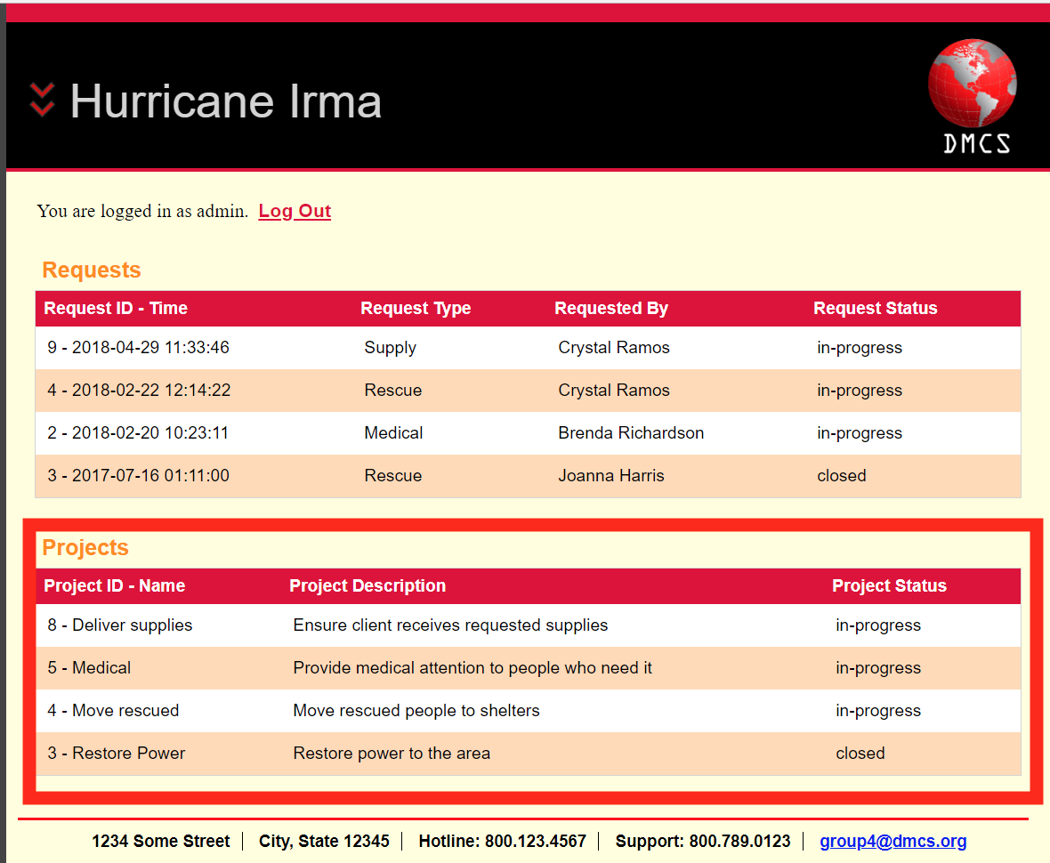

Project with ID(1) is deleted from DMCS site as well.