**ITS 364**

**EERD**

**TEAM 04**

Michelle Gutierrez  
Jose Huizar

Dhruvkumar Patel

Jeremy Savage  
Donn Villaruz

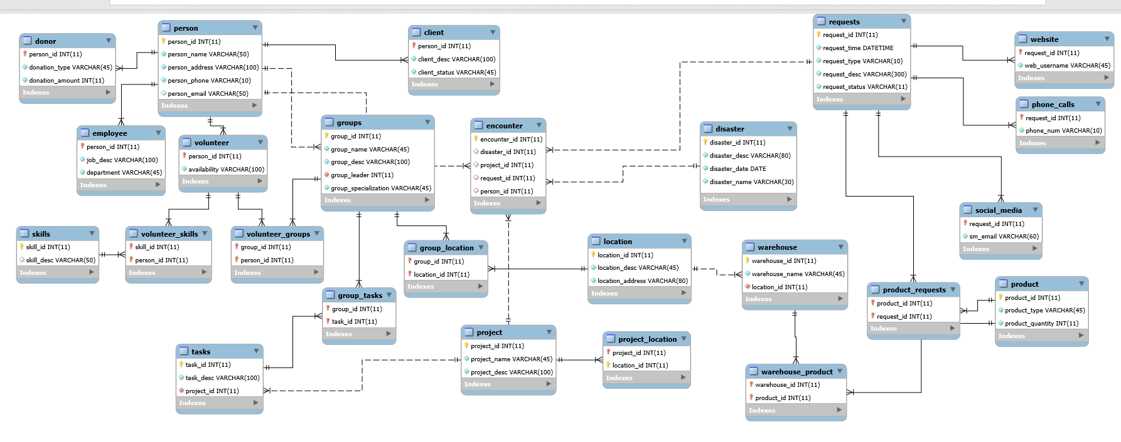

*NOTE*

PERSON, EMPLOYEE, DONOR, CLIENT, LOCATION, ENCOUNTER, WAREHOUSE, DISASTER, and PRODUCTS are tables from original DMCS. We have kept the relevant field names.